Homework will be uploaded to the glow blog every Monday. https://blogs.glowscotland.org.uk/sh/ollaberryprimaryschool/
If you have any questions or queries please contact the school by phone or email: jenna.m.peterson@shetland.gov.uk
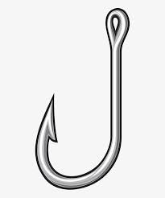
‘k’ Sound

Spelling List:

- hook
- fork
- back
- brick
- deck
- flock
- struck
- rucksack
- nineteen
10. twenty

Practice your spelling words: Look – Cover – Write.

Choose three words and write a sentence for each.

