Homework will be uploaded to the glow blog every Monday. https://blogs.glowscotland.org.uk/sh/ollaberryprimaryschool/
If you have any questions or queries please contact the school by phone or email: jenna.m.peterson@shetland.gov.uk
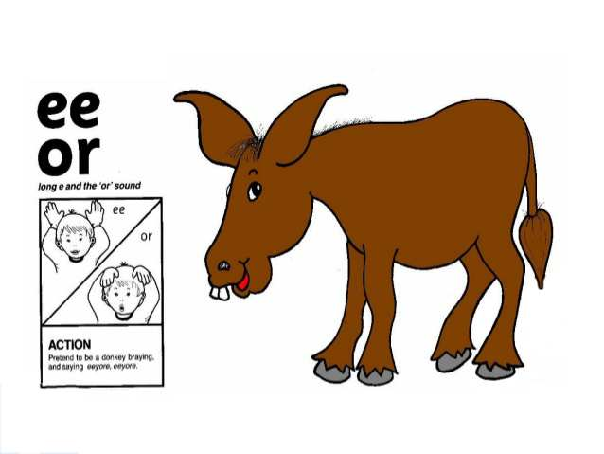
‘Or’ Sound

Pretend to have ears like a donkey saying ‘ee-or.’

Spelling List:

- got
- bun
- belt
- fork
- storm
- horse
- forty
- goes
- does
10. morning

Practice your spelling words: Look – Cover – Write.

Choose three words and write a sentence for each.

