Homework will be uploaded to the glow blog every Monday. https://blogs.glowscotland.org.uk/sh/ollaberryprimaryschool/
If you have any questions or queries please contact the school by phone or email: jenna.m.peterson@shetland.gov.uk
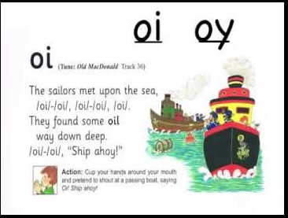
‘Oy’ Sound

Cup your hands around your mouth and say ‘oy ship ahoy!’

Spelling List:

- jet
- dig
- help
- boy
- toy
- enjoy
- annoy
- two
- four
10. destroy

Practice your spelling words: Look – Cover – Write.

Choose three words and write a sentence for each.

