Homework will be uploaded to the glow blog every Monday. https://blogs.glowscotland.org.uk/sh/ollaberryprimaryschool/
If you have any questions or queries please contact the school by phone or email: jenna.m.peterson@shetland.gov.uk
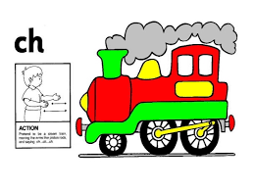
New sound
Your new sound is ‘ch’

Pretend you are a train and say ‘ch, ch, ch’.

Watch the clip and practice the sound:
(15) The CH Sound | Phonics Video | Scratch Garden - YouTube

You can draw a picture and write a sentence for one of your words.
- chin
- chat
- watch
- match
- catch

