Homework will be uploaded to the glow blog every Monday. https://blogs.glowscotland.org.uk/sh/ollaberryprimaryschool/
If you have any questions or queries please contact the school by phone or email: jenna.m.peterson@shetland.gov.uk
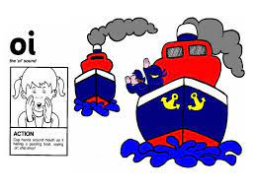
‘Oi’ Sound

Cup your hands around your mouth and say ‘oi ship ahoy!’

Spelling List:

- bug
- had
- film
- oil
- coin
- noisy
- toilet
- would
- right
10.boiling

Practice your spelling words: Look – Cover – Write.

Choose three words and write a sentence for each.

