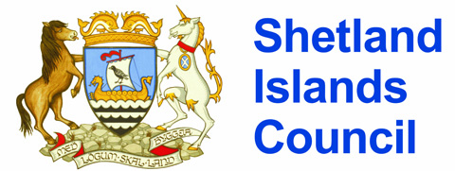

Ollaberry Primary School, Ollaberry, Shetland ZE29RT
01595 807270 www.ollaberry.shetland.sch.uk
ollaberry@shetland.gov.uk
juliamcginlay@shetland.gov.uk

4th May 2021

Dear Parents/Carers of Pupils in P4 and P7

Scottish National Standardised Assessments (SNSA)

School staff plan to conduct the Scottish Government National Standardised Assessments in literacy and numeracy with pupils in P4 and P7 in May. The assessments are online in format and will be administered as part of normal classroom activities. If you do not want your child to take part in this assessment, please contact me at school by Monday 10th May.

The results are diagnostic to provide teachers with information about children’s learning rather than simply being about “marks”. No results will be sent home but teachers will probably refer to these to inform ongoing curriculum planning.

Finally, it is important to note that the assessments will not be used to compile league tables of schools.

If you would like further information about SNSA there is a section specifically for parents on the SNSA website at: https://standardisedassessment.gov.scot/parents-and-carers/

If you require further information please do hesitate to contact the school.

Yours Sincerely

Julia McGinlay

Acting Head Teacher

