Make a fruit smoothie using your favourite fruit. Add some milk or yogurt to make it delicious! Or make a fruit kebab for a tasty snack. | Phone, FaceTime or write a letter to a friend. Tell them all your news. Ask them how they are. | Go for a walk outside and look for animal tracks and signs that wildlife have left behind. Indoors, recreate your own signs, pretend animal footprints or even fake poop! | Build a bridge that will hold your weight so you can cross a puddle. Or make a mini bridge inside that holds up a bag of sugar. | 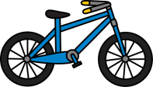  Get out on your bike, scooter or anything with wheels! Search Shetland Active Schools actify for some video with tips and advice.
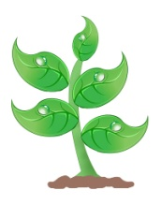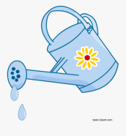 Help out in the garden. Water, weed or plant some seeds. | Plan a secret kindness mission for someone in your home. Choose a day to do something as a surprise to make them smile. | Choose a recipe you have never made before and bake or cook something new! | Make a playlist of songs and have a family disco at home! Ensure everyone has the chance to choose their favourite songs. | Create a treasure hunt with clues around the garden/house and to a final destination.  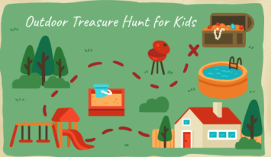
Use your imagination and as a family create a story, each taking it in turns to add one line/ word/sentence. | Have a picnic in your garden or inside your house, invite some teddy bears to come along as well.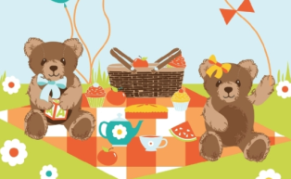 | 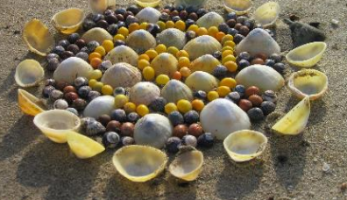Walk to the beach and create a picture out of things you can find. | Lie down on the floor and close your eyes, listen to your breath. Imagine you are somewhere amazing! What can you see, feel, hear and taste? | Host a karaoke with your family. Sing your favourite songs together!

