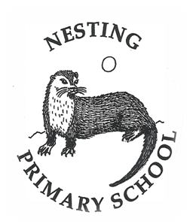


Nesting Primary School

Standards & Quality Report
2023-2024

and

School Improvement Plan
2024-2025

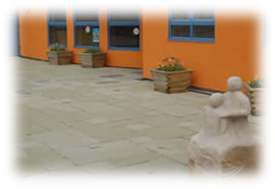
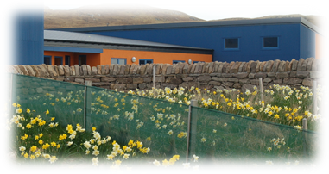


Introduction

Shetland Islands Council is committed to delivering the best possible outcomes for children and young people so that they have the best start in life and are ready to succeed by following the principles of Curriculum for Excellence, the National Improvement Framework, Getting it Right for Every Child (GIRFEC), and Developing the Young Workforce.
We want to know how well we are doing this and how we can improve. We are continuously evaluating what we do and how it makes a difference to our learners. We have been asking ourselves – staff, pupils, parents/carers, and other partners – the questions contained in this Standards and Quality Report. Our self-evaluation – involving staff, pupils, parents/carers, and other partners – is in the pages that follow, along with our main improvement priorities for session 2024/25. This report is based on the quality indicators in How Good is Our School? 4th Edition (2015) and How Good is our Early Learning and Childcare? (2016) and on the priorities and drivers of the National Improvement Framework.

The current National Improvement Priorities are:

- Improvement in attainment, particularly in literacy and numeracy;
- Closing the attainment gap between the most and least disadvantaged children;
- Improvement in children and young people’s health and wellbeing; and
- Improvement in employability skills and sustained, positive school leaver destinations for all young people

The National Improvement Drivers are:

Our Vision for Nesting School
‘We want Nesting School to be a place where pupils, parents and staff can achieve their full potential.
A place where pupils, parents and staff are respected and valued for their contributions and uniqueness.
A place where children are nurtured and inspired to go forward into an ever changing world with the values and skills they need to succeed.’

At Nesting Primary School we aim to:
- Ensure that all children at are safe and happy in School with caring adults they trust.
- Ensure that all children benefit from the Curriculum for Excellence to achieve their full potential.
- Ensure pupils have opportunities to make friends.
- Ensure pupils learn to be responsible for their own learning.
- Ensure all pupils know how to stay healthy and safe.
- Ensure that all pupils are included and uniqueness is celebrated.
- We will respect and take responsibility for our School and all the people in it and treat others as we would wish to be treated.

We achieve this by all staff and pupils being Ready, Respectul and Safe at all times in our school.

Our Curriculum
The school vision, values and aims continues to be up-dated, with all school stakeholders playing a role within this.
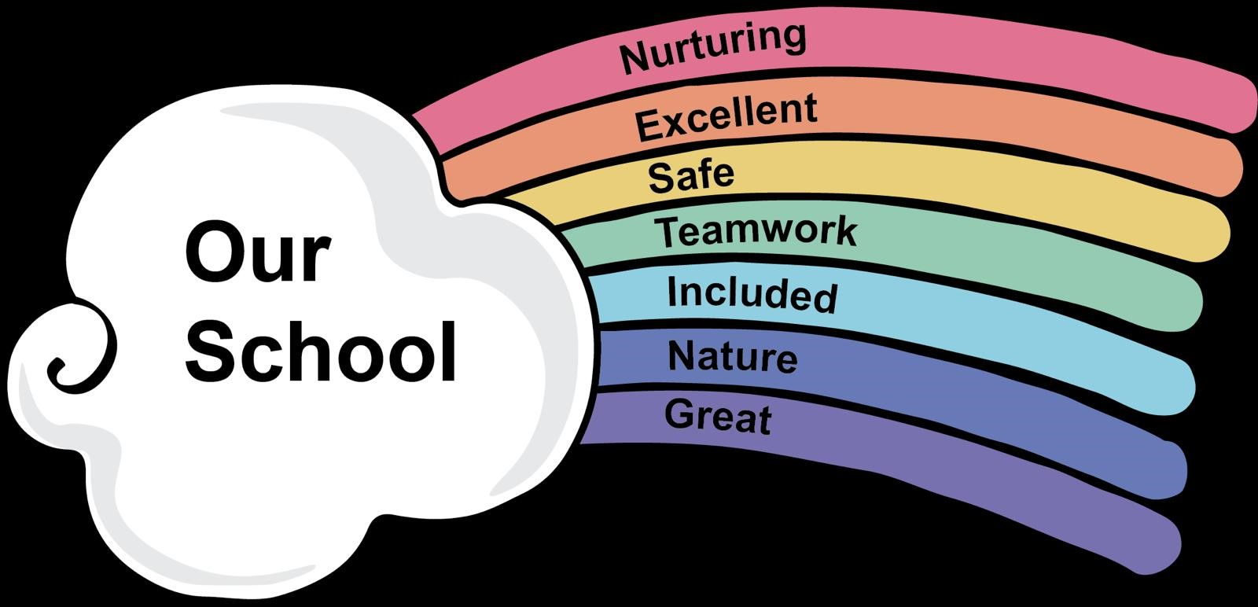

Our School
- Nesting Primary School is situated in the North East Shetland Mainland. The catchment area extends to Catfirth, Essick and North Nesting. Standing beside the Village Hall, the school provides a focal point for life in the Community. The School is housed in a bright, modern building (opened in 2004) with extensive play areas and grounds which offer scope for pupils to become actively involved in caring for their Environment. There is also an enclosed multi-court for sporting activities.
- There is no early years setting attached to the school, so the majority of pre-school children attend Tingwall, Lunnastaing or Brae for their pre-school years. This ends up having a direct impact on our school role.
- We have a canteen and hot meals are prepared on site. The parent council also provide a healthy snack at break times each day.
- There is an active Parent Council and Pupil Council in the school.
- The school enjoys good links with many outside agencies including, the Health Visitors, Speech and Language Therapy, Occupational Therapy, Child Smile, Psychological Services Outreach, Police Scotland, Active Schools, Shetland Library and Ability Shetland. Our school is used by community groups such as the Nesting History group, Nesting Hall and phone box project, CDCN, Community Council and Toddler group.
- We have good links with UHI and other organisations, and where possible try to support students.

Self Evaluation
Self-evaluation is at the heart of our practice in Nesting school. We use Self-evaluation in the following ways:
- Parents and carers opinions are sought through questionnaires, parent council meetings and an open-door/communication policy
- Staff complete departmental reviews annually from which targets are set
- The school is reviewed under the HGIOS 4 indicators.
- Informal reflection/ discussions
- Continuous Staff Review and Development
- SHANNARI scores from all pupils are collected, collated and tracked
- There is an active Parent and Pupil Council
- Sampling and moderating pupil work
- Closely working with AHS cluster, including peer HT mentoring with focus groups of pupils
- Local businesses have been involved in identifying priorities and fundraising towards them
- SNSA data and teacher judgements inform next steps
(SNSA data and CfE judgements are not shared publicly. Our small school roll would mean that confidentiality would be difficult to ensure)

Collaboration and consultation with our stakeholders
Who? | When? | How? | What did we find out?(bullet points on key themes)
Staff | Annual  Termly  Continuously | PRD meetings  Staff meetings  Informal consultation | Head Teacher, Sandra Petrie, has been seconded to SJHS with Laura Meier as Acting Head until her return. We have ensured as much consistency and continuity as possible. All staff continue to be invested in the school, ensuring a friendly, nurturing and positive ethos.
Children and young people | Continuously  Termly | Pupil Council  assemblies  SHANARRI evaluations  UNCRC | Pupils’ SHANARRI scores weren’t vastly different to previous times, and most comments were very positive. On discussions with pupils, they are generally very positive. Children able to discuss articles from UNCRC and link them to SHANARRI and VVA.
Parent and Carers | Continuously | Open door policy  Questionnaires  Regular emails  Parent council meetings  School meetings | Parents are happy overall and feedback from open days and learner lead afternoons were extremely positive.
Community and other stakeholders | Regular contact | Email etc | It is great to have visitors back in school, supporting with delivery of a rich curriculum, as well as other professionals supporting some of our ASN pupils.  Visit to CDCN and Scrap Store, community events at the hall at Christmas and UHA.

Progress made with the Priorities from our 2023-2024 School Improvement Plan
Standards & Quality Report
2023-2024

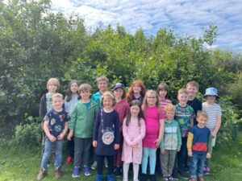

NIF PRIORITIES  -Improvements in attainment, particularly in Literacy and Numeracy  -Closing the attainment gap between the most and least disadvantaged children  -Improvement in children and young people’s health and wellbeing  -Improvement in employability skills and sustained, positive school leaver destinations for all young people  (highlight as appropriate) | NIF DRIVERS  School Leadership  Teacher Professionalism  Parental Engagement  Assessment of Children’s Progress  School Improvement  Performance Information | 1.1 Self-evaluation for self-improvement  1.2 Leadership for learning  1.3 Leadership of change  1.4 Leadership and management of staff  1.5 Management of resources to promote equity | 2.1 Safeguarding and child protection  2.2 Curriculum  2.3 Learning, teaching and assessment  2.4 Personalised support  2.5 Family Learning  2.6 Transitions  2.7 Partnerships | 3.1 Ensuring wellbeing, equality and inclusion  3.2 Raising attainment and achievement/Securing children’s progress  3.3 Increasing creativity & employability/ Developing creativity & skills for life & learning

Priority 1: Refresh school’s vision, value and aims

What were our aims? | What did we do? | What was the impact on learners? | What are the next steps and how do you plan to evidence the impact of further actions required.
A more effective partnership between stakeholders, for a shared ethos to help achieve high quality standards, and empower continuous improvement. | - Communicate with parents the progress to date and discuss how it will be embedded within the school.  - Update school website through use of Glow blog.  - Update school logo/badge for rebranding.  - Ensure vision, values and aims is visible throughout the school and woven into curriculum.  - By term 4, have a new curriculum rationale, with vision, values and aims at the centre. | Clear vision, values and aims for whole school.  Rainbow visual has been woven in to school displays and will be being used with 2024/2025 plan for UNCRC priority.  • Creation of QI tool for HGIOS for each pupil – effective to gauge undestanding and promote use of these images, ideas and tools. | • Use rainbow display to link vision, values and aims to UNCRC priority.  • Assess children’s understanding of our rainbow before and after new priority.  • Extend use of new rainbow across the whole school ethos and environment  Next steps – draw up new curriculum rationale with VVA at the heart when normal staffing has resumed.

NIF PRIORITIES  -Placing the human rights and needs of every child and young person at the centre of education.  -Improvements in attainment, particularly in Literacy and Numeracy  -Closing the attainment gap between the most and least disadvantaged children  -Improvement in children and young people’s health and wellbeing  -Improvement in employability skills and sustained, positive school leaver destinations for all young people  (highlight as appropriate) | NIF DRIVERS  School Leadership  Teacher Professionalism  Parental Engagement  Curriculum and Assessment of Children’s Progress  School Improvement  Performance Information | 1.1 Self-evaluation for self-improvement  1.2 Leadership for learning  1.3 Leadership of change  1.4 Leadership and management of staff  1.5 Management of resources to promote equity | 2.1 Safeguarding and child protection  2.2 Curriculum  2.3 Learning, teaching and assessment  2.4 Personalised support  2.5 Family Learning  2.6 Transitions  2.7 Partnerships | 3.1 Ensuring wellbeing, equality and inclusion  3.2 Raising attainment and achievement/Securing children’s progress  3.3 Increasing creativity & employability/ Developing creativity & skills for life & learning

Priority 2: National Writing Project

What were our aims? | What did we do? | What was the impact on learners? | What are the next steps and how do you plan to evidence the impact of further actions required.
Raise attainment in writing. | All teaching staff will attend initial full day training on 19/09/23, followed by 6 twilight sessions, ending with a reconnect full day on 8/2/24.  Implementing new pedagogy as our knowledge and understanding develop. | • Children can use the tools of writing with clarity and better metacognition  • Children can describe what these tools are better and how we use them  • Better shared LI, SC and expectations  • All children on target, except those with specific barriers, and everyone made good progress. | • Continue use as a block of work in the new year.  • Track outcomes with more clarity for staff, with clear line of progress.  • Use data collection for outcomes and tracking.

NIF PRIORITIES  -Placing the human rights and needs of every child and young person at the centre of education.  -Improvements in attainment, particularly in Literacy and Numeracy  -Closing the attainment gap between the most and least disadvantaged children  -Improvement in children and young people’s health and wellbeing  -Improvement in employability skills and sustained, positive school leaver destinations for all young people  (highlight as appropriate) | NIF DRIVERS  School Leadership  Teacher Professionalism  Parental Engagement  Assessment of Children’s Progress  School Improvement  Performance Information | 1.1 Self-evaluation for self-improvement  1.2 Leadership for learning  1.3 Leadership of change  1.4 Leadership and management of staff  1.5 Management of resources to promote equity | 2.1 Safeguarding and child protection  2.2 Curriculum  2.3 Learning, teaching and assessment  2.4 Personalised support  2.5 Family Learning  2.6 Transitions  2.7 Partnerships | 3.1 Ensuring wellbeing, equality and inclusion  3.2 Raising attainment and achievement/Securing children’s progress  3.3 Increasing creativity & employability/ Developing creativity & skills for life & learning

Priority 3: Scottish Book Trust Reading School Accreditation
What were our aims? | What did we do? | What was the impact on learners? | What are the next steps and how do you plan to evidence the impact of further actions required.
Increase in pupil motivation, skills and enjoyment, which will lead to higher attainment in all areas of the curriculum, particularly literacy. | - Revamp library area, including a book weed, cataloguing all fiction and non-fiction books, as well as reorganising reading areas within the school. (July/August)  - Complete online audit in August to ascertain which level of accreditation we are aiming for.  - Carry out Reading school action plan. | • Greater engagement in reading  • More books being taken out  • Greater comprehension of texts  • More discussions and enjoyment of reading | - Library has been revamped but continue to develop use of library – continue training library monitors and provide longer periods of time for pupils to become immersed in reading  - Carry out Reading School Action Plan  - Build more links with community and reading together  - Develop reading displays to link with current learning

Pupil Equity Fund Reporting, 2023-2024
Project/intervention: Breakfast club, School Trips, subscriptions
What data/evidence informs this? (what is your gap?) Cost of living crisis, as well as identified, vulnerable families.
Interventions for Equity Interventions for Equity | Self-evaluation | National Improvement Hub (education.gov.scot) (highlight the interventions that apply)
Early intervention and prevention | Social and Emotional Wellbeing |  |  | Promoting healthy lifestyles | Targeted approaches to literacy and numeracy | Promoting a high quality learning experience | Differentiated support
Use of Evidence and Data | Employability and Skills Development |  |  | Engaging beyond the school | Partnership working | Professional learning and leadership | Research and evaluation to monitor impact
Planned Outcome  - Increased concentration in class  - Improve pupil health and wellbeing  - Increase engagement in learning  - Improve attendance  - Support for vulnerable families  - Wider achievement activities for all to boost confidence |  |  | Measures of impact on learners  - Breakfast Club was well used for the first part of the year and we saw benefits of the soft start and focus for the day. Although it was well received initially, interest reduced and it was reducing time with support staff in class. We took the decision to end breakfast club at that point and focus on support in class. We will review this again in the new year.  - The subscriptions are been very valuable again. They have contributed to good levels of attainment but also to increased motivation. Children are motivated to improve skills to progress in the online platforms. Interest in maths in particular has grown and the class wants to create a Maths Club in the new year. There continues to be a good level of interest in this, and NESSY is excellent for targeting skills to help our learners’ progress.  - Our trips have increased confidence in the children. They have been able to share new experiences and engage with learning beyond the school. They have met new people and talked to them with growing confidence. This is of vital importance when coming from a small school setting. The children have had active experiences which many haven’t tried before and this is resulting in them wanting to repeat this physical experiences or try new ones.
Teaching and Learning
Leadership
Family and Community |  | x

School self-evaluation, 2023-2024, and priorities for further improvement
For each of the Quality Indicators listed below, answer the questions and include an overall evaluation using the six-point scale from “How good is our school?” (4th Edition). The self-evaluation grade should be for the whole Quality Indicator, not for individual themes within it. The questions are those used in self-evaluation forms before Education Scotland inspections.

Please refer to relevant qualitative and quantitative data when considering relevant evidence to support your statements

Qualitative Data | Quantitative Data
Classroom observations, learning visits, learning walks, etc.  Focus group discussions  Feedback from online and face-to-face meetings  Conversations in staffrooms  Verbal feedback from learners and parents and carers | Attainment in the Broad General Education and Senior Phase (where applicable)  Attendance, absence and late-coming  Measures of learner engagement, participation, inclusion and health and wellbeing  Tracking and Monitoring  Planning documentation  Curriculum rationale  Questionnaires and surveys with stakeholders and minutes of meetings with them  Bullying and exclusion statistics  Child Protection referrals  Free School Meals data  PRDs  Professional learning records  Child’s Plans, CSPs and IEPs  School Improvement and Team Improvement reports  Education Scotland and Care Inspectorate inspection reports

Education Scotland’s evaluative statements can support your analysis of the key Qis:

All 100%; Almost All 91%-99%; Most 75%-90%; Majority 50%-74%; Minority/less than half 15%-49%; A few less than 15%

Leadership of Change (QI 1.3)

Features of highly effective practice/challenge Questions | Practice and evidence
- To what extent does our school community have ownership of our vision, aims and values?  - How well do we use our vision, aims and values when making decisions about future improvement priorities? | Children, families and staff have all been involved in creating and enhancing new visions, values and aims. Feedback from parents about the ethos of the school has been excellent and they are very appreciative of the school ‘family’ feel.  These are the words children and families voted for best represent our school. We are now weaving them into everyday school life and linking to SHANARRI and UNCRC.  Pupil Council, Parent Council and others gropus will be encouaged to use this regarding decision making.
- All staff have consistently high expectations of all learners.  - Pupils, parents, partners and staff are all involved in the creation and ongoing review of the vision, aims and values of the school | Our vision, values and aims are shaped by a clear understanding of the social, economic and cultural context of our school community, although these are still being up-dated with stakeholders. All staff show commitment to shared educational values and professional standards, this is reflected in regular PRD meetings and continuous professional development. Staff engage in professional dialogue and professional learning. Regular PRD meetings identify staff development needs and training.  Senior leaders provide strong leadership which is now enabling our school and wider community to develop an aspirational vision. This underpins our continuous improvement.  Pupil voice is demonstrated through our pupil council, JRSO and Sports Leadership Awards. We also have weekly opportunities for children to share achievements and have their ‘voice’ heard.  The school has positive relationships within the school community. They should now be used to develop shared understanding and commitment to improvements in learning and teaching.  The Head Teacher strives to create conditions where staff feel confident to initiate well-informed change and are committed to collective responsibility in the process of change. All staff work well together, taking individual and group responsibility for running the school smoothly and effectively.  Conditions have been created to allow work to on identified priorities. Raising attainment in literacy and numeracy continue to be priorities.
Self-evaluation grade on the HGIOS?4 six-point scale: 4

Learning, teaching and assessment (QI 2.3)
Features of highly effective practice/challenge Questions | Practice and evidence
- The learning environment is built on positive, nurturing and appropriately challenging relationships which lead to high-quality learning outcomes.  - Learners’ achievements in and out of school are recorded and recognised. They understand how these achievements help them develop knowledge and skills for life, learning and work.  - How well do we motivate and engage all learners in all aspects of school life?  - How confident are we that all learners experience activities which are varied, differentiated, active, and provide effective support and challenge?  - How well do we communicate the purpose of learning and give effective explanations for all learners? | There is a caring ethos which is underpinned by respectful relationships and principles of nurture. The ethos and culture of our school reflects a commitment to children’s rights and positive relationships.  Almost all of our children and young people are eager and active participants in their learning.  We make use of digital technology to support learning but we recognise the need for a digital Progression framework.  Children are polite and keen to learn.  Increased consistency in approach to sharing learning intensions and skills to ensure all children are aware of the purpose of their learning and the skills they are developing. The school is working towards active learning where appropriate.  We are committed to evaluating our learning spaces and developing neutral, flexible fit for purpose learning environments – most recently with our play areas.  Robust use of SEEMIS and other tracking including data lead progress in NIWP.  Progression pathways for Literacy and Numeracy (including resource tracker) are in place and staff are now using these in conjunction with a new planning system. This will enable teacher judgements to be more accurate and our data collection to be more robust.  A formal assessment schedule for our school continues to evolve and we are at the stage of embedding this into our practice.  Informal formative assessment is now considered at the planning stage, and there is a termly meeting dedicated to discussing assessment and pupil progress.  These assessments are used to make informed judgements interventions for pupils.  Teachers at the AHS have given very positive feedback on P7/S1 pupils who have moved up from Nesting, communicating that the pupils were hard working, achieving well, and in appropriate work streams.
Self-evaluation grade on the HGIOS?4 six-point scale: 4

Ensuring wellbeing, equity and inclusion (QI 3.1)
Features of highly effective practice/challenge Questions | Practice and evidence
- The whole learning community has a shared understanding of wellbeing and the children’s rights.  - All stakeholders promote a climate where children and young people feel safe and secure  - All staff and partners model behaviour which promotes and supports the wellbeing of all.  - All staff and partners are sensitive and responsive to the wellbeing of each individual child and colleague.  - Staff, children and young people know, understand and use the wellbeing indicators as an integral feature of school life.  - Staff and partners have created an environment where children and young people feel listened to and are secure in their ability to discuss personal and sensitive aspects of their lives because they feel cared about | School ethos is caring and friendly.  The school continues to develop nurturing and inclusive approaches to create a supportive learning environment for all children.  Staff know children and their families extremely well.  A range of appropriate strategies and resources are targeted well to support children with additional support needs in making appropriate progress. These interventions are well planned and regularly reviewed to ensure a positive impact for children. Safe and nurturing spaces are used well for children who have barriers to their learning. This is allowing children to discuss their feelings and develop strategies to apply in other learning environments. Staff and children indicate this is having a positive impact on children’s resilience and readiness to learn.  PEF funding is used successfully to support pupils, academically as well as socially and emotionally.  SHANARRI continues to be used to allow pupils the opportunity to voice themselves in a safe, non-threatening way.  Health and Wellbeing progression pathway now needs to be embedded into our planning.  School has good links with support services such as SALT, Social work, School Counselling service, Active schools and NHS.  School works within the GIRFEC framework, Child’s Plans and IEPs are in place for children who need them.  Child protection procedures are in place and understood by all staff – CP update organised.  Staff have worked hard, with parents to ensure issues with pupil attendance and interrupted learning have been resolved, ensuring pupils are getting the full range of educational experiences.
Self-evaluation grade on the HGIOS?4 six-point scale: 5

Raising attainment and achievement (QI 3.2)
Challenge Questions | Practice and evidence
Almost all children and young people are attaining appropriate levels and a few have exceeded these. 4 Attainment levels in literacy and numeracy are a central feature of the school’s priorities for improvement and are raising attainment. 4 Very good progress is demonstrated through robust tracking of attainment over time in all curriculum areas and at all stages | Attendance has been very high, allowing for a consistent approach in our recovery phase and communication from parents has been extremely positive. Teachers continue to know individual children and families very well, and a range of high quality opportunities has ensured all children are making good progress.  ASN children have needed enhanced support to fully engage with all classroom activities, and reduced service delivery from outside agencies has hindered some areas significantly. However, all pupils are now in full time attendance and in a good, daily routine.  We continue to work collegiately as a staff to ensure breadth and depth of the curriculum, through our planning cycles, as well as a school improvement focus on tracking and assessment. All tailored to our unique school and multi-composite school setting.  Daily focus on core literacy and numeracy skills, and pupil health and wellbeing.  Confident teacher judgements, together with the use of benchmarks, SNSA data, Leuven scale of engagement, and various other formative and summative assessment techniques are used to inform planning, leading to attainment in core areas being raised.  Delivery of curriculum continues to be highly differentiated and individualised for each pupil or small group, thus ensuring thorough and meaningful learning for each child, at a pace and challenge appropriate to them.
Self-evaluation grade on the HGIOS?4 six-point scale: 4

School Improvement Plan
2024-2025

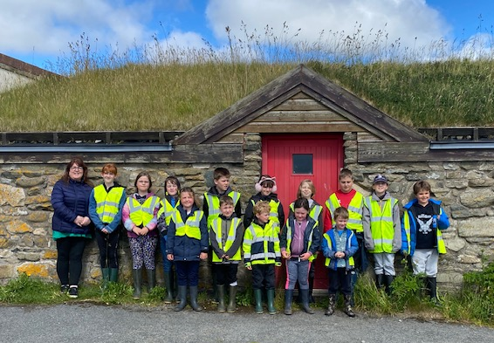

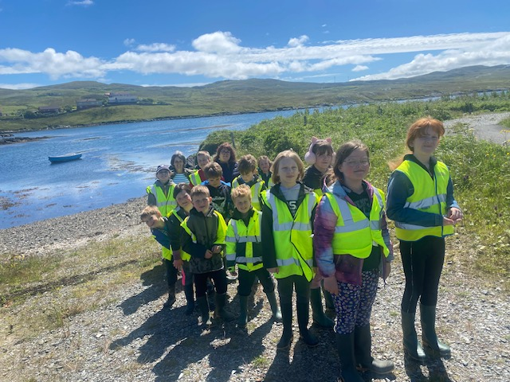

Factors Influencing the 2024/2025 School Improvement Plan
Local authority factors  - Shetland Islands Council National Improvement Framework Plan  - Children’s Services, Recovery and Renewal Plan  - Children’s Services, Directorate Plan SIC Operational Guidance: School Improvement Planning and Standards and Quality Reporting  - SIC Strategy for Parental Involvement 2018 | National factors and drivers  - Curriculum for Excellence  - Realising the Ambition  - National Improvement Framework  - The Scottish Attainment Challenge  - Education Reform and Empowerment  - Getting It Right for Every Child  - Developing Young Workforce  - Digital Learning and Teaching Strategy  - The Equity Audit  - “Learning Together”: Scotland’s national action plan for parental involvement etc. 2018-2021
School factors  - Staffing – new LSW, HT seconded, Acting Head in place, teacher cover in place for admin. cover.  - In receipt of PEF – £1225. | Local factors  - CDCN  - Toddler group in school  - Links with local community hall  - Windmills on our doorstep
UNCRC  - This is embedded in the ethos of our school  - Assemblies and lessons focusing on rights | Tacking Inequalities, Poverty Proofing and Cost of the School Day  - Support to access grants and free school meals is offered  - Gemma from Anchor project has strong links with school and attends open evenings, transition events etc

Improvement Priorities for 2024-2025

NIF PRIORITIES  - Placing the human rights and needs of every child and young person at the centre of education.  - Improvement in children and young people’s health and wellbeing  - Closing the attainment gap between the most and least disadvantaged children and young people  - Improvement in skills and sustained, positive school-leaver destinations for all young people  - Improvement in attainment, particularly in literacy and numeracy.  (highlight as appropriate) | NIF DRIVERS  - School and ELC leadership  - Teacher and practitioner professionalism  - Parent/carer involvement and engagement  - Curriculum and assessment  - School and ELC improvement  - Performance information | 1.1 Self-evaluation for self-improvement  1.2 Leadership for learning  1.3 Leadership of change  1.4 Leadership and management of staff  1.5 Management of resources to promote equity | 2.1 Safeguarding and child protection  2.2 Curriculum  2.3 Learning, teaching and assessment  2.4 Personalised support  2.5 Family Learning  2.6 Transitions  2.7 Partnerships | 3.1 Ensuring wellbeing, equality and inclusion  3.2 Raising attainment and achievement/Securing children’s progress  3.3 Increasing creativity & employability/ Developing creativity & skills for life & learning

Priority 1: Embedding specific and robust rights and responsibilities education into our core learning.

(Why take this on as a priority?) | Planned Outcome | How exactly are we going to do it? | Resources and lead person? | Monitoring the impact of the priority on learners
• children and parents aware of SHANARRI but specific teaching and learning needed about UNCRC | • Children learn rights from the charter  • Children learn responsibilities directly related to each right  • Learn why being responsible is important and how our behaviour can effect others. | - Staff training about UNCRC  - Teach children about needs and wants  - Teach children specific articles from the charter  - Link to responsibilities for each articles  - Link to our vision, values and aims  - Promote rights and responsibilities within school and community (Voar Redd Up, etc)  - Demonstrate how this is the core of SHANARRI. | Head Teacher  Whole staff  UNCRC resources (trying to borrow from Whalsay School but will ask PC to fund if this is unavailable – having the core resource creates robust planning and creates biggest impact)  Rights Respecting Schools Primary Starter Pack - UNICEF UK – ask parent council if they will buy this for the school. | • Improved personal accountability for behaviour  • Embedding core rights to raise expectation for self-improvement and achievement  • Promotion of vision, values and aims to share expectations among families.

NIF PRIORITIES  - Placing the human rights and needs of every child and young person at the centre of education.  - Improvement in children and young people’s health and wellbeing  - Closing the attainment gap between the most and least disadvantaged children and young people  - Improvement in skills and sustained, positive school-leaver destinations for all young people  - Improvement in attainment, particularly in literacy and numeracy.  (highlight as appropriate) | NIF DRIVERS  - School and ELC leadership  - Teacher and practitioner professionalism  - Parent/carer involvement and engagement  - Curriculum and assessment  - School and ELC improvement  - Performance information | 1.1 Self-evaluation for self-improvement  1.2 Leadership for learning  1.3 Leadership of change  1.4 Leadership and management of staff  1.5 Management of resources to promote equity | 2.1 Safeguarding and child protection  2.2 Curriculum  2.3 Learning, teaching and assessment  2.4 Personalised support  2.5 Family Learning  2.6 Transitions  2.7 Partnerships | 3.1 Ensuring wellbeing, equality and inclusion  3.2 Raising attainment and achievement/Securing children’s progress  3.3 Increasing creativity & employability/ Developing creativity & skills for life & learning

Priority 2: Enhancing play provision to develop science skills, outcomes and enquiry
(Why take this on as a priority?) | Planned Outcome | How exactly are we going to do it? | Resources and Lead Person | Monitoring the impact of the priority on learners
• build on progress made with PSW and make better use of science resources with specific goal to develop science skills and knowledge through play. | • increased use of scientific skills and processes  • increased use of scientific vocabulary  • confidence in creating and explaining hypotheses | • Organise science resources for easy access and for planning in the moment  • Use robust planning and structure to ensure outcomes have been met, weaving in child led learning  • Have longer periods of time with resources for children to play with and develop scientific skills  • Create a science display to help promote and monitor our journey, as well as displaying vocabulary learnt along the way. | Head teacher  Whole staff | • Leuven’s scale of engagement before and after project  • Observations of sustained periods of learning and investigating  • Increased knowledge and use of scientific vocabulary.

NIF PRIORITIES  - Placing the human rights and needs of every child and young person at the centre of education.  - Improvement in children and young people’s health and wellbeing  - Closing the attainment gap between the most and least disadvantaged children and young people  - Improvement in skills and sustained, positive school-leaver destinations for all young people  - Improvement in attainment, particularly in literacy and numeracy.  (highlight as appropriate) | NIF DRIVERS  - School and ELC leadership  - Teacher and practitioner professionalism  - Parent/carer involvement and engagement  - Curriculum and assessment  - School and ELC improvement  - Performance information | 1.1 Self-evaluation for self-improvement  1.2 Leadership for learning  1.3 Leadership of change  1.4 Leadership and management of staff  1.5 Management of resources to promote equity | 2.1 Safeguarding and child protection  2.2 Curriculum  2.3 Learning, teaching and assessment  2.4 Personalised support  2.5 Family Learning  2.6 Transitions  2.7 Partnerships | 3.1 Ensuring wellbeing, equality and inclusion  3.2 Raising attainment and achievement/Securing children’s progress  3.3 Increasing creativity & employability/ Developing creativity & skills for life & learning

Priority 3: Scottish Book Trust Reading School Accreditation (continued from last year)
(Why take this on as a priority?) | Planned Outcome | How exactly are we going to do it?  What?  When? | Resources and Lead Person | Monitoring the impact of the priority on learners
• Gather more evidence to add to and complete this accreditation | Increase in pupil motivation, skills and enjoyment, which will lead to higher attainment in all areas of the curriculum, particularly literacy. | - Library has been revamped but continue to develop use of library – continue training library monitors and provide longer periods of time for pupils to become immersed in reading  - Follow goals from online audit to reach accreditation  - Build more links with community and reading together  - Develop reading displays to link with current learning | Head teacher  Whole staff  Pupils  Scottish Book Trust Reading Schools website | • Greater number of books read  • Raising attainment in literacy  • Higher engagement in reading together  • Engagement in showing comprehension of texts read through fun activities and displays.

Pupil Equity Fund – Planning
Project/intervention: School trips and subscriptions (Toe By Toe, Nessy and Sumdog)
What data/evidence informs this? (what is your gap?) Cost of living crisis, as well as identified, vulnerable families. Closing the attainment gap.
Interventions for Equity Interventions for Equity | Self-evaluation | National Improvement Hub (education.gov.scot) (highlight the interventions that apply)
Early intervention and prevention | Social and Emotional Wellbeing |  |  | Promoting healthy lifestyles | Targeted approaches to literacy and numeracy |  | Promoting a high quality learning experience |  | Differentiated support
Use of Evidence and Data | Employability and Skills Development |  |  | Engaging beyond the school | Partnership working |  | Professional learning and leadership |  | Research and evaluation to monitor impact
Planned Outcome  - Improve pupil health and wellbeing  - Increase engagement in learning in and out of school  - Improve attendance  - Support for vulnerable families  - Targetted support for ASN children |  |  | Details of project/intervention:  - School trips in collaboration with Active Schools to give all pupils opportunities to participate in different experiences, particularly sporting activities.  - Social and recreational activities outside school to build links and expand social experiences for our children.  - Subscriptions to Sumdog and Nessy, to help motivate pupils and enhance their learning experiences, through individualised support. |  |  | Resources and Lead Person  Teaching and support staff.  Active School (Eoin Leask) |  | Measures of impact on learners  - Attendance  - Pupil engagement and concentration (Leuven Scale)  - Discussion with pupils and parents  - Sumdog and Nessy diagnostic reports.
Teaching and Learning |  | x
Leadership
Family and Community |  | x

