J | Mid Yell Junior High School  Mid Yell  Shetland  ZE2 9BN | Shetland Islands Council    Tel: 01595745050  Email: midyell@shetland.gov.uk  Web: www.midyell.shetland.sch.uk
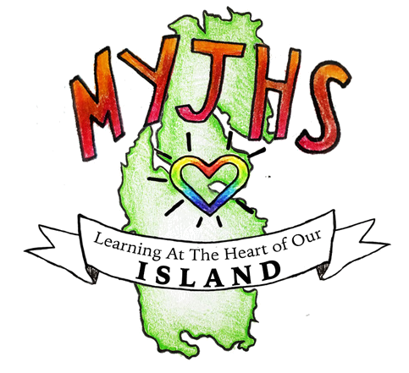
Head Teacher: Mr Mark Lawson B.Ed (Hons)

22 September 2025

Dear Parent/Carer

S1 Progress Evening

I am delighted to invite to our S1 Progress Evening on Wednesday 1st October 2024.

The Progress Evening will be held in our Main Hall from 18:30 where you can meet all their teachers and discuss with them how your child has settled into S1, their current attainment and next steps.

With your child now in secondary, taking more responsibility for their learning, progress and next steps, it is important that they accompany you during the evening and get involved in the discussions.

If you are unable to attend, please contact the school and we will try to make alternative arrangements.

Yours sincerely,

Louise Nicholson
Principal Teacher of Pupil Support
Mid Yell Junior High School

