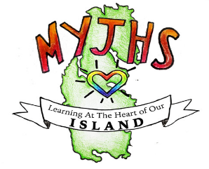 | Mid Yell Junior High School  Mid Yell  Shetland  ZE2 9BN | Shetland Islands Council  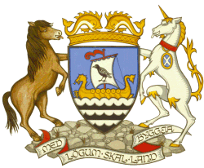  Tel: 01595745050  Email: midyell@shetland.gov.uk

Head Teacher: Mr Mark Lawson B.Ed (Hons)

1st September 2025

Dear Parent/Carer

DEVELOPING THE YOUNG WORKFORCE TRIP – MOOTIE’S HOOSE, SHETLAND MUSEUM

On Thursday 11th of September, S3 art pupils have been invited for a guided tour of the current exhibition in the Shetland Museum, after this pupils will take part in a practical workshop with the artist where they will create their own sketchbooks and work in mixed media. There will then be a careers focused talk looking at industry in Shetland and creative industries.

A bus will be leaving Yell on the 9:15 ferry from Ulsta.

Pick Ups
8:35 – Gutcher
8:45 – Mid Yell Junction
9:10 – Ulsta

We will return on the 15:00 ferry from Toft.

A packed lunch is required – if you would like a school packed lunch then can you please let us know, by Tuesday 9th September. Can you please let us know by email or returning the slip below that you give permission for them to attend.

Yours sincerely

Emma Shaw
Art Teacher

I give permission for my child ____________________________ (please insert name) to attend

the S3 Art trip on Thursday 11nd September 2025.

Signed ________________________________ Date _______________________

