 | Mid Yell Junior High School  Mid Yell  Shetland  ZE2 9BN | Shetland Islands Council    Tel: 01595745050  Email: midyell@shetland.gov.uk  Web: www.midyell.shetland.sch.uk
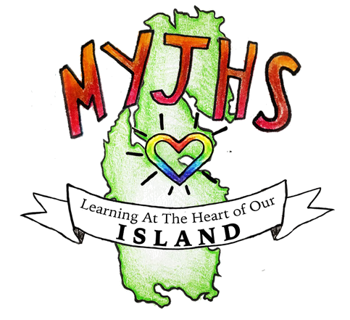
Head Teacher: Mr Mark Lawson B.Ed (Hons)

25 August 2025

Dear Parent/Carer

S4 Progress Evening

I am delighted to invite to our S4 Progress Evening on Tuesday 2nd of September 2025.

The Progress Evening will be divided into two parts:

- Q&A Session about National qualifications in the Social Studies room from 1810 hours

This session is for parents/carers who are unsure of how National qualifications work.

- Teacher Meetings to discuss current attainment and pupil ambitions from 1830 hours in the Main Hall.

If you are unable to attend, please contact the school and we will try to make alternative arrangements.

Yours sincerely

Louise Nicholson
Principal Teacher of Pupil Support
Mid Yell Junior High School

