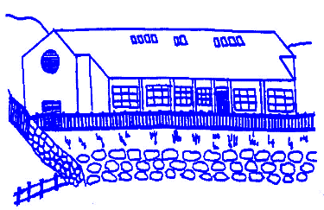

Lunnasting Primary School

Vidlin Shetland ZE2 9QB

Email: [lunnasting@shetland.gov.uk](mailto:lunnasting@shetland.gov.uk)

Website: <https://blogs.glowscotland.org.uk/sh/lunnastingprimaryschool/>

Acting Head Teacher: Mrs Louise Malcolmson

22 August 2024

Dear Parent/s

**Updates for Term 1**

Thank you to everyone for booking meals through Parentpay. We notice that packed lunches are being booked when pupils will be absent, please just leave those days blank. The packed lunch figures are added on to meals when the figures are sent through to the kitchen. If children are absent they then have to be cancelled off the system.

We would be grateful for any pictures and descriptions of children’s wider achievements. These will be recognised during Friday Fun and added to our achievement board.

We are looking for donation of trainers or clothing that children have outgrown. These will kept as spares.

On Thursday 26 September P1-7 will be going to Mareel to see a performance of Treasure Island. We will be leaving the school at 9.15am and will return in time for lunch. Children should take their snacks with them.

Mr Danny Peterson will, once again, be running an After-school multi-sports club. This will be from 3-4pm, starting on Wednesday 28th August for P4-6, and run for 6 weeks. Permission slips are attached and should be returned to the school by Monday 26 August. There will also be a club for P1-3 running for 6 weeks from Wednesday 30 October. As this is the first day back after the holidays I have attached a permission slip for this too.

You will find Termly Overviews on the school website from Tuesday 27 October under the ‘For Parents’ section.

Homework grids for this term will be sent home on Friday. These are due by 30th September.

Consent forms for fluoride varnish are enclosed. The Childsmile team are booked in to do this on Monday 16 September.

Flu consent forms for P1-7 are enclosed these should be returned to the school as soon as possible.

I have also enclosed Photo/Video Consent forms. Please return these as soon as possible.

Please do not hesitate to contact the school if you have any queries or require any further information.

Yours sincerely

Louise Malcolmson

Mrs L Malcolmson

Acting Head Teacher