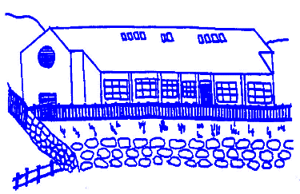

Lunnasting Primary School

Vidlin, Shetland ZE2 9QB

Email: [lunnasting@shetland.gov.uk](mailto:lunnasting@shetland.gov.uk)

Website:<https://blogs.glowscotland.org.uk/sh/lunnastingprimaryschool/>

Acting Head Teacher: Mrs Louise Malcolmson

14 May 2024

Dear Parent/s,

We are now nearly half way through the term and have some updates for you.

**Dates for your diary**

|  |  |
| --- | --- |
| Monday 20th May | Occasional Holiday – School closed |
| Friday 31st May | Garden Tidy – Open to the community |
| Tuesday 11th June | Child-led open evening 5 – 7.30pm |
| Thursday 13th June | Moving Up Day for all pupils |
| Friday 14th June | Whole school day trip to the South End (more details to follow) |
| Monday 17th June | Sports Day (details to be confirmed) |
| Thursday 20th June | Outdoor Education Day P4-7 (details and permission slips to follow) |
| Wednesday 26th June | P7 Leavers Assembly 2pm – 3pm – everyone welcome |
| Friday 28th June | Last Day of Term |

**Garden Tidy**

The children will be taking part in the garden tidy, 2 – 3pm on Friday 31st May. We are looking for volunteers to help with this garden tidy, more the merrier! It would be ideal if children could take gloves and any spare gardening equipment.

**Child-led open evening**

This is an excellent opportunity for your child(ren) to showcase their learning. If you feel you need a confidential one-to-one with staff, we will have separate meeting rooms. We will also be seeking the views of parents to help us set improvement targets for the next academic year. There will be feedback forms at this event.

If you have any queries, please do not hesitate to contact me.

Yours sincerely,

Louise Malcolmson

Mrs L Malcolmson

Acting Head Teacher