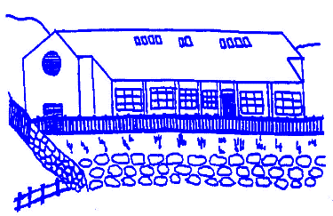
Lunnasting Primary School
Vidlin, Shetland ZE2 9QB

Email: lunnasting@shetland.gov.uk
Website: https://blogs.glowscotland.org.uk/sh/lunnastingprimaryschool/
Acting Head Teacher: Mrs Louise Malcolmson

04 March 2024

Dear Parent/s,

World Book Day
World Book Day is on Thursday 7th March and children are very welcome to dress up as book characters. We have lots of exciting World Book Day activities planned through the day.

Family Fun Night
We are looking forward to having you all at our Family Fun Night on Thursday 7th March 6 – 7.30pm. Please share the invite with extended family. Everyone is welcome to come in their World Book Day costumes. The Pupil Council and Parent Council have organised a quiz to get us started on the night and there will be Bingo fun. The Pupil Council suggested that it would be nice to have some live music, so if you play an instrument, please take it along!

Team Improvement Visit
The Quality Improvement team are looking for parents who would be keen to come in and speak with them as part of their visit. Please see separate email.

Delting Up Helly Aa
Delting Up Helly Aa takes place on Friday 15th March. The Jarl Squad will be arriving at 9.15am, so our doors will be open from 9am. Everyone welcome.

Red Nose Day
Children can come to school dressed in something red for Comic Relief on Friday 15th March. Pupils are welcome to bring in a donation and we will forward it on to the charity.

Shetland Youth Music Festival
Primary 4 – 7 are attending this year’s music festival on Tuesday 19th March as a choir entry. School uniform/smart clothing is encouraged. Pupils will need a snack and packed lunch, we will be out all day taking part in workshops and watching other groups perform. Pupils will travel to Mareel by bus. Miss Magnussen will accompany the class, however we are looking for a parent volunteer. Please let me know if you are available to spend the full day with the class. Parents are welcome to come along and watch.

If you have any queries, please do not hesitate to contact me.

Yours sincerely,

Louise Malcolmson

Mrs L Malcolmson
Acting Head Teacher

