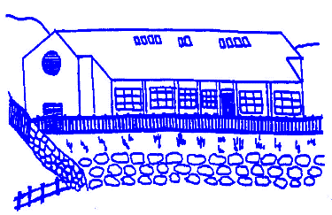
Lunnasting Primary School
Vidlin Shetland ZE2 9QB

Email: lunnasting@shetland.gov.uk
Website: https://blogs.glowscotland.org.uk/sh/lunnastingprimaryschool/

Acting Head Teacher: Mrs Louise Malcolmson

Application for Leave of Absence

It is important that we have full information as to exact date, time and reason for absence. We would encourage you to ensure that your child is not absent from school any longer than is necessary.

Pupil(s) Name: ___________________________________________________

Date and Time of Departure:________________________________________

Date and Time of Return: ___________________________________________

Reason for Absence: ______________________________________________

______________________________________________________________

______________________________________________________________

______________________________________________________________

Signed__________________(Parent/Guardian) Date _________________

Office use only:

Other Authorised Absence (ABS) - includes immediate family weddings, bereavements,
sporting and cultural events.

Authorised Parental Holiday (PHL)- family holidays judged to be important to the well- being and cohesion of family.

Holiday Unauthorised (UPH) - other family holidays

