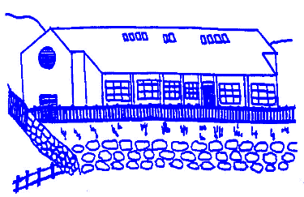
Lunnasting Primary School
Vidlin Shetland ZE2 9QB

Email: lunnasting@shetland.gov.uk
Website: https://blogs.glowscotland.org.uk/sh/lunnastingprimaryschool/

Acting Head Teacher: Mrs Louise Malcolmson

10 November 2023

Dear Parent/s,

Termly guide

Please find attached the learning overview for Term 2. This is a guide to show what your child will be learning this term. This is also available on our school website where you can also find our Class Blogs.

Parent Appointments

We look forward to seeing you for your Parents’ Meetings. You will be emailed your appointment times today. Please let us know as soon as possible if you are unable to attend, we will endeavour to find you a new slot. These parent appointments will replace the termly report. A larger, more detailed report will follow in Term 4. There will also be the child-led evening in May, however if you have any questions regarding your child’s learning, at any time, please get in touch as soon as possible and the Class Teacher will be happy to discuss these.

Christmas dates

The Christmas concert is on Thursday 14th December. As usual, there will be an afternoon show and an evening show to ensure that all family will get an opportunity to see it. Times will be confirmed nearer to the time.

Our school Christmas Dinner is on Tuesday 12th December.

The last day of term is on Friday 22nd December and Term 3 will resume on Monday 8th January with a staff in-service day and open on Tuesday 9th January for pupils.

Winter information

It is getting much colder outside, however we continue to encourage outdoor play and learning as far as possible. Please ensure your child(ren) come to school in appropriate clothing. Winter jackets, hats, scarves and gloves. We encourage you to label all garments as far as possible.

This is also the time of year where we see a rise in children becoming unwell. As per NHS guidelines, please keep your child off school until they have not been sick or had diarrhoea for at least 48 hours.

PE update

Mrs Margaret Duncan is temporarily covering PE classes for the remainder of the term on Thursday afternoons. Therefore, P1–3’s Class Teacher PE day is now on Friday mornings. This means that PE days for P1–3 are on Thursdays and Fridays. P4–7 PE days continue to be on Wednesdays and Thursdays.

Music update

Mr Seth Travins is continuing to cover Music classes for the remainder of this term.

Blythswood Shoe Box Appeal

I would like to take this opportunity to thank everyone for their generous donations. Through the super support from you, we handed over 8 shoe boxes today. Well done Lunnasting!

Yours sincerely,

Louise Malcolmson

Mrs L Malcolmson
Acting Head Teacher

