**Happyhansel School Newsletter**

**June 2021**

**Happyhansel Primary School**

Walls

Shetland

ZE2 9PG

School 01595 807450

Early Years 01595 807458

Head Teacher ~ Mrs Elizabeth Garrick

Principal Teacher ~

Mrs Julie Thomson

Email : happyhansel@shetland.gov.uk

**Parent Council**

Chair Person ~ Emma Chittick

**Next meeting ~**

**Active Schools**

**Jacqui Murray** 01595 744043

**Emergency Contact Details Update**

Child’s Name _______________________

Class ______

Emergency Contact :

Name__________________

Number_________________

**Medical Information Update**

**Pupil __________________**

**Class ______**

**Medical Condition _______________________________________________**

**________________________________________________________________________**

**Hi Everyone!**

The end of the term is fast approaching. It’s been an unusual year in lots of ways. Here are a few updates and dates for your diary.

**Staffing**

We are losing Mr Lindsay who is going to Peterhead. We are also losing Peter as our cleaner in charge who will finish at the end of term.

Recruitment for the one day post in P1-4 and Support Worker in Early Years will be completed by the end of the week. We will have more news for you about those posts before long.

**End of Year Events**

My sincere apologies I cannot invite you to our end of term assembly as normal. Our end of year assembly will be outside tomorrow or Friday weather dependant. After the assembly we will have a

“ Garden Party” in the playground with small treats. We would encourage everyone attending to bring a silly hat!

**Growing in the Polycrub**

We have a few things ready for harvesting. School lettuce has featured at lunch time once or twice and has been well received by pupils. A huge thanks to Helen Fleck for all her help.

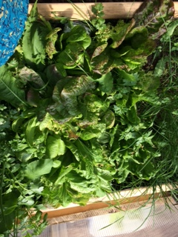

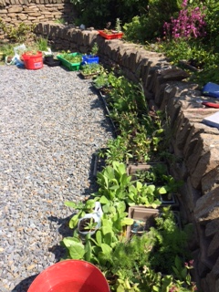

qi

**Fr**

**Friday Friday 26th Fri**

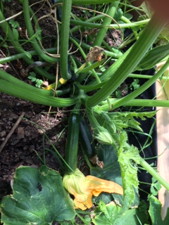 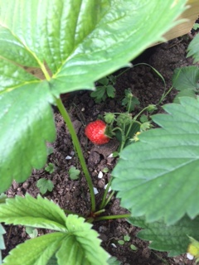

**Welc** We have a fewbedding plants left

if you have any space in your garden.

**Diary Dates 2021/22**

**June 2021**

**25th** Last Day

**Next Academic Year**

**16th,17th August In Service Training**

**Term 1**

**18th August Back to School**

**8th Oct Last day of Term 1**

**11th-22nd Oct Holidays**

**Term 2**

**25th,26th Oct In Service Training**

**27th Oct Begin term 2**

**21th Dec Last day of Term 2**

**22nd-4th Jan Christmas Holidays**

**Term 3**

**5th Jan In Service Training**

**6th Jan Back to School**

**26th Jan Up Helly Aa Holiday**

**25th, 28th February Long Weekend**

**1st April Last day of Term 3**

**Term 4**

**18th April Occasional Holiday**

**19th April First day of Term 4**

**1st July Last day of Term 4**

**Fiddle Tuition**

We have spaces available from August if anyone is interested in learning to play fiddle for pupils in upper primary. Please follow the link below.

If you click on the link then “continue without an account”. You should receive a confirmation email once the form has been submitted successfully. [CHS - Children and Families - Instrumental Instruction Waiting List Application - Self (shetland.gov.uk)](https://my.shetland.gov.uk/en/AchieveForms/?form_uri=sandbox-publish%3A//AF-Process-567b6ca8-e1cc-4aa5-b85c-941f1f4c0c7f/AF-Stage-ba648fe5-caaa-43eb-8fad-9cc2c8ca9998/definition.json&redirectlink=/en&cancelRedirectLink=/en) For help filling out the form Katrena Anderson on 01595 743832.

**Digital Inclusion Laptops Update**

Anyone who received a digital inclusion laptop through lockdown needs to bring it back to school as ICT will be in over the holidays to do updates.

**Vacant Seats on School Transport**

Usually this is the time of year when families apply for vacant seats available on school transport. This will be delayed this year until the end of August.

**As this is the end of term, please ensure dinner/milk money is up to date on Parentpay.**

**For next session, Dinner & Milk money** – School meals will be free for P1-4, for P5-7 the price of a school lunch will remain at **£2.20** per day. Milk money £1 per week. Balances can be viewed and paid on **Parentpay**.

**Free School Meals** ~ All pupils in Primary 1 to 4 receive Free School Meals next year. However, these pupils should still be included on application forms if they wish to apply for Free School Milk and/or a Clothing Grant.

Application forms are available on our website at [www.shetland.gov.uk/education/ClothingGrants.asp](http://www.shetland.gov.uk/education/ClothingGrants.asp).

Paper application forms are also available on request from Children’s Services, Hayfield House on 01595 743845.  Completed application forms can be e-mailed to [childrensservices-finance@shetland.gov.uk](mailto:childrensservices-finance@shetland.gov.uk) or posted to:  Children’s Services, Hayfield House, Lerwick, Shetland ZE1 0QD.

[Free Period Products](https://www.shetland.gov.uk/schools-learning/ema-bursaries-grants/4?documentId=221&categoryId=20050) - Free Period Products are available to all young people attending School. Pupils can complete an order form linked on the website to sign up to a 3 monthly subscription or for a trial one-off 3 month supply.  Products are delivered straight to the pupils’ home.