**Happyhansel School Newsletter**

**February 2021**

**Happyhansel Primary School**

Walls

Shetland

ZE2 9PG

School 01595 807450

Early Years 01595 807458

Head Teacher ~ Mrs Elizabeth Garrick

Principal Teacher ~

Mrs Julie Thomson

Email : happyhansel@shetland.gov.uk

**Parent Council**

Chair Person ~ Emma Chittick

**Next meeting ~**

**Active Schools**

**Jacqui Murray** 01595 744043

**Emergency Contact Details Update**

Child’s Name _______________________

Class ______

Emergency Contact :

Name__________________

Number_________________

**Medical Information Update**

**Pupil __________________**

**Class ______**

**Medical Condition _______________________________________________**

**________________________________________________________________________**

**February Long Weekend ~ School is closed to pupils on Thursday 18th, Friday 19th and Monday 22th of February 2021.**

**Staffing Update** ~ We are sad to be losing two members of our Early Years team. Jennifer Jamieson will begin maternity leave on the 22nd of February. Emily Handley will also have her last day with us on 22nd February. Emily is returning to the Edinburgh area to be nearer to family. All of our school community thank you for the care and support you have shown our smallest pupils. You will both be missed very much.

Vaila Cumming will be returning to Early Years in June. Meantime recruitments are underway.

**Mr Chris Pearson** is joining the staff to cover Mr Lindsay’s probationer days when we return to school. Meantime he is providing us with topic activities on The Romans. As you won’t be able to meet him in person here is a little introduction below. A very big thank you to Mrs Holden for filling this post until Mr Pearson completed his move to Shetland.

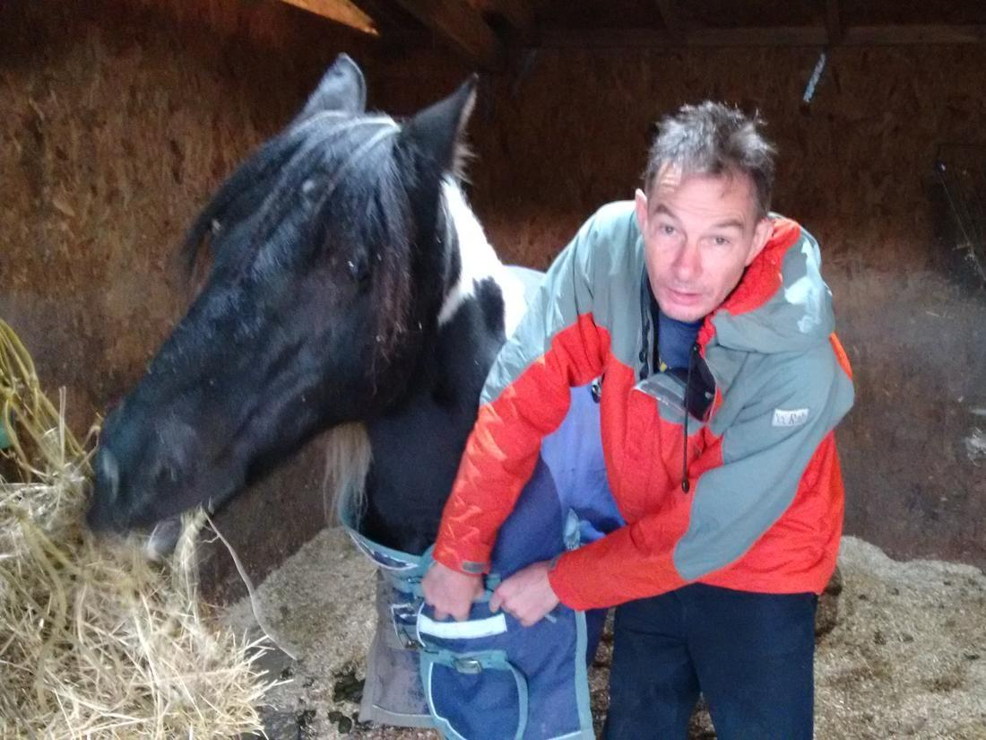 Mr Pearson and Jaz the Pony.

Hello everyone at Happyhansel Primary School from Mr Pearson. Here is a picture of me and one of my animal friends – Jaz - who is a very gentle pony - but always hungry!

I like all animals – especially both those we can see in the wild - such as birds and seals – as well as pets such as dogs and cats. I look forward to finding out what pets and animals everyone at Happyhansel has.

I enjoy being out of doors exploring the coast and running, climbing and orienteering (finding hidden flags with the help of a map). I have enjoyed teaching orienteering at my previous school in Aberdeenshire, and look forward to offering to introduce this to the children (and parents!) at Happyhansel. Some of my favourite things are:

Favourite Animal: dog Favourite Food: bananas Favourite Place: on top of a mountain Favourite Sport: orienteering Favourite Holiday Place: India

**Welc**

**Diary Dates 2020**

**February 2021**

**18th –** School closed

**19st –** School closed

**22nd –** School closed

**25th –** P7 at Aith: Social Fitness

**March 2021**

**26th** – last day

**April 2021**

**12th** – back to school

**May 2021**

**21st – School Closed**

**24th - School Closed**

**June 2021**

**23rd**- Joint Picnic & Church at Sandness

**25th** Last Day

**Grant Awarded-** Happyhansel has been awarded money from CCAF

(Community Climate Asset Fund).The sum of £1,366.98, has been awarded to the school for food growing equipment. This includes wood to build raised beds in the polycrub and outside, as well as other gardening equipment. If anyone would like to volunteer their expertise in building raised beds please phone and let us know. For more information follow the link.

In order to comply with the terms of the grant we now need to work towards our next eco flag. There may be a few “eco” activities appearing on the blog before too long.

[Organisations awarded CCAF grants | Keep Scotland Beautiful](https://www.keepscotlandbeautiful.org/climate-change/community-climate-asset-fund/organisations-awarded-ccaf-grants/)

**Dinner & Milk money** – School meals will continue to be free for P1-3, for P4-7 the price of a school lunch is **£2.20** per day. Milk money is 90p per week. Balances can be viewed and paid on **Parentpay**.

**Free School Meals** ~ All pupils in Primary 1 to 3 receive Free School Meals. However, these pupils should still be included on application forms if they wish to apply for Free School Milk and/or a Clothing Grant.

Application forms are available on our website at [www.shetland.gov.uk/education/ClothingGrants.asp](http://www.shetland.gov.uk/education/ClothingGrants.asp).

Paper application forms are also available on request from Children’s Services, Hayfield House on 01595 743845.  Completed application forms can be e-mailed to [childrensservices-finance@shetland.gov.uk](mailto:childrensservices-finance@shetland.gov.uk) or posted to:  Children’s Services, Hayfield House, Lerwick, Shetland ZE1 0QD.

**The Early Help Team** have been set up in response to the currant Covid-19 situation. Their website and referral information are in the links below. Many people in Shetland are now benefiting from their assistance.

You can complete the online referral form here; [Early Help Team - Request for Support](https://my.shetland.gov.uk/en/AchieveForms/?mode=fill&consentMessage=y&form_uri=sandbox-publish://AF-Process-f41b12f1-130b-47a7-8aaf-0e477317a9b5/AF-Stage-452a99d6-28c6-42d5-84f4-9ba470aef4c8/definition.json&redirectlink=%2Fen&cancelRedirectLink=%2Fen&consentMessage=yes) and view the new webpage here: [Early Help Team](https://bit.ly/EarlyHelpTeam)

The help they provide comes in the form of a fortnightly grocery bag deliveries to the local school that can then be picked up by families. There is no assessment of eligibility for this help and it is offered to anyone who requests it so please don’t hesitate if your family would benefit from this.

The Early Help Team also provide help to understand the benefits system and fill out forms.

**CPAG Scotland** (Cost of the School Day Child Poverty Action Group) have released two new surveys, asking parents and children about their experiences this school year.  To respond to this please follow the links below.

For children and young people: bit.ly/36cqQhu

For parents and carers: bit.ly/3qNHQCm