As we all try to navigate the ongoing impact of Covid-19, we understand that some families may benefit for some extra support on a short-term basis.
The Early Help will be attached to your local school to help fill these gaps and ensure all families are supported in whatever way they need.

What can we help with?
This help can be for many reasons, your family are facing a more challenging time financially. Maybe you have been furloughed and are concerned how you can continue meeting all your financial burdens. You might be concerned about a change in your family circumstances, maybe a recent separation or loss and can’t easily access support at this time with restrictions. You are maybe unsure of which service can help you and we can support you to access the right provision.
As a way of reaching out to families, school services can put you in touch with the Early Help Team. If you have any concerns, big or small and are unsure of how to access support then speak directly with your child’s school and they can refer you into the Early Help Team. This is a voluntary referral which you can opt out of at any time so it’s worth exploring if we can help in any way.
Food Parcels We have access to food parcels for any family experiencing financial hardship. These parcels contain dry and tinned food as well as a selection of fruit and veg and can be delivered to your local school fortnightly for collection (or we can support with delivery to your home if required). Requests can be made directly to your school or if you would prefer you can email our service directly; anchor@shetland.gov.uk or call 01595 745242/745246

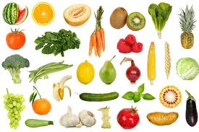
Clothing A collection of second hand clothing is available, mostly sportswear but also some outdoor items. If you are in need of a particular item for your child or yourself then get in touch and we will see if we can source it for you.

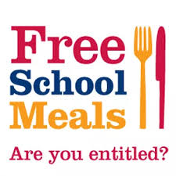
Free School Meals/Benefits We are aware many families who would qualify for Free School Meals (FSM) do not apply. What many families do not realise is that eligibility for FSM also means that you can apply for other financial supports such as Warm Home Discount and Best Start Grants. So, even if your child prefers a packed lunch, a FSM application is worthwhile. Free school meals can be applied for at any point in the school year. The Early Help Team can also support families who have benefit queries and will be able to support you to get your benefits checked through the Citizens Advice Bureau.

Useful Links
Best Start Grants www.mygov.scot/best-start-grant-best-start-foods/
Citizens Advice www.citizensadvice.org.uk/benefits/
Free School Meals/Clothing Grants www.shetland.gov.uk/education/clothinggrants.asp
Warm Homes Discount Scheme www.gov.uk/the-warm-home-discount-scheme

