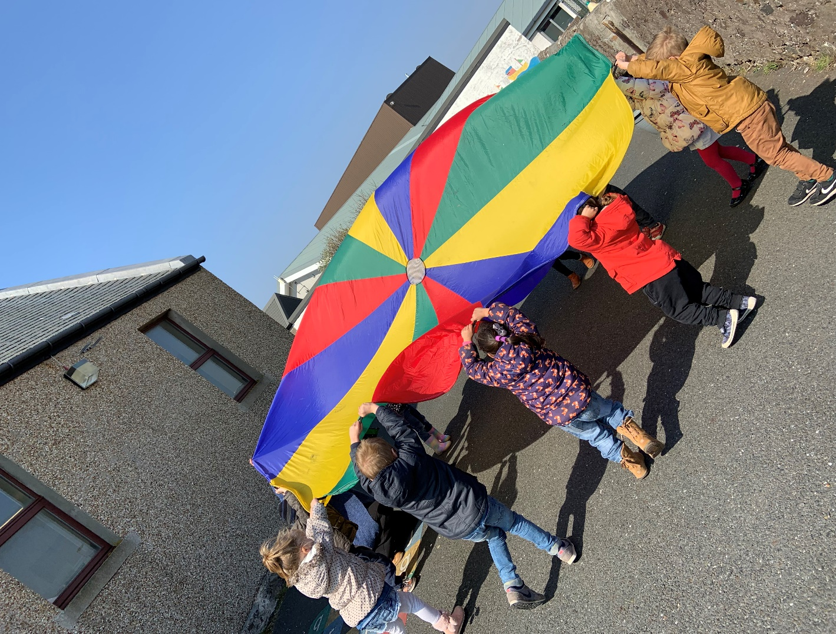
Happyhansel Early Years
Welcome Pack

Contents

Contact Details
Staff
The Nursery Session
Weekly Timetable
Term Dates
What Does My Bairn Need to Take to Nursery?
Sickness and Medication
Planning
Communication and Links with Home
Learning Stories
Extra Information
All About Me Form – to be returned please

Contact Details

Happyhansel Early Years
Happyhansel School
Walls
Shetland
ZE2 9PG

Tel: 01595 807458
School Tel: 01595 807450
Email: happyhansel@shetland.gov.uk

Staff
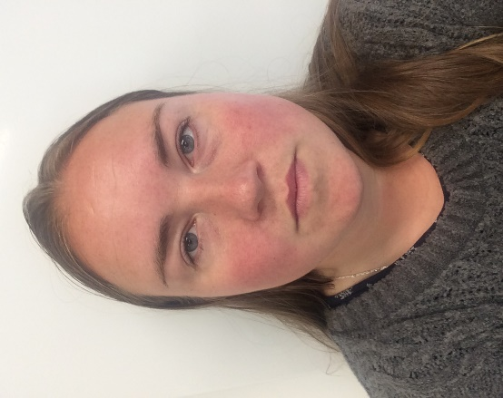
Miss Handley is our Senior Practitioner. She is in every day.
Miss Cumming is our Early Year Practitioner. She is in every day
Mrs Jamieson is our Early Years Support Worker. She is in every day.

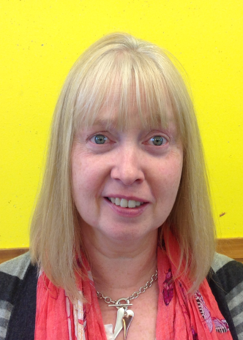
Mrs King is our Head Teacher and therefore the Nursery Manager. She is always around for guidance and pops in to see everyone in the nursery often, as well as leading the weekly assembly.
Mrs Geddes is our Early Years Teacher and is in the setting on either a Monday or Thursday and Friday mornings. She also teaches in the nursery in Aith and Skeld.

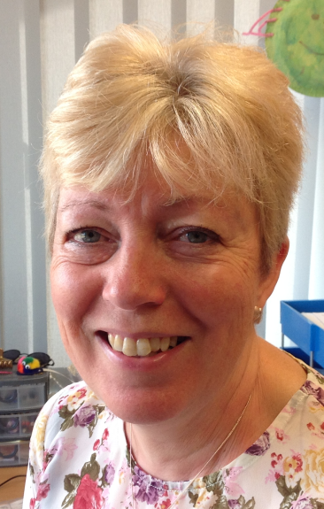
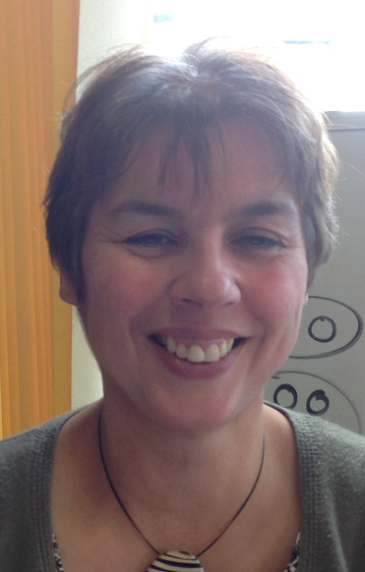
Norma works in the office in the school and is who we speak to about forms and paperwork and anything else which we are stuck with!
Mrs Thomson is the school Principal Teacher and teaches in P123, so the bairns get to know her well in the term before they go up to Primary 1. She also stands in for Mrs King if she is ever unavailable.

The Nursery Session
Our nursery session starts at 8.15am finishes at 4.15pm and runs five days a week from Monday to Friday. Lunch time is between 12.15pm and 1.15pm.
You have a maximum of 30 hours a week which you can use in any childcare setting. You will be asked to fill out paperwork to let us know which hours and days you will be attending Happyhansel Early Years. Pick-up and drop-offs can be at a time of your choosing but cannot be in the lunch hour. This information is used for staffing at the beginning of the year so if you need to change your hours or times please get in contact with a member of staff. When choosing your hours please choose the maximum amount of hours you may require as it is easier to drop hours than get extra.
When picking up and dropping off please use the buzzer at the door and use the time to read information on notice boards, posters and in your child’s tray where you will find their Learning Story.
Please be punctual for pick up – especially at the end of the day - as young children who are left can easily become upset. If someone different is picking up your child, or if you require an earlier pick-up for appointments, lessons or social engagements please let us know so we can note it for all staff.
If your bairn is not coming in on their usual day please let us know in advance or phone on the morning if they are ill.
Your child gets a healthy snack and drink every day and we share details of the snack and lunch menu in the porch. We welcome snack suggestions! Individual water bottles are provided.
We have a short Together Time every morning to talk about different topics, share news and discuss rules, as well as another short talk before story time at the end of every day.

Timetable
Monday – No timetabled activities
Tuesday - PE
Wednesday – Library
Thursday – PE/drama
Friday – Music
Assembly days vary from week to week.
Session 2019-20 Term Dates
Term 1 | Wednesday 21 August to Friday 11 October (inclusive)
October Holidays | Monday 14 October to Tuesday 29 October
Term 2 | Wednesday 30 October to Friday 20 December (inclusive)
Christmas Holidays | Monday 23 December to Tuesday 07 January 2020
Term 3 | Wednesday 08 January to Friday 27 March
Spring Holidays | Monday 30 March to Monday 13 April  (Spring Holiday Dates include Good Friday and Easter Monday)
Term 4 | Tuesday 14 April to Friday 3 July
Occasional Holiday Dates | Wednesday 29 January 2020  Thursday 20 February 2020 (Additional In Service Day)  Friday 21 February 2020  Monday 24 February 2020  Monday 13 April 2020  Monday 25th May 2020
If the school is closed for adverse weather conditions a staff member will phone to let you know.
All school closures are shared via local media and we will also put a blog post up as soon as a decision has been made.

What Does My Bairn Need to Take to Nursery?
WEAR : Comfortable clothes which you don’t mind them getting wet or messy.
TAKE IN: A full change of clothes, outdoor clothes suitable for the season, welly boots, smucks or cosy socks for inside play, and snack money (snack is 50p a day). Please label all clothes. We also welcome any junk modelling materials, loose play parts (bottle tops, beads, pine cones, basically anything which you are chucking out which a child would probably put in their pockets!)
TAKE HOME: Please look in your child’s tray for notes, art work and your copy of the weekly plan.
In our nursery children learn through play so please do not dress your child in their best clothes. We supply aprons for painting and water play but accidents do happen! We have spare clothes but we ask parents to please take in a change of clothes with name tags on to stay at the nursery. Clothes which can be easily removed for visits to the toilet are also advisable.
We spend a lot of time outside and can get muddy and wet – providing appropriate outdoor clothes for the time of the year means that bairns feel comfortable to take part in all outdoor activities and do not ruin their inside clothes while doing so.
Please put sun-cream on your child before they come on sunny days – we have sun-cream in the nursery which we will use at your request if you forget, so please have a look at it to make sure it is suitable for your child.
Staff and bairns can wear smucks/slippers or cosy socks in the nursery. All of this year’s pupils seem to like to take their shoes off as soon as they come in the door so after talking to both bairns and parents we decided to give it a go. If you have something cosy for your child’s feet please take it in and if not we are starting to build up our own supply – we welcome any wellies or smucks which are too small for your child but which might fit another bairn.
Teddies and comforters – if your child has a favourite toy which they need to have close at hand when they first start nursery then staff are very supportive of this. Other toys and trinkets from home can be taken in but should be left in your child’s tray or in our toy box just inside the nursery door to make sure it is safe.

Sickness & Medication

If your child is required to have medication administered within the setting you will need to fill out an administration form.
Children who have had sickness or diarrhoea should not return until forty-eight
hours after the last bout.
Please refer to:
http://www.publichealth.hscni.net/sites/default/files/Guidance_on_infection_control_in%20schools_poster.pdf for extra information.
Childsmile and Teethbrushing
Childsmile experts visit to introduce a teeth brushing programme and afterwards bairns brush their teeth daily with supervision. Letters detailing this and the application of fluoride varnish are sent home periodically. Non-fluoride toothpaste is available on request.
Planning
Each week we will have our weekly plan displayed out in the porch for you to see as well as putting a copy into your child’s own personal tray.
We have a very loose idea of what we are going to do each term based on events and seasons but our plans are done weekly and are based on what the children have been doing and are showing interest in.
We try to do most of what is on the plan but sometimes the children have found something much more exciting they want to play with or find out about, so of course we go with that.
We also do not ONLY do what is on the plan – there are teaching moments all the time in the Early Years and we have to follow the child’s interest and encourage and praise them every step of the way.
On the bottom of the plan is a “things you could do at home” section. These are activities or discussions relating to our weekly plan which you may want to engage in with your child at home. These can be used to expand their learning but also as a way to help you find out what has been happening at Early Years. Despite what they say, we promise they have not been doing “nothing” all morning!
Communication and Links with Home
Happyhansel Early Years have an open-door policy and though a lot of communication is done informally at drop off and pick up, we are happy to have more formal meetings and are keen for feedback of any description too.
We have regular Stay and Play Sessions and have also recently started Parents’ Evenings. The Parents’ Evenings are useful for a more in-depth chat about your child’s learning and development and are optional. If we have any concerns to discuss or celebrations to share we will let you know about them as soon as possible and encourage you to do the same.
Stay and Play Sessions are also optional, but are a fun way for you to explore the setting, watch your child interact with others and of course play with them. We often have brilliant ideas for new activities, trips or fun from parents when we chat to them at these sessions so we do encourage attendance!
We have created an Early Years Blog that enables us to share your child’s learning through pictures and posts. We can also use it to share information with parents/carers about what’s coming up or any reminders.
The URL for the blog is:
https://blogs.glowscotland.org.uk/sh/happyhanselearlyyears/
We have started a Nursery Newsletter which goes out every term and the School also does newsletters which you will receive.
We have a Suggestion and Comment Box just as you come in the door of the porch and use the porch walls to share documents and posters which you may find useful, as well as a Dry-Wipe Whiteboard which we use to share information and ask for feedback.

Learning Stories
We have been working hard the past few terms to revamp and improve our planning and tracking and the Learning Story folder that each child keeps in their tray is a big part of that. These folders will go up to the school with your child so we have been liaising with the school to ensure they streamline with their current documentation and that we are providing the most useful information to help make transition go well for every child.

Floor Book
We take lots of photos during each day and add these to a scrap book with the children as a way to encourage them to talk about their play, reflect on their learning and speak to us about what they would like to learn or find out about next. The book is then put out in the porch for parents to see at pick up time. We aim to have the book filled in at least three times a week.

Parent/Family Helpers
We require helpers on trips out-with the nursery but also welcome visitors from home any time during the year. If you want to help or introduce an art activity, do some sports coaching during PE, help when we start our woodwork again, bake or cook with us, come in and read a favourite story or share some skill with nursery staff and pupils we would love to have you. Please just let us know.

Extra Information
Policies and Documents
We have reams of documents, guidelines, policies and paperwork which all inform and help us make Happyhansel Early Years a happy, safe and nurturing environment for your child. We are happy to provide parents with online links or hard copies of any of these if you would like further information and will provide details of some of the main ones in further drafts of the handbook. The Information Area in the porch has details of many of these already.
Risky Play and Risk Benefits
We are gradually introducing more risky play into Happyhansel Early Years as children who are supported to test their boundaries and ‘flirt with uncertainty’ gain better social skills, physical strength and balance, risk management skills, resilience, and confidence. This play includes everything from lots of outdoor play, fun on the climbing frame and gymnastic and balance skills in PE, to using sharp knives when helping prepare snack, making fires and roasting marshmallows and simple woodwork. Children are supported and supervised at all times and risk assessments are always carried out, but we also look at doing a risk benefit assessment too, which really helps remind us why we are introducing this type of play and helps us make sure the children are getting maximum benefit out of the activities we introduce. Watch this space for more information in the future.

