**Happyhansel School Newsletter**

**November 2019**

**Happyhansel Primary School**

Walls

Shetland

ZE2 9PG

School 01595 807450

Early Years 01595 807458

Head Teacher ~ Mrs Sue King

Principal Teacher ~

Mrs Julie Thomson

Email : happyhansel@shetland.gov.uk

**Parent Council**

Chair Person ~ Emma Chittick

**Next meeting ~** Wed 27th Nov 7pm

**Active Schools**

**Jacqui Murray** 01595 744043

**Emergency Contact Details Update**

Child’s Name _______________________

Class ______

Emergency Contact :

Name__________________

Number_________________

**Medical Information Update**

**Pupil __________________**

**Class ______**

**Medical Condition _______________________________________________**

**________________________________________________________________________**

**Staffing Update** ~ We are delighted that Mr Travins took up the post of Music Instructor this week, the pupils had a great lesson on Tuesday.

We have Miss Clubb with us on student placement in P4-7. She is a 4th year student from Aberdeen University. She is going to be a brilliant teacher.

**MacMillan Coffee Morning** ~ Thank you for supporting our coffee morning last term with cakes and pennies. We raised a brilliant £167 which is just phenomenal!! The P7’s did a super job organising it ~ well done.

**Play van –** The play van will be coming on Monday 9th December which is always loads of fun!!

**Shoe Box Appeal** – We have managed to complete 15 boxes for a range of ages – what a special Christmas for those less fortunate. Thank you for all your donations.

**Joint Parent Council Meeting –** Wednesday 27th November at Happyhansel Primary School. Mr Neil Beattie, Catering Manager, is coming to speak to parents about the new menu being introduced in January. This will be followed by a discussion about Parental Engagement events and Fundraising for the Edinburgh Trip. Everyone is welcome.

**Children In Need ~** It’s Pudsey Bear time again on Friday 15th November and our Pupil Council have been organising!! We thought we should wear our slippers and bring our teddies to school so we can read them a story. PJ’s and dressing gowns are optional. Snoring is not allowed! Bring a wee donation too ☺

**Christmas Jumper day** is on December 13th so if you have something festive to wear – T-shirt, jumper, dress or hat etc please wear them and pop a wee donation in the tub for Save The Children, thank you.

**Christmas Shop at Happy Hansel 17th Dec ~** Pupils will be able to buy mum and dad a small gift and then wrap it in Christmas paper they have designed so there’s a little surprise under the tree. If you have any new/ nearly new items – book, DVD, ornament, scarf etc you can donate for the sales table that would be great. Hopefully you’ll not get your own gift back!!!

**Pupil Council** ~ The pupils have voted and decided on their Pupil Council for this year, I think they’re going to do a great job. P7 – Liam, Ryan & Drewie. P6 – Adah, P5 – Sadie, P4 – Ruaridh, P3 – Amy, P2 – Jessica, P1 - Immy

**Our Eco Warriors** are Ena, Tamzyn and Adam.

**School Logo** ~ Fiona Sinclair is coming to assembly on Thursday to brainstorm what school means to the children. She’ll take all their ideas and then design an up to date logo for us. Absolutely magic ☺

**Welc**

**Diary Dates 2019-20**

**November 2019**

**15th –** PJ & Teddy day for Children In Need

**6-27th** Wednesday morning bowling for Primary 5,6,7

**27th** – Joint Parent Council Meeting. 7pm at Happyhansel

**December 2019**

**11th –** Sandness Christmas Show

**12th –** HappyhanselChristmas Show 7pm with Nursery

**13th** – Christmas Jumper Day

**17th –** 9.30am Christmas shop

11am Christmas church service at Methodist Church

Followed by Christmas lunch and Dance party at Happyhansel

**20th –** last day

**January 2020**

**8th –** Back to school

**29th** – *Up Helly Aa* School Closed

**February 2020**

**20th –** School closed

**21st –** School closed

**24th –** School closed

**March 2020**

**17th –** Parent Interviews - OPTIONAL

**27th** – last day

**April 2020**

**14th** – back to school

**May 2020**

**25th** – School closed

**July 2020**

**3rd** – Last Day

**Absence** – Please call/e-mail school to notify us if your child is absent before 9.30am



**School Christmas Shows** ~ Nursery are performing Once Upon a Christmas Eve, P1-3 are dazzling us with Ralph The Reindeer and P4-7 are stunning us with Aladdin. Please help them learn their lines and songs.

We will be doing a raffle again for a Christmas hamper – an adult one and a child’s one, so please pop any donations up to school.

**Old Nursery Sale ~** We have some resources and items of furniture which we will be selling off for nursery funds on Monday 18th November from 2-5pm.

**Dinner & Milk money** – School meals will continue to be free for P1-3, for P4-7 the price of a school lunch is **£2.20** per day. Milk money is 90p per week. Balances can be viewed and paid on **Parentpay**.

**Snack Money** – If your child attends our Early Years – the cost of snack is £2.50 per week, or 50p per day.

**Free School Meals** ~ All pupils in Primary 1 to 3 receive Free School Meals. However, these pupils should still be included on application forms if they wish to apply for Free School Milk and/or a Clothing Grant.

Application forms are available on our website at [www.shetland.gov.uk/education/ClothingGrants.asp](http://www.shetland.gov.uk/education/ClothingGrants.asp).

Paper application forms are also available on request from Children’s Services, Hayfield House on 01595 743845.  Completed application forms can be e-mailed to [childrensservices-finance@shetland.gov.uk](mailto:childrensservices-finance@shetland.gov.uk) or posted to:  Children’s Services, Hayfield House, Lerwick, Shetland ZE1 0QD.

**Nursery Update** - All requests from parents to change any aspect of their nursery placement must come through the ELC inbox – [elc@shetland.gov.uk](mailto:elc@shetland.gov.uk). The ELC team will contact the setting regarding any requests and once agreed will write to families to confirm arrangements.

Please remember a PE kit and painting apron/old shirt. These can be left in school.

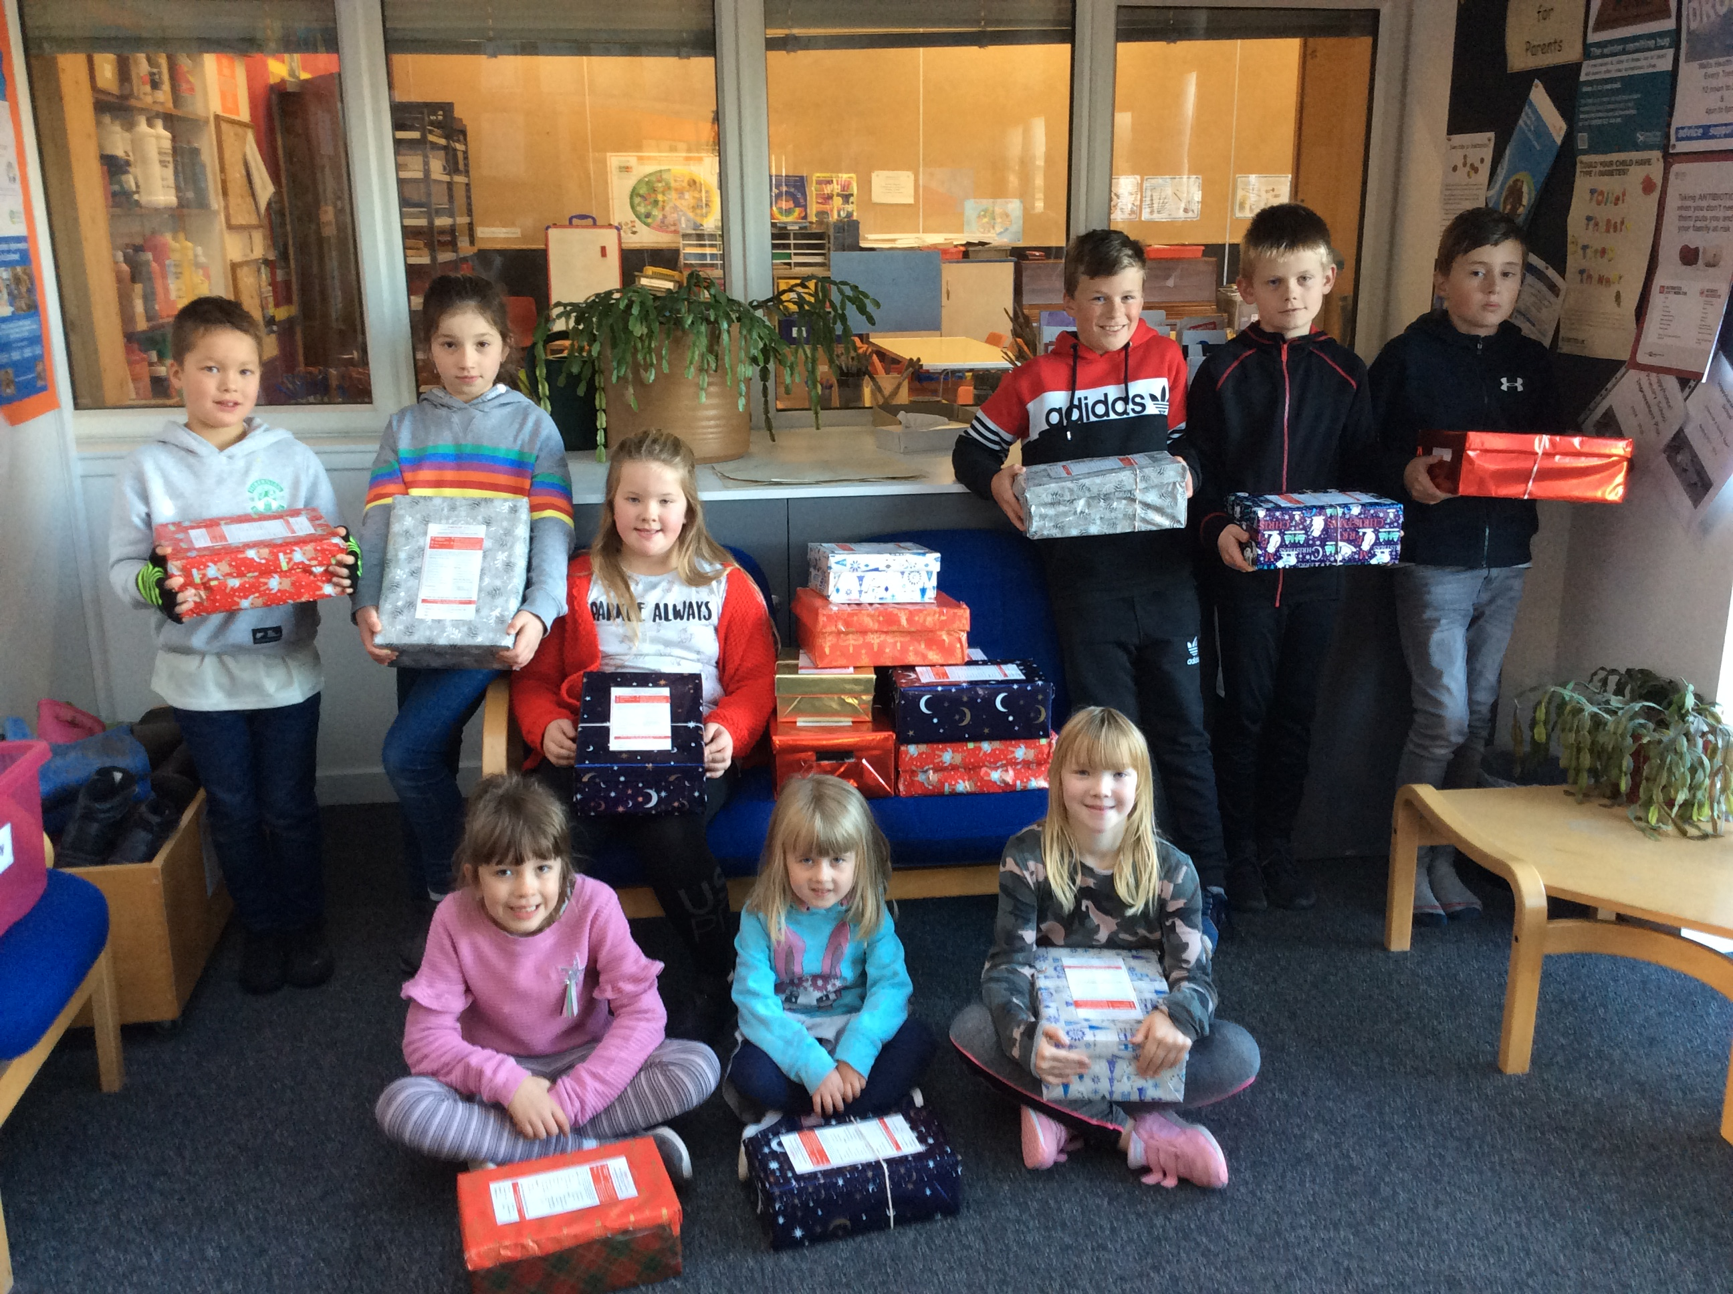

Our Pupil Council with this year’s Shoe Boxes.