**Happyhansel School Newsletter**

**February 2020**

**Happyhansel Primary School**

Walls

Shetland

ZE2 9PG

School 01595 807450

Early Years 01595 807458

Head Teacher ~ Mrs Sue King

Principal Teacher ~

Mrs Julie Thomson

Email : happyhansel@shetland.gov.uk

**Parent Council**

Chair Person ~ Emma Chittick

**Next meeting ~**

**Active Schools**

**Jacqui Murray** 01595 744043

**Emergency Contact Details Update**

Child’s Name _______________________

Class ______

Emergency Contact :

Name__________________

Number_________________

**Medical Information Update**

**Pupil __________________**

**Class ______**

**Medical Condition _______________________________________________**

**________________________________________________________________________**

**February Long Weekend ~ School is closed to pupils on Thursday 20, Friday 21st and Monday 24th of February 2020.**

**Staffing Update** ~ We are delighted for Mrs Wagstaff but very sad for Happyhansel as she is moving to a teaching post at Bell’s Brae. We wish her all the very best in her new job. Her post will be advertised shortly.

**Drama Festival ~** Elaine Drakeford has very kindly written a Shetland dialect play for P4-7 to perform at the Drama Festival on March. This is not compulsory as it is being done out with school. The dress rehearsal is on **Wednesday 4th March, pupils will require a packed lunch**. Parents will be responsible for transporting pupils to the Garrison Theatre for the performance on **Thursday 12th March**. Tickets can be purchased from the Box Office soon.

**Edinburgh Trip –** There will be an information evening for the P6/7 Edinburgh trip on Monday 16th March at 6.30pm in the canteen at Aith. The pupils are on the boat on Sunday 19th and arriving home at 7am on Friday 24th April. All pupils are expected to attend school on Friday. The February payment is due on the 28th and the March payment is due on the 27th. These are to be made on Parentpay.

**SWIMMING –** Swimming will start at the end of this term with 3 sessions befor the holidays and 3 after. Thursday12th, 19th and 26th March; 16th & 30th April and May 7th. P1-3 will swim first at 9.10 so they may want to wear their swim suits to school to make it quick and easy. Sandness will have break and lunch at Happyhansel so all the bairns can have some fun together.

**ZEN Schools** – We will be having a twilight at Happyhansel on Wednesday 11th March from 3.30 – 4.30pm. All parents are welcome and I really do hope you’ll come along to see what we’ll be up to.

**Scottish Opera** – The Pupils in P5-7 will be taking part in the Scottish Opera production of *Warriors! The Emperor’s Incredible Army*. Date of performance to follow.

**STEM** – Emma Chittick will be running 3 sessions later this term for P5-7 to broaden their skills, knowledge and confidence with some amazing technology.

**Welc**

**Ukulele Fundraiser** – Mr Travins, our music instructor, organised a fundraiser at the Walls Hall on Sunday 2nd Feb which raised £400. 21 ukuleles have been ordered. Well done and Thank you Mr Travins ☺

**Staff Welfare –** We have an open door policy at Happyhansel and are more than happy to speak to parents, in fact we welcome this. Please be mindful that staff are not to be shouted at or called names. If this happens again I have instructed staff to walk away or end the phone call. Another meeting can then be arranged. I am sure you will all support this.

S**ocial Fitness** – P7 will have a fun filled session at Aith on February 25th and March 10th with all pupils going into S1 in August.

**Badminton** - Jane Grant, from Badminton Scotland was in school for a badminton coaching session with P5-7 last Tuesday. She was very impressed with them ☺

**Dinner & Milk money** – School meals will continue to be free for P1-3, for P4-7 the price of a school lunch is **£2.20** per day. Milk money is 90p per week. Balances can be viewed and paid on **Parentpay**.

**Free School Meals** ~ All pupils in Primary 1 to 3 receive Free School Meals. However, these pupils should still be included on application forms if they wish to apply for Free School Milk and/or a Clothing Grant.

Application forms are available on our website at [www.shetland.gov.uk/education/ClothingGrants.asp](http://www.shetland.gov.uk/education/ClothingGrants.asp).

Paper application forms are also available on request from Children’s Services, Hayfield House on 01595 743845.  Completed application forms can be e-mailed to [childrensservices-finance@shetland.gov.uk](mailto:childrensservices-finance@shetland.gov.uk) or posted to:  Children’s Services, Hayfield House, Lerwick, Shetland ZE1 0QD.

**Nursery Update** - All requests from parents to change any aspect of their nursery placement must come through the ELC inbox – [elc@shetland.gov.uk](mailto:elc@shetland.gov.uk). The ELC team will contact the setting regarding any requests and once agreed will write to families to confirm arrangements.

Please remember a PE kit and painting apron/old shirt. These can be left in school.

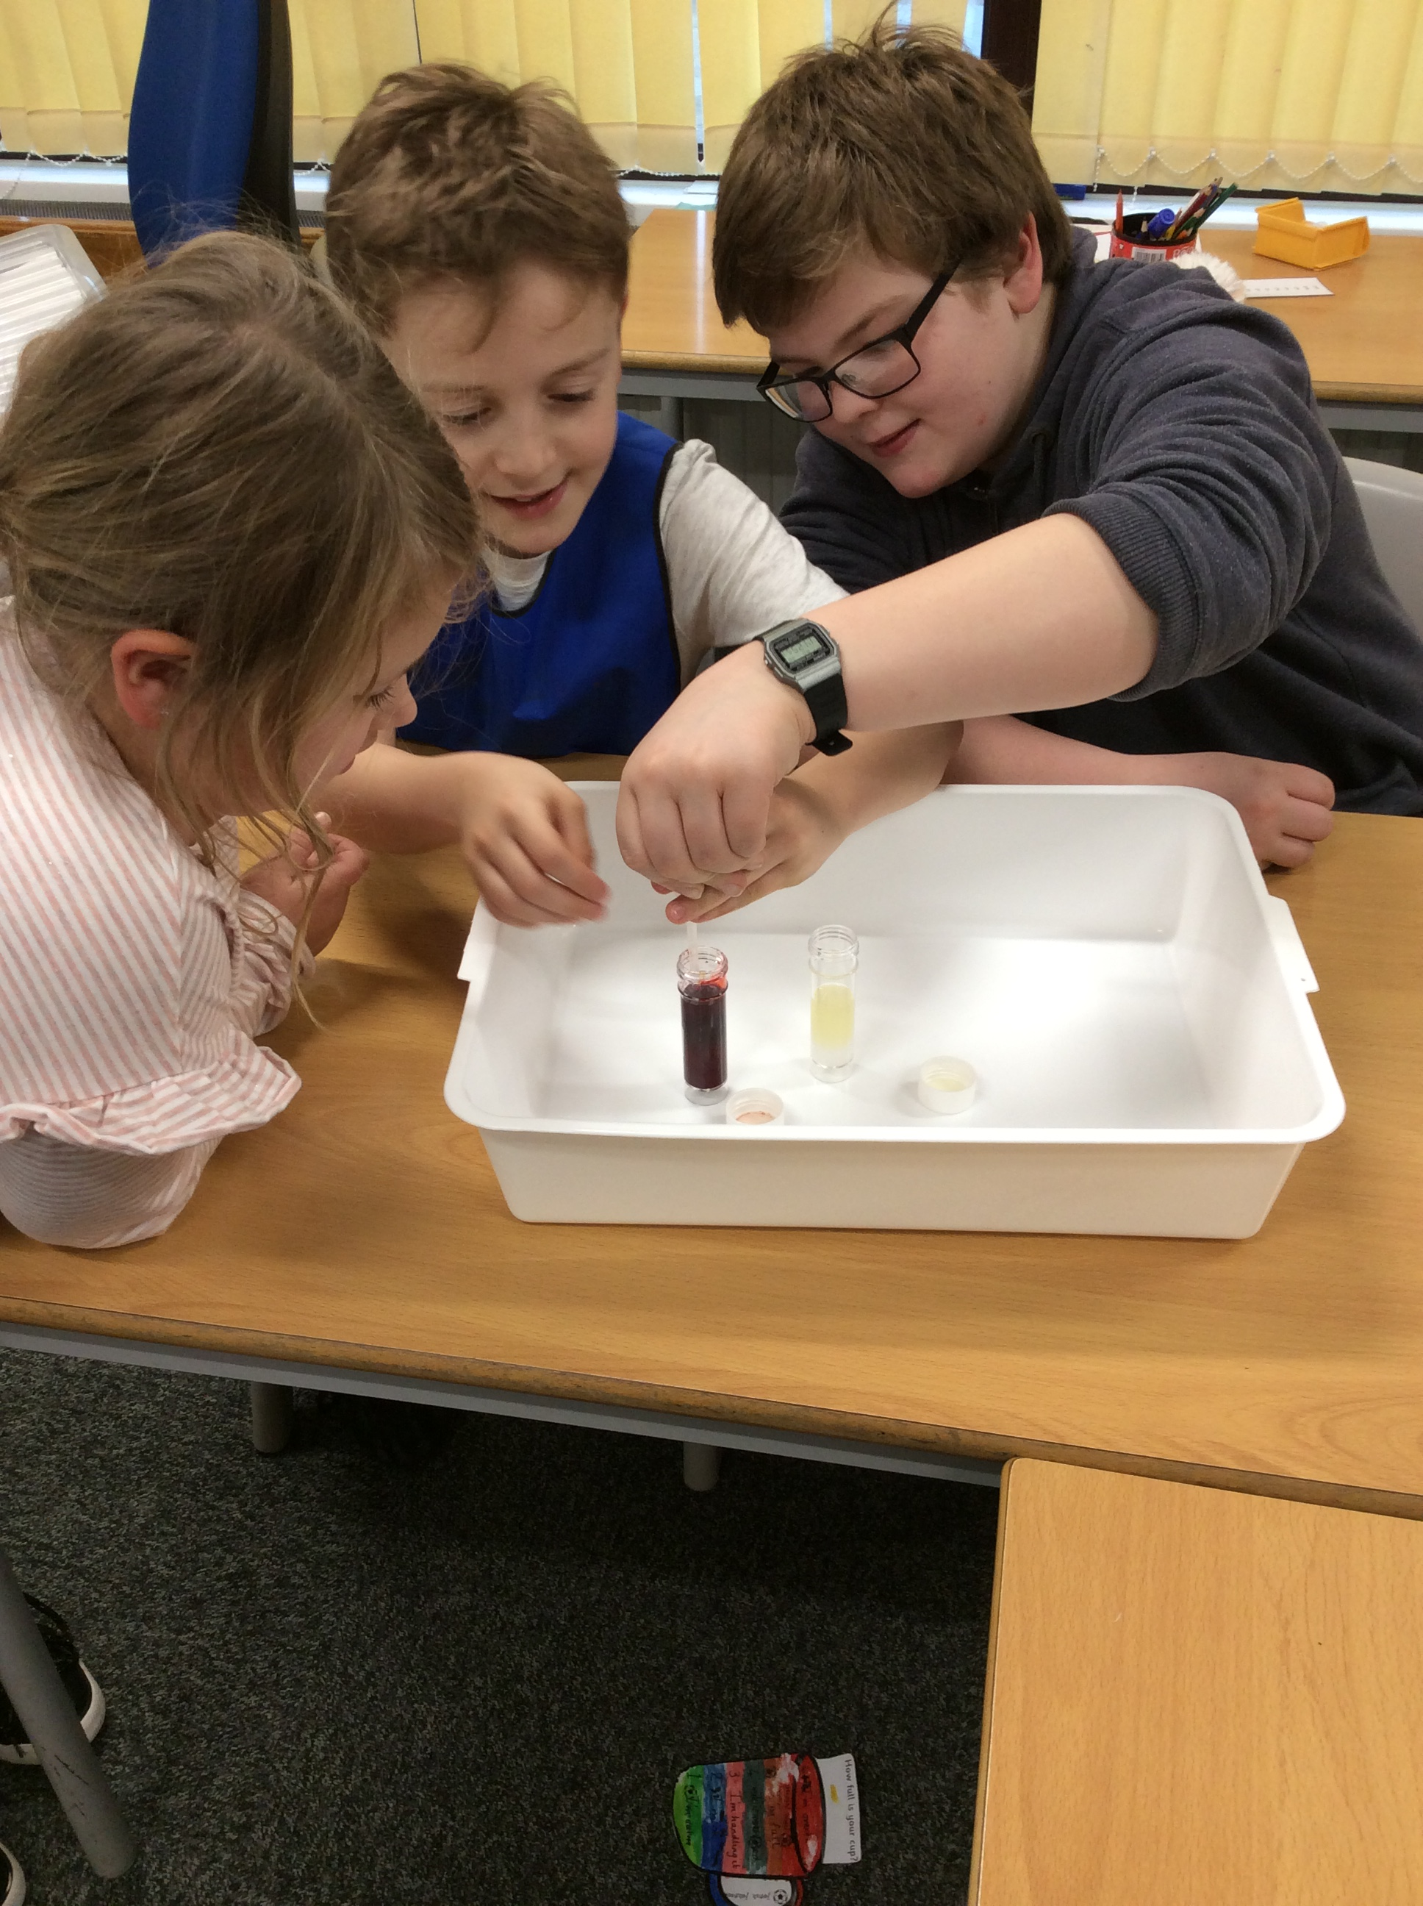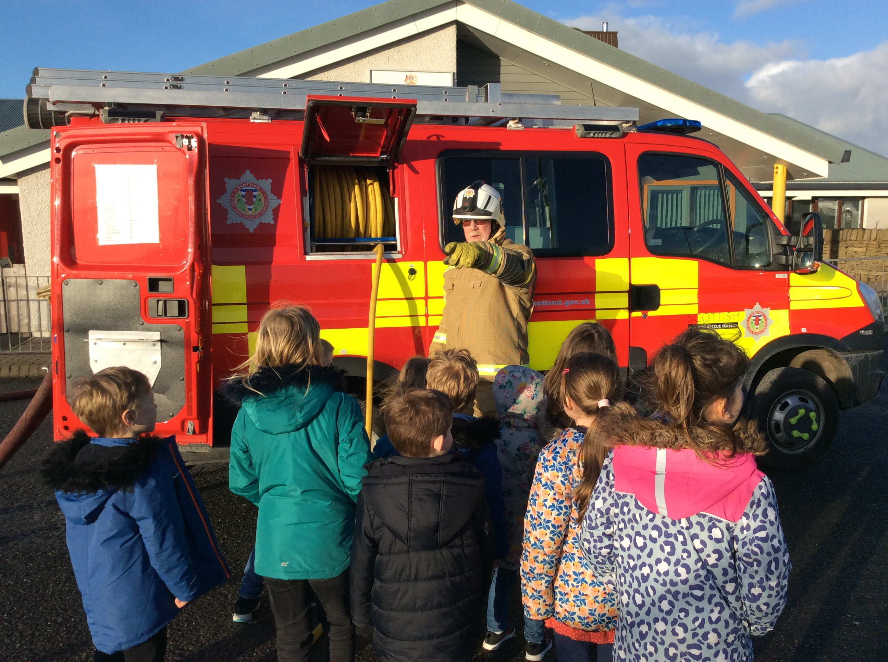

**Diary Dates 2020**

**February 2020**

**20th –** School closed

**21st –** School closed

**24th –** School closed

**25th –** P7 at Aith: Social Fitness

**March 2020**

9th – STEM

**10th** – P7 at Aith: Social Fitness

**11th** – ZEN Schools twilight at HappyHansel 3.30pm

**12th** – Swimming

**16th** - STEM

**16th –** P6/7 Edinburgh trip meeting Aith Canteen 6.30pm.

**17th -** Parent Interviews – ***OPTIONAL***

**19th** – Swimming

**23rd** – STEM

**25th** – Indoor carpet Bowls competition, Lerwick.

**26th** - Swimming

**27th** – last day

**April 2020**

**14th** – back to school

**16th** – Swimming

**30th** - Swimming

**May 2020**

**6th** – Clickimin for small schools activity day

**7th** – Swimming

**14th** – Hockey Festival in Brae

**15th** – Westside Sports P6/7

**25th** – School closed

**26th** – Scottish Opera rehearsal

**28th** – Football/Netball Brae

**June 2020**

**2nd –** County Sports Lerwick

**4th** – Sports Day Happyhansel

**16th** – P7 Outdoor Day

**17, 18 & 19 –** P7 transition Days at Aith

**23rd**- Joint Picnic & Church at Sandness

**26th** – Prize Giving 9.30am

**July 2020**

**3rd** – Last Day