Happyhansel Primary School

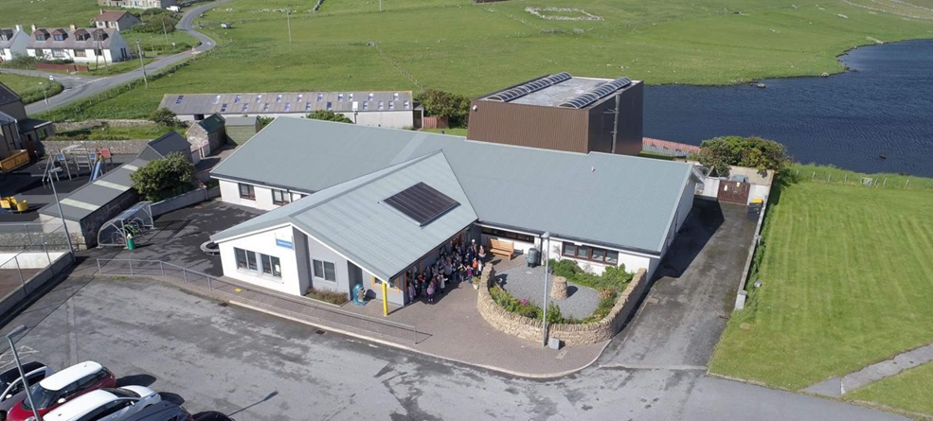

Standards & Quality Report
2018-19

and

School Improvement Plan
2019-20

Introduction

Shetland Islands Council is committed to delivering the best possible outcomes for children and young people so that they have the best start in life and are ready to succeed by following the principles of Curriculum for Excellence, Getting it Right for Every Child (GIRFEC), and Developing the Young Workforce.
We want to know how well we are doing this and how we can improve. We are continuously evaluating what we do and how it makes a difference to our learners. We have been asking ourselves – staff, pupils, parents/carers, and other partners – the questions contained in this Standards and Quality Report. Our self-evaluation – involving staff, pupils, parents/carers, and other partners – is in the pages that follow, along with our main improvement priorities for session 2019-20. This report is based on the quality indicators in How Good is Our School? 4th Edition (2015) and How Good is our Early Learning and Childcare? (2016) and on the priorities and drivers of the National Improvement Framework.

The current National Improvement Priorities are:

- Improvement in attainment, particularly in literacy and numeracy;
- Closing the attainment gap between the most and least disadvantaged children;
- Improvement in children and young people’s health and wellbeing; and
- Improvement in employability skills and sustained, positive school leaver destinations for all young people

The National Improvement Drivers are:

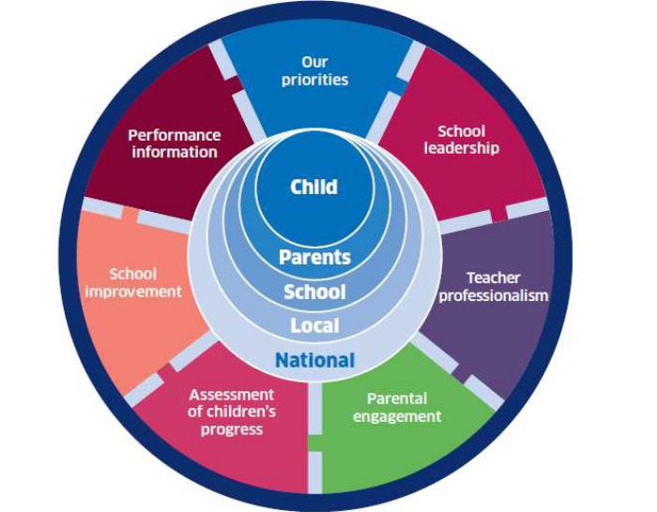

Context of the School

Happyhansel Primary is situated in the village of Walls, a small rural community on the West Mainland of Shetland. The school has a shared Head Teacher who covers Happyhansel and Sandness Primary schools.
We are a non-denominational school catering for pupils from nursery to P7. Secondary schooling for S1 to S4 is provided at Aith Junior High School with S5 & S6 education provided by Anderson High School in Lerwick.

We are currently a two teacher school with 38 pupils. A P1-3 of 19 and a P4-7 of 19.

The pupils are also supported by an Additional Support Needs Teacher who is in 1 day per week. In addition the pupils are assisted by a Learning Support Assistant. 2 Learning Support Workers work 1 to 1 with 2 pupils.

We have visiting specialists for PE, Art and Music who visit weekly.
We also have regular visits from our local Ministers who support assemblies and church services.
The pupils have access to various specialists who will visit school for a block of time ~ Drama, Drumming, Science, Shetland Dance and IT. The pupils have a 6 week swimming block in the Walls Swimming Pool.

We have an Early Years provision for 22 pupils 5 days per week from 8.15am to 4.15pm. This is staffed by a Senior Practitioner, Practitioner and 2 Early Years Support Workers.

The school has an active and very supportive Parent Council who have an extremely useful and informative FaceBook page which all parents are signed up to.

How has the school engaged pupils in decisions about improving its work?

Pupil Council/ECO
JRSO
Assembly
Class/group discussions
Pupils Notice Boards

How has the school engaged parents and carers in decisions about improving its work?

Questionnaires
Comments boards at events
Newsletters
Facebook Page
Parent Council meetings/Parent Forum
Notice boards

How has the school engaged its staff in decisions about improving its work?

Staff meetings
Self Evaluations
QI sweep
Specific QI’s
PRD/ERD meetings
Forward planning meetings
Informal discussions
Professional Dialogue

How has the school engaged community partners in decisions about improving its work?

Parent Council meetings

Progress made with the Priorities from our 2018-19 School Improvement Plan
Standards & Quality Report
2018-19



Priority 1: Raising Attainment in Literacy and Numeracy |  | National Improvement Priorities: Improvement in attainment, particularly in literacy and numeracy.  National Improvement Framework Drivers: School Leadership, teacher professionalism, parental engagement, assessment of children’s progress, school improvement  Quality Indicators (HGIOS? 4):1.2 Leadership of Learning, 1.3 Leadership of change, 2.3 Learning, teaching & assessment, 2.4 Personalised Support  3.2 Raising Attainment & Achievement
What did we want to achieve for learners?  Pupils as learners will:  - have their individual learning needs met  - make appropriate progress in literacy and numeracy  - work in fluid groupings  - Encourage growth mindset in staff and learners  Staff as learners will:  - be able to use robust evidence to demonstrate the progress of each learner  - understand the developmental approach to emerging literacy and how we can build on this throughout the school.  - engage with the maths progression developed by the Northern Alliance  - engage with Literacy progression frameworks  - use benchmarks and the moderation hub to enhance practice  use data more effectively to meet learners’ needs | How exactly did we plan to do it?  - Assess reading and spelling age at beginning and end of year  - Emerging Literacy Project  - Whole school approach to Paired Reading  - Improve quality of learning intentions and success criteria for lessons  - Revisit work on formative assessment strategies  - Ensure suitable differentiation in place to meet needs of all learners  - Provide stimulating, varied and active learning experiences  - Develop robust assessments to evidence learning  - Using data effectively to improve attainment  Improve numeracy skills, especially foundations skills | Progress made  Done in Aug/Sep & June  P1 assessed 3 times per year. P2 re-assessed.  None  Some work done on this to increase pupil awareness of what they are learning and why.  Touched on  Needs met through differentiation and using varying teaching styles  Always  PLP’s developed to reflect /record learning  Discussions at planning meeting or with ASN teacher  Basic number was a focus | Next steps  Do in Nov not Aug/Sep and June  2019/20 SIP  Continue  Continue  Liaise with Aith to ensure continuity  Introduce Leckie & Leckie Maths scheme in P4-7  Times tables to be a focus

Priority 2: Nurture & Pupil Voice . |  | National Improvement Priorities: Improvement in children and young peoples’ health and wellbeing. Closing the attainment gap between the most and least disadvantaged children.  National Improvement Framework Drivers: School Leadership, teacher professionalism, parental engagement, assessment of children’s progress, school improvement  Quality Indicators (HGIOS? 4): 1.2 Leadership of Learning 1.3 Leadreship of change 2.1 Safeguarding and child protection 2.3 Learning, teaching & assessment 2.4 Personalised support 2.5 Family Learning 3.1 Improving wellbeing, equality and inclusion 3.2 Raising Attainment & Achievement
What did we want to achieve for learners?  Desired Outcomes What difference will it make for learners? (What impact do we expect to see?)  Pupils as learners will:  • Have an understanding of SHANARRI and what these indicators mean to them in real life contexts  • Be able to self-assess and track emotional wellbeing at a developmentally appropriate level  • Have access to an appropriate and progressive curriculum for health and wellbeing  • Have an awareness and understanding of Growth Mindset and Mindfulness and how they can use them  • Develop positive, trusting relationships with staff and peers within the school community enabling them to access the curriculum and achieve success in their learning  • Have a positive attitude to learning  • Build self-esteem and resilience  • Have a meaningful say in all aspects of school life and school improvement  • Work within House Teams, encouraging positive relationships with others of all ages and a sense of identity  • Feel valued  • Have ownership and responsibility for their own learning  Staff as learners will:  • Develop their understanding of SHANARRI  • Contribute to planning for and implement the health and wellbeing programme within the school using SCARF resources  • Be very familiar and use the benchmarks effectively  • Use SEEMIS for Pastoral notes  • Develop a greater understanding of the principles of nurture and adopt them into their everyday practice  • Actively encourage participation from all members of their group  • Lead on areas of the school development plan to make this more meaningful to all stakeholders | How exactly did we plan to do it?  Engage with all aspects of SHANARRI in all classrooms and develop age appropriate resources for use in each class.  Implement SCARF materials as part of a whole school approach to health and wellbeing  Further develop Nurture across the whole school to include Growth Mindset and Mindfulness through group and class work  Introduce a Social Skill at assembly  Develop sense of pride and achievement in redeveloping Garden area  Pupil Voice/Eco  Familiarise staff and pupils with ‘How Good is OUR school’ materials  Audit current practice with all stakeholders  Childrens Improvement Plan (CHIP) and evaluations | Progress made  Pupils aware of language through discussion  Scarf assemblies all done  Nurture groups for small groups in place.  Term 1 only  Polycrub erected  Meetings held when required  How Good Is Our School not used  Not done  Not Done | Next steps  Continue  Look at Blob trees/check ins  Classes to use resource  Mindfulness to be developed – Ed Psych input  Expand nurture groups  Utilise polycrub in Enterprising way  Timetable regular Pupil Council meetings and display minutes

Priority 3 SSERC / STEM / DYW | National Improvement Framework Priority ~ Improvement in attainment, particularly in literacy and numeracy.  Driver ~ School Leadership, teacher professionalism, parental engagement, assessment of children’s progress, school improvement  Quality Indicator ~ 1.2 Leadership of Learning, 2.3 Learning, teaching & assessment, 2.4 Personalised Support, 3.2 Raising Attainment & Achievement

What did we want to achieve for learners?  Pupils as learners will:  Gain skills and knowledge through various science topics  Be able to use scientific language more confidently  Take part in Careers week and STEM workshops  Have fun learning to use Scratch and Sway | How exactly did we plan to do it?  Audit current practice/resources  Devise progression linked to benchmarks  Staff to sign up and participate in SSERC meets online.  N Wagstaff/J Garrick to attend SSERC day on transition  Involve local community/parents/SIC staff to present at Careers Fayre  Blocks of input on Sway, Scratch/coding, Mobislyder, STEM coding  Create STEM/Science home activity packs | Progress made  Resources organised and streamlined  Still to be done  Various SSERC meets done  Both attended  Very successful event  Positive comments from parents  Blocks of input done  Never received Mobyslider from SIC  P1-3 and P4-7 bags made up and going home. | Next Steps  Resource list linked to planning.  Continue to apply for SSERC meets  Run another event with a different focus  Change contents once all pupils have had bag home  Nursery bags to be made up by Parent Council

Priority 4 Early Years | National Improvement Framework Priority ~ Improvement in attainment, particularly in literacy and numeracy.  Driver ~ School Leadership, teacher professionalism, parental engagement, assessment of children’s progress, school improvement  Quality Indicator ~ 1.2 Leadership of Learning, 2.3 Learning, teaching & assessment, 2.4 Personalised Support  3.2 Raising Attainment & Achievement

What do we want to achieve for all learners?  Target: To develop the Early years provision and provide enhanced learning opportunities for all pupils.  School’s current position: New EY provision is currently being constructed within the main building. Care Inspectorate visit (light touch) in September 2018. EY to follow up on any actions.  Pupils as learners will:  Broad and balanced experiences  Enhanced outdoor learning  Experience transition to meet all needs | How exactly did we plan to do it?  Audit current resources in Nursery  Order new resources for new location  Staff to become familiar with nursery publications to move thinking and practice forward  Devise a planning & tracking format which is effective and efficient  Staff to develop transition to enhance learners experience  Use pupil/parent ideas to develop the outdoor space  Implement a new observation plan – Involving parents with a play plan produced for each pupil with next steps | Progress Made  Resources sorted through and moved to new setting  New resources ordered and in place  Transition not ideal as new setting was not complete  This is still ongoing as Parent Council have just secured funding from Cooke Aquaculture for mud kitchen | Next Steps  Settle in to new setting and resources.  Upskill staff and build confidence in observations, recording and self-evaluation.  Define role of teacher in progression of curriculum  Update policies

School self-evaluation and priorities for further improvement

Leadership of Change (QI 1.3)

How well are you doing? What’s working well for your learners?
The school works together to make positive changes and improvements involving all stakeholders.
School Improvement Plan is progressed as a team to ensure ownership. Pupils consulted about playground, canteen etc
The head teacher ensures the pace of change is appropriate and that all staff are well informed of its intensions.

How do you know? What evidence do you have of positive impact on learners?
We have seen our learners better informed about what they are doing and why. We have seen pupils confidence and self-esteem improve when we have interven ed to support them (Nurture provision/soft start). The staff are involved in deciding the common goal and the direction the school is moving in.

What are you going to do now? What are your improvement priorities in this area?
Give Pupil Council a bigger role and invite to Parent Council meeting
Ensure all support staff are consulted

Self-evaluation grade on the HGIOS?4 six-point scale: 4

Learning, teaching and assessment (QI 2.3)

How well are you doing? What’s working well for your learners?
To ensure high quality learning experiences for all our children, staff consider carefully the learning opportunities children have. Through monitoring and evaluating, staff work to match motivating and challenging learning content to the needs and interests of the pupils. Pupils play a role in deciding on what they will learn and evaluating if they have achieved it. Staff undergo professional development and training to continue to keep up to date with meaningful interventions. We use assessment effectively, tracking and monitoring termly ensures planned curriculum matches needs. Targeted support from heavily timetabled LSA is ensuring support. Good communication with ASN teacher has proved vital in supporting pupils effectively.

How do you know? What evidence do you have of positive impact on learners?
Code Cracker/Toe by Toe/small group work assessments showing good improvement.

What are you going to do now? What are your improvement priorities in this area?
Upskill staff in analysing data to inform next steps.
Look at planning and progression for Reading, Writing and Spelling. Produce parent info leaflets.
Use Accelerated Reading with upper school.

Self-evaluation grade on the HGIOS?4 six-point scale: 4

Ensuring wellbeing, equity and inclusion (QI 3.1)

How well are you doing? What’s working well for your learners?
Staff are supported by the GIRFEC framework and ASN staff work collaboratively with teachers and support staff to regularly consult on targeted interventions for our pupils who have additional support needs. We ensure our pupils are able to actively participate in the life of the school through nurture/soft start time promoting successful learners; confident individuals; responsible citizens and effective contributers.
ASN and LSA time with targeted groups according to need. Staff work hard to include all pupils with teaching styles and activities and differentiation.

How do you know? What evidence do you have of positive impact on learners?
Staff observations, pupil comments and self-esteem, parent comments.

What are you going to do now? What are your improvement priorities in this area?
H&WB – Mindfulness, nurture, Pastoral notes on SEEMIS, SCARF and Planning & tracking. Build more capacity for pupil voice while ensuring pupil accountability and responsible undertaking of roles.

Self-evaluation grade on the HGIOS?4 six-point scale: 4

Raising attainment and achievement (QI 3.2)

How well are you doing? What’s working well for your learners?
The school is able to measure progress in emergent literacy, numeracy and HWB effectively. Through use of teacher judgement, SNSA, regularly monitoring and assessing understanding and skills, staff are able to measure progress made using our newly developed tracking and monitoring systems from Early Years to Primary Seven.

How do you know? What evidence do you have of positive impact on learners?
Assessments, Attainment. Pupil demeanour and self-esteem.

What are you going to do now? What are your improvement priorities in this area?
Literacy – Reading, writing and spelling ~ progressions, tracking & planning
Technologies – ICT & SSERC, planning and trackers

Self-evaluation grade on the HGIOS?4 six-point scale: 4

School Improvement Plan
2019-20

Factors Influencing the Improvement Plan

School factors
- Rurality
- Staffing
- Budget
- Time

Local authority factors
- Shetland Islands Council NIF Plan
- Schools and Quality Improvement Service Plan
- SIC Operational Guidance: School Improvement Planning and Standards and Quality Reporting
- SIC Strategy for Parental Involvement 2018

National factors
- National Improvement Framework
- “Learning Together”: Scotland’s national action plan for parental involvement etc. 2018-2021
- How Good Is Our School (4th Edition)
- How Good is our Early Learning and Childcare?
- Inspection guidance note 2019/2021
Improvement Priorities for 2019-20
Priority 1: Curriculum Pathway in Literacy |  | National Improvement Priorities: Improvement in attainment, particularly in literacy  National Improvement Framework Drivers: School Leadership, teacher professionalism, parental engagement, assessment of children’s progress, school improvement  Quality Indicators (HGIOS? 4):1.2 Leadership of Learning, 1.3 Leadership of change, 2.3 Learning, teaching & assessment, 2.4 Personalised Support  3.2 Raising Attainment & Achievement
What do we want to achieve for learners?  To make the curriculum more meaningful and relevant by developing a literacy pathway to ensure progression of writing, reading, grammar and spelling.  To engage families fully into how their children learn and how they can support them in literacy.  Pupils are enthused to share their learning with their family.  Parents are better informed about how their children learn.  Parents are better equipped to support their child’s learning. | How exactly are we going to do it?  Consider each Literacy experience and outcome from Curriculum for Excellence and group taking account of resources, expertise and knowledge to ensure a clear pathway. (Bundle the curriculum)  Produce Information Leaflets for parents to ensure shared knowledge and purpose and also home support.  Hold an open day/evening learning event. | Personnel  HT and CT’s. | Time Scale  6 x Staff meetings in term 1, 2 and 4 | Resources  Some resources may be identified for purchasing. Cost unknown at this point. | Monitoring and evidence  HT and CT’s  Evidence of E’s and O’s coverage in termly overviews and progression of curricular pathways produced.

Priority 2: Leadership of change  Improve the school environment incorporating Health and Well Being  And Parental Involvement |  | National Improvement Priorities: Improving attainment, particularly in literacy and numeracy. Improvement in children and young people’s health and wellbeing. Closing the attainment gap between the most and least disadvantaged children.  National Improvement Framework Drivers: School leadership, teacher professionalism, school improvement, performance information  Quality Indicators (HGIOS 4): 1.3, 1.5, 2.7, 3.1, 3.2, 3.3
What do we want to achieve for learners?  A school environment that nurtures and motivates pupils to be inspired and want to learn  Calm environment  Organised environment  Inspiring environment  Respected by all environment | How exactly are we going to do it?  Review the use of the school areas indoor and out - consider its impact on all learners  - Reorganise spaces to increase fit for purpose use  - Engage with all school users – respectful use of school building and property  - Develop outdoor area to include mud kitchen and traversing wall  - Fully utilise newly erected Poly Crub  - Further develop Mindfulness/growth mindset and Nurture  - Staff Well Being cluster day in Jan at Aith JHS  - Nursery developing Yoga sessions  - Creative learning opportunities outdoors | Personnel  All school staff;  All pupils;  Parent Forum and Parent Council.  Ed Psych input | Time Scale  2 hours  1x 1 hour meeting  Term 1-4  Parent/  janitor as required  January In Service | Resources  All staff  Janitor  Parents  Cooke Aquaculture grant of £2000 | Monitoring and evidence  Impact on use of space and behaviour  Monitoring of respectful use of school and property – pupil responsibility

Working Time agreement for: | Happyhansel & Sandness Primary Schools
School Session: | 2019-20
The purpose of this template is to provide a clear structure for schools to construct a working time agreement. It is offered as an option for schools to use should they consider it useful. The template should be used flexibly, e.g. Each item may not be appropriate for all settings, other items may need to be added.
Item | Detail | Hours
Teaching and Learning
Class Teaching | Based on 1.0 FTE | 22.5
Personal preparation and correction | One third of class contact time | 7.5
Collegiate Time
Collegiate time (Annual) | 5 hours x 39 weeks. This does not include time within the In-Service days. | 195
Essential School Activities
Reporting to Parents | Number of reports X agreed time allocated = regular blog updates | 30
Moderation Activities | Agreed Time Allocation | 15
Tracking and Monitoring | Agreed Time Allocation | 25
Parents evenings | Number of meeting X agreed time for meeting plus associated Preparation time | 12
Staff meetings | Number of business meetings X Agreed duration 26x1.5 | 40
Christmas Performance | Evening Concert | 5
Monitoring/tracking | HT consultation | 8
Staff Development & Review Cycle | PRD Meeting plus associated preparation. | 2
Briefings | These can only be considered if they take place outwith pupil timetabled day | 10
ASN Consultations | 1 x term | 4
Total | Time required for essential school operational activities | 151
Collegiate time remaining for development tasks
School Improvement Plan Tasks | Time allocated for tasks to address priorities on School Improvement plan | 14
 | Nurture - ilearn and reading | 4
 | Familairisation with benchmarks | 4
 | Flexibility | 22
Total | Time allocated to developement tasks | 44
Total | Total collegiate time allocated | 195

