Hamnavoe Primary Positive Behaviour Policy December 2023

Hamnavoe Primary School is committed to creating an environment where positive behaviour is constantly promoted by everyone in our school community. Everyone should aim to reflect the school values , accept responsibility for their behaviour and encourage others to do the same.
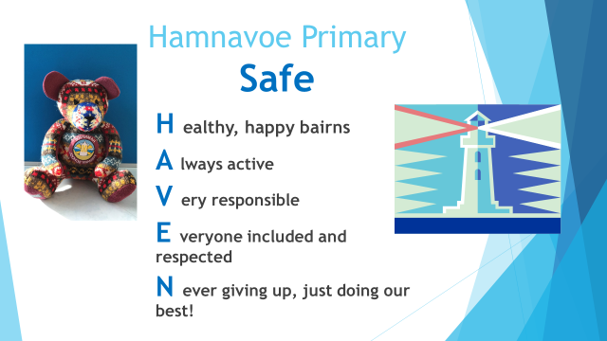
Our policy (December 2023) is built on consistency and echoes our vision and values – Hamnavoe a Safe Haven and the principles of SHANARRI (Safe, Healthy, Active, Nurtured, Achieving, Respected, Responsible and Included). In March 2021 the Convention of the Right of the Child (UNCRC) became law. Our Positive Behaviour Policy aligns with this.
Our Positive Behaviour Policy has been developed in partnership with pupils, parents, staff and outside agencies. It also recognises recent educational research from across Scotland. (See Appendix)
We believe in the nurturing principles that “All behaviour is communication” and needs to be understood and be responded to appropriately. All behaviours have consequences – positive and negative.

Our Aims
- To create a culture for positive behaviour – for learning; for community; for life
- To help learners to take responsibility for their behaviour and the associated consequences
- To ensure that all are treated fairly, shown respect and kindness and to promote good relationships
- To promote consistency in practice
- To create an environment where discrimination is challenged and diversity is valued.

Our Responsibilities
Learners will
- Demonstrate the school values
- Agree a class contract of expected behaviour in their classroom
- Follow the Class Rules or contract
- Reflect on their actions and contribute to appropriate restoration
- Accept their actions will have consequences
- Celebrate your success and success of others

Staff will
- Demonstrate the school values
- Participate in the development of class rules or contracts and review these termly with pupils
- Model and build positive behaviours and relationships
- Praise, recognise and reward positive behaviour
- Challenge learners who are not following the rules
- Support learners through restorative conversations, nurture and consequences
- Involve the HT when challenging behaviour hasn’t been resolved though a restorative conversation and or consequences

The Head Teacher will in addition
- Support staff where finding a resolution is proving difficult
- Support staff in managing learners with more complex behaviours
- Work in partnership with staff, learners, parents and carers and outside agencies to support and promote positive behaviour
- Lead assemblies where the values are reinforced and the positive behaviour is praised
- Lead the implementation of the Positive Behaviour policy
- Record bullying incidents

Parents and Carers will

- Engage with and uphold the school’s positive behaviour policy
- Support their child by discussing problems that arise
- Work in partnership with the school to find solutions
- Work in partnership with other agencies or organisations
- Celebrate positive behaviour with us – Wider Achievement recommendations, Blog stories, Parental Engagement events, phone calls, emails and notes
Our Steps to Managing Challenging Behaviour

All behaviour that doesn’t align with the values and class rules or contract will be challenged through the following steps:

- A verbal reminder based on the Safe Haven values by any staff
- In the playground challenging behaviour may result in a request for pupils to come inside. This is non-negotiable
- A restorative conversation between a staff member and pupil(s) will take place at the soonest possible opportunity.
- Where a resolution is not initially reached or emotions are running high, a decision may be taken to wait until a later time to try and reach a satisfactory outcome
- Consequences will be agreed with the pupil(s).
- Further attempts will be made to restore relationships. Parental involvement may be requested at this point.
- Relationships will be monitored by trusted adults.
- Persistent challenging behaviour, where a resolution is not reached, will involve the HT and parents.
- Incidences of bullying will be recorded according to the policy

If the above steps fail then the ultimate sanction is exclusion. (See Appendix)

Restorative Conversations and Consequences

A restorative approach provides a framework of values, thinking and language that is helpful when ‘something’ needs to be restored. A restorative approach will promote personal responsibility. By focusing on
- understanding the impact of our own behaviour on others
- empathy and understanding for another person’s perspective
- relationships or friendships
- respect
- effective communication
The teachers and support staff at Hamnavoe Primary have all been trained in this approach through Space2face.
Restorative Questions are used as a basis for Restorative Conversations
- What are the facts? (What happened?)
- What was the result of your actions? (How you were thinking of feeling at the time?
- The future? (What needs to be done now to make it right or better and how can we do things differently in the future?)

There may also be consequences. These must be related and logical. These should happen, where possible, close to the time of the event. This will be decided on an individual basis. It will take into account the severity of the behaviour, the age and stage of the learners. Consequences reduce the likelihood of the behaviour being repeated. Loss of privileges, time-out and quiet time are examples of consequences used at Hamnavoe school.

It is hoped that this will support pupils to reach a positive resolution.

Bullying

Bullying is both behaviour and impact: the impact on a person’s capacity to feel in control of themselves. Bullying takes place in the context of relationships: it is behaviour that can make people feel hurt, threatened, frightened or left out. This behaviour happens face to face and online.
We adhere to the Shetland Islands Council and Scottish Government advice to protect all children and young people from all forms of bullying including prejudice-based and cyber bullying and we aim to prevent such behaviours from developing. Bullying is a breach of Children’s Rights and will be recorded and monitored in accordance with Local Authority guidance.
Appendix
Link to SIC Bullying policy
anti-bullying-in-shetland-schools-policy
Link to UNCRC
UN Convention on the Rights of the Child - UNICEF UK
Link to LA ASN policy
Additional Support Needs Information – Shetland Islands Council
Link to PPP and Incredible Years parenting courses
Shetland Family Centre – Shetland Islands Council
Link to SHANARRI and GIRFEC National Models for Health and Wellbeing
Wellbeing (SHANARRI) - Getting it right for every child (GIRFEC) - gov.scot (www.gov.scot)
Link to National Report on School Behaviour December 2023
Behaviour in Scottish schools: research report 2023 - gov.scot (www.gov.scot)
Link to Hamnavoe Primary Wider Achievement policy
Wider Achievement | (glowscotland.org.uk)
Link to Restorative Approaches Training
Restorative approaches | Social and emotional factors | Specific support needs | Additional support | Parentzone Scotland | Parentzone Scotland (education.gov.scot)

Resources section
Zones of Regulation
How it Works | The Zones of Regulation
Restorative conversation booklet
Positive Behaviour | (glowscotland.org.uk)

