Hamnavoe Primary School Parent Council Presents………..
Family Fun Night
Friday 8th September 2023
From 5.30 until 7.30 pm
in the School Gym Hall
Football Theme
- Fancy Dress Competition
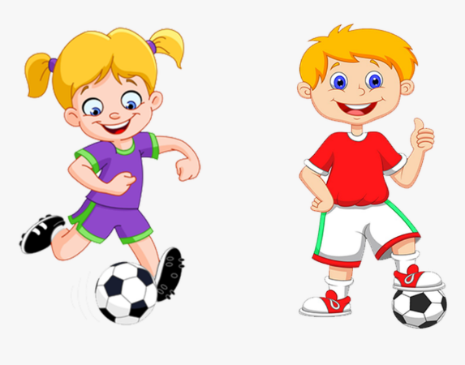
- Hand Bag Game
- Quizes
- Music
- And much more!

Please bring a plate of food
P1 & P2 Class – Bairns Savoury Food
P3 & P4 Class – Bairns Sweet
P5 & P6 Class – Grown-up Savoury Food
P6 & P7 Class – Grown-up Sweet

