PE Home Learning 8/3/23
P6/7 – Volleyball
Watch these highlight clips from Youtube.
The first one shows the 2 player version of the game – Beach Volleyball
https://youtu.be/csWmwDCUM_c

The second shows a full game 6 v 6 on a bigger court.
https://youtu.be/Bgzia3N2mwM

These give you an idea of how quick and complex Volleyball can be at the top level.
As you can see jumping is very important in Volleyball – one of the best ways to improve your jump is Plyometric Exercises – some are pictured below.
Try 10 of each exercise with at least half a minutes rest between each one. The rest is very important as it allows you to complete the exercises at your maximum level.

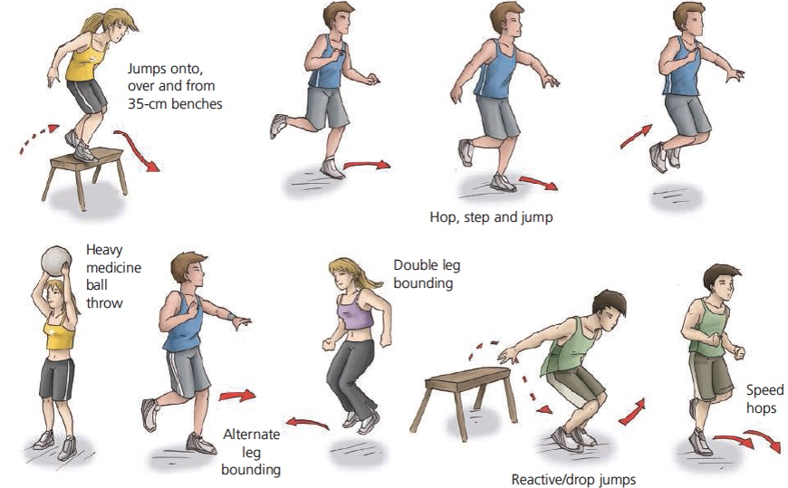
You can use any step or stair – you could even make a snow medicine ball. Miss out any that you think you cannot do safely.
At some point today get out and enjoy the snow! Mr K!

P3/4 – Cricket
Watch this highlight clip from Youtube.
https://youtu.be/rVMHOFVK_R0
You do not need to watch it all, try to watch about 10 minutes, although the end is very exciting!
This will give you an idea of bowling, batting and fielding in the full game.

Ball Skills Warm Up
If you have a small ball at home then use t – if not you can do most of these with a rolled up pair of socks.
We did some of these in class with the rainbow ball.
10 of each.
Throw and catch the ball in your right hand
Throw and catch the ball in your left hand
Throw with your right and catch with your left hand, and back.
Circle the ball round your waist clockwise
Circle the ball round your body anticlockwise
Figure of eight round your legs
Throw the ball up and catch in your t shirt
Throw the ball up and see how mny claps you can complete before catching the ball.
Throw the ball up, let it bounce and catch it between your knees.
If you like you could get someone to time how long each one takes you.

At some point today get outside and get active in the snow! Mr K!

