Below are some further suggested home learning activities shared by class teachers this morning. You should also have the Winter Weather closure grid that was shared before Christmas. Link below will take you to these.
https://blogs.glowscotland.org.uk/sh/hamnavoeprimary/2022/12/13/school-closed-for-snow/
Have a fine day at home,
Kindest regards Mrs Robertson

P1-2
Suggested activities
P2
Place Value Basketball - Dienes Game for 5 to 8 Year Olds (topmarks.co.uk) – for practice with counting up in tens and ones.
P1
Ladybird Spots - Counting, Matching and Ordering game (topmarks.co.uk) – choose matching or ordering for practice
Play in the snow if you can!
You could also take some snow inside in a bowl and time how long it takes to melt for a little science experiment. Write down how long you think it will take (estimate) then how long it actually takes.
If you’d like to do some drawing or writing - draw a picture of something you do today, or write about what the snow feels like.
Have a lovely day,
Mrs Paul
P3-4
Suggested Activities
Good morning Primary 3/4
Below is a range of activities you could try today at home.
Some online links have also been added below.
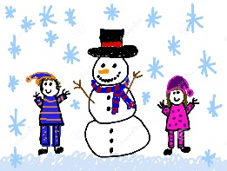  Create a picture to show/or write about what you like best about wintertime. | Make an outdoor Winter picture using outdoor materials like stones and sticks. | 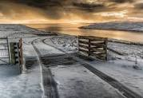  Go for a walk with a grown-up and take a camera to capture some lovely winter photographs.
Build a snowman and take photographs of him to document how he melts. | Get cosy and read some of your favourite books. | 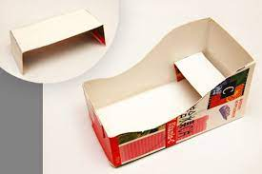  Build a sledge for a small toy using household materials.
Create the perfect winter menu. What would be your ideal meal for the chilly, wintery months? | 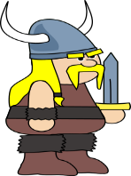  Find out some facts about the Vikings, since we are learning about them in class. | Work on your throwing skills by throwing snowballs at a target.
Online games
Hit the Button - Quick fire maths practise for 6-11 year olds (topmarks.co.uk)
2D and 3D shapes - Topmarks Search
Teach Your Monster: Free Phonics, Reading and Mathematics Games
Education City- https://go.educationcity.com/ (spelling/reading/maths)
(User name and password should be in your homework diary)

Have a fine snowy day! Mrs Mikolajczak

P5-6
Further Suggested activities
Everyone has a new reading book so they can be reading that. Then we’ve been adding measurements (m and cm or cm and mm) so if they can they can find and measure items and add up those lengths. They can also use subtraction to find out how much bigger one item is than another. Everyone also knows which times tables they need to practice so they can learn those too. Timestables.com is a great website for this. It has a test at the end so pupils can see how theya re progressing.
Enjoy the snow!
From Mr Soper
P6-7
I have set a Sumdog challenge for the class.

I would also like them to look at this website for writing inspiration.

https://www.onceuponapicture.co.uk/portfolio_page/above-the-sky/

And then create an imaginative writing piece focusing on the first 6 bullet points to help prompt their thinking. They should apply their learning of imagery, which we worked on last week. This includes similes, metaphors and adjectives to help the reader imagine what’s happening. They can upload into Glow or handwrite it and take it into school tomorrow.

Enjoy the snow from Mrs Malcolmson

