Curriculum Overview – Primary 5/6 - Term 1 2022/23 - Mrs Hunter
Literacy
Listening and Talking
- We are learning about non-verbal techniques when giving presentations. For example; eye contact and body language.
- We can recognise techniques used by a presenter to engage or influence the listener.
Reading
- We are learning how to find, select and use information in a text.
- We can identify the main ideas and purpose of the text.
Writing
- We can use our knowledge of spelling patterns throughout our writing tasks.
- We can use a variety of punctuation accurately when creating pieces of text.
- We are learning how to use paragraphs to separate the main ideas in our writing.
Curriculum links: LIT 2-02a, ENG 2-03a, LIT 2-14a, LIT 2-21a, LIT 2-22a
Numeracy and Mathematics
Numeracy
- We are developing our understanding of addition.
- We are learning mental and written strategies to add up to four digit numbers.
Time
- We are developing our understanding of both analogue and digital clocks. We will learn how to tell the time in 5- minute intervals.
- We will develop skills to solve time problems.
- We will be learning how to tell the time using the 24 hour clock.
Curriculum links: MNU 2-02a, MNU 2-03a, MNU 2-09a. 2-09b, 2-09c, MNU 2-10a
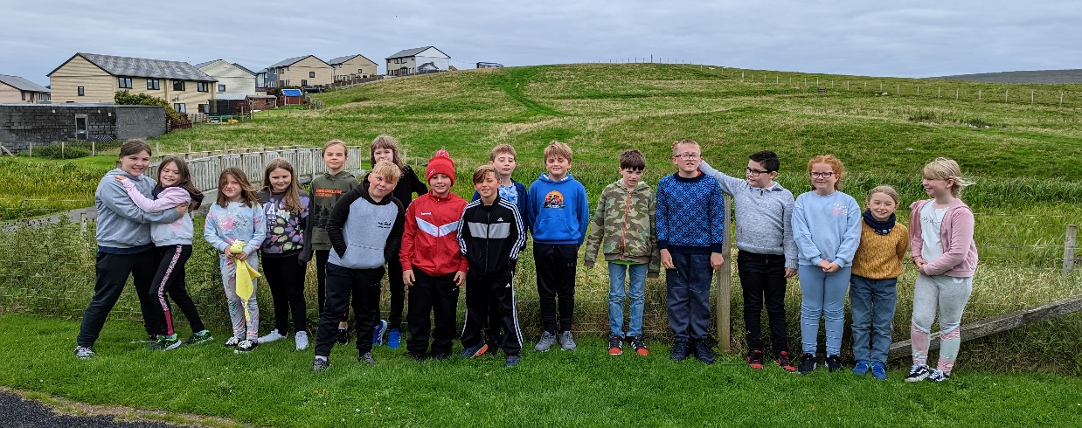
TOPIC: Living things and Animals
Science
- We understand the difference between living and non-living things.
- We know the 7 main features of living things.
- We can classify living into categories through their characteristics.
- We know the difference between vertebrates and invertebrates.
- We understand the lifecycle of the five main types of vertebrates and can compare them.
- We are beginning to be able to construct simple branched keys to identify animals.
- We know the role that the environment plays in the survival or extinction of a species.

- Curriculum links: SCN 2-01a, 2-02a, 2-14a
Expressive Arts
Music
- We will have weekly music lessons with Mrs Pottinger.
Art
- We will have weekly art lessons with Mrs Burr.
P.E
- We will develop our fitness with Mrs Hunter.
- We will develop our team - working skills through Rugby with Mr Kirkness.

Technologies
- We can identify and save files in our own folder in the pool.
- We can save files using an organised filing system.
- We can select appropriate software to complete a task.
- We understand how to stay safe online and what ‘consent’ looks like in terms of technology.
- We are developing our knowledge and understanding of PowerPoint and can create engaging PowerPoints.
Curriculum links: TCH 2-01a, TCH 2-03a
Health & Well-being
- We are learning about Children’s Rights. We understand the terms Children’s Rights and what this means for our daily life.
- We are learning about SHANARRI. We understand that every child has the right to be safe, healthy, achieving, nurtured, active, responsible, respected and included. We know and understand all these terms and can give example of how the adults in school, at home and in our wider community play a role in ensuring our needs are met.

