
Shetland Islands Council

Dunrossness Primary School


Nursery Handbook
2020-21

“Living, Laughing, Learning”

Tel: (01595) 745440
Email: dunrossnessnursery@shetland.gov.uk
Blog: https://blogs.glowscotland.org.uk/sh/dunrossness
The following information will let you know all about our nursery setting as part of Early Learning and Childcare (ELC) in Dunrossness Primary School. We hope that you find this useful and look forward to welcoming you to our school.

Contents
 | Section | Page
1. | Contact Details | 3
2. | Introduction | 4
3. | School Ethos | 8
4. | Staffing | 9
5. | Our Nursery | 11
6. | The School Day and Practical Information | 16
7. | Communication with Parents and Your Child’s Learning Journey | 18
8. | Annual Events and Term Dates | 19
9. | Attendance/Absence, Sickness, Medicines and Allergies | 21
10. | Parental Involvement | 23
11. | Curriculum | 24
12. | Transition into Primary 1 | 26
13. | Concerns and Complaints | 27
14. | Additional Information | 28

PLEASE NOTE:
Some pupils have allergies and we have measures in place to protect pupils. At this time, the nursery is an egg-free environment. Any foods containing egg must not be brought into the nursery.
- Contact Details

Name: Dunrossness Primary School

Address: Dunrossness, Shetland, ZE2 9JG

Telephone: 01595 745440

Website: https://blogs.glowscotland.org.uk/sh/dunrossness/

Email: dunrossness@shetland.gov.uk
dunrossnessnursery@shetland.gov.uk

Stages of education: Nursery/Primary

Roll: Early Years Department: 27
Primary Department: 99

Denominational status: Non-denominational

Headteacher: Ms Andrea Henderson

Principal Teacher: Mrs Louise Leslie

Parent Council Chair: Gemma McClelland
Parent Council email: jimjam58@hotmail.com
Parent Council website: Facebook – Dunrossness Primary School Parent Council

- Introduction

Dunrossness Primary School

Welcome to Dunrossness Primary School! Our school is situated in the South Mainland of Shetland in a rural setting on the east coast of the island. Our catchment area includes the communities of Levenwick, Bigton, Quendale, Boddam and Virkie.

We are fortunate to be set in beautiful countryside with excellent amenities close by. We have wonderful beaches and a variety of places to visit, including Jarlshof, Old Scatness, Sumburgh Lighthouse, Quendale Mill and many more. There is a rich variety of wildlife to be seen in the local environment, including sea birds, otters and if you are lucky you may even spot a whale!

Dunrossness School is proud of our strong relationship with our parents. This handbook provides information for parents for the school year 2020/21. Although the information is believed to be correct it is possible that changes have occurred, or will occur during the year, that will affect the contents for this year or for the following school years.

Due to the ongoing Covid-19 pandemic, we cannot provide a definite picture of what education will look like during this school year. We will keep parents and families up to date through emails and letters.

For further information or clarification, please contact the school and/or look at our school blog at https://blogs.glowscotland.org.uk/sh/dunrossness/. Throughout this handbook, links to websites are provided for further information. Hard copies and different formats of the handbook (for example in Braille or large print) will be made available by request to the school. The handbook for the Primary Department can be found at https://blogs.glowscotland.org.uk/sh/dunrossness/parent-council/school-handbook/2020-dunrossness-school-handbook-doc-1/.

Handbooks for all Shetland Islands Council’s schools can be found on the council’s website.
The direct link is: http://www.shetland.gov.uk/education/SchoolHandbooks.asp.

Dunrossness Nursery (Early Learning and Childcare)

Our nursery setting offers a caring and nurturing environment where children feel safe to be curious and creative, explore and communicate. Much of the learning occurs through play, most of which is child led, where we follow the child’s interests.

The skilled staff in nursery are able to observe the children at play and support and extend their play, sometimes standing back, sometimes intervening to extend or offer ideas. The staff are experienced in planning in the moment and using questioning or suggestions to extend learning. We focus mainly on the learning process, not the product. There are also some adult led play activities and areas set up to help children practise a skill or develop ideas.

Many of the ideas for learning come from the children and their current learning needs. We may utilise broad themes, supporting children to connect learning experiences. For example, colours or seasonal topics such as winter. Much of the learning is planned using a cross-curricular approach to help ensure meaning and relevance and to give fun and enjoyment and is led by the children’s interests, creativity and curiosity. The nursery is very much part of the school and the children have many opportunities to become used to the whole school building and the wider school community.

Playing outside is fun, exciting and important for children’s leaning and development. We encourage children to develop a greater interest in the natural environment so we spend time outdoors on a daily basis, and in all weathers. The staff will observe, support and extend children’s play in the same way they would inside.

Staff are available daily and are delighted to answer any questions or concerns you may have.

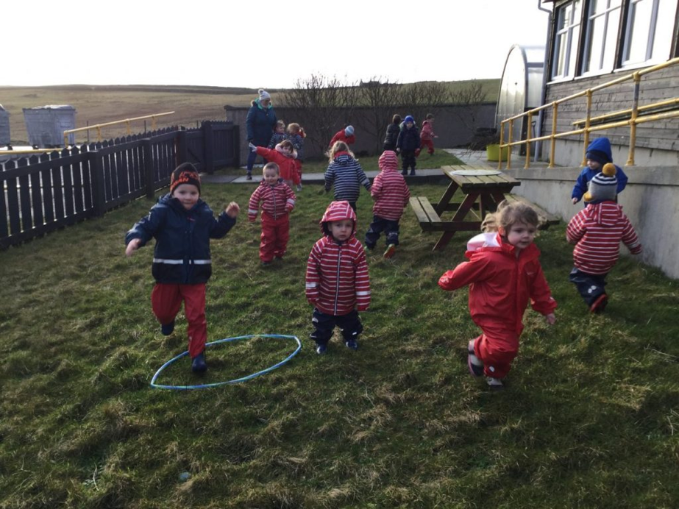

When will my child start Nursery?

Children are enrolled into the Dunrossness Nursery setting using the SIC Education Service admission policy. After enrolling your child, you will be contacted at home to arrange a ‘home visit’, if you wish. Staff members will bring with them registration forms, an ‘All About Me’ booklet to be filled in by parents and children, tooth brushing consent and other relevant paperwork. This visit gives staff, children and parents a chance to develop relationships; please use this time to share a little more about your child’s development. If your child has any special requirements for snack or allergies, please also let us know and any worries about toileting can be discussed so they can be sensitively handled. At this meeting you and your child will then be invited to visit the setting in the weeks before they are due to start. We have a relaxed induction programme, and sessions can be built up gradually as and when children are ready.

We want to make sure that your child’s time in at Dunrossness is a happy, safe and enjoyable experience from the beginning. Some children settle quickly while others take longer to gain confidence. We get to know our pupils well as individuals and as learners, learning about their strengths and building on them. Staff and parents work together in partnership, sharing this important stage of your child’s development. Parents can stay initially with their child when they are settling in, with the time the child is able to spend on their own being gradually extended until the child stays for the whole session. Staff will advise you on this and will take the best approach to suit your family.

The Scottish Government has set out a vision to extend the Early Learning and Childcare (ELC) entitlement from 600 hours to 1140 hours per year, by 2020. Dunrossness ELC setting has been chosen as a test setting for this 1140 hours proposal, with the aim of providing a more flexible model of Early Years provision within a local authority setting, which fully meets the developmental and care needs of the children. This equates to 30 hours per week and our daily provision starts at 8:15am until 4:15pm, with a protected session for lunch 11:45am – 1:15pm, with no collection or drop offs during this time.

We offer a great degree of flexibility, but in order to make Nursery operationally manageable, we ask that you adhere to the times you have set. This enables us to plan the best provision for the children in the setting. We support those who build up their sessions gradually. If you wish to make a change to your child’s hours, you should email elc@shetland.gov.uk who will check if this is possible and get back to you as well as informing the nursery. Please discuss with nursery staff if you are unsure.

Any additional hours required after funded places are allocated may be available to parents at a cost, to be discussed with the Early Years QIO, Hayfield. It is also possible to divide your 30 funded hours between the ELC and your childminder; again, this must be discussed and agreed with the Early Years QIO prior to starting at Dunrossness.

You are under no obligation to send your child for the full entitlement and this can be discussed with the ELC staff and/or at a home visit.

The start date for each child is dependent on their date of birth:

Birthday | Nursery Start Date
1 March until start of new school year (August) | Start of Term 1 of the upcoming school year (August)  Children who attain their third birthday after 28th February will be eligible to come to Nursery the following school year (August), still allowing two full years of Nursery provision.
After start of new school year until 28 February | The day after the child’s 3rd birthday or an agreed date within a month of the child’s 3rd birthday.

- School Ethos
Living Laughing Learning
A caring, happy school that nurtures, encourages and supports every individual to Determinedly Pursue Success in all areas of their lives.

Values Kindness Happiness Honesty Fun Respect Patience Responsibility

Aims
- To provide a safe, happy and healthy learning environment where mutual respect is shown
- To promote independence, resilience and responsibility and develop skills for life;
- To encourage, motivate and support curiosity, creativity and feel free to experiment and learn from our mistakes;
- To inspire, recognise and celebrate effort, success and achievement;
- To foster cooperation, connections, responsibility to others and a thoughtful global outlook at the heart of our local community.

Behaviour Blueprint
Staff and pupils have worked together to make our ‘Behaviour Blueprint’ which applies across the whole school. The adults and children follow the same rules!

Our Rules

- Ready
- Respectful
- Safe
Adult Behaviour
- We meet and greet you at the door.
- We are calm and consistent with high expectations for all.
- We display the behaviour we want to see.
Behaviours to strive towards
- Good manners – all the time
- Kindness
- 100% effort in everything you do
- Move calmly through the school

- Staffing in the Nursery Department

Who’s who?

 |  |  | 
Mrs Andrea Henderson  Head Teacher | Mrs Louise Leslie  Principal Teacher/  ASN Teacher | Mrs Kathleen Mullay  Nursery Teacher | Mrs Sadie Meadows  Senior Practitioner
 |  |  | 
Mrs Amy Colvin  Practitioner | Mrs Leona Smith  Practitioner | Miss Curstaidh Mackay  Practitioner/Support Worker | Mrs Jay Dutch  Support Worker
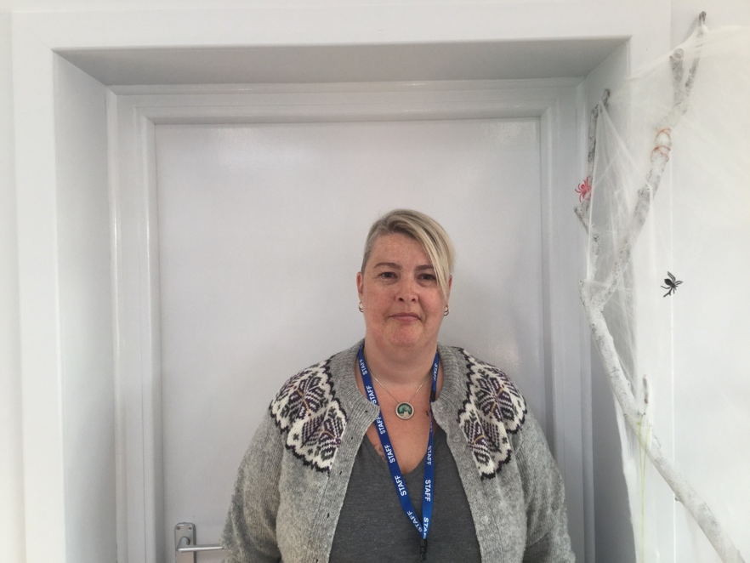 | 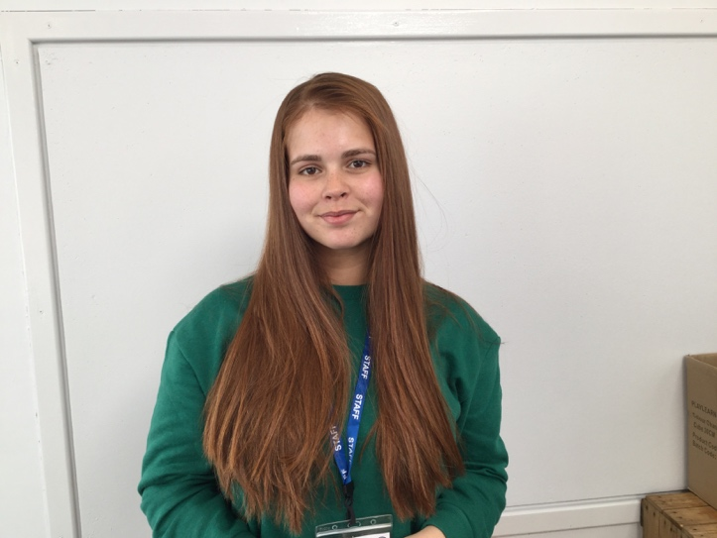 |  | 
Mrs Amanda Fraser  Support Worker | Miss Ella Roberts  Modern Apprentice | Mr John MacKenzie  Head Janitor | Miss Jackie Bishop  Clerical Assistant

Miss Katherine Henderson
Canteen Staff
Other School Staff

Primary
Primary 1/2 Mrs Valerie Inkster
Primary 2/3 Mrs Helen Moar
Primary 4/5 Mrs Kim Wells
Primary 5/6 Mrs Fiona Henderson/Mrs Brenda Smith
Primary 7 Ms Gina Scanlan

Support Staff
Learning Support Assistant Ms Linda Hughson
Learning Support Worker Mrs Emma Graydon
Learning Support Worker Mrs Anna Mainland
Learning Support Worker Ms Linda Hughson
Learning Support Worker PEF Funded Post – TBC
Playground Supervisor Ms Michelle Leybourne
Admin Assistant Mrs Jackie Jamieson
Clerical Assistant Miss Jackie Bishop
Janitor Mr John Mackenzie

Visiting Teachers and Instructors
Physical Education Mrs Joan Smith
Music Mrs Jeanna Inkster
Art Ms Fiona Burr
Piano Mrs Moira Peterson
Woodwind Mrs Sue Briggs
Traditional Fiddle Ms Eunice Henderson
Lower Strings Mrs Annalie Irvine
Accordion Mr Peter Wood
Guitar Mr Arthur Nicolson

Canteen Staff
Head Cook Mrs Donna-Louise Duncan
Canteen Staff Miss Katherine Henderson
Canteen Staff Mrs Marina Smith
Canteen Staff Vacant Post
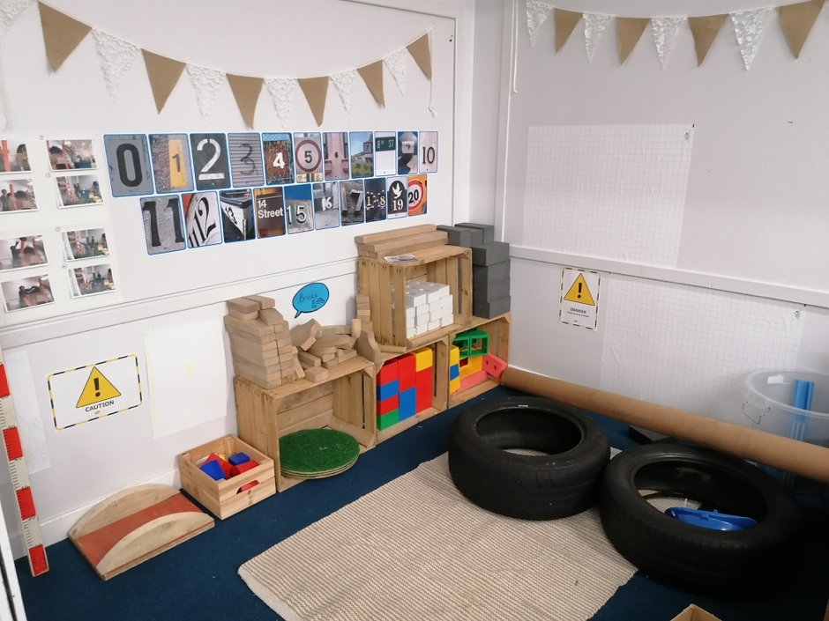
- Our Nursery

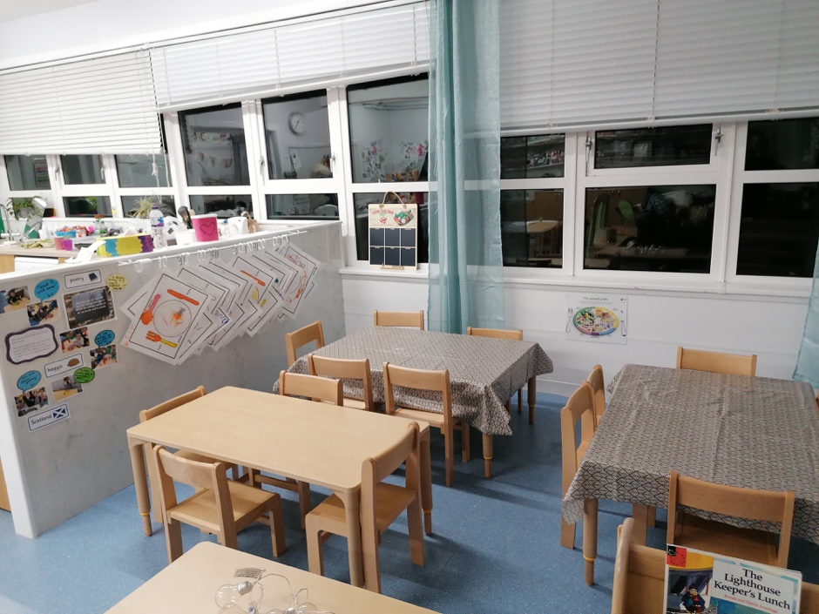
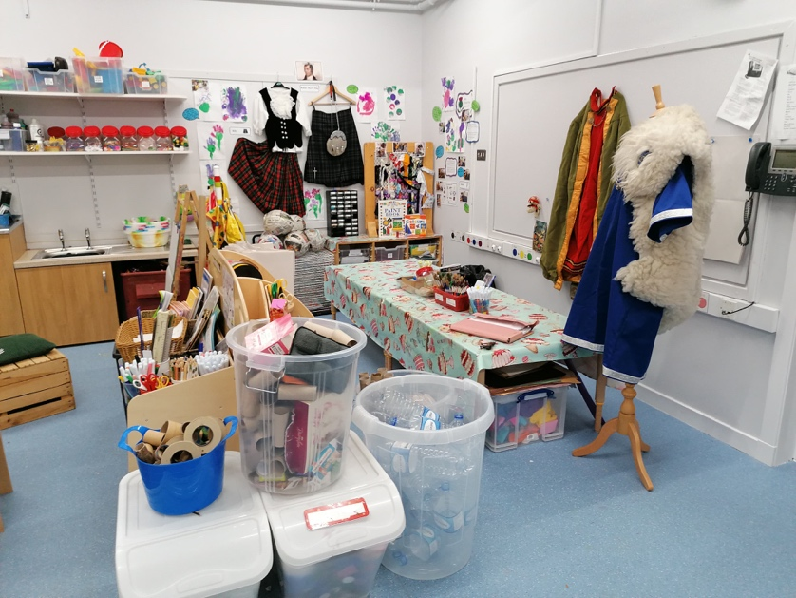
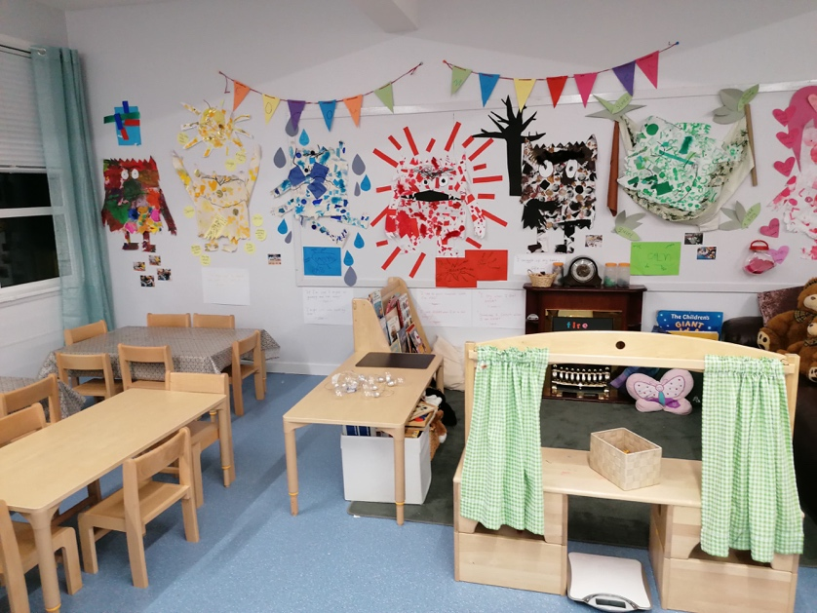
We use a variety of play resources and natural materials.
We enjoy eating together and have a ‘rolling lunchtime’ which gives pupils some choice over when to eat if they are absorbed in a play activity.
It’s okay to take resources from one area of the nursery to another!
We like to play with open ended resources to help children create their own play ideas.
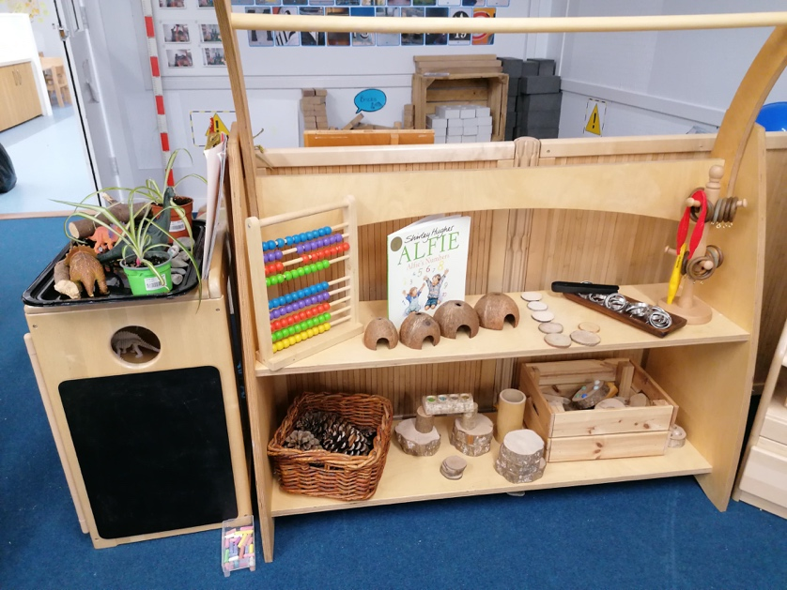
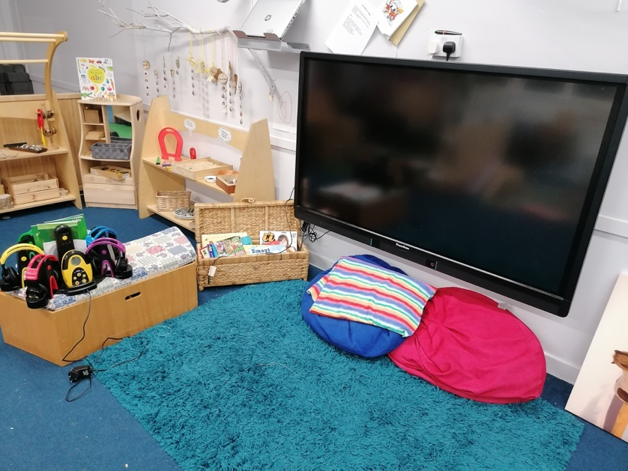
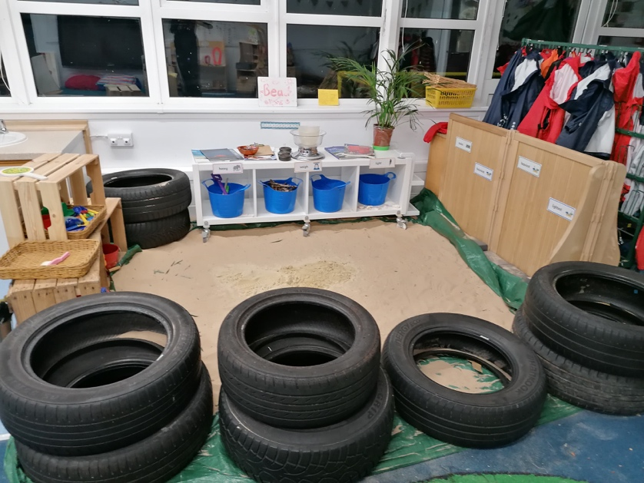
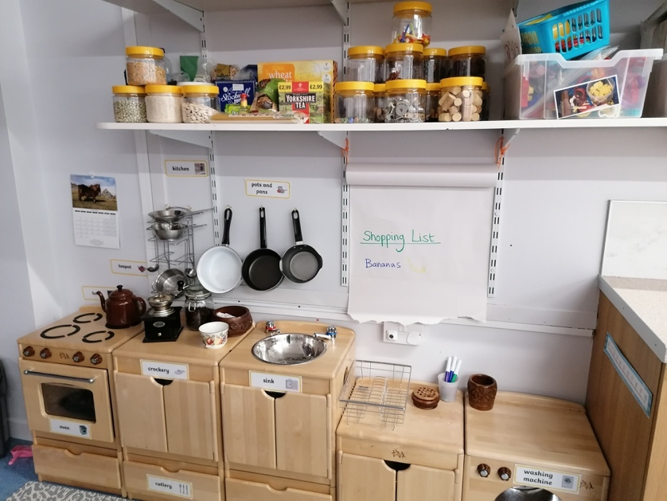
We love imaginative play – tell us what you’re interested in and we can help you find resources to extend your learning.
There are several quiet and cosy corners in nursery if you just want some chill out time!
We use technologies in a variety of ways.
Sometimes our play might get messy! That’s okay – it’s all about learning about risks, consequences and the world around us, exploring all our senses.

Here are some areas we explore regularly and

view as an extension of our nursery!

The Nursery Playground
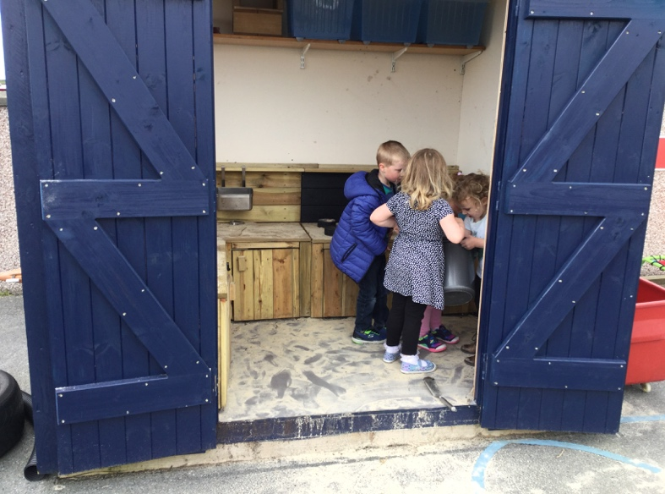

As the bairns grow their interests and needs change, therefore the nursery is continuously changing too. The bairns are fully involved; leaders in decision making, planning, building and evaluating.

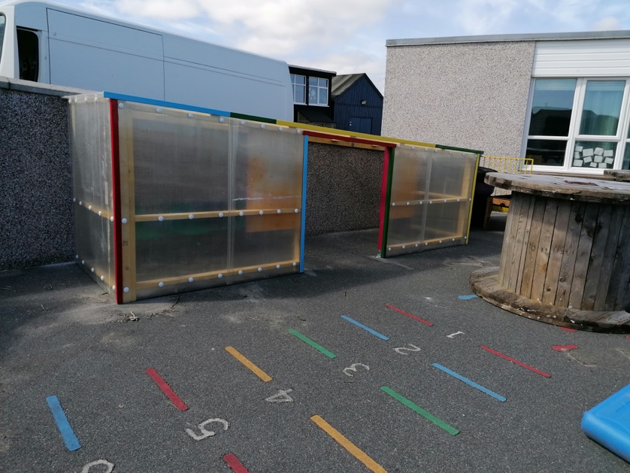
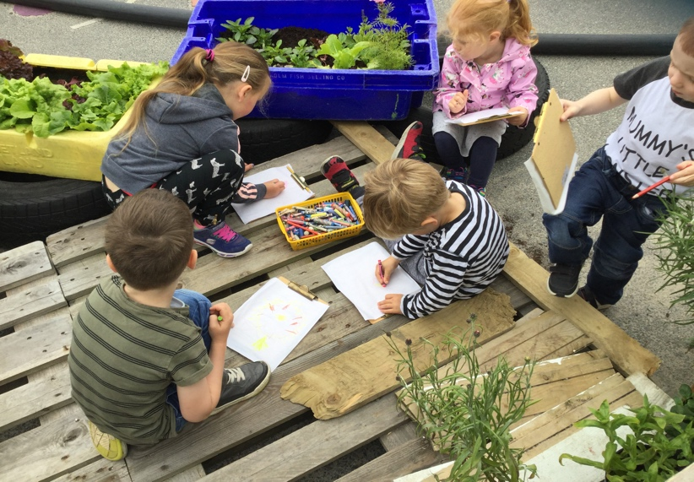
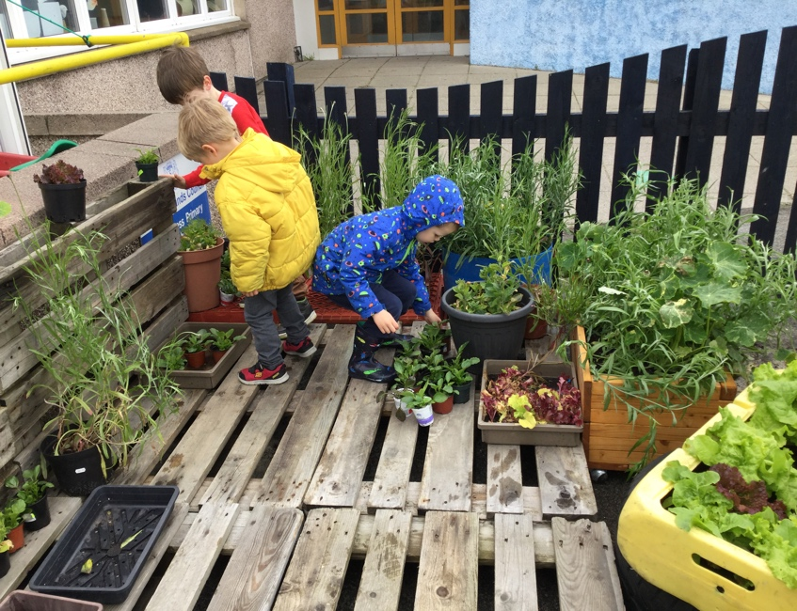
Playground shelter

Mud kitchen

Homemade garden

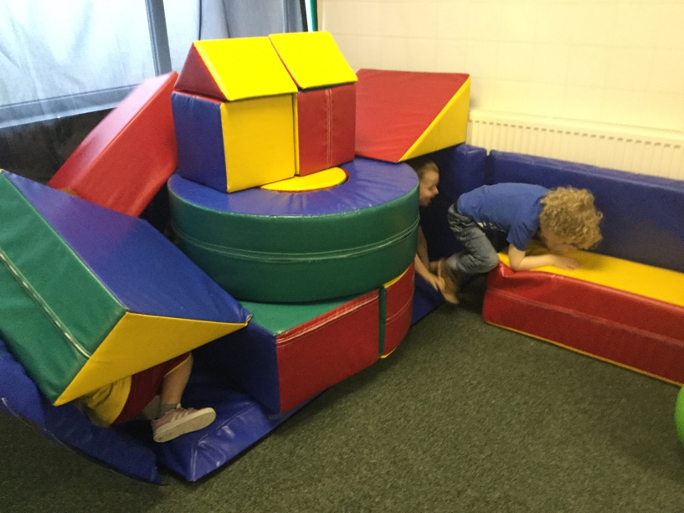
The Pool Room
We have soft play, a climbing frame and other toys here. There is space to run around and is a great change of scenery especially when we cannot get outside.

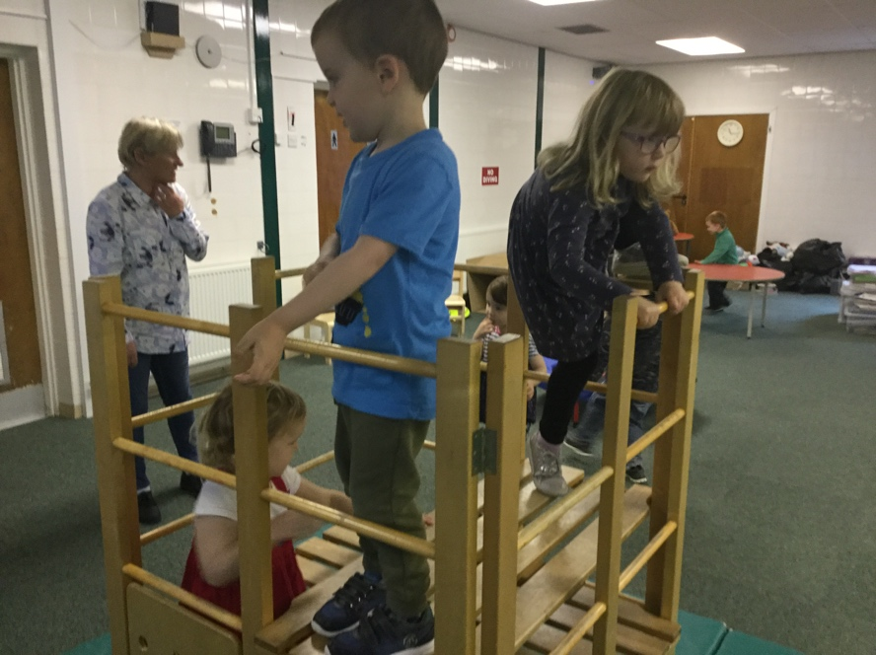

The ‘Big’ Playground

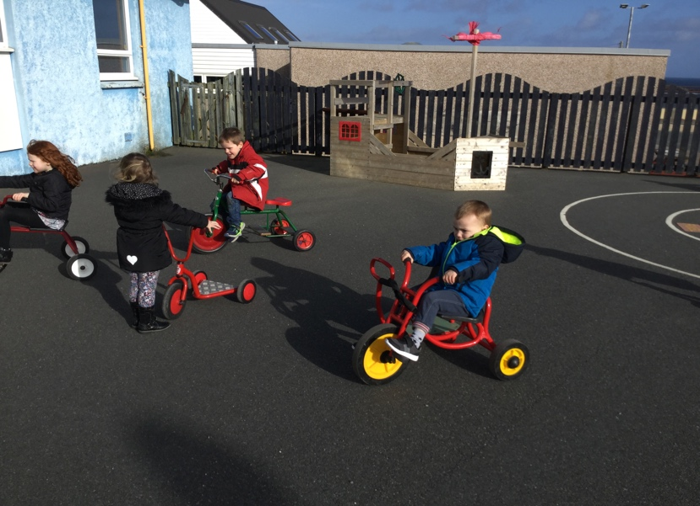

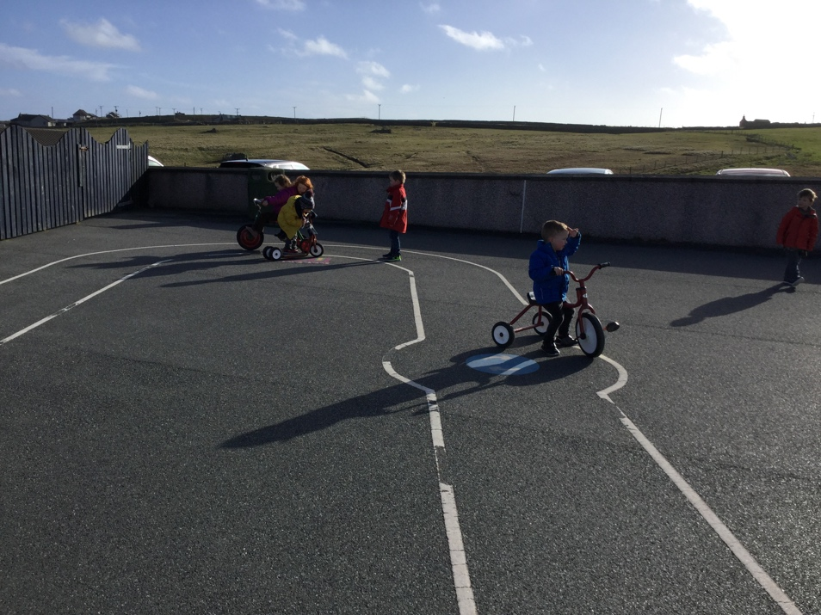

We often use other playgrounds around

the school and take our bikes and scooters out.

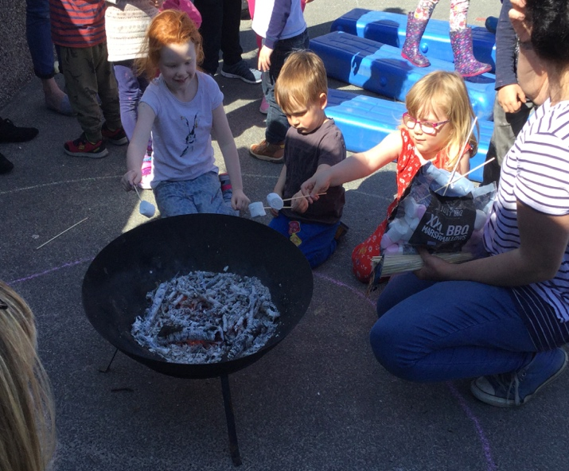
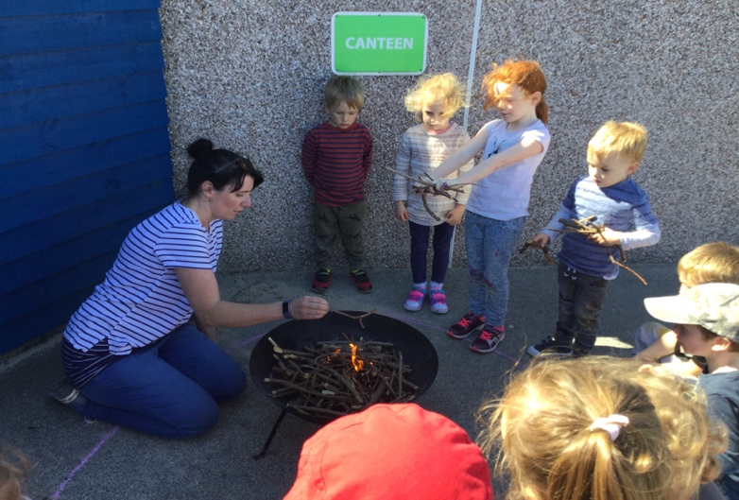

Fire pit and toasting marshmallows!

The Pond

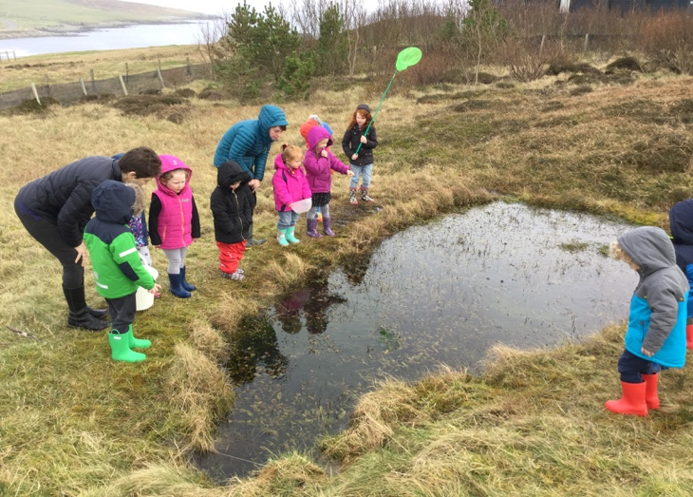
We get to learn about the life cycle of a frog up close!

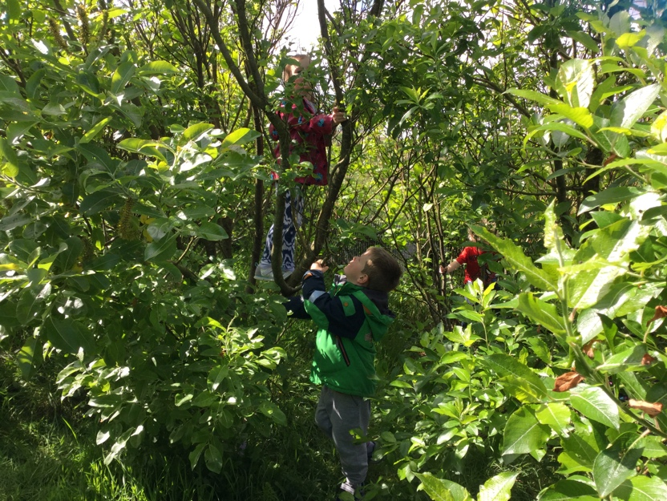

The Forest!

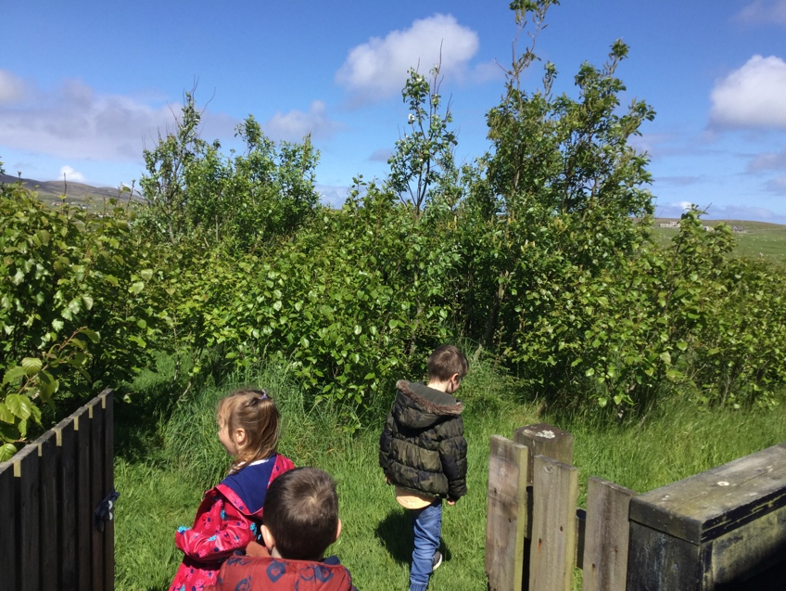

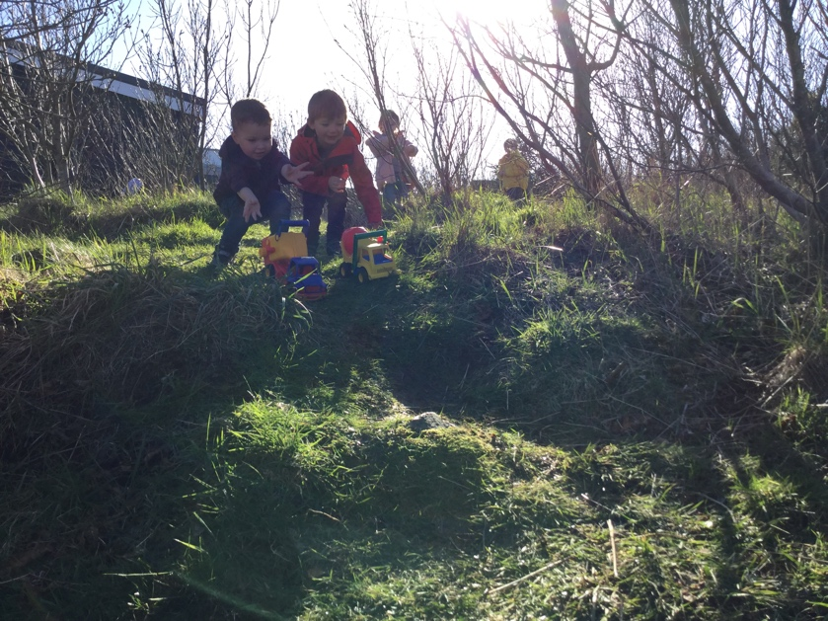

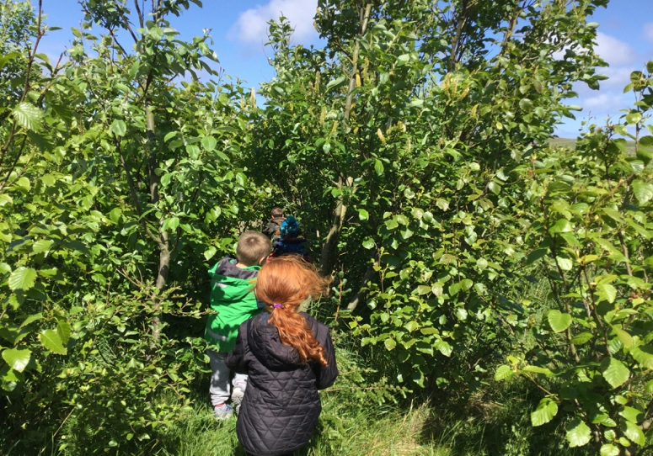

- The School Day and Practical Information

Transport

Parents are responsible for taking their child to and from nursery. No additional transport is provided. If a family is having financial or physical problems in doing this then help may be available from the Shetland Childcare Partnership.

The safety of children on the way to and from nursery is the responsibility of the parent or guardian. Children must be accompanied in to and collected from nursery by an adult. Upon arriving/leaving nursery, the “Signing in/out” sheet must be filled in. Please ensure full names are noted (mum/dad/grandparent etc can be written next to the persons full name if you wish). Staff should be informed if someone else is picking up your child. Staff will not release any child to someone who is unknown to us so please ensure we know of any alternative arrangements you make prior to the end of the session in question.

Clothing

It is a good idea to put on clothes that your child can manage independently for going to the toilet. Please send your child in clothes that can get dirty or wet as there are many messy and creative activities on offer every day. Please bring a bag with spare clothing, clearly labelled with your child’s name.

Equipment

In addition to the equipment provided within the unit, we ask that you equip your child with the following:

- Suitable outdoor clothing and footwear: where possible, this should be in school every day to allow for outdoor play in most weathers.
- Suitable indoor footwear: with the increased hours we are aware some children may be in for most of the day and therefore we are happy for children to bring in slippers to wear, if they find it more comfortable. However, we do ask that children do not wear crocs to nursery, due to safety reasons.
- Nappy changing items: if your child requires, we have full changing and nappy disposal facilities available. Please provide suitable nappies and wipes for your child.
- P.E kit: this should include shorts and plimsolls. These can be left in school.

Please make sure that all clothing is clearly marked with your child’s name. Thank you!

Please do not bring expensive or very special toys, which may be lost or damaged, as the school cannot be responsible. It is school policy that no toy guns or weapons are permitted. Your child will have a tray allocated to them and we ask that any toys brought in can fit in this tray for safe keeping. If your child requires a particular toy/item to aid their transition into nursery, please discuss with nursery staff.

Snack/Milk

Snack is now free.

Fresh fruit or vegetables, along with a variety of other foods, are offered as part of snack every day. All children are encouraged to take part in snack time and to try the range of food on offer, and are invited to help to create the menu and shop for snack. Snack times are approximately 10:00-10:30am and 2:30-3:00pm. Water is available at all times. Both milk and water are available at morning and afternoon snack time. Children are encouraged to pour their own drink and to wash up their own dishes.

Lunch

School lunches are now free for nursery pupils.

School lunch is available to nursery children who are staying in the setting over the protected lunch time period 11:45am – 1:00pm. Lunch is served at 12:00pm.

If you wish to provide your child with a packed lunch from home, there is a designated area for parents/carers to leave their child’s lunchbox on arrival and staff will then transfer them to the fridge if required. Please ensure your child’s lunch box and water bottle (if they have one) are labelled with your child’s name and are placed in the “Lunchbox Box” situated outside the nursery door.

Following guidelines given for pack lunches from the Care Inspectorate, children will unpack their own lunch box onto a plate. The children are encouraged to pour their own drinks into a glass at lunch time including if they have brought their own water bottle. If providing a drink, we ask that this is milk or water. Cups and water are provided at the table. We would also like to ask that any grapes and cherry tomatoes are cut into halves/quarters and that nuts are chopped into smaller pieces for your child’s safety.

- Communication with Parents and Your Child’s Learning Journey

Personal Care Plans
It is an expectation within the Health and Social Care Standards (Care Inspectorate) that each child in nursery has a personal care plan with input from parents/carers and staff. These plans are in place to meet the health, welfare and safety needs of each child in the setting. Personal Care Plans should be completed by both parents/carers and Early Years Practitioners within 28 days of the child beginning to attend the setting. These must be reviewed as and when required and updated with parents/carers at least every six months.

Learning Journals
We use an online platform called ‘Learning Journals’ to share your child’s learning journey with you. Your child will have their own online profile to which both staff and parents can add text and photos/videos to record learning. In nursery, our main form of assessment of learning is by observing children in their play. Staff will write ‘observations’ which demonstrate learning and will be shared with you via Learning Journals. Observations are linked to the curriculum and over the course of the year will give an insight into a child’s progress in their learning. Children will have a ‘focus week’ three times per year, when staff particularly observe play across the curriculum and in a variety of nursery activities. You will be invited to contribute your insights from home into your child’s learning journey, too, via a form provided to you ahead of your child’s focus week, but also by uploading ‘Achievements From Home’ onto your child’s Learning Journals profile.

Communication methods
As well as sharing your child’s learning through Learning Journals, there are a variety of ways that staff and parents can communicate.

We have an open-door policy at the nursery – please just ask us if you have any questions, feedback, or want to share information about your child/family. Equally, you may wish to make an appointment with our nursery teacher or senior practitioner if you have any queries or concerns. The daily feedback you receive is the main form of reporting in nursery. We aim to talk to each parent/carer daily to pass on or receive information. You will have the opportunity to attend an informal Parents’ Evening to view your child’s work and progress in Term 4. We would be pleased to arrange an informal chat to discuss any questions, concerns, feedback or ideas you may have as they arise.

The school is also contactable by telephone or email; see Section 1 – Contact Details.

At various times throughout the year, we will share information via letters/forms which will be placed in your child’s tray – please check this each time you collect your child. Some correspondence may be emailed to you, and there is also a Messaging option within Learning Journals.
- Annual Events and Term Dates

Annual Events

There are a range of annual events at Dunrossness Primary School, some of which are specifically for nursery and others which incorporate the whole school and community.

We do not have set dates for the session 2020-21 as yet, but will send out information as and when events are confirmed. Annual events involving nursery usually include a Christmas performance, Christmas party, SMUHA, a range of nursery ‘Stay and Play’ sessions, open days, Sports Day, Nursery Graduation, class trips and school fundraising events such as the Coffee Morning.

Funding for Christmas parties, special events, trips out and special items of equipment is raised through a variety of fundraising events and enterprises. This is supplemented by donations and funding from other miscellaneous sources. We will call on you from time to time to help out at these events and/or donate homebakes or items for raffles, tombolas, sales, etc. Any ideas you have for raising funds would be very welcome as we will need to self-fund more of our activities in the future as Council budgets are tightened.

Term Dates

The dates overleaf are true at the time of printing but may be subject to change. The new school year commences on Wednesday 18th August 2021.

Term dates for the current and forthcoming school years can be found on Shetland Islands Council’s website.
The direct link is: http://www.shetland.gov.uk/education/term_dates.asp

There are a total of five occasional holidays throughout the year, four of which are decided by central service and one floating day to be set by schools within their clusters, in consultation with Parent Councils; this date is still to be confirmed.

August 2020 |  |  |  |  |  |  |  | September 2020 |  |  |  |  |  |  |  | October 2020
Mo | Tu | We | Th | Fr | Sa | Su |  | Mo | Tu | We | Th | Fr | Sa | Su |  | Mo | Tu | We | Th | Fr | Sa | Su
 |  |  |  |  | 1 | 2 |  |  | 1 | 2 | 3 | 4 | 5 | 6 |  |  |  |  | 1 | 2 | 3 | 4
3 | 4 | 5 | 6 | 7 | 8 | 9 |  | 7 | 8 | 9 | 10 | 11 | 12 | 13 |  | 5 | 6 | 7 | 8 | 9 | 10 | 11
10 | 11 | 12 | 13 | 14 | 15 | 16 |  | 14 | 15 | 16 | 17 | 18 | 19 | 20 |  | 12 | 13 | 14 | 15 | 16 | 17 | 18
17 | 18 | 19 | 20 | 21 | 22 | 23 |  | 21 | 22 | 23 | 24 | 25 | 26 | 27 |  | 19 | 20 | 21 | 22 | 23 | 24 | 25
24 | 25 | 26 | 27 | 28 | 29 | 30 |  | 28 | 29 | 30 |  |  |  |  |  | 26 | 27 | 28 | 29 | 30 | 31
31
November 2020 |  |  |  |  |  |  |  | December 2020 |  |  |  |  |  |  |  | January 2021
Mo | Tu | We | Th | Fr | Sa | Su |  | Mo | Tu | We | Th | Fr | Sa | Su |  | Mo | Tu | We | Th | Fr | Sa | Su
 |  |  |  |  |  | 1 |  |  | 1 | 2 | 3 | 4 | 5 | 6 |  |  |  |  |  | 1 | 2 | 3
2 | 3 | 4 | 5 | 6 | 7 | 8 |  | 7 | 8 | 9 | 10 | 11 | 12 | 13 |  | 4 | 5 | 6 | 7 | 8 | 9 | 10
9 | 10 | 11 | 12 | 13 | 14 | 15 |  | 14 | 15 | 16 | 17 | 18 | 19 | 20 |  | 11 | 12 | 13 | 14 | 15 | 16 | 17
16 | 17 | 18 | 19 | 20 | 21 | 22 |  | 21 | 22 | 23 | 24 | 25 | 26 | 27 |  | 18 | 19 | 20 | 21 | 22 | 23 | 24
23 | 24 | 25 | 26 | 27 | 28 | 29 |  | 28 | 29 | 30 | 31 |  |  |  |  | 25 | 26 | 27 | 28 | 29 | 30 | 31
30
February 2021 |  |  |  |  |  |  |  | March 2021 |  |  |  |  |  |  |  | April 2021
Mo | Tu | We | Th | Fr | Sa | Su |  | Mo | Tu | We | Th | Fr | Sa | Su |  | Mo | Tu | We | Th | Fr | Sa | Su
1 | 2 | 3 | 4 | 5 | 6 | 7 |  | 1 | 2 | 3 | 4 | 5 | 6 | 7 |  |  |  |  | 1 | 2 | 3 | 4
8 | 9 | 10 | 11 | 12 | 13 | 14 |  | 8 | 9 | 10 | 11 | 12 | 13 | 14 |  | 5 | 6 | 7 | 8 | 9 | 10 | 11
15 | 16 | 17 | 18 | 19 | 20 | 21 |  | 15 | 16 | 17 | 18 | 19 | 20 | 21 |  | 12 | 13 | 14 | 15 | 16 | 17 | 18
22 | 23 | 24 | 25 | 26 | 27 | 28 |  | 22 | 23 | 24 | 25 | 26 | 27 | 28 |  | 19 | 20 | 21 | 22 | 23 | 24 | 25
 |  |  |  |  |  |  |  | 29 | 30 | 31 |  |  |  |  |  | 26 | 27 | 28 | 29 | 30
May 2021 |  |  |  |  |  |  |  | June 2021 |  |  |  |  |  |  |  | July 2021
Mo | Tu | We | Th | Fr | Sa | Su |  | Mo | Tu | We | Th | Fr | Sa | Su |  | Mo | Tu | We | Th | Fr | Sa | Su
 |  |  |  |  | 1 | 2 |  |  | 1 | 2 | 3 | 4 | 5 | 6 |  |  |  |  | 1 | 2 | 3 | 4
3 | 4 | 5 | 6 | 7 | 8 | 9 |  | 7 | 8 | 9 | 10 | 11 | 12 | 13 |  | 5 | 6 | 7 | 8 | 9 | 10 | 11
10 | 11 | 12 | 13 | 14 | 15 | 16 |  | 14 | 15 | 16 | 17 | 18 | 19 | 20 |  | 12 | 13 | 14 | 15 | 16 | 17 | 18
17 | 18 | 19 | 20 | 21 | 22 | 23 |  | 21 | 22 | 23 | 24 | 25 | 26 | 27 |  | 19 | 20 | 21 | 22 | 23 | 24 | 25
24 | 25 | 26 | 27 | 28 | 29 | 30 |  | 28 | 29 | 30 |  |  |  |  |  | 26 | 27 | 28 | 29 | 30
31

School Holidays In-Service Days – school closed to pupils Occasional Holidays

- Attendance/Absence, Sickness, Medicines and Allergies

Absences

It would be extremely helpful if you could inform nursery if your child will not be attending so as the sessions activities are not affected. If your child is due to have a school lunch and is absent please phone the school office by 9.30am to inform them.

Early Closing And Urgent Communications
Sometimes, in periods of severe weather, decisions have to be taken to close schools to ensure the safety of pupils. Conditions may arise when it becomes necessary to send the children home during the school day without delay. For this and other reasons, it is important that information on emergency contacts for all pupils is kept up to date.

Parents are reminded that it is their decision whether or not they feel it is safe for their family to travel to school during severe weather conditions, if it is open for pupils.

Illness in School

If your child has taken ill, we will try to contact you if he/she needs to be sent home. We ask that you provide the phone number of a grandparent, relative, friend or neighbour for us to contact if need be, in case of emergency or accident. It is important to keep us informed if you and your emergency contact are both going to be away and for you to have a contingency plan in place which you have shared with us.

Please keep the school informed of any change of address, telephone number and your work phone number. This will help speed up the time taken to contact you in the case of an emergency.

Sickness and Diarrhoea

Children suffering from this should remain at home until fully recovered. Children should not return until 48 hours after the symptoms have ceased to help prevent distress and the further spread of infection, which is particularly important to protect vulnerable people. Please see our Pupil Illness Policy on the school website for more details.

Allergies

It is vital that we are informed of any food or medical allergies that your child may have. Please do this on the official registration form.

Medicines

Medicine is best administered to your child at home. If, however, it is essential that your child should receive medicine in school, please contact the Nursery so that arrangements can be made to administer medicines.

PLEASE NOTE: A medical consent form must be completed and signed by parents before administration. We are not permitted to administer the first dose of a new medicine to your child; this must be done by a parent. Medicine must come in the original packaging with dosage instructions. Medicine prescribed by a doctor must come in the original packaging including a prescription label detailing the child’s name, name of medicine, dosage and date prescribed. If these are not in place, staff will be unable to administer medication. A medical consent form is included in your pack and are available on the school website or from the school office. It should be noted that no member of staff can be held responsible for the safety of medicine in the classroom.

Sun Screen

Please apply sun screen to your child before they attend nursery and indicate this on the signing in sheet. There is a consent form within your start pack, please fill this out and return it to us so we can reapply sun screen when required.

PLEASE NOTE: During the Covid-19 pandemic, we are currently unable to apply sun screen to your child. Please ensure this is applied before your child comes to nursery. Our current nursery sun screen is: Garnier Ambre Solaire, Kids Sensitive Advanced, SPF 50+, 3* UVA. Please inform a member of staff if your child cannot use this type. You are welcome to bring in your own sun screen, please let a member of staff know if you choose to do this.

- Parental Involvement

The role of family is of the utmost importance in your child’s learning, development and wellbeing. We aim to build strong relationships between nursery and families, meaning that these carry on as the children transition into the primary at Dunrossness. We value and respect the contributions parents make and are respectful of each family’s unique qualities. It is recognised that the outcomes for all children are much better if families are involved with their child’s education, including the early learning and childcare setting. We try to involve families in a variety of ways including encouraging and extending learning from nursery-home and home-nursery. We welcome parental involvement and encourage you to share any skills in the setting. Please do let us know if you would like to share something. Equally, we would like to offer support, for example through family learning opportunities. We would welcome suggestions or requests.

Below are useful websites for resources and ideas to support your child’s development:
- https://bumps2bairns.com/
- https://www.shetland.gov.uk/education/pre_school.asp
- https://www.shetland.gov.uk/childrens_resources/bruce_family_centre_parentingcourses.asp

We work in partnership with other agencies and can support you or your child in accessing services you need. For example, we can contact Speech and Language Therapy, Pre-School Home Visiting service, among many others to help meet the needs of your child.

Parent Council
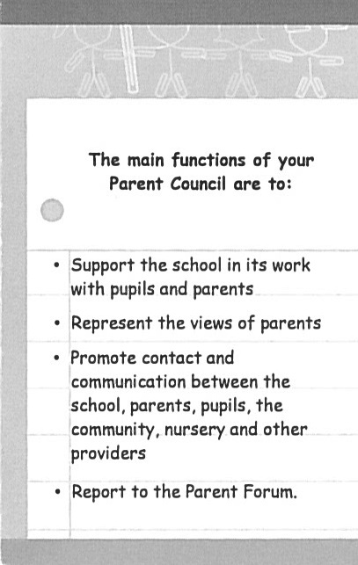
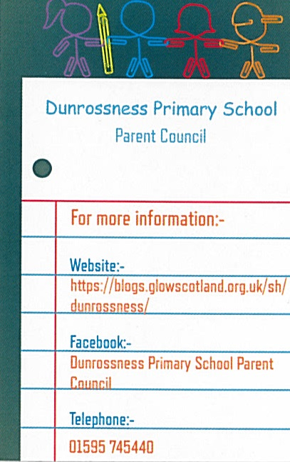
Parents are represented on a Parent Council that meets six times a year to assist in fostering good links between home and school and to develop projects to help children with their learning. We are very fortunate to have such a committed and supportive Parent Council who work hard to help with a variety of projects in the school and in fundraising activities. If you feel this is an area you would like to become involved with, please contact one of the following members.

You can contact the school’s Parent Council directly and/or access information on Education Scotland’s website.
The direct link is: http://www.educationscotland.gov.uk/parentzone/getinvolved/parentcouncils/index.asp
- Curriculum

Overview
The Curriculum for Excellence is followed by all establishments providing education for Scotland’s children and young people. The curriculum is designed to provide a coherent, flexible and enriched curriculum throughout a child’s life from 3 to 18 years old. The curriculum aims to ensure that all children and young people in Scotland develop the knowledge, skills and attributes they will need if they are to flourish in life, learning and work.

Learning Through Play
In their play, children practise and consolidate their learning, play with ideas, experiment, take risks, solve problems and make decisions individually and in small or large groups. The development of children’s self-image and feelings of self–worth and self–esteem are central to this process.

The curriculum within our setting aims to meet the needs of all children including those who are at an early stage of development and those who are more able. The curriculum will be appropriate to the individual child’s needs and stage of learning rather than focussing solely on age-related outcomes to be achieved. Children will be helped to move on to the next stage in their learning when they are developmentally ready and at their own pace.

The Four Capacities
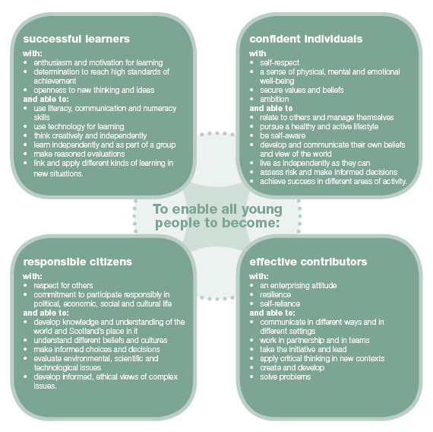
The curriculum in Scotland aims to develop four capacities for successful learning and living. These are:
The Curricular Areas
There are eight curricular areas. These are broken down into statements known as ‘experiences and outcomes’. In nursery, we explore and discover all curricular areas through play:

- Literacy and English
- Numeracy and Mathematics
- Sciences
- Social Studies
- Health and Wellbeing
- Religious and Moral Education
- Expressive Arts
- Technologies

The Curriculum Levels
Curriculum for Excellence defines five levels of learning. The first four levels provide a broad general education, with progression to qualifications described under a fifth level, the senior phase.

Level | Stage
Early | The pre-school years and P1, or later for some.
First | To the end of P4, but earlier or later for some.
Second | To the end of P7, but earlier or later for some.
Third and Fourth | S1 to S3, but earlier for some.
Senior phase | S4 to S6, and college or other means of study.

Under Curriculum for Excellence, everyone involved in education has a responsibility to develop young people’s literacy, numeracy and health and well-being skills across all areas of their learning.

Detailed information about Curriculum for Excellence can be found on Education Scotland’s website. This includes:
- how the curriculum is organised
- the entitlements of every child
- how progress is assessed.
The direct link is: http://www.educationscotland.gov.uk/thecurriculum/index.asp

If you would like more information about Curriculum for Excellence, you can visit https://education.gov.scot/parentzone. If you would like any further information about how the curriculum is delivered at Dunrossness Nursery, please contact the nursery teacher.

- Transition into Primary 1

We aim to prepare our pre-school children for Primary 1 as best we can and therefore offer an extensive transition process inclusive of various experiences for them throughout the year. Most of these will be offered in the mornings, which we hope will help prepare your child for the morning routines of school. Further details will be provided when applicable.

In the terms before starting school we begin to prepare children for the move into Primary 1, aiming to make the transition as smooth as possible. Closer to the end of the pre-school nursery year, children will also get the opportunity to ‘move on’ and experience a day in P1 along with lunch time in the canteen and break time in the playground.

Parents of children whose birthday falls after 28th February and who wish an early admission to P1 should in the first instance discuss this with the Nursery Teacher and Head Teacher. If they wish to proceed they will need to make a formal request in the first instance to the Head of Service who will involve other agencies to help them come to a decision.

Parents of under-age children who have been refused admission into Primary 1 have a right to appeal. Appeals should take the form of Placing Requests and be made, in the first instance, to:

Head of Schools
Children’s Services
Hayfield House
Hayfield Lane
Lerwick
ZE1 0QD

- Concerns or Complaints

Please remember the care and education of your child is a home-nursery partnership and that means communication must be two-way. If there are any problems or issues you wish to discuss, please contact us and we will do our very best to help.

In the event that you have a concern or a complaint about any area of our service, please discuss this in the first instance with the Nursery staff. Should you feel that the complaint is unresolved after this action, you should speak to the Head Teacher, Ms Andrea Henderson. If this does not bring about a suitable conclusion, you can then contact the Quality Improvement Officer for the school. A copy of the full complaints policy is available within the school and in the policy folder.

Schools Service, Hayfield House, Hayfield Lane, Lerwick, Shetland. ZE1 0QD.
Tel: 01595 744000

The School Complaints Procedure can be found on Shetland Islands Council’s website.
The direct link is:
http://www.shetland.gov.uk/education/hpc_complaints_procedure.asp

- Additional Information

Policies

Policies can be found in the school office or our book of Nursery Policies is displayed along with the children’s achievement folders within the Nursery. Please feel free to look through this at any time. Any comments you have to make on these policies will be very welcome.

Policies applicable to all schools across Shetland can be found on Shetland Islands Council’s website. The policies include:
- healthy eating
- bullying
- exclusion
- school trips
- equality and diversity
- adverse weather.
The direct link is:
http://www.shetland.gov.uk/education/policies_guidelines_and_forms.asp

Getting It Right For Every Child (GIRFEC)

In Shetland, we believe that children can be better supported by adults working closely together and sharing important information with each other. This process is known as GIRFEC: getting it right for every child.
Before GIRFEC can be used, consent from the parent of the child and/or the child (depending on the age of the child) is required. The staff asking permission will explain more about what GIRFEC means. Detailed information about the process can be found on Shetland Islands Council’s website.
The direct link is: http://www.shetland.gov.uk/children_and_families/GIRFEC.asp

Child Protection

The security, care and well-being of all our children is our ultimate priority. We have been trained in the use of and follow the agreed Shetland Islands Council Inter-Agency Child Protection Procedures. A copy of these procedures is available for parents online at www.shetland.gov.uk/children_and_families/documents/ChildProtectionProcedures.pdf

Ms Henderson is responsible for Child Protection in our school and will contact the relevant agency in the event of a child protection concern.

It is every child’s right to be cared for and protected from harm. It is every person’s responsibility to make sure that happens. The Shetland Child Protection Committee provides help when there is a need. Their website gives information on how to access that help.
The direct link is: http://www.childprotectionshetland.com

Shetland Islands Council’s website also provides information on our responsibilities towards children and includes where to find help and support.
The direct link is:
http://www.shetland.gov.uk/children_and_families/child_protection.asp

Data Protection

All data held regarding your child will be treated in a strictly confidential manner. As a parent, you are able to access any information held about your child as laid out in our Open Access Policy. If at any time you would like to look through your child’s information folder, please ask a member of staff who will access it for you to look through.

Online Protection

For information about online protection for your child, you may like to look at the Child Exploitation and Online Protection Centre’s website.
The direct link is:
http://www.thinkuknow.co.uk

Financial Help for Parents

Grants are available for clothing. Guidance and an application form can be found on Shetland Islands Council’s website.
The direct link is:
https://www.shetland.gov.uk/education/ClothingGrants.asp

If after reading this handbook, you have any further questions, then please contact us at school and we will be pleased to be of assistance.
