Shetland Islands Council

Dunrossness School
Information Handbook
Living, Laughing, Learning

2021/22

Contact Details | Page 3
Introduction | Page 4
School Staff for 2021/22 | Page 5
Visiting the school | Page 6
School Security | Page 6
The School Day | Page 6
Breakfast Club/Out of school Club | Page 6
Communication | Page 7
Parental Involvement | Page 7
Parents’ Evenings | Page 8
Learner Led Event | Page 8
Progress Report | Page 8
Transitions | Page 8
Early Learning and Childcare | Page 9
Nursery Snack | Page 9
Placing Requests | Page 10
School Ethos | Page 11
Behaviour | Page 12
Our School Rules | Page 12
Community | Page 12
The Curriculum for Excellence | Page 13
Numeracy and Mathematical Development | Page 14
Literacy and Language Development | Page 14
Health and Wellbeing | Page 15
Learning and Teaching | Page 16
Assessment | Page 17
Support for Pupils | Page 18
Getting It Right For Every Child | Page 18
Child Protection | Page 18
School Improvement | Page 19
Focus Fridays | Page 19
Policies | Page 20
Trips | Page 20
Instrument Tuition | Page 20
Religious Observance | Page 20
Concerns | Page 20
Complaints | Page 20
Absence/Sickness | Page 21
First Aid | Page 21
Family Holidays | Page 21
Requests for Leave of Absence | Page 22
Collecting your Child During School Hours | Page 22
School Closure Information | Page 22
Transport | Page 22
Snack Time | Page 23
School Meals | Page 23
Allergies | Page 23
Equipment | Page 23
School Fund | Page 24
Financial Help for Parents | Page 24
Online Protection | Page 24
How Can You Help Prepare Your Child for School? | Appendix 1
School Calendar | Appendix 2

Updated January 2022

Contact Details

Name | Dunrossness Primary School
Address | Dunrossness  Shetland  ZE2 9JG
Telephone | 01595 745440
Website | https://blogs.glowscotland.org.uk/sh/dunrossness/
Email | dunrossness@shetland.gov.uk
Stages of education | Early learning and childcare (nursery) and Primary
Roll | Primary: 99  Early Learning and Childcare: 32
Denominational status | non-denominational
Head teacher | Ms Andrea Henderson
Parent Council Chair | Gemma McClelland
Parent Council Email | jimjam58@hotmail.com

Introduction
Welcome to Dunrossness Primary School! Our school is situated in the South Mainland of Shetland in a rural setting on the east coast of the island. Our catchment area includes the communities of Levenwick, Bigton, Quendale, Boddam and Virkie.
We are fortunate to be set in beautiful countryside with excellent amenities close by. We have wonderful beaches and a variety of places to visit, including Jarlshoff, Old Scatness, Sumburgh Lighthouse, Quendale Mill and many more. There is a rich variety of wildlife to be seen in the local environment, including sea birds, otters and if you are lucky you may even spot a whale!
Dunrossness School is proud of our strong relationship with our parents. This handbook provides information for parents for the school year 2020/21. Although the information is believed to be correct it is possible that changes have occurred, or will occur during the year, that will affect the contents for this year or for the following school years.

Due to the ongoing Covid-19 pandemic, we cannot provide a definite picture of what education will look like during this school year. We will keep parents and families up to date through emails and letters.

For further information or clarification, please contact the school and/or look at our school blog. https://blogs.glowscotland.org.uk/sh/dunrossness/

Throughout this handbook, there are links to websites are provided for further information. Hard copies and different formats of the handbook (for example in Braille or large print) will be made available by request to the school.

Handbooks for all Shetland Islands Council’s schools can be found on the council’s website.
The direct link is: http://www.shetland.gov.uk/education/SchoolHandbooks.asp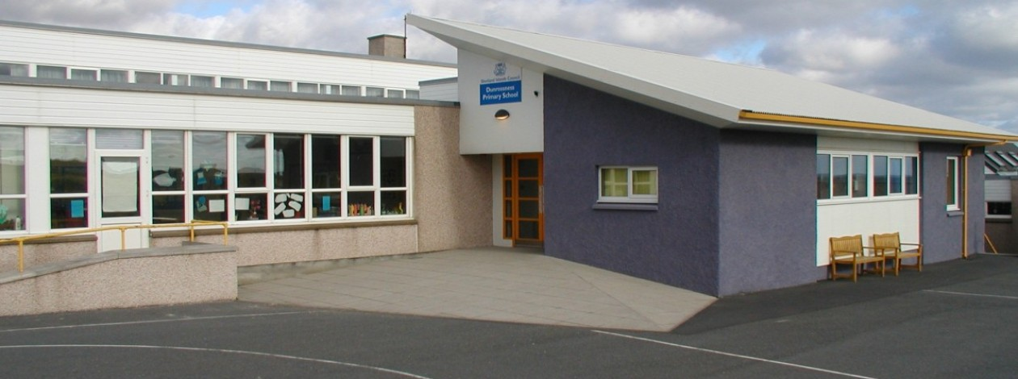

School Staff for 2021-22

Head Teacher | Ms Andrea Henderson
ASN Teacher | Mrs Louise Leslie
Class Teachers
Nursery | Mrs Kathleen Mullay
Primaries 1/2 | Mrs Valerie Inkster
Primaries 2/3/4 | Mrs Helen Moar
Primaries 4/5/6 | Mrs Fiona Henderson/Mrs Brenda Smith
Primaries 6/7 | Mrs Gina Scanlan
Support Staff
Acting Early Years Senior Practitioner | Mrs Jay Dutch
Early Years Practitioners | Mrs Leona Smith  Mrs Amy Colvin
Early Years Support Workers | Miss Ella Roberts
Leaning Support Assistant | Miss Ella Roberts
Learning Support Workers | Mrs Emma Graydon  Mrs Maureen Newlands  Mrs Carrie Morrison  Mrs Amy Colvin
Playground Supervisor | Ms Michelle Leybourne
Admin assistant | Mrs Jackie Jamieson
Clerical Assistant | Mrs Emma Mylett
Head Janitor | Mr John MacKenzie
Visiting Teachers and Instructors
P.E. and Swimming | Mrs Joan Smith
Music | Mrs Jeanna Inkster
Art and Design | Ms Fiona Burr
Piano | Mrs Moira Peterson
Traditional Fiddle | Ms Eunice Henderson
Accordion | Mr Peter Wood
Guitar | Mr Stevie Hook
Lower Strings | Ms Annalie Hayward
Canteen Staff
Head Cook | Mrs Norma Walterson
Mrs Marina Smith
Miss Nicole
Vacant post
Parent Council
Chair | Gemma McClelland
Vice Chair | Kathryn Lomax
Treasurer | Sharon Waddell
Clerk | Emma Mylett

Visiting the school (Temporary restraints due to Covid)
If you are seeking a place for your child, or you have been offered a place, we would be delighted to arrange for you to visit us. We will take you on a tour of the school and will introduce you to the staff members. We are committed to making sure that children are confident and ready to start and can work with you to put in place what your child needs to ensure their move is as straightforward as possible. Please contact the school directly to make arrangements.

School Security
The school has a security system in operation. All external doors are locked whilst pupils are in class. Visitors to the school during class times should use the main entrance and report to the school office where Miss Jackie Bishop will be able to give further help and instructions.

The School Day
School Starts: 9.00
Morning Interval: 10.50 - 11.05
Lunch: 12.55 – 1.40pm
School Closes: 3.00pm

You should make sure your child arrives at school on time. A late start and finding classmates already in class with learning underway can be stressful. It is also good training for the future.

School doors are open to children from 8.45am approximately. Please do not send your child to school before this as supervision cannot be guaranteed.

Children are supervised by Playtime Supervisors during playtimes both inside and out of doors. In fine weather, they are encouraged to play outside, having first put on coats or jackets if necessary. When a parent wishes their child to be kept in at playtimes it is necessary for a note to be written in the child’s school diary giving a reason for this and the duration.

Breakfast Club/ Out of School Club (Temporarily Closed)
We run a Breakfast Club in the mornings from 8am until 8.45am in the Ness Out of School Club room, across in the huts. Our Out of School Club staff run this club and can be contacted through the school office to arrange attendance. As this club runs every day, pre-booking is not essential although it does help with our planning. Children pay £1.00 per day to attend and have an opportunity to enjoy a healthy breakfast and some games with their friends in a supervised setting.

(Temporarily Closed)
The Out of School Club operates in the school huts after school. By prior arrangement, the Out of School Club may open during the school holidays and in-service closure days. It is run by the school through a Play Practitioner, which is currently a vacant post and play support worker, Vacant post. Please contact the school office if you wish to use this service. To ensure the correct staffing ratio, we do need 24 hours advance notice of attendance and of cancellation or charges will be incurred. Obviously if an emergency arises, we will do our very best to accommodate your needs.

Communication (Temporary restraints due to Covid)
Dunrossness School aims to develop effective lines of communication with our parents and we pride ourselves on our open-door policy and welcoming ethos. Routine communication with parents is usually done through diaries, face to face contact, letters, email and via our school blog. Urgent communication may also be necessary through phone calls and radio announcements, in the case of school closure.

If there are events or circumstances which may affect your child’s enjoyment of their school experience such as a poor night’s sleep, a new baby in the family or a family bereavement, please let our staff know. We will treat the matter with absolute confidentiality, and we will be able to support your child with any short- or long-term difficulty or need more effectively – communication is a two-way process.

We will use your child’s diary to communicate with you, so please ensure you look through it every night. We highly recommend you look through your child’s bag every night as we send home several information letters and other forms of paperwork that need your attention. We prefer to email letters to parents and will ask for a suitable email address on our enrolment form. Sometimes children are asked to bring in items connected with topics they are studying (photographs, toys, etc). We welcome parental input in this area, and, if your job, hobbies or pets could help us generate interest in a topic, please let us know and we’ll arrange for you to come in and give the class the benefit of your expertise.

Parental Involvement (Temporary restraints due to Covid)
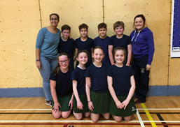
Dunrossness School openly welcomes the involvement of parents in the life and work of the school. This can take many forms, including sharing expertise and experiences in class or at assemblies, helping with extracurricular activities and clubs, supporting school trips and excursions, and fundraising.

We believe that the more involved you are as parents, the more successful your child’s learning experience within the school will be. We regard the fostering and maintenance of good relations between home and school is of vital importance in education. Please see our Reporting Calendar for opportunities to meet with staff and when you will be updated on progress.

At Dunrossness School, we value parents as partners and as such we strive to fully involve parents in their child’s learning. In addition to our ‘open door’ policy, there are several ways parental involvement is promoted. Our plans for developing skills for learning, life and work through themed weeks will enable parents to come into the school to experience learning activities. Special class and school assemblies allow children to demonstrate aspects of their work to their parents. Teacher will post on the class blogs the plans for the coming term. Our formal parents' meetings allow children’s progress to be discussed and provides a platform for parents and teachers to discuss how best to support learning at home.

For further information and resources regarding getting involved with your child’s learning, please contact the school and/or take a look at Parentzone on Education Scotland’s website. The direct link is: https://education.gov.scot/parentzone/

The staff at Dunrossness School actively seek, and take account of, parental views on the education we provide. We welcome feedback and suggestions at any time, on any aspect of the life and work of the school. This can be done by telephone, email or by speaking to any member of staff. We regularly ask for parent’s views on specific areas of our work and each year we undertake a comprehensive audit of views in order to evaluate the school’s performance.

Our school benefits from a very active parent council which represents the views of our parents and plays an important role in supporting the life and work of the school. Up to date information on meetings and minutes of previous meetings can be viewed using the following link:
https://blogs.glowscotland.org.uk/sh/parentcouncil/

You may wish to learn more about the role of the Parent Council in representing your views on education matters. You can contact the school’s Parent Council directly and/or access information on Education Scotland’s website. The direct link is:
https://education.gov.scot/parentzone/getting-involved/parent-councils

Parents' Evenings (Temporary restraints due to Covid)
Parents' Evenings are held in October. An appointment is made to enable parents to have a private interview with class teachers to look over their children's work and discuss progress. These appointments are ten minutes long and times should be strictly adhered to. If a longer appointment is required, please contact the office when you receive your appointment letter. In the Summer Term you will have the chance to make an appointment if required.

Learner Led Event (Temporary restraints due to Covid)
During the month of May, children will prepare for and take the lead in sharing their learning. The children decide who they would like to invite and are also responsible for selecting and sharing pieces of their work, discussing their reasons. This allows the child to share what is important to them. Staff are in attendance and are available to discuss progress with the child and parent/carer. Should you require more time, you can opt to make a separate appointment.

Progress Reports (Temporary restraints due to Covid)
In order to keep you up to date with your children’s progress, we hold Parents’ Evenings in Term 1, a Learner Led Evening and an Opt in Parents Evening in Term 4 In addition to Parents’ Evenings, we issue a full report in Term 3. Continual reporting takes place through our School Blog and in communication between home and school. Please see separate reporting booklet.

Transitions
Transitions occur at key points in a child’s education when they move on to a different stage of learning. Transitions can include moving from nursery to primary 1, moving to the next stage of primary education, moving from primary to secondary school, moving to the senior phase of Curriculum for Excellence and then post-school learning, training or work. Transitions can also include any changes in a pupil’s learning journey, for example when a pupil changes school or when learning is interrupted.
Each year, the school has two ‘Transition Days,’ during which each year group in the school moves into their new class. This enables the children to experience their new class and teacher and help them with their transition into the next year.

Most of the children who come to Dunrossness School transfer to Sandwick Junior High School (SJHS) to start their secondary education. We have well established strong links with SJHS and throughout their time at Dunrossness School they will have opportunities to visit SJHS and meet many of the staff members there. For example, all our primary classes make a weekly visit to the school for a six week block each year during their swimming block.

We have in place an extremely well-planned transition programme for the Primary 7 pupils. The programme aims to ensure that every child has a smooth transition into the next stage of their learning. This involves outdoor education days, a transition project, sporting events, visits from secondary staff and former pupils and three taster days at SJHS. Specific information is issued to the parents of primary 7 pupils each year.

National organisations, such as Parenting Across Scotland, provide advice to parents on supporting their child’s transitions. The direct link to Parenting Across Scotland is:
http://www.parentingacrossscotland.org/
https://scottishtransitions.org.uk/7-principles-of-good-transitions/
https://www.gov.scot/publications/supporting-childrens-learning-statutory-guidance-education-additional-support-learning-scotland/

We recognise that children with additional support needs may need transition arrangements that are additional to those made for their peers. This enhanced process begins two years prior to the transition. Further details can be found on Shetland Islands Council’s website. The direct link is:
http://www.shetland.gov.uk/education/documents/TransitionAdmissionsandPlacingRequestsInformationForParents.pdf

Early Learning and Childcare
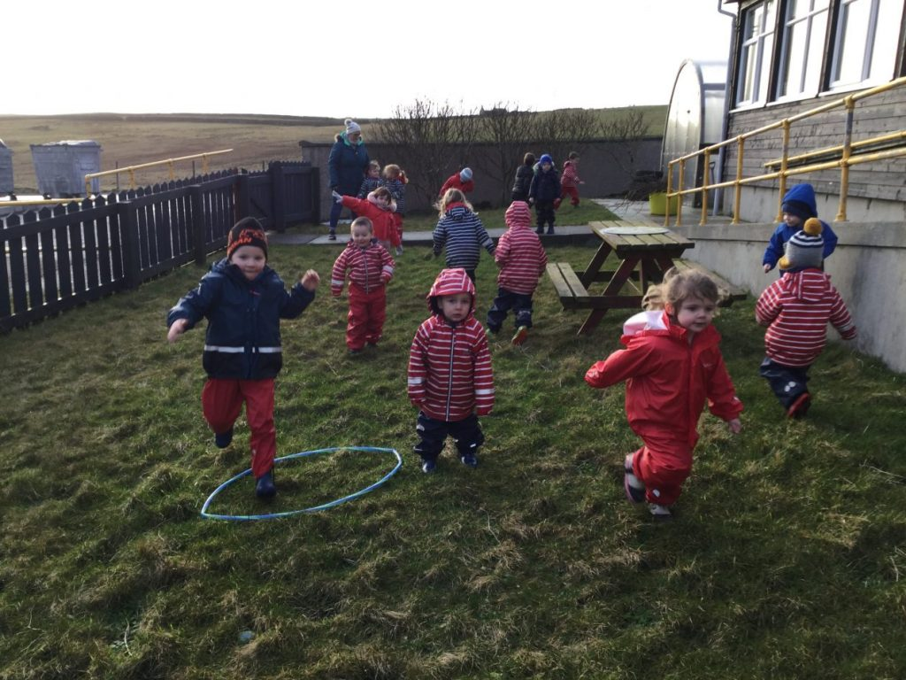
Children enrolled in the Dunrossness Early Learning and Childcare setting using the SIC Education Service admission policy. After enrolling your child, you will be contacted at home to arrange a ‘home visit’, if you wish. Staff members will bring with them, registration forms, an ‘All about Me’ booklet to be filled in by parents and children, tooth brushing consent and other relevant paperwork. This visit gives staff, children and parents a chance to develop relationships and please use this time to share a little more about your child’s development. If your child has any special requirements for snack or allergies, please also let us know and any worries about toileting can be discussed so they can be sensitively handled. At this meeting you and your child will then be invited to visit the setting in the weeks before they are due to start. We have a relaxed induction programme, and sessions can be built up gradually as and when children are ready.

We want to make sure that your child’s time in at Dunrossness is a happy, safe and enjoyable experience from the beginning. Children learn through play and activity. Some children settle quickly while others take longer to gain confidence. We get to know them very well as individuals, learning about their strengths and building on them. Staff and parents work together in partnership, sharing this important stage of your child’s development. Parents can stay initially with their child when they are settling in, with the time the child is able to spend on their own being gradually extended until the child stays for the whole session. Staff will advise you on this matter. Staff are always available daily and are delighted to answer any questions or concerns you may have.

The Nursery is very much part of the school and the children have many opportunities to become used to the whole school building and the wider school community. In the terms before starting school we begin to prepare children for the move into Primary 1, aiming to make the transition as smooth as possible. Closer to the end of the pre-school Nursery year children will also get the opportunity to ‘move on’ and experience a day in P1 along with lunch time in the canteen and break time in the playground.

Nursery Snack
Nursery snack is now funded centrally. This ensures each child has a healthy and nutritious snack provided each day in a family type setting. The social elements of eating together provide great stimuli for social communication and learning. This money can be paid directly to nursery staff termly or weekly by arrangement.

Placing Requests
If you do not wish for your child to attend your catchment area school, you can place a request with Shetland Islands Council that your child attend another school. Details of how to make a placing request can be found in Shetland Islands Council, Children’s Services, Admissions Policy. The policy can be found at: http://www.shetland.gov.uk/education/default.asp
Please make your Placing Request in writing to:

Director of Children’s Services
Children’s Services
Hayfield House
Hayfield Lane
Lerwick ZE1 0QD
To help you, the Scottish Government has published a guide for parents on choosing a school and the placing request system. It is available on the Scottish Government’s website. The direct link is:
http://www.gov.scot/Publications/2010/11/10093528/0

Enquire is the Scottish advice service for additional support for learning. If your child requires additional support for learning and you wish to place a request to have your child schooled elsewhere, you may wish to look at leaflets that Enquire have produced; Factsheets 2, 3 and 6 have particular relevance. Please request these from your child’s school or refer to Enquire’s website. The direct link is:
http://enquire.org.uk/information/factsheets

In Shetland, we have two special Additional Support Needs departments (attached to Bell’s Brae School and Anderson High School). A request for a child to access a place in one of these special departments is at the discretion of Children’s Services. Further information can be found on Shetland Islands Council’s website. The direct link is:
http://www.shetland.gov.uk/education/documents/TransitionAdmissionsandPlacingRequestsInformationForParents.pdf

Shetland Islands Council’s Children’s Services Admissions Policy can be found at:
http://www.shetland.gov.uk/education/default.asp

School Ethos
Our Vision, Values and Aims
Living Laughing Learning
Dunrossness Primary School –
A caring, happy school that nurtures, encourages and supports every individual to Determinedly Pursue Success in all areas of their lives.

Kindness Happiness Honesty Fun Respect Patience Responsibility

- To provide a safe, happy and healthy learning environment where mutual respect is shown;
- To promote independence, resilience and responsibility and develop skills for life;
- To encourage, motivate and support curiosity, creativity and feel free to experiment and learn from our mistakes;
- To inspire, recognise and celebrate effort, success and achievement;
- To foster cooperation, connections, responsibility to others and a thoughtful global outlook at the heart of our local community.
What an amazing week da bairns have had. Friday morning was wonderful, what a lot of hard work by the teachers and pupils – thank you – Parent following SMHUA 2019
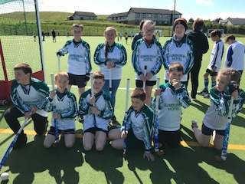

I’d happily take these children anywhere! They were so well behaved and were so supportive of other teams’ Mrs J Smith – after Hockey Festival

Focus Fridays mean we all get a chance to make decisions about the school
Pupil
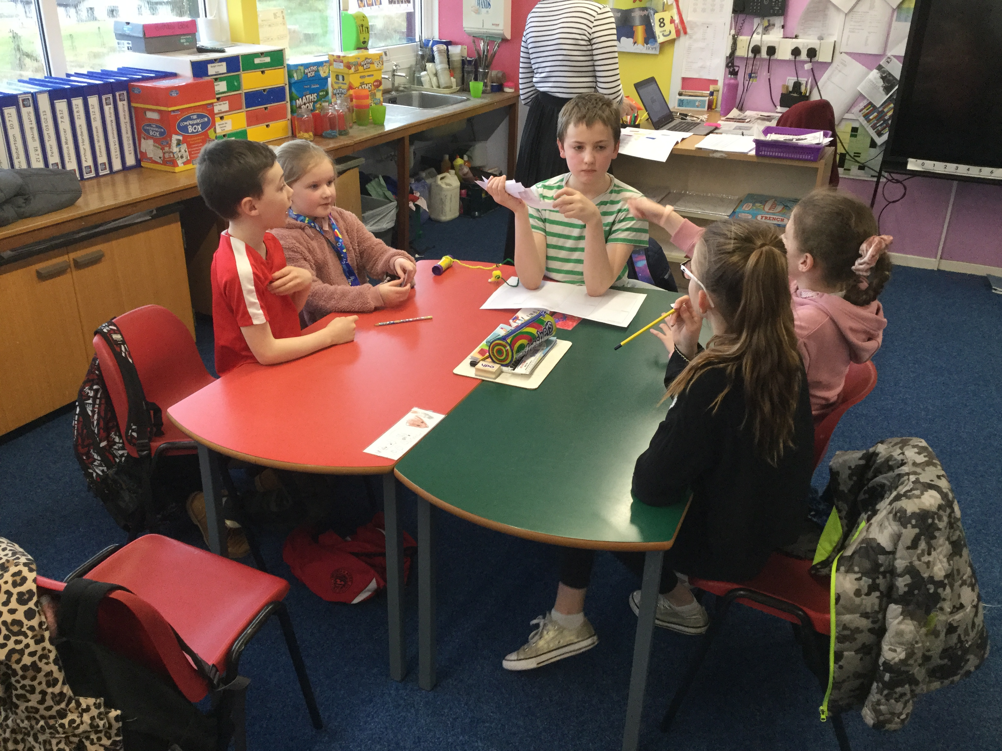

Behaviour
We have high expectations of our learners. Staff members promote positive behaviour by developing good relationships between pupils, parents and staff. Behaviour issues are dealt with in accordance with the school Positive Relationships Policy. The policy is on the blog or paper copies are available at the office on request. We are a nurturing school and have many forms of nurture provision in all areas of our school.

Our School Rules

READY RESPECTFUL SAFE

You may wish your child to carry a mobile phone for after school events, but we ask that they are kept in your child’s school bag and not used at all during the school day. Any phone that is seen to be used will be taken from your child and returned to them at the end of the day.

Community
We pride ourselves on being at the heart of the local community and on making a positive contribution to the wider area. We develop opportunities for our community to come together by, for example, organising special assemblies and hosting local events. The school supports the work of voluntary groups operating in the local community by providing facilities, fundraising or collecting charity donations and taking part in community events. We support national events such as Children in Need and Christmas Jumper Day and we link with schools in other countries. These experiences provide valuable learning opportunities, helping pupils to develop a strong sense of community and culture.
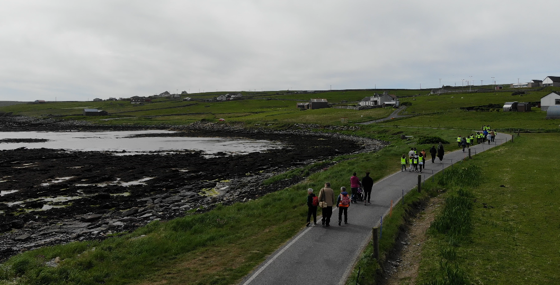

The Curriculum for Excellence
This curriculum aims to develop four capacities for successful learning. These are:

Successful Learners
With:
- Enthusiasm and motivation for learning
- Determination to reach high standards of achievement
- Openness to new thinking and ideas.

Confident Individuals
With:
- Self-respect
- A sense of physical, mental and emotional well-being
- Secure values and beliefs
- Ambition.

Responsible Citizens
With:
- Respect for others
- Commitment to participate responsibly in political, economic, social and cultural life.

Effective Contributors
With:
- An enterprising attitude
- Resilience
- Self-reliance

As part of this development the boundaries between each of the stages of schooling have been blurred, helping to create a curriculum for all children from 3-18 years.

Some children may be using the Curriculum for Excellence milestones.
https://education.gov.scot/improvement/learning-resources/Milestones%20to%20support%20learners%20with%20complex%20additional%20support%20needs%20-%20Literacy%20and%20English

A child’s journey through Primary School is now organised under the following stages:

Early - In pre-school and in Primary 1
First - By end of P4, but earlier for some
Second - By end of P7, but earlier for some

These stages provide scope for challenge and depth. There is no pressure to speed through the levels but nor are there be any ceilings to learning. The focus is very much on individual progress and achievement with the child at the centre of their learning. Further information can be found at www.ltscotland.org.uk/curriculumforexcellence

At the very heart of our curriculum planning, lies the holistic development of children and their skills across the curriculum, building on their previous learning experiences, knowledge and skills. Children will learn through first-hand experiential activities within play-based situations. In their play, children practise and consolidate their learning, play with ideas, experiment, take risks, solve problems and make decisions individually and in small or large groups. The development of children’s self-image and feelings of self–worth and self–esteem are central to this process.

The curriculum within the Early Stages is progressive and aims to meet the needs of all children including those who are at an early stage of development and those who are more able and more independent. The curriculum will be appropriate to the individual child’s stage of learning rather than focussing solely on age related outcomes to be achieved. Children will be helped to move on to the next stage in their learning when they are developmentally ready, at their own pace.

In line with the Curriculum for Excellence, learning is organised under the following headings:

- Literacy and Language
- Numeracy and Mathematics
- Science
- Social Studies
- Health and Well-being
- Religious and Moral Education
- Expressive Arts
- Technologies

Digital learning is embedded within all the above areas and is seen as an integral part of all the curriculum programmes as are aspects of learning such as citizenship and enterprise.

Much of the learning is planned using a cross-curricular approach to help ensure meaning and relevance and to give fun and enjoyment. This also opens possibilities for personal learning and choice.

Numeracy and Mathematical Development
From the time your child joins us, they will experience a gentle approach to number recognition, building on knowledge already acquired. This will lead on to simple addition and subtraction. Work on simple shape, measurement and money is part of the curriculum and the children will be given opportunities for problem solving. There is less emphasis on the completion of workbooks and more on learning by doing – active learning. This means that there will be less written work than you may have seen in the past and there may be workbook pages that have not been completed as the children have learned the concepts involved through practical activities instead of repetitive examples. This is a major part of our curricular reform. We also use 'Stages of Arithmetical Learning (SEAL)' as an approach to teaching numeracy, with an emphasis on developing a secure number knowledge. This is the foundation on which all areas of maths are built on.

Literacy and Language Development

Literacy and Language involve the four skills of reading, writing, talking and listening. All four are essential skills and need to be taught at home and at school.

We have been part of the Emerging Literacy project, as part of the Northern Alliance partnership of Education Authorities across the north of Scotland. The areas we work on are:
Concepts of print
- Know to write from left to right
- Know what each of the letters look like
Phonological awareness
    - Know the sounds which make up each of the words
    - Hear the individual words within the sentence
    - Listen to and recall the words within the sentence
Oral Language
    - Understand the meaning of the words within the sentence
    - Can follow the instructions to complete the activity
Fine Motor Skills
    - Hold the pen correctly
    - Form the letters correctly
We will use these areas to support your child from the moment they start Primary 1. Emerging literacy helps us to identify when a child is ready to learn, and to identify areas to develop skills for each individual child.

When we feel your child is ready, we use Jolly Phonics, to teach the main 42 sounds of English, not just the alphabet sounds. With this knowledge, they are taken through stages of blending sounds to form words and then to reading. The rate of learning these sounds will vary, dependant on the child.

Due to the importance of these early reading and writing exercises, the children will not get a ‘reading book’ right away. They will, however, have the opportunity to choose books from the class and school library to take home to share with parents and guardians. There is a vast array of research showing the importance of reading to your child in the development of their language skills.

Preparation for reading is provided through the Oxford Reading Tree. This special purpose early reading scheme introduces children to whole words through a series of amusing family sketches. Reading scheme books will not be sent home until your child is ready to begin to read independently. The children also learn comprehension skills through this reading scheme. This is learning that goes with each story to build on the children’s understanding of texts, build their vocabulary and their understanding of grammar, spelling and punctuation. This is why one book will be given over a period of time instead of a book a night – there is more to reading than just reading!

The children are encouraged to build an enjoyment of stories and rhyme through a variety of books, songs and games. This is something that you can easily do at home too.

Writing begins with talking and expressing views, opinions, passing on information and instructions and using our imaginations to make up stories, rhymes and role play. From this, we move onto mark making, expression through drawings and then onto using words. All children develop the skills involved with writing at different rates depending on a host of factors such as their vocabulary, their fine motor skills and finger muscle development, their ability to deconstruct words into sounds and then further down to the letters that represent these sounds. Children will be supported as they develop the skills and confidence to write independently.

Throughout all of the subjects, children will be given the opportunity to play and experiment with a variety of materials and media. Staff will carefully plan for both free and structured play along with more focussed group activities using techniques such as peer tutoring, cooperative learning and experimentation.

Health and Wellbeing
The need for changes to lifestyles in Scotland to promote good health has meant this curricular area is now, like literacy and numeracy, the responsibility of all teaching staff in the school. This means it has great importance in our school and is promoted through our ethos, our values and through health promotion in the wider community. The teaching of Health and Wellbeing is supported by a resource called ‘Jigsaw’ and includes aspects such as staying fit and healthy, healthy food choices, emotional and social health, taking responsibility and staying safe

Learning and Teaching
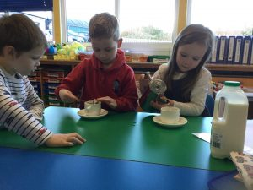
We apply a range of teaching and learning approaches in order to challenge and motivate learners to achieve their best. These include:
- Active learning
- Co-operative and collaborative learning
- Enterprising teaching and learning
- Outdoor learning
- Digital learning

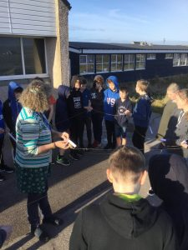
As a school we are provide opportunities for interdisciplinary learning, through which experiences and outcomes from within and across curriculum areas are grouped to provide coherent and relevant learning experiences and stimulating contexts to meet the needs of our children. Our teaching staff involve children in deciding what and how they learn, ensuring a focus on personalisation and choice.

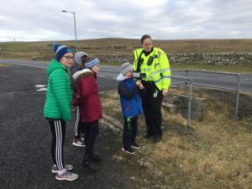
We carefully consider the totality of experiences provided for learners to help them develop important skills for learning, life and work.
We develop relevant partnerships with people, groups and agencies to enhance learning. Active schools, the police, the fire service, health professionals, local ministers and local education officers, to name a few, all provide their expertise to enhance the quality of the education we provide.

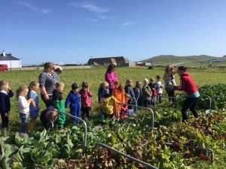
A range of local organisations support and enhance the delivery of learning experiences out with the classroom. Relevant trips out to places like the Shetland Museum, Quendale Mill, Scholland Farm, the Shetland Croft House, the local shop, the Waste to Energy plant, local farms and many others offer our pupils real life learning experiences.

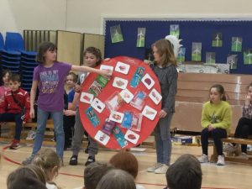
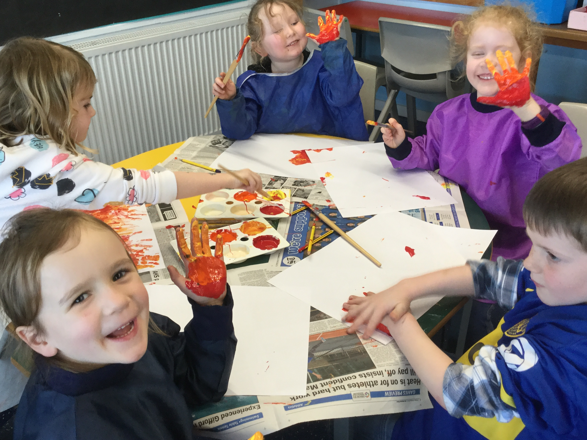
Our learners benefit from the expertise and skills of our visiting specialists for art and design, music and physical education, who encourage pupils to develop their skills beyond the school. We are proud of our longstanding instrumental achievements through a team of dedicated instrumental teachers. Our children get regular opportunity to show their talents at a range of different events.

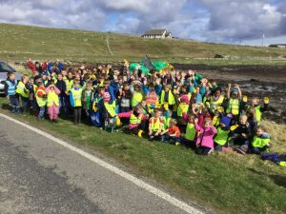
At Dunrossness School, citizenship and enterprise are embedded throughout our curriculum. Careful planning allows children experience a range of contexts to help them develop informed decision making and the ability to take thoughtful and responsible action both locally and globally. For example, at a local level the children participate in ‘Da Voar Redd Up’, the annual spring clean of Shetland’s beaches and roadsides. This helps children to realise the impact of litter on the local environment and to help them make informed choices about waste.

There are many events throughout the school year, such as Children in Need, Christmas Jumper Day and World Book Day. It is also a great way to raise money for great causes and an opportunity to get all the children and their families together!

Assessment
Assessment is an integral part of learning and teaching. We use a range of approaches to provide a clear picture of our pupil’s progress and achievement and to identify next steps in learning. We aim to engage our pupils in all aspects of assessment by sharing learning intentions and success criteria, providing opportunities for peer and self-assessment, giving quality feedback to pupils about their progress and discussing next steps in learning.

Parents are also an integral part of the assessment process. We encourage parents to discuss their child’s progress with them. We have the official parents’ evenings, during which parents can discuss their child’s progress with the class teacher. Parents are also welcomed into the school at various different times to share in their child’s learning. Our homework diaries and open door policy, aim to ensure parents and teachers have regular, open lines of communication so that any issues or concerns can be discussed, and strategies implemented, at the earliest opportunity. A comprehensive report is sent home to parents annually.

Further information on achievement, reporting and profiling can be found on Education Scotland’s website. The direct link is:
https://education.gov.scot/parentzone/learning-in-scotland/assessment-and-achievement

Support for Pupils
My child is well supported in school.
Parent response to Nurture questionnaire 2019
We strive to give pupils the support they need to fully
access the curriculum in the general course of their
education. There will be times when some pupils will
need additional support. This could be on a long-term basis with the amount of support varying according to the needs of the pupil as progress is made through school or as a temporary support when a need arises.
Information on how pupils’ additional support needs (ASN) are identified and addressed can be found on Shetland Islands Council’s website. The website also provides information on mediation and dispute resolution services, links to the NHS and other agencies or organisations that can provide further support, information and advice about support and advocacy. The direct link is:
http://www.shetland.gov.uk/education/asn_home.asp
The school has been amazing in supporting my son overcome his difficulties. He has really come on these past 6 months and is a much happier child in class and at home.
Parent response to Nurture questionnaire 2019
Dunrossness School has a dedicated ASN teacher, learning support workers and a learning support assistant, who are responsible for ensuring that the relevant support is given. This may be in the form of extra resources, one to one or small group tutoring, helping a child in their own classroom, making classroom observations or taking the rest of the class to allow the class teacher time to work with the pupil. The ASN teacher will consult with the rest of the staff on support strategies and will liaise with other professionals in order to ensure the needs of the child are met. The ASN teacher work very closely with parents to identify and agree the level and type of support needed and will review needs on a regular basis. If you think that your child needs additional support or you would like further information or advice, you should contact Mrs Leslie. Contact details are at the start of the handbook.
An educational review for a child with ASN should take place at least once per year, for those with more complex needs this could be every 6 months or more often as needed. All members of the multi-agency team involved with a child should be invited to attend the review meeting. Parents/carers and others involved with a child’s education will be sent a copy of the summary of any review meeting.
I think the school does an excellent job and both my child and me as a parent feel very supported
Parent response to Nurture questionnaire 2019
Other useful information and advice regarding additional support for learning can be found on http://www.shetland.gov.uk/education/documents/STAGEDINTERVENTIONGUIDANCEMAR18.pdf and on the Enquire website. The direct link is: http://enquire.org.uk/

Getting It Right For Every Child (GIRFEC)
In Shetland, we believe that children can be better supported by adults working closely together and sharing important information with each other. This process is known as GIRFEC: Getting It Right For Every Child. Before GIRFEC can be used, consent from the parent of the child and/or the child (depending on the age of the child) is required. The staff asking permission will explain more about what GIRFEC means. Detailed information about the process can be found at:
http://www.shetland.gov.uk/children_and_families/GIRFEC.asp
https://www.gov.scot/policies/girfec/

Child Protection
It is every child’s right to be cared for and protected from harm. It is every person’s responsibility to make sure that happens. The Shetland Child Protection Committee provides help when there is a need. Their website gives information on how to access that help. The direct link is: http://www.safershetland.com/

Shetland Islands Council’s website also provides information on our responsibilities towards children and includes where to find help and support. The direct link is: http://www.shetland.gov.uk/children_and_families/child_protection.asp

School Improvement

Dunrossness School is committed to self-evaluation and continuous improvement. Each year the school produces a single document, called the ‘Standards and Quality Report and Development Plan’, which outlines the progress we have made each year along with the areas identified for future development. This document can be viewed using the following link:

Each year, the school fully self-evaluates its practice and this, along with feedback from parents, pupils, staff and partners, is used to inform our Standards and Quality Report and Development Plan. Further information on our school improvement can be seen on the school improvement section of our website.
The direct link is: https://blogs.glowscotland.org.uk/sh/dunrossness/parent-council/school-improvement-plan-2/

Information about the school’s performance at national level can be found on the Scottish Government’s website and on the Education Scotland’s Scottish Schools Online website which also includes HMIe Inspection Reports.
Direct links are:
http://www.gov.scot/Topics/Statistics/Browse/School-Education

HMIe Inspection reports and School Consultation reports can be accessed directly on Education Scotland’s Reports webpage.
The direct link is: https://education.gov.scot/

Other useful websites
Information on the following websites may also be of interest to you:

Scottish Qualifications Authority
http://www.sqa.org.uk/sqa/41292.html

Scottish Credit and Qualifications Framework
http://scqf.org.uk/parents-carers/

Scottish Survey of Literacy and Numeracy
For general information on the survey:
https://education.gov.scot/parentzone/learning-in-scotland/assessment-and-achievement/Scottish%20Survey%20of%20Literacy%20and%20Numeracy

Focus Fridays
Several Times throughout the year, the whole school works together in their house teams to help drive forward the School Improvement Plan; this is led by school staff and enables all pupils to have a voice in their school.

Policies
A range of school policies support the work of the school. These can be accessed by contacting the office directly or by checking our website.

Policies applicable to all schools across Shetland can be found on Shetland Islands Council’s website. The policies include:
- healthy eating
- bullying
- exclusion
- school trips
- equality and diversity
- adverse weather.

The direct link is: http://www.shetland.gov.uk/education/policies_guidelines_and_forms.asp

Trips
Throughout the course of the year a wide range of opportunities are available for pupils to be involved in the school including sports and outdoor activities. This information will be distributed to parents, as required and is also accessible through the school blog. At the start od a school year, we will send a generic permission slip for trips out. You will always be informed of upcoming trips, but the generic slip means we will not have to gather returned slips each time we go out.

Instrument Tuition
Shetland Island Council’s website provides information on instrument instruction along with other creative learning opportunities. The direct link is: http://www.shetland.gov.uk/education/creative_learning.asp

Religious Observance
Scotland is a society with a longstanding Christian tradition, and we draw upon the rich resources of this tradition when planning religious observance as part of our assembly programme. Our school community also contains pupils and staff from other faiths and those with no faith commitment and therefore it is of central importance that all pupils and staff can participate with integrity in forms of religious observance without compromise to their personal faith. Alternative activities are organised for pupils whose parents wish to exercise their right to withdraw them from participation in religious observance. A list of our school assemblies is available on the school blog.

Concerns
Dunrossness School aims to ensure that any concerns parents voice about their child is dealt with in a sensitive and effective manner that brings about positive outcomes for the child. If you have any concerns, you should discuss it directly with the classroom teacher or head teacher in the first instance.

Complaints
Please direct a complaint to the Head Teacher in the first instance. The School Complaints Procedure can be found on Shetland Islands Council’s website. The direct link is:
http://www.shetland.gov.uk/education/hpc_complaints_procedure.asp

Absence/Sickness
If your child is ill or if you think it is necessary for your child to be absent from school for any other reason, please contact the school with the details, as soon as possible. The school office will contact parents if a child has not turned up for school and no information on that child’s absence has been provided. If your child is going to be absent for any other reason, you should contact the school office, who will provide a leave of absence form, which should be completed and returned to the school as soon as possible.
Please remember that no one should return to school until 48 hours after the final episode of sickness or diarrhoea
For further information on school attendance, a guide for parents can be found on the Scottish Government’s website. The direct link is: https://www.gov.scot/publications/included-engaged-involved-part-1-attendance-scottish-schools/

If your child becomes unwell at school, the school will contact you to make arrangements for them to be taken home. If immediate medical treatment is required, the school will arrange for the pupil to be taken directly to the hospital and will contact you immediately. Please ensure that emergency contact numbers are kept up to date and emergency arrangements are in place.

If your child is suffering from an injury or illness which may affect their ability to participate in school activities, please inform the school as soon as possible. Where possible, medicines should be administered at home. However, in some circumstances it may be possible for medicines to be administered at school. If circumstances make it essential that your child should receive medicine in school, please contact the Head Teacher so that arrangements can be made to administer medicines. In these circumstances it would be expected that the dosage for that day only would be sent with the child. A medical consent form must be completed and signed by parents. These are available on the school website or from the school office. If you require suntan lotion to be applied to your child, please fill in an Administration of Medicines form and send to the school.

First Aid
If your child has an accident or becomes ill at school, we will assess their needs and you may be contacted in order that arrangements are made for your child to be sent home. Please keep the school informed of any change of address, telephone number and your work phone number. This will help speed up the time taken to contact you and prevent further distress to your child.

In the case of injury considered to require immediate medical treatment, the child will be taken directly to the doctor and the home contacted. It is best, whenever possible, that parents collect their own children from school but, if that is not possible, transport will be arranged. If there is the possibility that no one may be at home, parents should ensure that alternative emergency arrangements are always made. Please keep the school informed.

If your child is suffering, even temporarily, from an illness or injury which may be affected by accidents or school activities, please inform the Head Teacher. This information will help to ensure that your child receives proper attention if the need arises

Family Holidays
Circular No 5/03 from the Scottish Government states that family holidays are to be classified as “unauthorised absence” from school, unless under exceptional circumstances.

Requests for Leave of Absence
All requests for leave of absence, other than for medical, dental or optician appointments (these are addressed to the class teacher) should be made in writing to the Head Teacher. There is a form available on the school website for you to download at home.

Collecting Your Child During School Hours
On arrival at the school, parents are asked to report to reception before collecting their child for an appointment. Parents should not be in school unaccompanied or without knowledge of the Head Teacher. Any children leaving school during school hours MUST be signed out by a known adult.

School Closure Information
In the event of school closure for severe weather, or any other reason such as loss of power, the school operates a “communication tree”. This allows information to be circulated quickly. Each family will be given a known point of contact, who will contact you with the details of the school closure. You should ensure that the school is kept updated on any changes to your contact numbers.

During periods of snow and ice, it is important to understand that buses cannot always operate on time, particularly in the morning, though bus operators will make every effort to keep to their schedule. The decision to send your child to school in adverse weather conditions rests with the parents, as they are best able to judge the weather conditions in their area. Parents must make arrangements for their child at all times, bearing in mind that in severe weather pupils may well be on their way home on the bus before they can be contacted.

Transport

Children within P1 are eligible for free transport to and from school within a defined distance area. We will inform the transport providers of your child’s details before they begin at school. You will be notified directly from the authority of bus details, this usually comes through the summer holidays. If you do not wish to use the school transport then please let us know.

If, for any reason, your child is to travel on a different bus from the usual one, it is most important that you inform the school by phone or letter on the day; word-of-mouth messages from young children are very unreliable. The best way to do this is by writing a short note in your child’s school diary.

It is also necessary to check with the transport operator as to the availability of spare seats on the other bus, because some routes are operating near full capacity.

If you, or a family member, are picking up your child instead of their catching their usual transport, we would appreciate this being added to their diary too. This means we are not holding any of the buses here whilst we check on your arrangements, allowing all the pupils to get home timeously.

Bus Operators Phone Numbers:

Nicolsons 477243
Boddam Cabs 460111

It is the parent’s responsibility to ensure their child has their seatbelt secured in the morning. The bus driver will ensure seatbelts are correctly fastened when children leave school to travel home. Seat belts should be kept fastened until the bus has come to a complete halt.

Children are expected to be well behaved and courteous on the buses. Although conduct of children on school transport is a matter of shared responsibility between the Bus Company and parents, the school is, nevertheless, interested and actively involved in helping to resolve any problems which may arise. Any child who repeatedly misbehaves on school transport can have their right to transport removed.

Snack Time
Your child is encouraged to bring a healthy snack for playtime.

Water should only be carried to school in leak proof plastic containers, never in glass bottles. Bottles can be filled from the drinking fountain in school. Pupils are not permitted to drink directly from this fountain.
Milk is available before playtime each day, at a cost of £12 per term from January 2022. Milk is paid through Parent Pay.

School Meals
Children have the chance to take a cooked school lunch. These are cooked on site and provide a healthy balanced meal from fresh ingredients. Meals cost £2.20 per day for P5-7 pupils, all children in P1 – 4 are entitled to a free school meal funded by the government. For those paying for school meals, they are payable through Parent Pay. Application forms for free meals may be obtained from the school.

The Council has a “Food on Plate” policy. This means that all children are encouraged to take one choice from each food group on to their plate. No child is forced to eat food that they do not like or want.

Parents who wish their child to take packed lunches to school should inform the school in writing in advance so that provision can be made. Lunch boxes should be securely packed and non-breakable containers used. All meals are eaten in the school canteen. To change from packed lunch to school lunch and vice versa, we need a term’s due to the ordering of foodstuffs.
To enable you to discuss choices with your child and to assist you with menu planning you will find the current menu on the school blog. https://blogs.glowscotland.org.uk/sh/dunrossness/

Allergies
It is vital that we are informed of any food or other allergies that your child may have. Please do this on the official registration form. For any medication needs with regard to allergy, please see Absence/Sickness

Equipment
Your child will be given a book bag for carrying their homework to and from school and a diary to aid home-school partnership. In addition to the equipment provided within school, we ask that you equip your child with the following:
- A school bag (large enough to hold an A4 size folder)
- P.E. kit: This should include t-shirt, shorts, and plimsolls to be kept in a drawstring bag on their peg.
- Swimming Kit: Costume, towel and goggles (you will be notified in advance of your child starting a 6 week swimming block)
Please make sure that all clothing is clearly marked with your child’s name. This includes the towel and goggles in the swimming kit. Name tags can be ordered through the school. We strongly advise you do this as we have a large number of unclaimed and unnamed items of uniform left in Lost Property. Thank you!

Please do not bring expensive or very special toys, which may be lost or damaged, as the school cannot be held responsible for looking after toys. Toys that children bring in should be able to be shared with others during play at the school otherwise they should be left at home. It is school policy that no toy guns or weapons are permitted.

School Fund
Funding for Christmas parties, special events, trips out and special items of equipment is raised through a variety of fundraising events and enterprises. This is supplemented by donations and funding from other miscellaneous sources. We will call on you from time to time to help out at these events and/or donate homebakes or items for raffles, tombolas, sales, etc. Your support is very much appreciated!

Any ideas you have for raising funds would be very welcome as we will need to self-fund more of our activities in the future as Council budgets are tightened.

Financial Help for Parents
Grants are available for school meals and clothing. Guidance and an application form can be found on Shetland Islands Council’s website. The direct link is:
http://www.shetland.gov.uk/education/hpc_clothing_grants_and_free_school_meals.asp
Information on the provision and finance of transport can be found on Shetland Island Council’s website.
The direct link is: http://www.shetland.gov.uk/education/hpc_school_transport.asp

Online Protection
For information about online protection for your child, you may like to look at the Child Exploitation and Online Protection Centre’s website. The direct link is: https://www.thinkuknow.co.uk/

Appendix 1:

How Can You Help to Prepare Your Child for School?
You will probably be doing many of these activities already as part of your daily routines. They all help with making your child’s transition into school easier and a less anxious for you and your child.

To Encourage Language Development
Talking and listening to your child is fundamental to their healthy development throughout childhood and into adulthood. The importance of this communication cannot be stressed enough.

Talk about:
- Things you do together and why you're doing them.
- What your child does at nursery or playgroup.
- What you see in the street, garden, countryside etc.
- The shops you go into and what you buy.
- Notices, street and road signs and what they mean.

Read Together:
  - Sharing storybooks is the best preparation for reading that your child could have.
  - Visit the local library.
  - Choose books and comics carefully.
  - Explain how to handle books (starting from the front, reading print left to
  - right etc).
  - Talk about what you are reading, ask questions and discuss pictures.
  - Reread favourite stories allowing your child to join in.
  - Don't forget Nursery Rhymes.

To Encourage Mathematical Awareness
- Discuss the size of things, big, small, tall, short.
- Use place words, in front of, behind, between.
- Use words such as heavy, light, more, less, many, few.
- Make sure they know the colour names.
- Say number rhymes and nursery rhymes.
- Count together.
- Set the table, one plate for each member of the family, etc.
- Share out e.g. sweets.
- Sort out buttons, counters, and beads.

To Encourage Writing Skills
It is probably best to leave the formal teaching of writing to the school as children may form incorrect writing habits that are often difficult to correct.
However, please do encourage your child to:
- Use pencils, crayons, chalk, and pens.
- Make patterns.
- Draw pictures.
- Colour in.
- Paint.
- Do 'dot to dot'.
All these activities help to develop the hand control necessary for flowing writing.

To Encourage Independence
- Encourage your child to do things for him/herself at home.
- Make sure your child knows how to use the toilet properly (flushing after use, then washing and drying hands).
- Make sure your child can use a tissue or handkerchief efficiently.
- Encourage your child to be tidy and put things away.
- Encourage your child to look after his/her belongings e.g. hats, toys, etc.

It will make life at school a lot easier for your child if they can do some of these things themselves. However, impress on your child that there is always an adult at school they can ask for help or speak to.

To Encourage Positive Relationships with Others
- Encourage good manners – a please and thank you make all the difference.
- Encourage your child to share toys, games etc.
- Talk about the importance of taking turns.
- Discuss why some things are right and other things are wrong.
- Explain why rules are needed for everyone's safety e.g. do not throw stones, do not kick or punch others.
- Encourage your child to listen to others.

Appendix 2:

Calendar of Events

We will update you on this information as soon as we are able to.

