Head Teacher: Ms Andrea Henderson Dunrossness Primary School
Dunrossness
Shetland ZE2 9JG
Telephone: 01595 745440
Fax: 01950 460803
E-mail: dunrossness@shetland.gov.uk
Blog: https://blogs.glowscotland.org.uk/sh/dunrosness/
22nd September 2020
Dear Parent/Guardian,

With current restrictions, peripatetic staff are only allowed in one setting per day. This means that we have additional art time on a Thursday afternoon.

Ms Burr has been delivering a session of extra class art in recent weeks but as of this week, she will be working with small groups or individuals in our All Stars room. These small group sessions will give children some time to be creative within a small group situation. It can help develop creativity skills but also provide a format for relationship building and increasing self-esteem.

If you do not want your child to be part of any additional art sessions, please contact the school office.

Yours sincerely
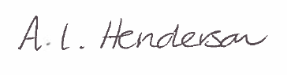
Andrea Henderson

