Head Teacher: Ms Andrea Henderson Dunrossness Primary School
Dunrossness
Shetland ZE2 9JG
Telephone: 01595 745440
Fax: 01950 460803
E-mail: dunrossness@shetland.gov.uk
Blog: https://blogs.glowscotland.org.uk/sh/dunrosness/
5th August 2020
Dear Parent/Guardian,

School Meals

Our school is following advice from the government and Shetland Island Council with regard to school meals and unfortunately, we are not currently able to offer hot school meals at Dunrossness Primary School.

Pupils who wish to have a school meal and those who receive free school meals, will instead be provided with a nutritious and tasty packed lunch.

Mrs Duncan and the canteen staff are working on a new menu which will be on the blog soon. In order to assist them with ordering and forward planning, can you please reply to this email before Friday 7th August indicating if your child/children will be bringing their own packed lunch to school or would like a school meal.

Yours sincerely
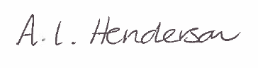
Andrea Henderson

