Dunrossne ss Primary School
Nurture Policy

"I hear babies cry,
I watch them grow,
They'll learn much more,
Than I'll ever know.
And I think to myself,
What a wonderful World" - Louis Armstrong "What a Wonderful World"

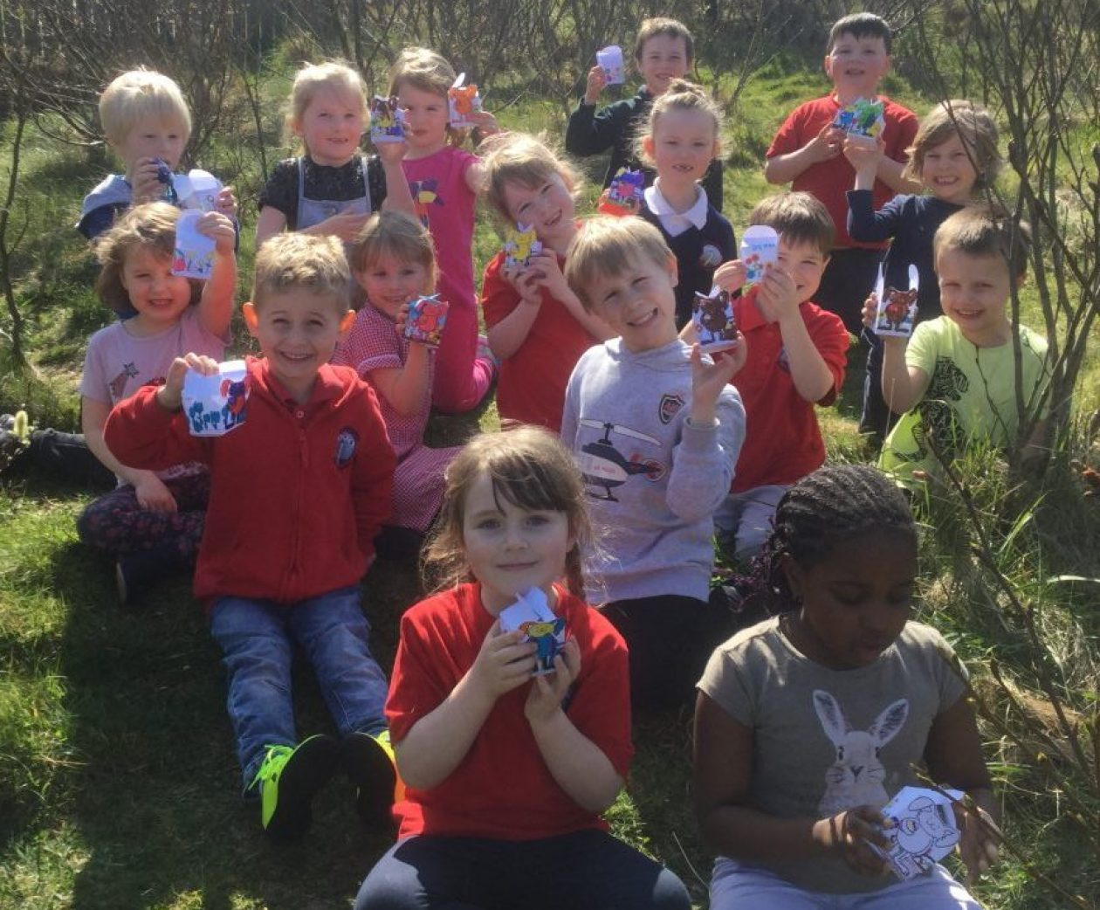

Dunrossness Primary School – Nurture Policy
Dunrossness Primary is endeavouring to ensure that all children benefit from the nurturing ethos of our school. Staff are available to support all in Dunrossness, whether on an individual, group or class basis. The school as a whole community is committed to maximising the social and educational engagement of all. We strive to create a positive morale amongst pupils, staff and the wider school community.
As a school we aim to:
- Build confidence, resilience, responsibility through respectful relationships between everyone within the school community
- Raise self-esteem and wellbeing
- Recognise that the importance of a holistic, whole child, approach, is vital in a child’s readiness to learn
- Raise achievement of all learners within our school community
- Increase inclusive practice for all children
- Facilitate a positive whole school culture, in line with the school positive relationships policy and the Rights Respecting School ethos
- Provide an approach that supports children with their specific needs while delivering teaching and learning in a way that all can access
- Welcome and involve parents and carers to see the improvement in their children’s confidence, learning and wellbeing both in and out of school
- Be at the heart of our community and play a central role in children and young people’s lives
The 6 Principles of Nurture
- Children’s learning is understood developmentally – the foundations of learning and trusting relationships begins at birth and develop through a close relationship with one or more adults. Staff respond to each child at whatever developmental stage he/she is at. We all learn in our own way and learning and teaching should reflect the different needs within each class and enable each child.
All adults’ learning is understood developmentally – it is important to recognise that adults are also learners with their own values, experiences and skills. We have a duty to support each other, recognising strengths and talents. Collegiate learning opportunities are key in developing consistently good practice across the school. We need to be mindful that adults learning within the school community are all at different places on their learning journey too so need appropriate levels of support or challenge.
- The classroom offers a safe base – There is a structure to the day which is predictable, adults who are reliable and firm that can set boundaries without being punitive. Children see adults working together, supporting each other and modelling respectful relationships. The experiences within the classrooms support development of children’s relationships with each other and with staff.
The school offers a safe base – we have to be mindful that the adults working within or visiting the school will be facing their own stresses and pressures. We make sure we have a trusting culture and climate to enable people to ask for and get the support they need to fulfil their role.
- The importance of nurture for the development of wellbeing – nurture is listening, being responsive, remembering and engaging in reciprocal shared activities such as play, reading, learning, listening and talking about events and feelings. Children respond to being valued and being thought of as individuals. This involves calling the children by their name, noticing and acknowledging their achievements.
The importance of nurture for the development of wellbeing – this includes all stakeholders within our school community. It is important that everyone feels valued for the work they do or the contribution they make.
- Language is understood as a vital means of communication – Language is more than a skill to be learnt, it is the way of putting feelings into words. Children sometimes act out their feelings as they lack the vocabulary or the understanding to recognise or name how they feel; they just have the feeling and don’t always know what to do with it. In the course of their day children have the opportunity to talk and listen in informal situations where words are used to express feelings and opportunities are created to extend conversations or play experiences to develop these skills.
Language is understood as a vital means of communication – we need to ensure that all stakeholders feel that their voices are heard and valued. We have open and honest communication and welcome opinions and contributions to help us move forward together.
- All behaviour is communication – Understanding what a child is communication through behaviour helps staff to respond in a firm but non-punitive way by not being provoked or discouraged. If the child can sense their feelings are understood this can help diffuse difficult situations. The adult makes the link between the external/internal worlds of the child. This principle underlines the adult response to the children’s distressed or difficult behaviour. For example; ‘given what I know about this child and their development, what is this child trying to tell me?’
All behaviour is communication – Apply this to adults too and remember that they can be communicating feelings through their behaviours too that they may not have been able to or want to share with others. It is important that we do not judge but offer support and ask the questions to find out what is really going on.
- Transitions are significant in the lives of children – the nurturing school environment helps children make transitions. On a daily basis there are numerous transitions for child to make, e.g. between learning sessions, classes, less structured social times and different adults. Changes in routines are difficult for some children and need to be carefully managed through preparation and support.
Transitions are significant in the lives of adults – there are many transitions for adults in the school day and year. It is important we recognise that this can be a challenge. A teacher moving stage, or saying goodbye to a class can have an impact on their wellbeing. There are also smaller transitions within the day to manage.
Role of teaching staff
- Maintain Nurture Principles at all times
- Be consistent
- Greet each child as they enter your classroom
- Recognise and acknowledge own emotional needs and ask for help when required
- Facilitate emotional check ins and follow ups when required
- Model positive interactions and respectful relationships
- Provide a safe space within or near to the classroom and negotiate guidelines for its use with the pupils
- Provide a carefully structured day/session where there is a balance of learning and teaching and stimulating and fun activities
- Organise learning experiences that meets the needs of all learners
- Communicate to pupils what is happening on each day or within the lesson (Art, PE, Music)
- Communicate with ASN staff
- Read and contribute to any ASN passports, IEPs and Pupils Support Sheets
- Communicate with parents in way that suits the individual situation, e.g. diary, emails or specific charts – social media should NEVER be used
Role of Support Staff
- Maintain Nurture Principles at all times
- Be consistent
- Greet each child when you see them
- Recognise and acknowledge own emotional needs and ask for help when required
- Model positive interactions and respectful relationships
- Know and abide by the ‘Safe Space’ guidelines throughout the school, being aware they may differ in each class
- Read and contribute to any ASN passports, IEPs and Pupils Support Sheets
- Engage in regular communication with all staff involved with pupils
Role of pupils
- Maintain Nurture Principles at all times
- Expect to be respected and treat others with respect
- Know that it is OK to have big feelings and that they will be supported to work through these
- Greet peers and staff in school
- Do the right thing, even when no-one is looking
- Be kind
- Be responsible
- Remember our values and demonstrate them often
- Trust that help and support will be there when needed
Role of Parents
- Communicate with us – we really do value your input and involvement
- Inform us of anything affecting your child/family
- Know you can ask us for help and support
- Trust that we are doing our very best for your child, and every child in the school
- Understand that we cannot discuss other children with you, or that we would discuss your child with others
- Keep up to date with school information and communication
- Use the school diary to communicate with the school, or a way that best suits you (telephone/email), please avoid social media

Visitors and Partners
We work in partnership with many agencies, including Allied Health Professionals, ASN Outreach, Play Therapy, Social Work, Early Intervention, Local Businesses, volunteers and others.
We expect people working within our school setting to adopt the Nurture Principles which are clearly displayed throughout the school.
All Stars
At certain times, and for a variety of reasons, pupils may need more intensive nurture input so they join our All Stars nurture group. Children are identified through consultation discussions between the ASN and class teachers, alongside parents. The inclusion in the nurture group may be short term or long term, depending on the needs of the child. This is decided on an individual basis, in consultation with parents, relevant staff members and partner agencies.
The Boxall Profile, which allows for an individual picture of the child’s social and emotional needs, is used as an assessment tool. Activities are planned to target areas which need development and repeat assessments are taken after intervention or within 6 months to show progress. Continual assessment takes place in All Stars and within the classroom to monitor the effectiveness of the group. There are careful observations made and communication between relevant staff is prioritised to ensure the interventions are working and adapted as necessary.
The structure and duration of the nurture group sessions vary according to age and level of need. There are always 2 members of staff and not more than 8 children within the group, allowing for trusting relationships to be developed within this safe environment. Children will have indoor or outdoor experiences to meet targets. There is an emphasis on play, games, preparing and sharing food and other activities that provide opportunities to develop social skills and resilience.
Reporting to parents
Reports based on the Boxall Profiles are sent to parents after the initial assessment in term 1 and again in term 3, as part of the full written report.
The Boxall targets can also inform review meeting for some pupils and will be included on a child’s Individual Education Plan (IEP) or Pupils Support Sheet (PSS.)
Informal reporting occurs on a regular basis in a format that works best for the parents, this may be via email, a diary or verbally.
Quality Assurance
Dunrossness Primary is working towards gaining Nurture accreditation from Nurtureuk.
In addition to this we use the following documents to monitor our progress and identify areas for development.
How Nurturing is Our School
How Good is Our School
This policy was written in consultation with staff, pupils and parents. It should be read in line with our other policies in school, particularly our positive relationships policy.
June 2019

