Head Teacher: Ms Andrea Henderson Dunrossness Primary School
Dunrossness
Shetland ZE2 9JG
Telephone: 01595 745440
Fax: 01950 460803
E-mail: dunrossness@shetland.gov.uk
Blog: https://blogs.glowscotland.org.uk/sh/dunrosness/
27th January 2020
Primary 5/6 Sharing Learning,

Primary 5/6 pupils would like to invite you to join them on Friday 31st January 2020 at 2.00pm in the school hall, when they will share some of their learning from terms 1, 2 and 3.

This will be an opportunity for pupils to share their learning, with some interactive activities in a relaxed atmosphere while you enjoy a tea or coffee.

We look forward to seeing you.

Yours sincerely
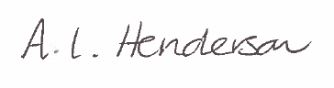
Andrea Henderson

