Head Teacher: Ms Andrea Henderson Dunrossness Primary School
Dunrossness
Shetland. ZE2 9JG
Telephone: 01595 745440
Fax: 01950 460803
E-mail: dunrossness@shetland.gov.uk
Website: www.dunrossness.shetland.sch.uk
Blog: https://blogs.glowscotland.org.uk/sh/dunrossness/
17th June 2019
Dear Parent/Guardian,

JRSO Presentation

Your child will be attending the Junior Road Safety Officer Presentation on Thursday 20th June 2019 at Islesburgh, Lerwick.

Pupils will be accompanied by Mrs Graydon and will be leaving school at 9.45 am and returning to school after lunch.

Children who normally take a school dinner will have a packed lunch provided.

If you do not wish your child to attend the presentation, please let the office know as soon as possible.

Yours sincerely,

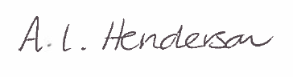

Andrea Henderson.
Head Teacher

