Head Teacher: Ms Andrea Henderson Dunrossness Primary School
Dunrossness
Shetland ZE2 9JG
Telephone: 01595 745440
Fax: 01950 460803
E-mail: dunrossness@shetland.gov.uk
Blog: https://blogs.glowscotland.org.uk/sh/dunrosness/
7th May 2018

Dear Parent/Guardian,

P4/5 Voar Redd Up

P4/5 are planning a Voar Redd Up for Wednesday 19th May 2018. We hope to leave school at 1.45pm and tidy up some of the area surrounding the school. If the weather isn’t suitable, we will try again on Thursday 20th May 2018.

As it is all weather depending, can you please make sure that your child brings suitable clothing and footwear to school on Wednesday and Thursday.

We would appreciate as much help as possible.

We look forward to seeing you on Wednesday.

Yours sincerely
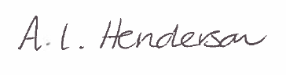
Andrea Henderson

