|  |  |  |
| --- | --- | --- |
| C:\Users\Louise\AppData\Local\Microsoft\Windows\INetCache\IE\1SQHX6VF\plant08[1].gifGrow a plant | Have a family games night | Buy a puzzle book and work on some activities together |
| Tell each other about your day over tea, or just before bed | C:\Users\Louise\AppData\Local\Microsoft\Windows\INetCache\IE\4W74RPFR\music_notes[1].jpgSing together | Explore the seasons – what makes autumn autumn? Look for seeds or crunchy leaves. Look for icy puddles in winter |
| Crafts – make a Halloween costume, or gifts for Christmas | Visit a friend, relative or neighbour | What wildlife can you find on your doorstep? Shetland is full of wonderful animals! Go on a bug hunt |
| Buy a comic or magazine and look at it together | Plan and cook a meal together | Help with household budgeting |
| Learn a new skill – knit, sew, building something from wood. Can a wider family member help? | Help plan the weekly shop, plan what will be eaten for the week, write a list of what is needed too | Geocaching – the app can be downloaded for free |
| C:\Users\Louise\AppData\Local\Microsoft\Windows\INetCache\IE\9V57D6RP\bradleys-book-outlet-books-only-logo[1].pngRead together – visit the library | Help with household chores – life skills that will eventually be needed! | C:\Users\Louise\AppData\Local\Microsoft\Windows\INetCache\IE\4W74RPFR\baking1[1].jpgBake something together, remember to lick the spoon! |
| Watch a classic film together, or watch a documentary, or quiz show and speak about what you see | Recite your times tables as you make tea or walk to the shop | Write a letter to someone, buy a stamp and post it. Wait for a reply! |
| Experience all the different weather we have, get out in the rain and wind, learn to dress appropriately | Visit somewhere new – be a tourist at home | There are lots of colouring books and mindful colouring is very popular, work on something together |

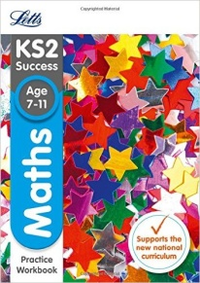

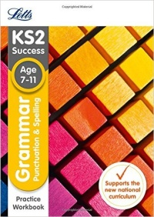Remember, there is a wide range of books available on the internet that can be used at home if you still want more ‘formal’ work for your child:

For example, search ‘Letts’ on Amazon