Head Teacher: Ms Andrea Henderson Dunrossness Primary School
Dunrossness
Shetland ZE2 9JG
Telephone: 01595 745440
Fax: 01950 460803
E-mail: dunrossness@shetland.gov.uk
Website: www.dunrossness.shetland.sch.uk
Blog: https://blogs.glowscotland.org.uk/sh/dunrossness/
23rd May 2016

Dear Parent/Guardian,

We are delighted to have Emily Handley joining our team as Early Years Worker, covering Leona Smith’s maternity. She will start on 13th June but she has already visited and met with staff and pupils.

Until Emily starts Wendy Malcolmson will be Early Years Worker on Monday, Wednesday, Thursday and Friday and Carrie Morrison will cover on Tuesdays.

Interviews for the post of Early Years Assistant, to cover Amy Colvin’s maternity, are on the 1st June.

Thank you for your support at this time of change. We are delighted that the children in our Nursery are so resilient and able to cope with the changes.

If you would like to discuss this any further, please do not hesitate to contact me.

Yours Sincerely,

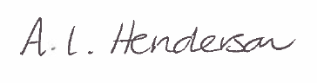

Andrea Henderson

