

**Nurture; Reconnection, Recovery, Resilience**

***Supporting Shetland’s Transition Back to School and Beyond***

**Shetland Islands Council**

**Children’s Services**

**Educational Psychology Service**

**Contents**

Introduction Page 1

Using the Framework Page 2

The 6 Nurture Principles and the RRR Framework Page 5

References Page 13

**Appendices**

Appendix 1: Synergy Page 14

Appendix 2: Seasons for Growth Page 15

Appendix 3:

Nurture, Synergy, Seasons for Growth, Trauma Informed Practice and Page 19

Appendix 4: Specific Interventions Page 20

**Nurture; Reconnection, Recovery, Resilience**

**Supporting Shetland’s Transition Back to School and beyond**

**Introduction**

This document sets out a framework designed to support the transition for children and young people back to school following closures as a result of Covid-19. It is intended to provide guidance to schools and the local authority to assist in the planning and delivery of that support at a school, class and family/individual level. It is fundamental premise of this work that all recovery planning focuses first on meeting the health and wellbeing needs of children, young people their families and the staff that support them.

It is important that the transition back to school is viewed as a process and not an end point. Therefore we accept that the Nurture: Reconnection, Recover and Resilience approach will have relevance beyond the date on which school reopen. Ongoing change and uncertainty has become part of all our lives as we live through a pandemic and experience its unfolding psychological, social and economic effects. It is important that we are able to recognise and respond to this in the months ahead, and particularly so for those who are disadvantaged or further disadvantaged by Covid-19, are already vulnerable and/or have additional support needs.

This framework recognises that across our schools and children’s services we already have a range of evidenced based approaches that can support children’s and young people’s health and wellbeing as part of our Covid-19 response.

Three approaches have particular relevance:

* [Nurture](https://www.nurtureuk.org/nurture/what-nurture)
* Synergy (Appendix 1)
* Seasons for Growth (Appendix 2)

This frameworks utilises and builds on these key approaches and develops them further by referencing 3 key interconnected and related themes of reconnection, recovery and resilience (please see figure 1). Developing and strengthening Nurturing practices is central and the key components are outlined in figure 2. This framework has been informed by Glasgow City Council’s Recovery, Resilience and Re-connection Scenario for a return to school/nursery Discussion Paper.

Figure 1

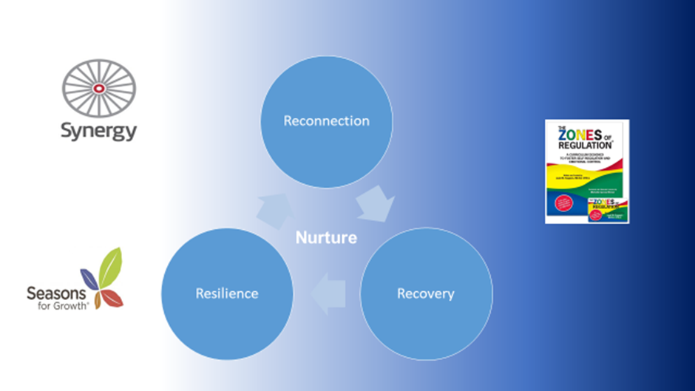

Nurture is central to this work which is defined by Education Scotland as:

*‘A nurturing approach recognises that positive relationships are central to both learning and wellbeing. A key aspect of a nurturing approach is an understanding of attachment theory and how a child’s early experiences can have a significant impact on their development. It recognises that ALL school staff (and partners) have a role to play in establishing the positive relationships that are required to promote healthy social and emotional development and that these relationships should be reliable, predictable and consistent where possible. A nurturing approach has a key focus on the school environment and incorporates attunement, warmth and connection alongside structure, high expectations and a focus on achievement and attainment’ (Applying Nurture as a Whole School Approach, ,Education Scotland).*

It is based on understanding of the 6 nurturing principles:

* Children’s learning is understood developmentally.
* Environment offers a safe base.
* Nurture is important for the development of wellbeing.
* Language is a vital means of communication.
* All behaviour is communication.
* Transitions are significant in the lives of children and young people.

**Using the Framework**

The Framework on page 4 sets out the 6 Nurture Principles and particular considerations/suggestions for practice and intervention under each theme of reconnection, recovery and resilience. Getting it Right for Every Child (GIRFEC) is core to enactment of practice set out in this document and is referenced throughout. Specific interventions e.g. The Zones of Regulation and links to good practice are also included where relevant and are described in more detail in the Appendix 4.

There is space for practitioners to comment and make notes. In this way can be used to facilitate reflection, audit practice and strategies and intervention. It can be used at the level of the individual child, class or school.

What we mean by interconnected themes of reconnection, recovery and resilience in the context of this work is described below:

Reconnection/Connection

Given that positive, warm and nurturing relationships are central to wellbeing, learning and development there will be a fundamental need to reconnect with children, young people and their families. We should continue to build and invest in relationships as a priority. Staff too will require opportunities for reconnection and relationship building and their wellbeing is paramount in order to build capacity to support our children and young people. Positive relationships, feeling connected to our schools and communities and having a sense of belonging is the basis of recovery and resilience and should be at the heart of our nurturing approach.

Recovery

There should be a strong focus on wellbeing of children, young people, their families and staff. There will be a need to continually be aware and understand the journey of children and young people and their families through the pandemic. For some children, the experience of ‘lockdown’ will have been positive and the majority will recover and adapt well even in the face of ongoing uncertainty. However, for some children and young people lockdown and the ongoing pandemic will have caused and might continue to cause significant adversity. The burden of the impact of the indirect consequences will fall disproportionately on children, particularly those who are already disadvantaged or vulnerable. It is important to remember too that we might not always know which families are struggling. The ongoing effects of the pandemic will require monitoring for everyone and help and support. It will be important to understand the journey and seek to mitigate its effects.

Resilience

Here we recognise and focus on the human capacity to be resilient. Now more than ever we should seek to develop resilience in children, young people and their families and the staff who support them. Being resilient helps us to cope, manage and adapt to challenge and adversity and to recover more quickly from difficult experiences. Resilience helps sense of optimism and self-efficacy and affords us opportunities to reflect on personal growth and success. Resilience is fostered by positive relationships, a sense of connection and belonging, self-awareness and understanding and emotional literacy.

The Nurture; Reconnection, Recovery and Resilience Framework

|  |  |
| --- | --- |
| 1. **Children’s learning is understood developmentally** | |
| *It is important to assess pupils’ health and wellbeing needs before returning to school to ensure that planned activities are manageable and allow success. Basic needs such as safety and security, relationships, and emotional support must be re-established before assuming readiness to learn. The attainment gap may have widened or altered during school closures.* | |
| Reconnection | Comments: |
| * Protected time is needed to reconnect with individual families to identify changes in circumstances and signpost relevant provision, e.g. unemployment/furlough, loss/bereavement/ separation, childcare, transport etc. |  |
| * Prepare to repeat some developmental stages and learning, teach new rules and routines etc. |  |
| * Re-establish classroom and school rules, and relationships for comfort. |  |
| * Staff have a basic understanding of the 6 Nurture Principles and have completed the Nurture training available on [iLearn](http://intranet2.shetland.gov.uk/Policy/SitePages/iLearn.aspx). |  |
| * Teachers understand the varying impact of Coronavirus in terms of change and loss according to the Seasons for Growth recovery model (Appendix 2). |  |
| * Returning to school resources are accessed and used to prepare children and families via [SIC Digital Schools Hub](https://blogs.glowscotland.org.uk/sh/digitalschoolhub/staff/additional-support-needs/). |  |
| Recovery | Comments: |
| * The [GIRFEC National Practice Model](https://www.gov.scot/publications/girfec-national-practice-model/) is used to assess and monitor wellbeing according to the SHANARRI indicators and wellbeing wheel. |  |
| * Staff are aware that a period of readjustment is to be expected in the current situation; this is not regression and, in isolation, is unlikely to warrant specialist service involvement. In this time of change and uncertainty difficult feelings and emotions are to be expected/normal and shouldn’t be medicalised. Listening and responding with empathy, understanding and reassurance will form an important part of the support.   “*We must guard against medicalising our response, and defaulting to an increase in Child and Adolescent Mental Health Services (CAMHS) referrals*,” ([Scottish Government, 2020](https://www.gov.scot/publications/vulnerable-children-report-15-2020-scottish-government-solace/)). |  |
| * The return to school prioritises the hierarchy of needs to be met before academic attainment or achievement is expected: safety and security; relationships and belonging; self-esteem. |  |
| Resilience | Comments: |
| * Emotional literacy and self-regulation programmes such as [The Zones of Regulation](http://www.zonesofregulation.com/index.html) and [The Incredible 5 Point Scale](https://www.5pointscale.com/) should be considered to support children and young people to recognise feelings in themselves and others, and express and manage these effectively. * Consider the Compassionate and Connected Classroom: A health and wellbeing curricular resource for upper primary <https://education.gov.scot/improvement/learning-resources/compassionate-and-connected-classroom> |  |
| * Access to calming tools and routines and mindful based approaches such as ZENS Schools to support self-regulation |  |
| * All children should have access to nurturing experiences in schools that promote their recovery and resilience and reconnection with staff, friends and peers. Some children will benefit from targeted Nurture groups. |  |
| * SIC’s [Digital Schools Hub](https://blogs.glowscotland.org.uk/sh/digitalschoolhub/staff/additional-support-needs/) and Glow platform provides access to resources and activities for social and emotional development and additional support needs. There is also a section of useful tools to support a return to school. |  |
| * For some children and young people, more targeted support may be needed if they experience ongoing struggles following change or loss. The traditional Seasons for Growth programme would be recommended after the recovery model (appendix 2) has been implemented. |  |
| 1. **The classroom offers a safe base** | |
| *The classroom layout and surroundings should be as warm, welcoming and predictable as possible. Boundaries should be established which teach appropriate behaviour and advocate safety and responsibility rather than punitive approaches.* | |
| Reconnection | Comments: |
| * Staff have opportunities to reconnect with colleagues and address own wellbeing needs before pupils return. |  |
| * Consistent and accessible information is shared across all schools and families regarding how schools will reopen and operate, and alleviate health and safety concerns |  |
| * It is recognised that there may be anxiety about proximity to others and planning is undertaken to manage this – pick up, drop off, playground, classroom, dining hall, toilets etc. |  |
| * Pupils have opportunities to reconnect with previous teachers as part of transition process. |  |
| * Changes are planned, predictable and explained. |  |
| * Staff are aware of relevant policies / updates, including dealing with crisis/ bereavement. |  |
| * Coordinated support is planned for NQTs. |  |
| Recovery | Comments: |
| * The school environment adheres to government & SIC guidelines for safety/personal protection. |  |
| * Appropriate signage and reminders are displayed and accessible to all. |  |
| * Re-establish routines to help establish feelings of safety. What is the same / different? Changes are explained in a developmentally appropriate way with visual aids and [social stories](https://blogs.glowscotland.org.uk/sh/digitalschoolhub/staff/additional-support-needs/) if appropriate. |  |
| * Create a sense of belonging through personalising the environment where possible while maintaining safety. * Staff have accessed are aware of and recognise the potential impact of trauma and adversity and have accessed information such as : <https://www.nes.scot.nhs.uk/education-and-training/by-discipline/psychology/multiprofessional-psychology/national-trauma-training-framework/trauma-informed-resources-opening-doors-and-sowing-seeds-animations.aspx>   And completed the Introduction to Trauma Informed Practice on ILearn: <http://intranet2/Policy/SitePages/iLearn.aspx> |  |
| Resilience | Comments: |
| * Safe, quiet spaces and access to pastoral support form part of schools’ health and wellbeing policies and planning. |  |
| * Pupils, families and staff are aware of how and where they can seek support in confidence. |  |
| * Information and signposting to access support is regularly reviewed, updated and shared. |  |
| 1. **The importance of Nurture for the development of wellbeing** | |
| *Unconditional positive regard is essential for children to develop a positive internal working model which tells them that they are worthwhile and resilient. Reassuring children that they have ‘normal reactions to abnormal events’ helps them feel accepted and re-establishes positive roles and routines.* | |
| Reconnection | Comments |
| * Confirm school priorities for term/session, acknowledging that health and wellbeing are prerequisites to attainment. |  |
| * Define immediate and ongoing support structures and systems for staff and pupil wellbeing. |  |
| Recovery | Comments: |
| * [How Nurturing Is Our School](https://education.gov.scot/improvement/Documents/inc55ApplyingNurturingApproaches120617.pdf) is used to prompt discussion about how to develop Nurture as a whole school approach in the current climate. |  |
| * Additional regular check-ins are offered to monitor and respond positively to pupils’ experiences and emotions, e.g. Zones of Regulation. * Awareness prevalence and impact of trauma and how nurturing relationships can support recovery. |  |
| Resilience | Comments: |
| * Schools consider how to track, monitor and seek individuals’ views to constantly support and improve the wellbeing of their pupils, families and staff. |  |
| * Growth mindset is promoted through teaching and learning. |  |
| * Success is measured through effort, enjoyment and participation as well as attainment. |  |
| * Highland’s [Resilient Kids](https://education.gov.scot/improvement/documents/sac86-Highland-EPS-Resilient-Kids.pdf) program is introduced across SIC schools as an example of evidence based practice to teach pupils emotional literacy and resilience |  |
| 1. **Language is a vital means of communication** | |
| *Children should be encouraged to talk, be listened to, and have positive language modelled by adults around them. Where language presents a barrier to understanding or expression, support should be offered. Nonverbal communication and language should always be positive and help the child to express their needs and emotions.* | |
| Reconnection | Comments |
| * New jargon and language needs to be discussed and clarified among professionals before teaching to children and parents, e.g. pandemic, social distance, ‘trauma’, ‘post Covid stress disorder’ * The use of simplified language and scripts and the use of visuals and social stories to support understanding. |  |
| * A consistent ‘*Reconnect, Recover, Resilience*’ message should be promoted across services for an effective multi-agency joined-up response. |  |
| * Information should be gathered about individual children’s and families’ experiences during lockdown in advance of their return to school, to inform planning for recovery. |  |
| Recovery | Comments: |
| * Accessible information is available to children and families in advance of their return to school. |  |
| * Consistent language is introduced and modelled to improve emotional literacy, e.g. Zones of Regulation / Seasons for Growth. |  |
| * Schools consider how to maintain connectedness and inclusion such that pupils and families feel affiliated to their local school and community despite inevitable disconnect. |  |
| Resilience | Comments: |
| * CfE health and wellbeing [experiences and outcomes](https://education.gov.scot/Documents/health-and-wellbeing-eo.pdf) are closely monitored and used to plan progress at an individual level. |  |
| * Schools and other agencies prioritise language and communication in children’s plans and ensure accessible opportunities exist for pupils to express their views about decisions that affect them. |  |
| * Emotional literacy is revisited in a cyclical approach to promote health and wellbeing as children progress developmentally. |  |
| 1. **All behaviour is communication** | |
| *All behaviour should be considered to be communicating something that the children perhaps do not have the language or maturity to express otherwise. Behaviour should always be managed calmly and positively by adults to avoid escalation and consequences should focus on recovery and repair.* | |
| Reconnection | Comments |
| * Seasons for Growth recovery model training (appendix 2) informs staff of expected behaviours and appropriate ways to manage/respond to these. * Dr Bruce Perry’s 3R’s model also offers staff a framework of how to help children to self-regulate. |  |
| * Care is taken not to medicalise behaviours that are considered appropriate and expected responses to the current situation. |  |
| Recovery | Comments: |
| * Resources, such as those on [Glow](https://blogs.glowscotland.org.uk/sh/digitalschoolhub/staff/additional-support-needs/), are made available to help parents and pupils recognise, express and manage their emotions positively. |  |
| Resilience | Comments: |
| * All staff understand that pupils’ behaviours may be communicating an unmet need and use appropriate problem-solving and recording to identify this need. |  |
| * Behaviours are not prevented or discouraged without offering and teaching a more appropriate alternative. |  |
| * Emotional literacy programmes are accessible at all ages and stages of children’s and young people’s education, e.g. Zones of Regulation, cognitive behavioural approaches etc. |  |
| 1. **The importance of transition in children’s lives** | |
| *Times of change and uncertainty can lead to stress and anxiety and this should be reduced where possible through consistent positive relationships, predictability, structure, and routine. Transition also offers opportunities to build resilience through learning effective coping mechanisms and reflecting on growth and success.* | |
| Reconnection | Comments |
| * Appropriate planning and resources are prepared to support pupils transitioning at all stages according to [National Improvement Hub](https://education.gov.scot/improvement/learning-resources/transitions/). |  |
| * Positive **and** negative experiences of Covid-19 are explored and discussed and used to plan appropriate responses/activities. |  |
| * Consider how to reconnect with those who have left, moved, retired, taken maternity leave etc. |  |
| * Transition passports / pupil profiles are completed and shared with new or unfamiliar staff. |  |
| Recovery | Comments: |
| * Seasons for Growth recovery model is delivered to support staff and children to return to school (appendix 2). |  |
| * Enhanced transitions are provided for ASN pupils/groups. |  |
| * Transition activities/plans/provisions are made for unstructured times and smaller daily transitions, e.g. playground/lunchtime. |  |
| * Consideration is given about how to re-engage with non-attenders and pupils who have preferred being at home and not in school. |  |
| Resilience | Comments: |
| * Transition support and information sharing is carefully planned for all significant transitions. |  |
| * It is recognised that transitions affect everyone differently and that an individualised approach to supporting transitions is needed based on the child or young person’s needs. |  |
| * Children and young people are offered opportunities to reflect on transitions and identify positives and losses associated. |  |
| * The profile of Seasons for Growth is raised across Shetland and is actively promoted to all families at various stages to fully utilise the capacity of the team of ‘Companions’ across the local authority. Schools should be mindful that they may not necessarily be, nor need to be, aware of changes and losses affecting their pupils and staff, and that this should not hamper access to support. |  |

|  |  |
| --- | --- |
| **For more information contact:**    **Rhonda Simpson**  Principal Educational Psychologist  [Rhonda.Simpson@shetland.gov.uk](mailto:Rhonda.Simpson@shetland.gov.uk) |  |
| **Lynn Nicholson**  Senior Education Outreach Worker (ASN)  [Lynn.Nicholson@shetland.gov.uk](mailto:Lynn.Nicholson@shetland.gov.uk) | **Helen Tait**  Manager Education Outreach Service (ASN)  [Helen.Tait2@shetland.gov.uk](mailto:Helen.Tait2@shetland.gov.uk) |

**Further reading and references**

[https://www.epinsight.com/post/supporting-post-lockdown-education-using-the-6-principles-of-Nurture](https://www.epinsight.com/post/supporting-post-lockdown-education-using-the-6-principles-of-nurture)

<https://education.gov.scot/improvement/Documents/inc55ApplyingNurturingApproaches120617.pdf>

[https://www.Nurtureuk.org/what-we-do/news/news/Nurture-schools-needed-now-more-ever](https://www.nurtureuk.org/what-we-do/news/news/nurture-schools-needed-now-more-ever)

[https://dera.ioe.ac.uk/31839/1/inc83-making-the-links-Nurture-ACES-and-trauma.pdf](https://dera.ioe.ac.uk/31839/1/inc83-making-the-links-nurture-ACES-and-trauma.pdf)

<https://www.nes.scot.nhs.uk/education-and-training/by-discipline/psychology/multiprofessional-psychology/national-trauma-training-framework.aspx>

Appendix 1: **Synergy**

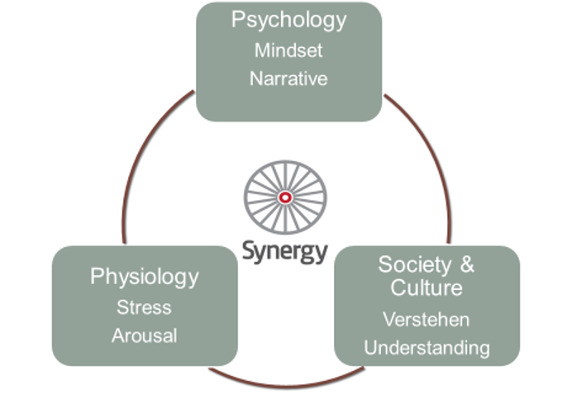

Psychology

Synergy tells us to be mindful of our *mindset*. Mindsets can affect our thoughts, our feelings and our behaviour. Fixed mindsets can prevent us from taking new and possibly helpful action. Synergy encourages us to have a mindset that is positive, open and willing to consider new ideas and opinions.

Developing a positive mindset can help us overcome difficult and challenging problems and situations.

Sociology

Synergy recognises the importance and influence of culture in all aspects of human behaviour. The cultures surrounding our children and young people should be nurturing, kind and respectful of difference.

We need to be aware of the potential impact of stigma on children and young people. Where negative narratives exist around children and young people and we need to work to ensure these are challenged and changed.

Synergy reminds us of social learning theory and the importance of role models. Children learning first and foremost by watching others. We therefore need to be mindful of our own behaviour and model the behaviour we want to see in our children.

Physiology

Perhaps most powerful of all the synergy messages, is the one that we need to be mindful of the role of stress and arousal in human behaviour and its impact on judgement and decision making. This is true for everyone, children, young people and adults alike.

When we are stressed our brains do not work well. The thinking parts of the brain shut down and give over to the emotional brain. According to Synergy when we are thinking with our emotional brain we are in ‘system 1’. We can make poor decisions in system 1 and we can act and behave in ways that are extreme and unhelpful.

When we are thinking with our rational brain, we are in ‘system 2’. We are able to respond better and more constructively in system 2. We make more considered decisions and choices and tend to act and behave in more helpful ways.

Synergy teaches us to recognise these systems in ourselves and others. It provides us with a framework to help us engage our rational brains in system 2 particularly in times of challenge and difficulty. Synergy helps us acknowledge the role of stress and supports us to manage it. We are then in turn able to respond as positively and as helpfully as we can.

Appendix 2: Seasons for Growth



**Context:**

Seasons for Growth is an educational programme originating in Australia which supports children and young people to look at their responses to change and loss in life. The emphasis is on peer support, normalising the emotions associated with change and loss and promoting resilience. It is not counselling or therapy.

The programme is widely delivered in most local authorities in Scotland and is recognised as good practice by HMIE. It fulfils many of the Health and Wellbeing outcomes in the Curriculum for Excellence (here see p2 + p19):

*Mental, emotional, social and physical wellbeing are essential for successful learning.*

*A resilient child can resist adversity, cope with uncertainty and recover more successfully from traumatic events or episodes.*

The Seasons for Growth programme has been delivered in Shetland schools and other agencies since 2003 by our network of locally trained Companions, most of whom are based in schools. During session 2018-2019 approximately 100 pupils participated in Seasons groups, the majority of these being P7 groups with a specific transition focus.

**Response to Covid-19:**

Given that this positively evaluated and well evidenced intervention is already established locally, it would be ideally placed to provide support for staff and pupils at this time of such change and uncertainty.

The network of Seasons for Growth Trainers in Scotland identified a need nationally for initial bespoke, stand alone, online training. This training will retain the key principles of the programme whilst increasing accessibility and taking into account the impact COVID-19 is having on our lives.

**Additional Resources:**

For this reason a national working group was created. The network of Seasons for Growth Trainers in Scotland has been meeting weekly, with hugely helpful input from our partners in Australia and New Zealand, to look at how to adapt the programme for universal delivery.

Seasons for Growth has a focus on the importance of building supportive relationships, therefore existing staff-pupil relationships provide us with a positive foundation to build upon.

The planned initial universal approach to delivery aims to ensure equity of provision to all staff and pupils, again stressing the importance of positive relationships, normalising feelings and building resilience. This is very much in line with our authority approach to the promotion of a nurturing community.

The current project will complement the existing suite of Seasons for Growth programmes available locally. It is likely that the delivery of these generic modules will help to highlight any child, young person or staff member who may require additional and more focused support. The Seasons Trainers will be able to assist in these discussions.

**Plan for Delivery:**

Like everything else at this time, these plans evolve and change regularly so the following information should be viewed as an outline structure:

* Priority is to finalise a presentation for staff teams by late May. This will then be delivered by the two Shetland Trainers with support from Companions online asap. This presentation will then enable staff to deliver a face to face input to children and young people once a physical return to school is possible
* Work is underway to complete two pupil presentations, one for children and one for young people, for delivery on return. The aim will be that these will ‘fit’ into a 50 min period, however more time may be needed depending on participants
* There will be ongoing support for staff to enable this delivery through our two local Trainers, with signposting to other services where required
* Information on the full suite of Seasons for Growth programmes available locally will be circulated following the universal delivery to staff

**Seasons for Growth Recovery Model Plan for Shetland**

|  |  |
| --- | --- |
| Nationally agreed presentation for SfG Trainers to deliver remotely to schools staff/staff in other settings |  |
|  |  |
| Staff having attended presentation to deliver nationally agreed presentations to Ch + YP in their current settings face to face with support from identified trained Companions in the authority |  |
|  |  |
| Ongoing support available through Trainers + Companions as appropriate |  |
|  |  |
| Information on full SfG programmes to be recirculated to all settings in anticipation of future need following return to school for those who have experienced particularly difficult loss + change |  |

Appendix 3

**Nurture, Synergy and Seasons for Growth; Links to Trauma Informed Practice**

Our three key approaches help us to be trauma aware and trauma responsive, in short they help develop Trauma Informed Practice according to the 4 Rs: *Realise Prevalence, Recognise Impact, Resist Retraumatisation, Respond (see Figure 3).*

They do this by:

* Putting positive relationships at the centre of health and wellbeing
* Understanding development according to the Nurture Principles
* Encouraging self-awareness and self-control
* Reminding us to practice kindness, empathy, tolerance and respect.
* Developing understanding and knowledge of personal journeys and experiences
* Recognising impact of loss and change

Figure 3

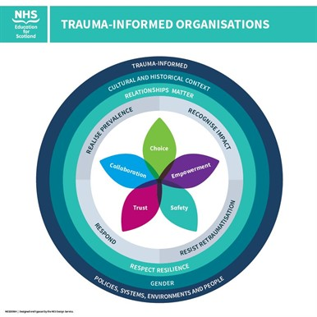

Appendix 4: Specific Interventions

The 3 R’s: How to support a child in distress

Credits to: Dr. Bruce Perry, Beacon House, South Ayrshire Council

Dysregulation occurs when the brain responds to sensory input in a manner that triggers the alarm state. This is referred to as the **Amygdala Hijack**.

The Amygdala is one of the smallest parts of the brain, but can be very powerful and “hijack” children’s emotions.  It processes emotions such as anger, fear and anxiety.  It responds to stress by either telling children’s brain to *fight* (panic attack or temper tantrum), *flee* (run) or *freeze* (shut down).

When hijacked, the rest of their brain that helps them make good choices, shuts down, being harder to listen, comprehend and cope. Practitioners may notice the following in a child:

* A strong emotional reaction with a sudden onset,
* Regret for their actions on reflection (when they are able to rationalise).

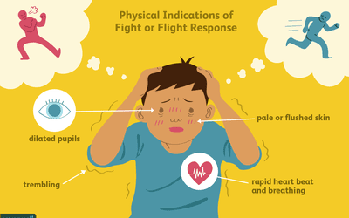

Credits to: verywellmind.com

Adults can help children learn to control their Amygdala and keep them from being “hijacked”. Dr. Bruce Perry developed a simple sequence to support this by going through 3 different steps with the dysregulated child. It is known that heading straight for the ‘reasoning’ part of the brain will not work well because as we’ve seen before, that bit of the brain shuts down when a child is in distress. Adults should instead regulate the child’s brain from the bottom up suing the **3R’s of Regulate, Relate and Reason**. The first stage of which is ensuring that you are regulated yourself - if safe to do so, get down on their level.

No matter the reason why a dysregulated brain state occurred, it’s not useful to discipline children’s behaviour or label it something that it is not. **Until a child is regulated, they are unlikely to relate to you** (feel connected). And **until a child is related, they are unlikely to have the mental capacity to reason with you.**

**Regulate:**

* Identify the source of the child’s trigger, then shift the focus on calming the child,
* Focus on soothing - since the young person is in the lower parts of their brain trying to reason with them won’t work. At this stage you’re all about making them feel calm, safe and loved.
* Use methods to calm and support the particular child, one size does not fit all.

**Relate:**

* As they calm down use short sentences e.g. *“I know you’re upset right now”, “I know this is very hard”*
* You can validate their feelings with your words and tone of voice while also providing them with a hug or even taking their hand.
* Your focus here is connecting with the child.

**Reason:**

* Once the young person is calm, you can make a plan together about how to move forward, possibly coming up with alternatives ideas about how they might respond if something similar happened again.
* You can reassure them that you love/care for them, but the behaviour they exhibited is not okay

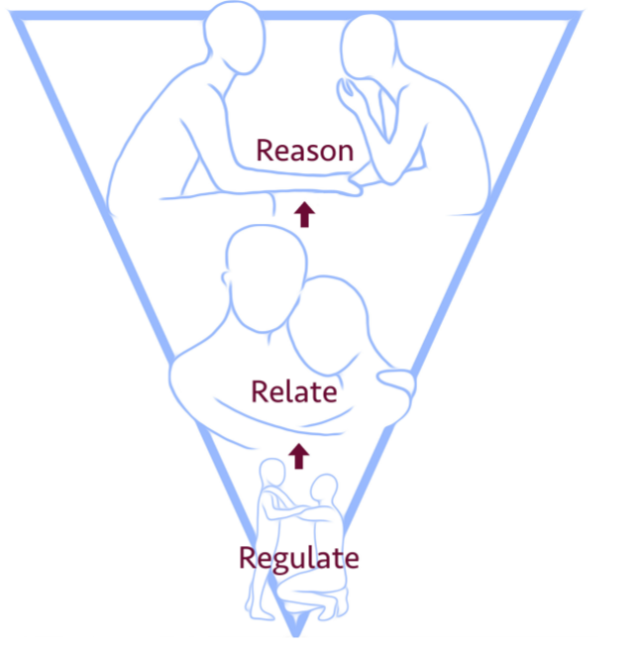

**First**: We must help the child to regulate and calm their fight/flight/freeze responses.

**Second**: We must relate and connect with the child through an attuned and sensitive relationship.

**Third**: We can support the child to reflect, learn, remember, articulate and become self-assured.

E.g.:

* Give time and space – if that helps
* Reduce language and keep language simple
* Reduce further demand – step back
* Model calm behaviour and model strategies and stay in control as the adult – use calm reassuring voice.
* Acknowledge and name the feeling -
* Teach strategies e.g. breathing, blow the anger,
* Give options for time out, to go to safe space
* Consider use of distractors/comforting objects/activities e.g blanket, teddy, fidget toy etc.

E.g.:

* Give reassurance, stay/be with child – if that helps
* Provide comforting presence; let them know you will help.
* Acknowledge and name the feeling or emotion – be empathetic and show understanding.
* Attune to the child – what do they need right now? Cuddle, reassurance, a familiar soothing activity that you can do together?

E.g.:

* Social stories or simple ‘scripts’ to support understanding.
* Discussion of alternatives for angry behaviour – use visuals to remind.
* The Zones of regulation
* Approach this developmentally – manage and explain as you might a younger child.

The below diagram helps you understand the 3R’s sequence and has some examples of what adults can do to support dysregulated children.

On this page, the diagram has blank spaces to be complete with ideas of what you might do to help your child in the different phases of the regulation process.



**First**: We must help the child to regulate and calm their fight/flight/freeze responses.

**Second**: We must relate and connect with the child through an attuned and sensitive relationship.

**Third**: We can support the child to reflect, learn, remember, articulate and become self-assured.



The Zones of Regulation

*The Zones of Regulation* is a systemic, cognitive behavioural approach that comprehends a range of activities to help children develop skills in the area of self-regulation. Self-regulation can go by many names, such as self-control, self-management and impulse control. It is defined as the best state of alertness of both the body and emotions for the specific situation. For example, when a child plays in a basketball game, it is beneficial to have a higher state of alertness. However, that same state would not be appropriate in the library.

**Some of the aims of *The Zones of Regulation* programme are:**

* To help children recognise when they are in the different Zones and how to change or stay in the Zone they are in.
* To gain an increased vocabulary of emotional terms so that they can explain how they are feeling.
* To gain insight into events that might make them move into the different Zones eg. disagreement with a friend, a certain subject being taught or a fire drill.
* To help children understand that emotions, sensory experiences, physiological needs (eg. hunger/lack of sleep) and environments can influence which Zone they are in.
* To develop problem-solving skills.
* To identify a range of different calming and alerting strategies/tools that support them. Tools identified may be personalised sensory supports, calming techniques or thinking strategies.

**The Colours:**

**Blue:** is used to describe low states of alertness and down feelings such as when one feels **sad, tired, sick, or bored**.

**Green:** is used to describe a calm state of alertness. A person may be described as **happy, focused, content, or ready to learn** when in the Green Zone.  This is the zone where optimal learning occurs.

**Yellow:** is also used to describe a heightened state of alertness and elevated emotions, however one has more control when they are in the Yellow Zone.  A person may be experiencing **stress, frustration, anxiety, excitement, silliness, the wiggles, or nervousness** when in the Yellow Zone.

**Red:** is used to describe extremely heightened states of alertness and intense emotions.  A person may be **elated or experiencing anger, rage, devastation, or terror** when in the Red Zone.



The Zones of Regulation curriculum has 18 lessons that can be delivered to a whole class or a specific group of children. It can also be used with a targeted individual.

**More information is available on** [**www.zonesofregulation.com**](http://www.zonesofregulation.com) **and the EPS can also be contacted for further guidance/support.**

References:

The Zones of Regulation: A curriculum designed to foster self-regulation and emotional control by Leah Kuypers

The Incredible 5 Point Scale

The Incredible 5-Point Scale, created by Kari Dunn Buron and Mitzi Curtis (2003), provides a visual representation of social behaviours, emotions, and abstract ideas. It is a simple scale used to teach social understanding. Kari stresses, that "the scale is about breaking social and emotional concepts into 5 parts. It is a teaching tool".

The Incredible 5-Point Scale simplifies behaviours by assigning them a number and /or colour. A scale is created for a specific individual or group of individuals and tailored for a specific situation or behaviour. It was developed to support the understanding of social situations by children on the Autism Spectrum Disorder, but can be used by any child as it’s a visual and very simple way of promoting understanding of different behaviours.

The premise is easy and can be adapted for almost every behaviour or expectation imaginable. In their book, The Incredible 5-Point Scale: Assisting Students in Understanding Social Interactions and Controlling Their Emotional Responses, Buron and Curtis (2003), provide multiple examples for use including: (a) controlling voice level, (b) dealing with obsessive behaviours, and (c) meeting and greeting others to name a few.

The key is to identify the behaviour, whether it be reducing anxiety around a situation by providing 5 steps or strategies, or labelling the levels of voice from whispering to shouting. Once a behaviour is identified, it needs to be task analysed or broken into concrete parts. An example provided by Buron and Curtis deals with understanding emotions from happy to angry. For their example, faces are used to identify or tag the feelings for the child. The child, working one on one with an adult, is taught what "angry" looks like, what it "feels" like, and how to get help or what to do when they are angry.

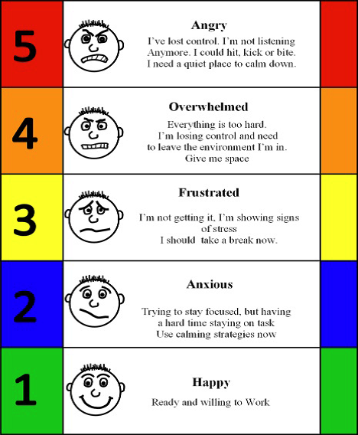

References:

The Incredible 5-Point Scale: Assisting Students in Understanding Social Interactions and Controlling Their Emotional Responses by Kari Dunn Baron and Mitzi Curtis

Mindfulness: The Zen Schools programme

Zen Schools is a resource pack which has been compiled by Educational Psychologists in consultation with the Education Outreach Service. The pack is intended to be used by teaching staff to support a mindfulness approach, particularly in primary schools. It includes 6 lessons based on the principles of: Awareness, Curiosity, Kindness (to self and others), Acceptance, Gratitude and Resilience.

Mindfulness is a state – an awareness and a mindset that we carry through life. But this state can be developed, or enhanced through activities. These activities are often also referred to as “meditation” or as “mindfulness practice”. Mindfulness practice can be divided into formal and informal practice.

Formal practice is mindfulness meditation where you sit, usually with the eyes closed, and focus attention on one thing, usually either your breathing or the sensations experienced within your body.

With informal practice you bring the same kind of improved attention that you might get from formal practice to everyday situations. This involves directing your full and non-judgemental attention to the activity you’re undertaking at a particular moment – it might be taking a shower, getting dressed, chatting with a friend or teaching. Reading is a great example of how we can benefit from informal mindfulness practice – where we need our full attention to really comprehend the words on the page, rather than being distracted or lost in other thoughts and not actually aware of what we are reading.

Mindfulness offers a range of benefits to support pupil’s readiness and engagement with learning. It is an effective tool for settling and focusing children at the beginning of any classroom activity, and is also a practice that strengthens and develops important cognitive skills related to learning, such as attention, concentration and memory.

Mindfulness can facilitate the development of important social and emotional skills through each developmental stage of a pupil’s life. It provides a foundational awareness and understanding of thoughts, emotions and behaviours and how to self-regulate. It also reduces emotional reactivity, behavioural issues, anxiety and depression.

Mindfulness also provides a calmer and more peaceful environment for both staff and pupils in the school.

**Training and support to implement this approach across Shetland schools is provided by the EPS.**

References:

Zen Schools by Shetland Islands Council Educational Psychology Service

Cognitive Behavioural Approaches

Cognitive behaviour therapy (CBT) is a term used to describe psychotherapeutic interventions that aim to reduce psychological distress and maladaptive behaviour by altering cognitive processes (Kaplan et al., 1995 *in* Stallard, P., 2002). CBT is based on the underlying assumption that affect and behaviour are largely a product of cognitions and, as such, that cognitive and behavioural interventions can bring about changes in thinking, feeling and behaviour (Kendall, 1991 *in* Stallard, P., 2002), it’s proved to work **very effectively for children and adolescents to overcome conditions such as**[anxiety](https://www.clinical-partners.co.uk/child-adolescents/a-z-of-issues/teenage-and-child-anxiety-support)**,**[depression](https://www.clinical-partners.co.uk/child-adolescents/a-z-of-issues/depression-in-children)**, OCD and anger management.**

The aim of CBT is to challenge patterns of behaviour and thought processes that are negative, destructive or distressing and replace them with more positive thought patterns.

**CBT works with the relationship between thoughts, feelings and behaviours.**

What you think

How you feel



What you do



CBT is based on the theory that it is not the event itself that people find upsetting, but the meanings that they associate with the event. It is very common for people to start believing their negative thoughts, even when they are unfounded. These beliefs become so powerful they alter how we behave. As our behaviours reinforce our thoughts, a negative cycle starts.

CBT aims to ‘reprogram’ people’s brains by identifying negative assumptions and helping them gain control of their thoughts, by challenging assumptions, encouraging healthy ‘self-talk’, finding effective coping strategies and, where suitable, facing the feared situation to show that things are in fact OK.

The benefits of CBT may include:

* Receiving emotional support
* Resolving conflicts with others
* Understanding how feelings impact thoughts and actions
* Reversing negative patterns of thinking, addressing bad habits
* Appropriately dealing with stress and frustration
* Participating positively in a variety of activities
* Setting goals to replace negative patterns of behaviour with positive ones
* Increase in self-esteem
* Improved performance at school, at home and in social situations
* Building emotional resilience and problem-solving abilities

**The EPS has two CBT programmes, one aimed at children and another at adolescents. Staff interested should get in touch with us for further guidance and support.**

References:

Think Good, Feel Good by Paul Stallard

Transition Passports

Transition passports can be useful for a child or group of children transitioning to a new stage e.g. nursery to primary 1 or primary 7 to secondary. The child should be involved in completing the passport and this should be used to share information about them e.g. likes, dislikes, future plans, adaptations required, etc. These can be personal and engaging for the child and help them to envisage a plan of support moving forward.

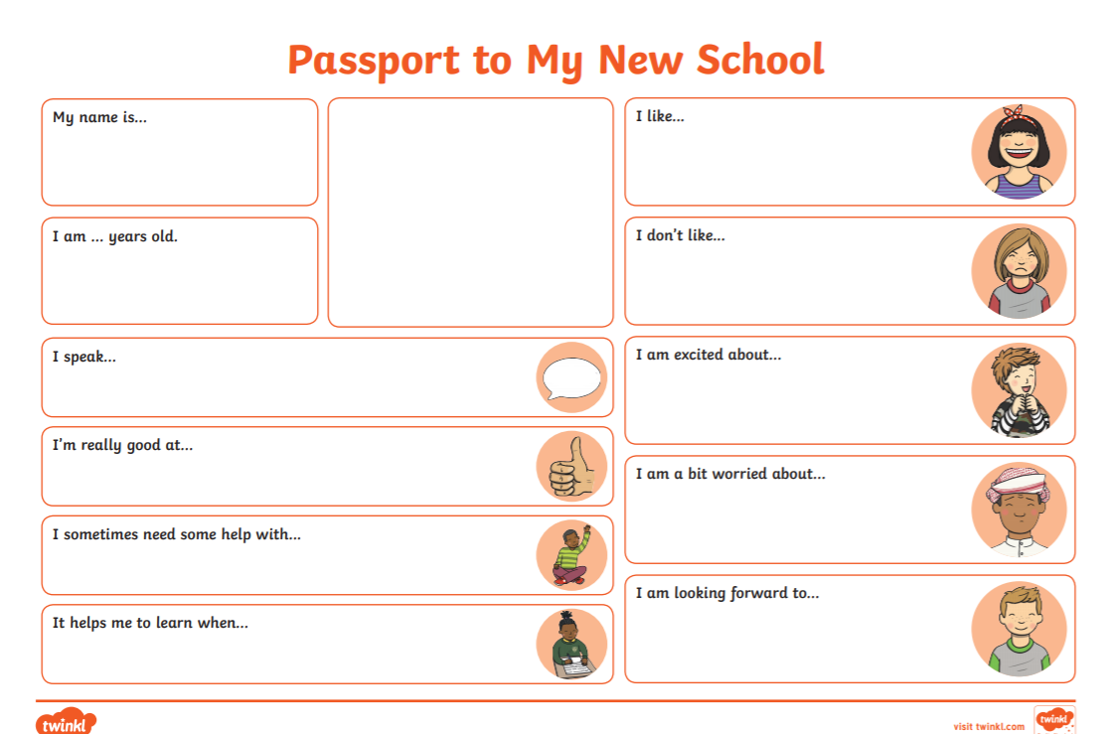

Passport template from [www.twinkl.co.uk](http://www.twinkl.co.uk)