

The 3 Rs: How to support a child in distress

Credits to: Dr. Bruce Perry, Beacon House, South Ayrshire Council

Dysregulation occurs when the brain responds to sensory input in a manner that triggers the alarm state. This is referred to as the **Amygdala Hijack**.

The Amygdala is one of the smallest parts of the brain, but can be very powerful and “hijack” children’s emotions.  It processes emotions such as anger, fear and anxiety.  It responds to stress by either telling children’s brain to *fight* (panic attack or temper tantrum), *flee* (run) or *freeze* (shut down).

When hijacked, the rest of their brain that helps them make good choices, shuts down, being harder to listen, comprehend and cope. Practitioners may notice the following in a child:

* A strong emotional reaction with a sudden onset,
* Regret for their actions on reflection (when they are able to rationalise).

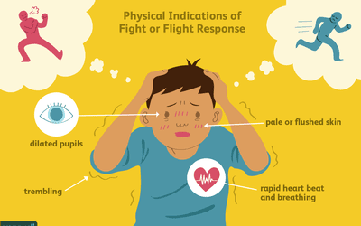

Credits to: verywellmind.com

Adults can help children learn to control their Amygdala and keep them from being “hijacked”. Dr. Bruce Perry developed a simple sequence to support this by going through 3 different steps with the dysregulated child. It is known that heading straight for the ‘reasoning’ part of the brain will not work well because as we’ve seen before, that bit of the brain shuts down when a child is in distress. Adults should instead regulate the child’s brain from the bottom up suing the **3Rs of Regulate, Relate and Reason**. The first stage of which is ensuring that you are regulated yourself - if safe to do so, get down on their level.

No matter the reason why a dysregulated brain state occurred, it’s not useful to discipline children’s behaviour or label it something that it is not. **Until a child is regulated, they are unlikely to relate to you** (feel connected). And **until a child is related, they are unlikely to have the mental capacity to reason with you.**

**Regulate:**

* Identify the source of the child’s trigger, then shift the focus on calming the child,
* Focus on soothing - since the young person is in the lower parts of their brain trying to reason with them won’t work. At this stage you’re all about making them feel calm, safe and loved.
* Use methods to calm and support the particular child, one size does not fit all.

**Relate:**

* As they calm down use short sentences e.g. *“I know you’re upset right now”, “I know this is very hard”*
* You can validate their feelings with your words and tone of voice while also providing them with a hug or even taking their hand.
* Your focus here is connecting with the child.

**Reason:**

* Once the young person is calm, you can make a plan together about how to move forward, possibly coming up with alternatives ideas about how they might respond if something similar happened again.
* You can reassure them that you love/care for them, but the behaviour they exhibited is not okay.

The below diagram helps you understand the 3Rs sequence and has some examples of what adults can do to support dysregulated children.

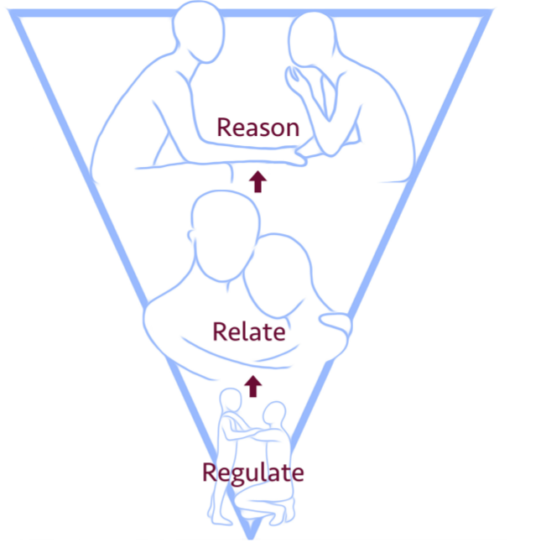

**First**: We must help the child to regulate and calm their fight/flight/freeze responses.

**Second**: We must relate and connect with the child through an attuned and sensitive relationship.

**Third**: We can support the child to reflect, learn, remember, articulate and become self-assured.

E.g.:

* Give time and space – if that helps
* Reduce language and keep language simple
* Reduce further demand – step back
* Model calm behaviour and model strategies and stay in control as the adult – use calm reassuring voice.
* Acknowledge and name the feeling -
* Teach strategies e.g. breathing, blow the anger,
* Give options for time out, to go to safe space
* Consider use of distractors/comforting objects/activities e.g blanket, teddy, fidget toy etc.

E.g.:

* Give reassurance, stay/be with child – if that helps
* Provide comforting presence; let them know you will help.
* Acknowledge and name the feeling or emotion – be empathetic and show understanding.
* Attune to the child – what do they need right now? Cuddle, reassurance, a familiar soothing activity that you can do together?

E.g.:

* Social stories or simple ‘scripts’ to support understanding.
* Discussion of alternatives for angry behaviour – use visuals to remind.
* The Zones of regulation
* Approach this developmentally – manage and explain as you might a younger child.



On this page, the diagram has blank spaces to be complete with ideas of what you might do to help your child in the different phases of the regulation process.



**First**: We must help the child to regulate and calm their fight/flight/freeze responses.

**Second**: We must relate and connect with the child through an attuned and sensitive relationship.

**Third**: We can support the child to reflect, learn, remember, articulate and become self-assured.



