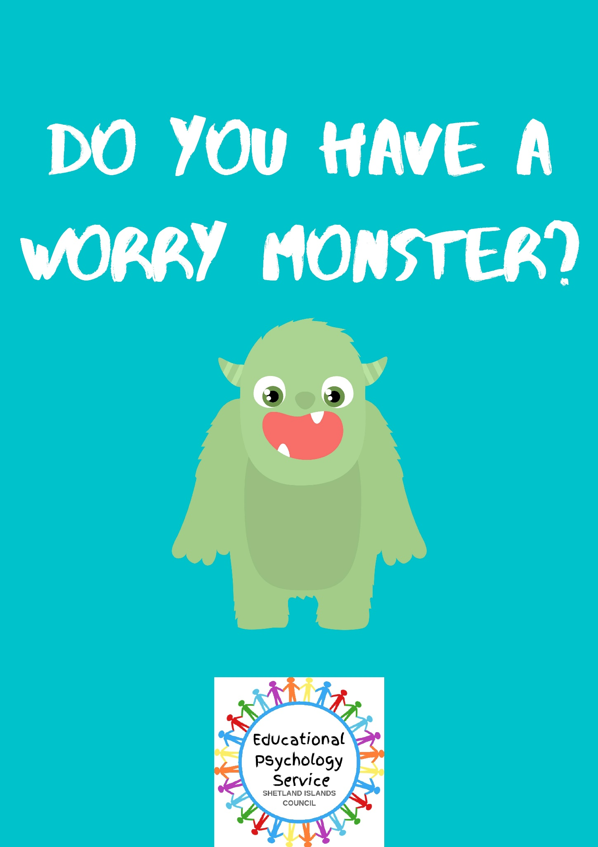
Introduction

This document is intended to provide information and advice to help you and your child talk about worries and how to manage these. It can be used by both parents and practitioners for children aged 5+. We all have worries, both children and adults. They are a necessary and normal part of life. Sometimes, when worries get out of hand or are irrational, they can stop us achieving our goals, dreams and living our life to the full.

Worries and anxiety can be expressed through physiological signs, such as headaches, sweating and stomach aches, or behaviours that might be difficult to manage, e.g. aggression, meltdowns, outbursts, or avoidance. If you have a child who worries a lot it is important to help them to understand that these feelings are normal and that talking about our worries can help us to feel better.

It is important to learn that we can control our feelings, and that they do not control us. Externalising is a strategy used in Narrative Therapy and teaches us to use language to recognise that we are not the problem, but that the problem is the problem. A useful tool to help your child externalise their worry is to describe it as a creature that is separate from themself. The best way to do this is to create a worry monster from their anxieties. This helps children to view their worry as an external being or bully who tries to bring them down. When we view our worries as a separate being it becomes easier to challenge them or ignore them altogether.

Steps to identifying a Worry Monster:

- Explain to your child that their anxious thoughts and feelings are being created by a worry monster. The worry monster tries to scare us by telling us all the bad things that ‘might’ happen, but we don’t have to listen to it. A lot of what the worry monster tells us starts with ‘what if…’ or ‘what will people think of me if…’

- To illustrate what a Worry Monster might be like, ask your child for examples of mean things someone might say. Emphasise, that although people can say mean things, we don’t have to listen to them.

- Next, have your child draw a picture of their worry monster (appendix A) to help them visualise it and hang this in a visible place in the home to refer back to. Let your child name their worry monster e.g. Meanie, Mr Negative or even a common name such as Fred or Sally.

- Now that you have a name and an image of the worry monster, it’s time to put it in its place. It’s important to refer to the worry monster by name rather than talking directly to your child. This helps them to remove the negativity they feel about themselves and associate it with the Worry Monster. Emphasise that your child holds the power over the worry monster, not the other way around.

- For example, you might say:
  - “Meanie, I see that you are trying to tell (child’s name) that she has to be perfect, but we all know that nobody is perfect and that is ok.”
  - “It looks like Meanie is trying to scare you. I know Meanie is loud and scary but you are brave and know that I will see you after school. Be brave and don’t listen to Meanie.”

A child might say:
  - “Meanie is scaring me about school. I am telling him that he is just a bully and even though I’m scared I know I will see you later on.”
  - “Leave me alone Meanie. Go and pick on someone else. I am going to be brave and go outside.”

The more often your child is able to stand up to the worry monster or ignore it, the more successful your child will be in lessening their worries.

- Here are some questions to ask your child to help them externalise their worry monster:
  - What does your worry monster look like? Is it big, small, fat or skinny?
  - Does it hide or sneak up on you?
  - Who else can see it?
  - What does it say?
  - How does it make you feel?
  - Is it scary or dangerous or just annoying?
  - Are there times when he/she isn’t there?
  - Can you remember when he/she first arrived?
  - Who do you think should be in charge of you: you or your worry monster?
  - Is there anything you can do to make him/her go away?
  - Can anyone else help?

- Help your child to make a tool box (appendix B) including:
  - A list of how their body feels when the worry monster is visiting e.g. sweaty, shaky.
  - What the worry monster usually says when he/she visits e.g. “You are no good, you are scared to go outside.”
  - What your child can say back to banish the worry monster e.g. “I don’t have to listen to you, you tell lies, go away I don’t like you.”
  - Exercises to do when the worry monster is around so they can stay calm and face him e.g. taking deep breaths, reading or going for a walk with a trusted adult
  - The name trusted adults who they can tell when the worry monster is visiting e.g. a teacher, parent or relative.

- These ideas take practice, patience and perseverance to help banish that pesky worry monster so take your time.

- Once you and your child have created their worry monster, have a go at the attached worksheets (appendix C to E) and generate discussion on what worries your child and how they can overcome this by facing the worry monster head on.

You may also like to watch this video with your child on The Huge Bag of Worries by Virginia Ironside - https://www.youtube.com/watch?v=FhX01CxHVrU This could help generate discussion with your child and help them reflect on which of their worries are actually theirs, which belong to other people, and which are things that we cannot control.

Adapted from https://www.psychologytoday.com/us/blog/worrier-warrior/201312/simple-steps-families-conquer-the-worry-monster and https://goodbyeanxietyhellojoy.com/externalizing-anxiety-with-a-worry-monster/
Appendix A

Draw your Worry Monster here

Name your Worry Monster…………………………………..

Appendix B
Worry Toolbox

Write 5 signs your body gives you when the Worry Monster is visiting e.g. sweaty, shaky | What does the Worry Monster say when he/she visits e.g. you are scared to go outside | What can you say back to banish the Worry Monster e.g. you tell lies, go away. | What do you like to do to stay calm when the Worry Monster is visiting e.g. read, go for a walk | Name some trusted adults you can talk to when the Worry Monster is visiting.
1. | 1. | 1. | 1. | 1.
2. | 2. | 2. | 2. | 2.
3. | 3. | 3. | 3. | 3.
4. | 4. | 4. | 4. | 4.
5. | 5. | 5. | 5. | 5.

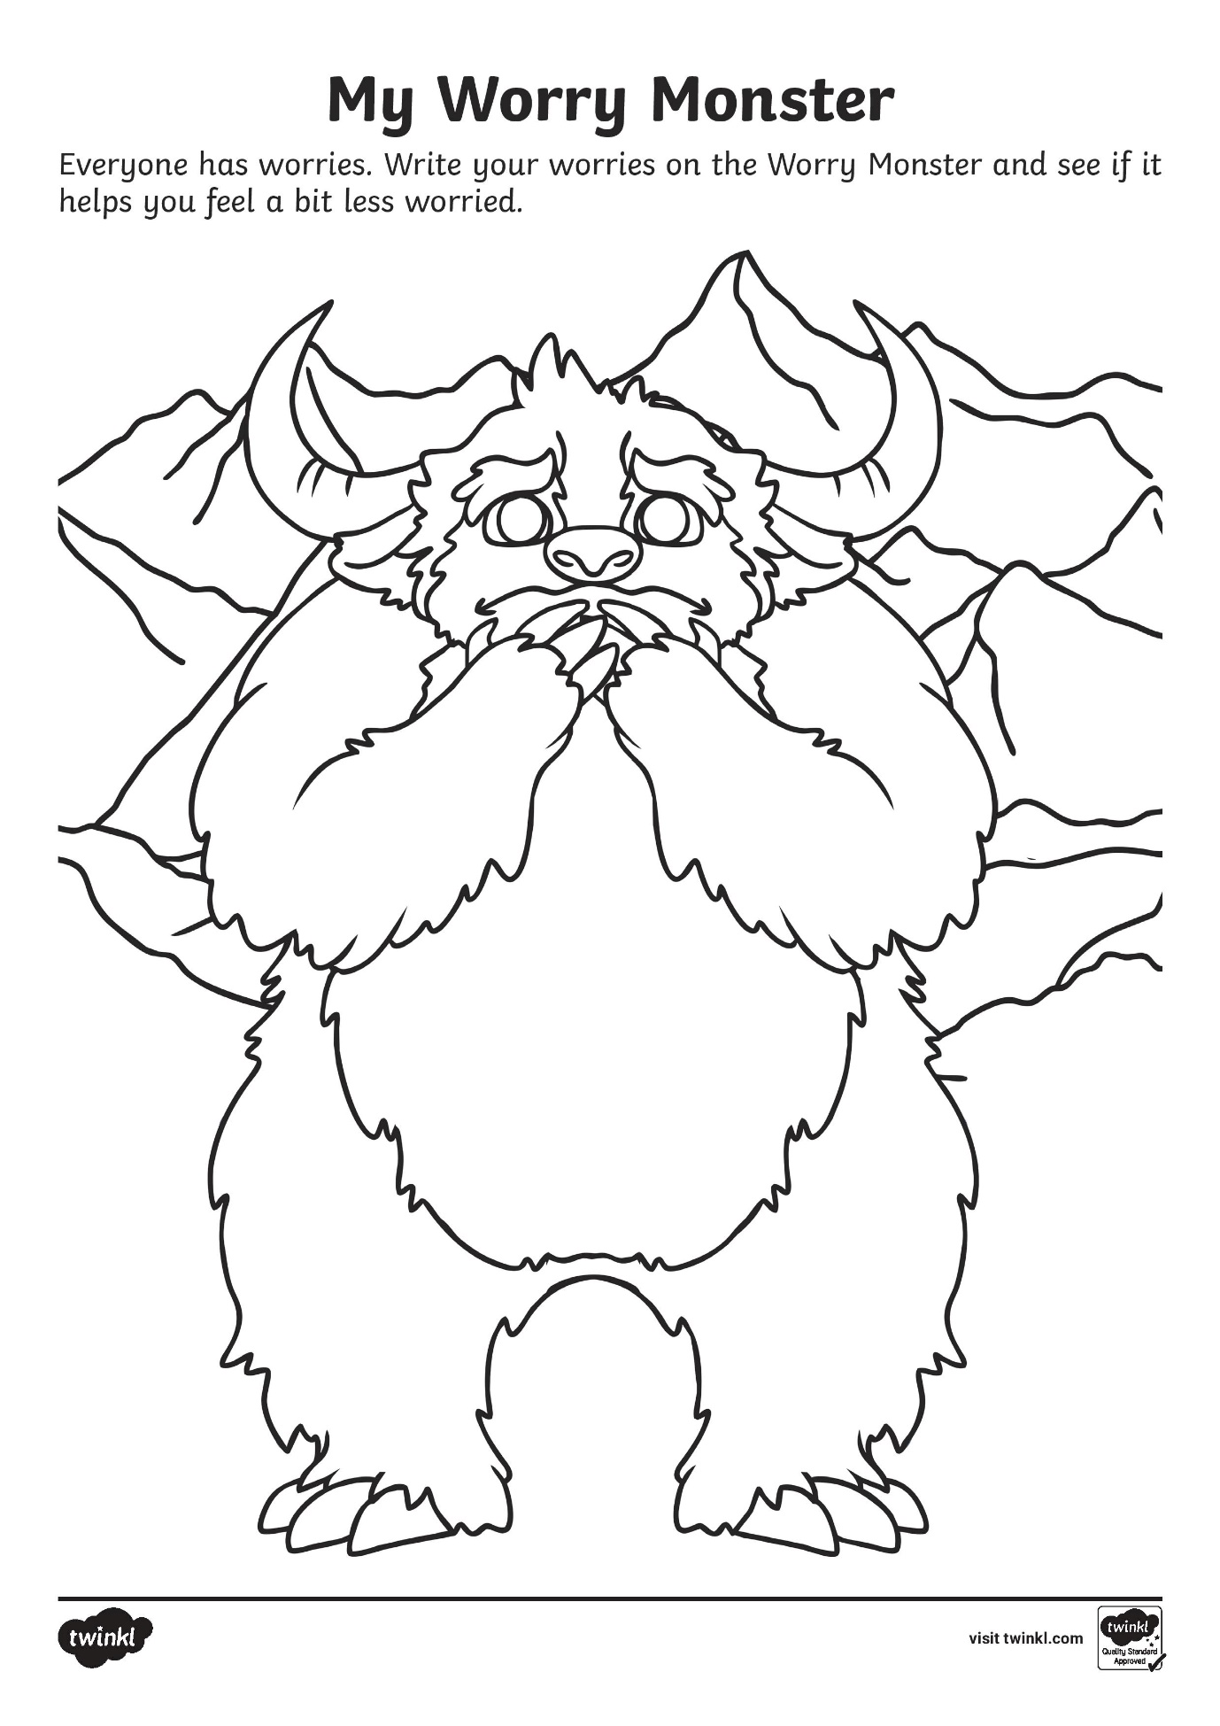
Appendix C

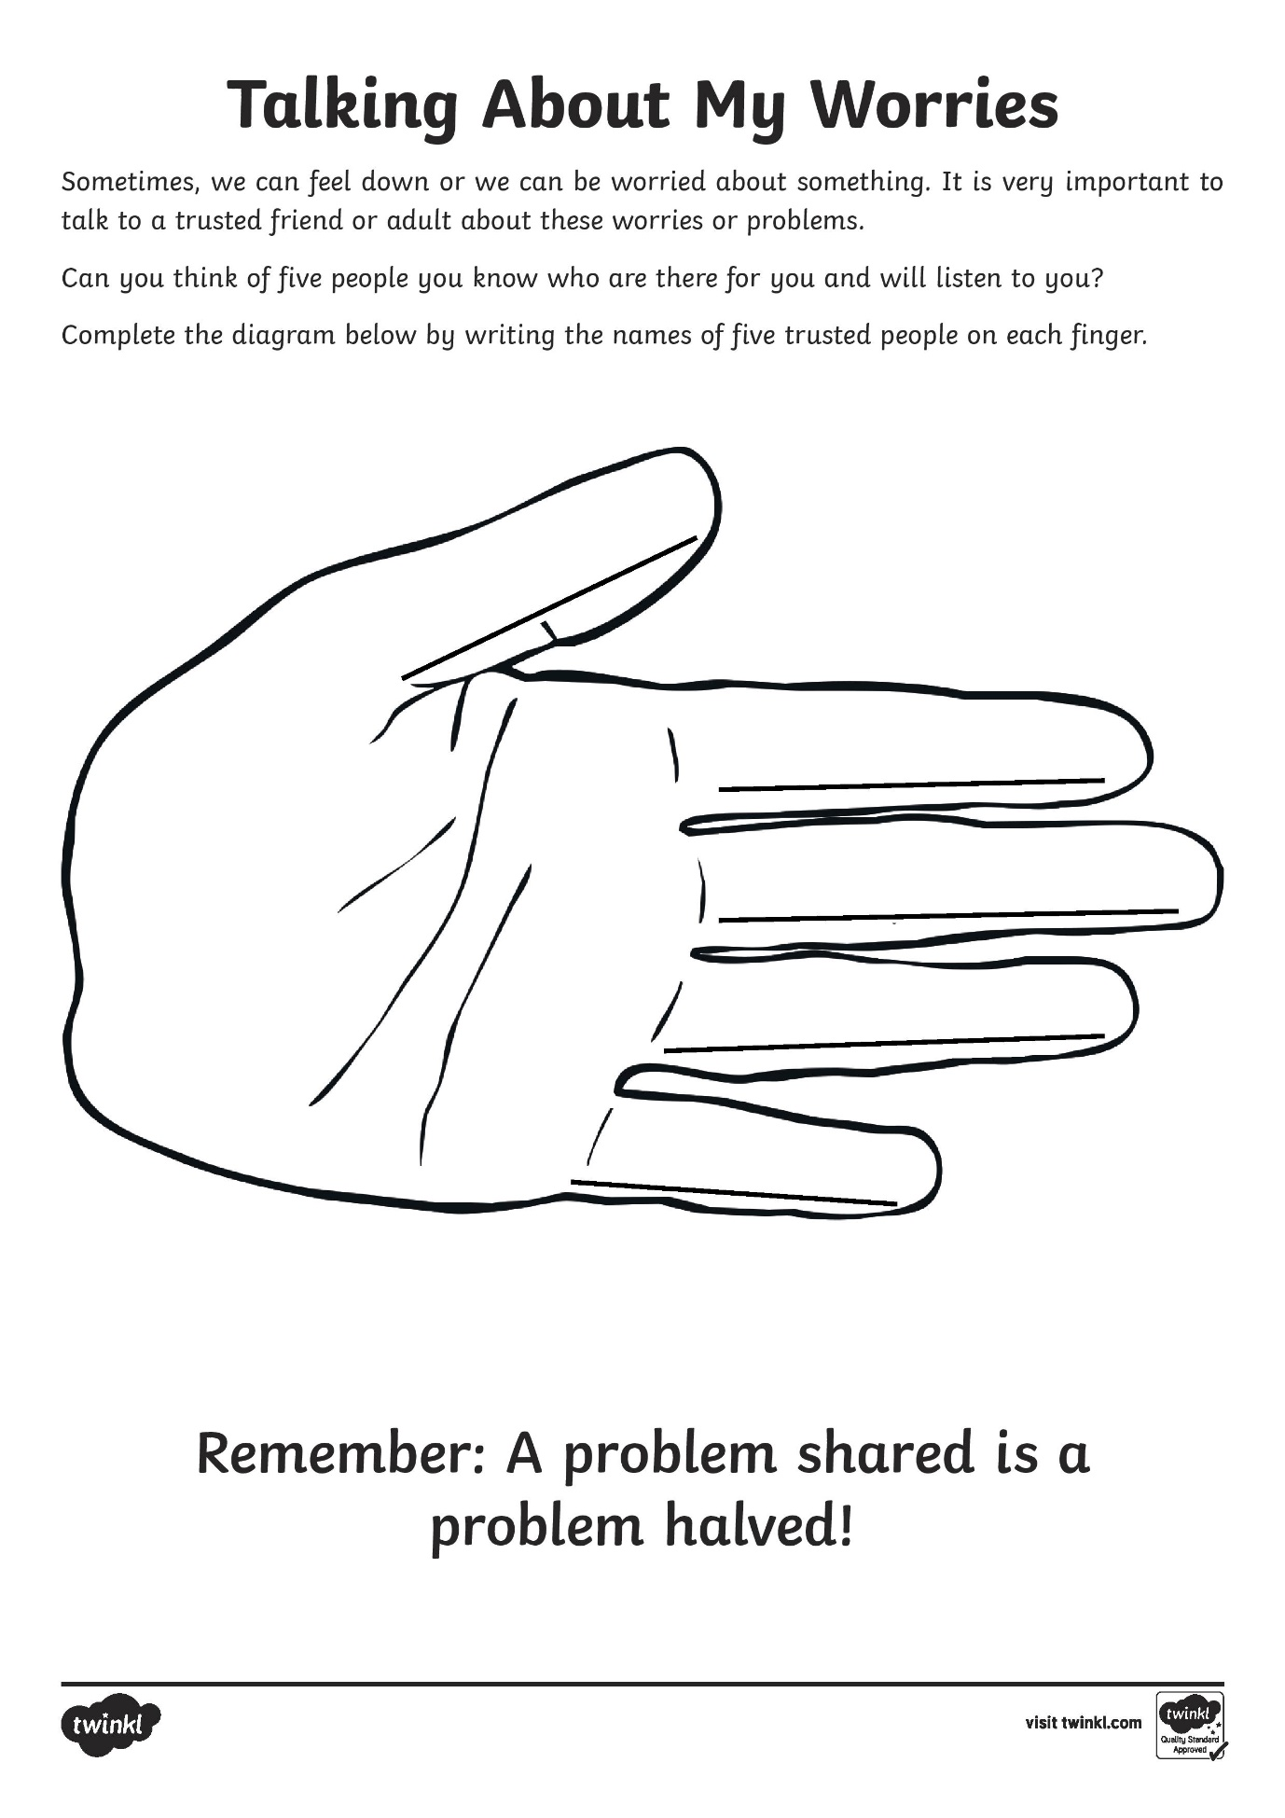
Appendix D
Appendix E

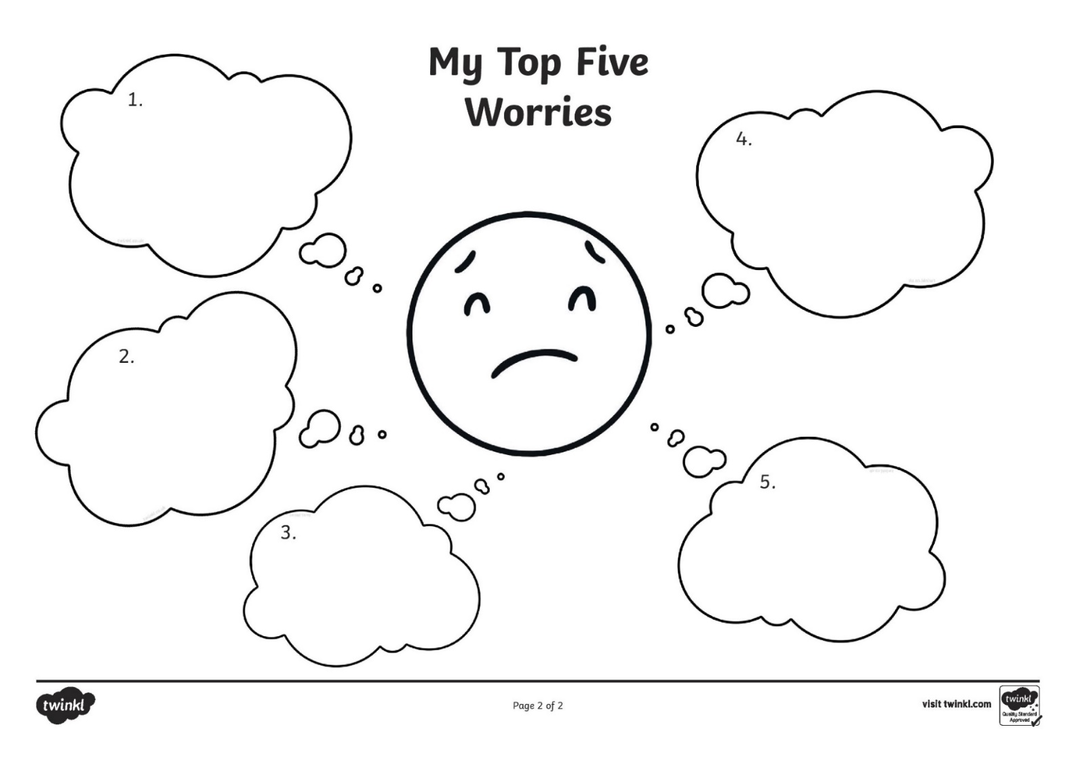
Write your top 5 worries in the thought bubbles below and discuss these with a trusted adult

