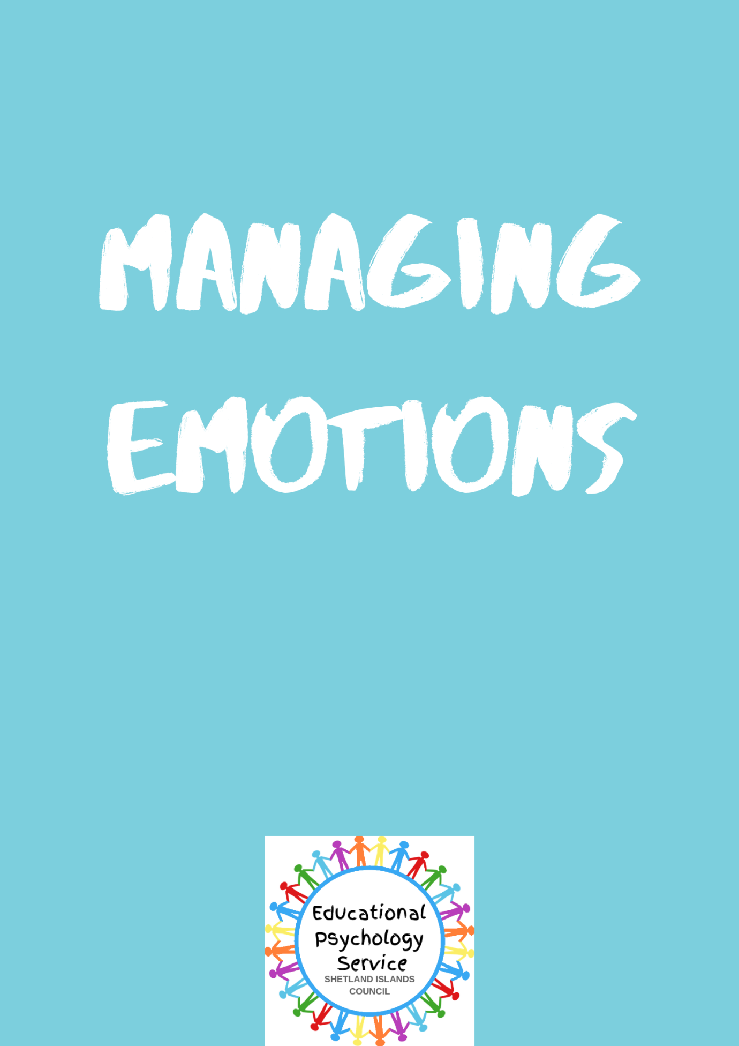

**Contents**

Introduction…………………………………………………………………………………….Page 4

Section 1: Talking to your Child about Feelings

Talking to Children about Feelings…………………..………………………...…………….Page 4

Inside Out: The Movie…………………………………..…………………………………….Page 6

Design Your Own Inside Out Character……………………………………...……………..Page 8

How Do I Feel Today? Check In ....................................................................................Page 9

Section 2: Anger

Helping Your Child with Anger………………………………………………………...……Page 10

What is Anger? ............................................................................................................Page 13

Anger Thermometer………………………………..………………………………………..Page 15

Volcano in your Tummy…………………………..…………………………………………Page 16

My Anger Triggers…………………………………………………….……………………..Page 17

Understanding My Feelings…………………..……………………………………………..Page 18

5 Point Scale: Anger Check In..……………..………….…………………………………..Page 19

Ok and Not Ok Reponses…………………………………………………….……………..Page 21

What Might Help ………………………..……………………………………………………Page 23

At Home, At School…………..……………………………………………………………….Page 25

My Stages of Anger………………………………………………………………………….Page 26

Section 2: Anxiety

Helping Your Child with Anxiety…………………………………………………………….Page 28

What is Anxiety?.………………………………………………...…………………………..Page 31

The 5 Point Scale: Anxiety Check In………………......…………………………………..Page 32

My Top Five Worries……………………………………….………………………………..Page 33

Big Problems and Small Problems…………………………………………………..……..Page 34

Comic Strip Conversations………………………………………………………………….Page 35

Social Stories ……..…………………………..……………………………………………..Page 37

**Tools**

My Calming Sequence…………………...………………………………………………….Page 38

Lazy 8 Breathing…………………………..…………………………………………………Page 39

The Six Sides of Breathing…………………...……………………………………………..Page 40

Skill Cards…………………………………….………………………………………………Page 41

**Appendix**

Appendix A: Building Resilience ……………………………………..…………………….Page 44

Appendix B: Identifying Emotions in Others……………………………….………………Page 45

Appendix C: The Feeling of Anger…………………………………………..……………..Page 49

Appendix D: The Stress Scale……………………………………………...………………Page 51

Appendix E: The High Low Scale…………………………………………….…………….Page 52

Appendix F: Cut Out and Keep Scales………...…………………………………………..Page 54

Appendix G: Inside Out: Getting to Know my Emotions……………………..…………..Page 55

Appendix H: Inside Out Trace Emotions………………………………….……………….Page 56

Appendix I: Inside Out Feelings and Calm Down Worksheet………..………………….Page 57

Appendix J: My Worry Monster………………………………………..……………………Page 58

Appendix K: Talking About My Worries…………………………………..………………..Page 59

Useful Links……………………………………………..……………….……………………Page 60

References……………………………………………………………………………………Page 63

**Introduction**

This document is intended to provide information, strategies and tools to help you help your child talk about their feelings and manage their emotions. It has been developed by Shetland Islands Council Educational Psychology Service using a range of materials and resources from a variety of sources. Resources are referred to throughout the document and you will find a complete reference list at the end of the document.

Section 1:Talking to your Child about Feelings

**Talking to Children about Feelings**

It is important to help children understand their feelings and why they might be feeling certain ways. You can help your child understand their feelings by letting them know it is good to talk about how we feel, you can model this by talking about your own feelings in a child friendly and age appropriate way. It is important for children to understand that all feelings are normal. It is how we cope with these feelings and how we behave that really matters.

The following might be helpful when talking about feelings with children:

* Let your child know that we all experience different feelings, all feelings are normal at one time or another. There are no right/wrong or good/bad feelings.
* Difficult feelings are usually a normal response to a particularly difficult or hard situation or event.
* Feeling worried, scared or angry are normal feelings that everyone has sometimes. It is very common for especially for young children to have fears and worries about things that seem to them scary and dangerous e.g. bumble bees, spiders, clowns etc. Sometimes children worry about making new friends, going to parties, doing school work or being away from their parents or home. Some children might get angry when a classmate breaks their toy or a teacher tells them off.
* We can all learn ways of managing difficult feelings and learning to feel brave, confident and calm even when difficult things happen.
* A first step to helping your child manage their feelings is to talk about them and give them an ‘emotional vocabulary’. This will help them talk about their feelings and emotions, it will help them learn and identify their own feelings. This is the first step to learning how to manage them.
* Feelings can also change from minute to minute and day to day depending on our situation and it is possible to experience different feelings at different times.

There are some great animated movies that can help children understand their feelings and emotions including *Angry Birds* and *Inside Out.*  You may want watch these at home as a fun and safe way to learn and talk about feelings and emotions.

Several themed worksheets are included here for you to try with your child (additional worksheets can be found in the Appendix).

An emotional check in worksheet is also included which can be done daily with your child. This should give you insight into how your child is feeling each day and open up discussion as to the reasons why and what can be done to help them.

The toolkit also provides various calming techniques and strategies that children may find helpful when trying to calm down and de-escalate their feelings.

Inside Out – The Movie

***Today I am feeling***

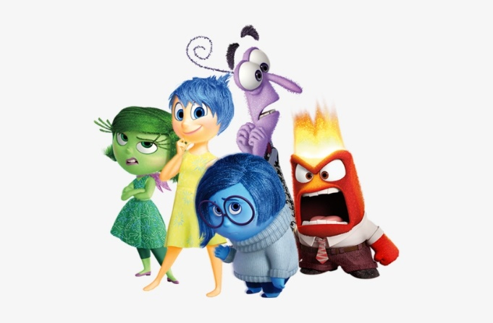

Because_________________________________________________________________________________________________________________________________________________________________________________________________________________________________________

I feel

When________________________________

_____________________________________



When_____________________________

__________________________________

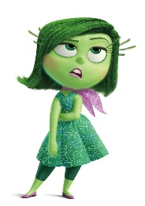

When_____________________________

__________________________________



When___________________________

________________________________



When_____________________________

__________________________________

Draw a time you felt either…..



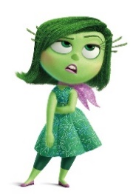



Adapted from <https://en.islcollective.com/english-esl-worksheets/search/Inside+Out>

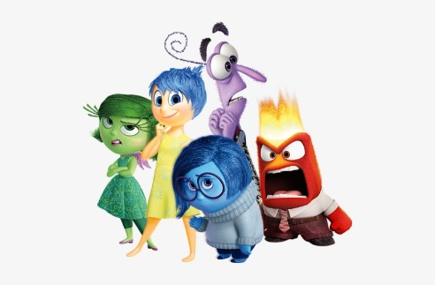**Design Your Own Inside Out Character**

Emotion………………………………………………

Name………………………………………………….

I chose this emotion because _________________________________

_________________________________

_________________________________

The shape is ______________________

I chose this because _________________

_________________________________

_________________________________

The colour is ______________________

I chose this because _________________

_________________________________

_________________________________

*Adapted from* <https://www.tes.com/teaching-resource/design-your-own-inside-out-character-11759544>

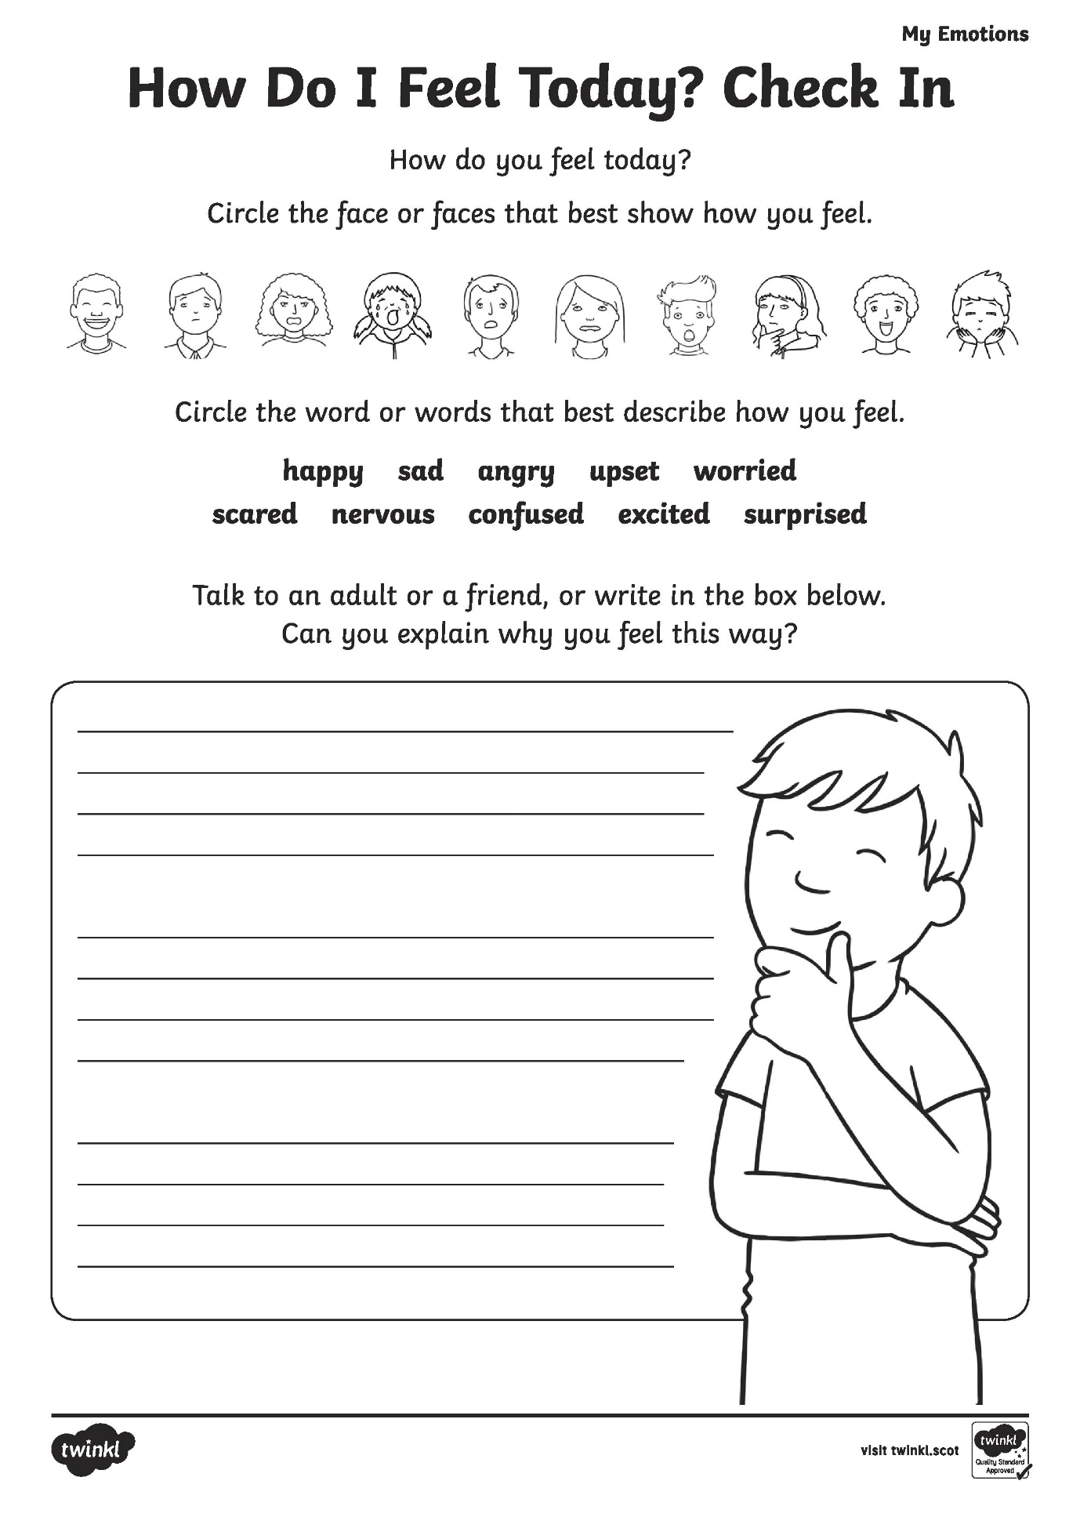

Section 2: Anger

**Helping your child with Anger**

This section about helping your child with anger has been adapted from Hands On Scotland accessible at: [www.handsonscotland.co.uk](http://www.handsonscotland.co.uk).

Anger is a very common emotion that everyone experiences at times. If a child or young person feels angry this is not a problem in itself. However, it is important that children and young people learn to express their anger constructively.

If anger is ignored it can build up inside and may lead to them expressing it in disruptive behaviour or turning their frustration on themselves and those around them. Expressions of anger can range from mild irritation to full-blown rages, verbal outbursts and physical violence[.](https://www.handsonscotland.co.uk/services-websites-apps/)

Feeling angry at times is as natural as feeling happy or sad. However we often see anger as a bad thing and we may even be scared of it, because of its occasional explosive nature.

Children and young people experience anger for the same reasons that adults do, for example, when they are stressed, frustrated, or feel that something is unfair. They may have been annoyed by something that just happened and are reacting to it immediately. They could also be feeling angry about things that happened in the past, and may be carrying a lot of bottled up anger around with them.

In trying to understand why a child or young person may be feeling angry, it is helpful to think about specific situations that may be causing them stress, for example:

* Are they struggling at school?
* Are they being bullied?
* Are there any issues at home?
* Has there been significant change, loss or bereavement?
* Are they unable to express themselves verbally? Anger can occur in children or young people who have difficulty in expressing their views or feelings in words.

Think about your response

Anger is something that we have all experienced at some time in our lives.  Everyone knows what it feels like to be angry or to experience someone else’s anger, and your experiences will affect your response to a child or young person who is angry. It is important to be aware of your own feelings and experiences so that you can respond helpfully to the child or young person.

What you can do

When they are angry

* Lead by example by remaining calm.

* When calming them down, be assertive but do not shout or lose your own temper. Instead, show them that you can handle their angry feelings without becoming aggressive yourself.

* Reassure them that you understand how they are feeling.

* Explain the situation to them. A child or young person may be feeling angry because they are feeling a lack of control, ignored or disrespected.

* Offer them choices, time and space to try to defuse and de-escalate the situation. This can be as simple as, "I wonder if it would help if we come back to this in a minute?’ or ‘We can come back to this later when we are feeling better’. "Do you want to get some air and come back to this in a few minutes?" Continuing with demands at this point is likely to lead to an escalation in behaviour so where possible reduce demands and offer preferred choices to calm down. Offering a favourite activity can help distract and calm a child down.

* Sometimes using humour can help distract and calm the child or young person, but be careful not to embarrass them or make them feel that you are not taking them seriously.

* It can be more difficult for them to back down if they fear losing the respect of friends. If they are not calming down, de-escalate by calmly encouraging them to go somewhere private/use a safe space or ask others to give you space so you can be with your child.

* If the child or young person is very angry and has lost their temper or is being aggressive, it may be necessary to remove them or others from the situation. This should always be done with the child or young person's safety in mind, as well as your own.

When they are calm

* Explain to the child or young person that anger is a normal emotion and everybody feels angry at times.

* Encourage them to talk about their feelings and help them explore their anger so that you can both try to understand what’s making them angry. This can help them feel less frustrated and also shows them that you understand.

* Try to identify what triggers their anger. Once you have identified the triggers and the reasons behind their anger, you can help them to develop different ways of coping and dealing with these situations.

* Help them to control their anger or express it in more positive ways. Praise and encourage them to notice situations in which they have handled their anger well or have expressed it effectively and calmly. This will build confidence, reduce frustration and will make it more likely that they will repeat the [positive behaviour](https://www.handsonscotland.co.uk/encouraging-positive-behaviour/).

* Talk to them about being respectfully assertive when they disagree with someone else’s opinion or behaviour. Role-playing in different situations can be a useful learning experience, and can be done one-to-one or with a group.

* Give the child or young person other ways of reducing tension, for example exercise or [relaxation](https://www.handsonscotland.co.uk/relaxation/).

* When in a difficult situation yourself, remember to stay calm and show them that anger is manageable and can be dealt with.

What not to do

* Don’t lose your own temper, as this shows the child or young person that this behaviour is ok, and it prevents you from responding helpfully.

* Don’t get into arguments, as the child or young person may become more frustrated and angry if they're losing the argument.

* Don’t make fun of them, as this is likely to make them feel humiliated and more frustrated and angry.

* Don’t use physical restraint, except to protect the child or young person or others from serious harm

**What is Anger?**

Anger is a difficult feeling. When you’re angry you might do bad things that you wouldn’t do if you were happy. But did you know that it’s normal to feel angry from time to time? It happens to everyone.

**Draw a picture of what you look like when you’re angry.**

**What is something you say when you are angry?**

All sorts of things can make a person feel angry. Some people get mad when they have to follow a rule they don’t like, or when another person is mean to them.

**List some things that cause you to feel angry.**

**Even though it’s normal to feel angry from time to time, it’s never ok to be mean, break things, hurt others or hurt yourself. Learning to control your anger is about learning new ways to act when you’re upset.**

**Here’s a list of healthy things you can do when you feel angry. Circle the ones that you might like to try.**

**Take deep breaths. Draw your anger.**

**Do jumping jacks. Write about your anger.**

**Count to 100. Walk away.**

**Talk to someone. Squeeze a stress ball.**

**Squeeze a stress ball. Play outside.**

**Listen to music. Practice a hobby.**

*Adapted from TherapistAid.com (2015)*

**Anger Thermometer**

Rank your experience with anger on a scale from 1 to 10. A ‘10’ should be the angriest you can imagine and a ‘1’ should be completely calm. Include:

A short description of what happened

How you reacted

How you felt

What the consequences were.

Everyone experiences anger in different ways, so your scale might not be the same as someone else’s.

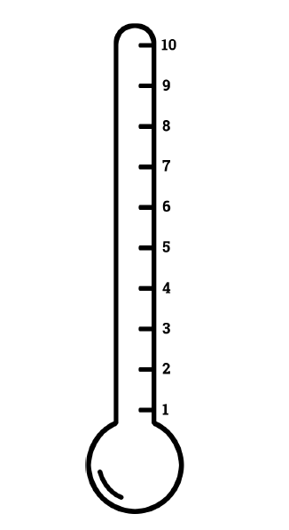

*Adapted from TherapistAid.com (2012)*

**Volcano in your Tummy**

Do you have a volcano in your tummy or explosions in your head?

When we feel angry, things happen to our bodies. Draw what happens to you and label your picture e.g. red face.

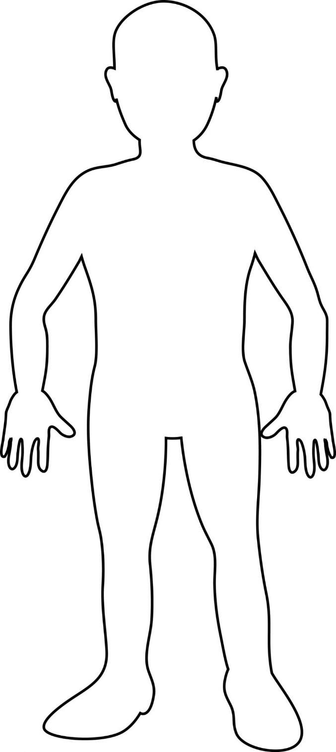

*Adapted from Putney, W. & Whitehouse, E. (1998) A Volcano in my Tummy, New Society Publishers*

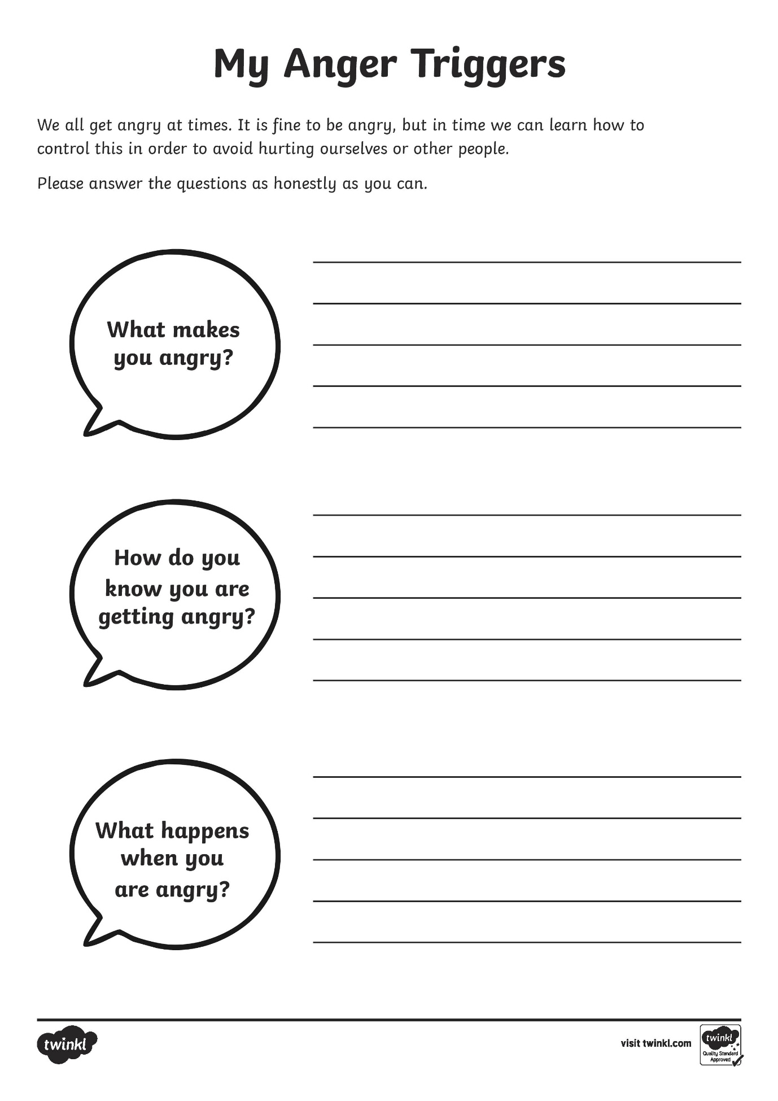

**Understanding My Feelings**

Can your child give their own examples in the right hand column. You could try this with any feeling or emotion.

**Feeling – Mad/Angry**

|  |  |
| --- | --- |
| **Example** | **Your Turn** |
| **My word for this is:**  Cheesed off | **My word for this is:** |
| **This is how I look:**  Frowning | **This is how I look:** |
| **This is how my body feels:**  Like it’s over heating | **This is how my body feels:** |
| **This is what I do:**  Throw stuff | **This is what I do:** |
| **This is what I say:**  GO AWAY!! | **This is what I say:** |

**5 Point Scale – Anger Check In**

The 5 Point Scale is used to help children become more aware of their emotions, such as anger, pain or worry. The scale helps children understand the level of the emotion in stages.

Using this scale, speak through with your child their levels of anger and how this can escalate. Keeping in mind the appropriate and non-appropriate responses. Giving a number in relation to the level of an emotion instead of naming it helps children think efficiently and make good decisions in a variety of situations.

Each number on the following page has a corresponding level of emotion e.g. 1 = Happy, 2 = Irritated, 3 = Annoyed, 4 = Mad, 5 = Angry. Explain these levels of emotion to your child so they understand and are able to communicate their feelings to you using the numbers.

Throughout the day ask your child what level of anger they are feeling. This could be done first thing in the morning, before going to bed or after completing a task. It may be helpful to display this somewhere in your home so your child can easily access this in order to communicate with you how they are feeling.

**Anger Check In**

|  |  |
| --- | --- |
| 5 | **Angry** |
| 4 | **Mad** |
| 3 | **Annoyed** |
| 2 | **Irritated** |
| 1 | **happy** |

*Adapted from Coffin, A. B., & Smith, S. M. (2009). The Incredible* 5-Point Scale*(Columbus)*

**OK and not OK responses**

Here is an example of an event which could cause anger and explains the ‘ok’ and ‘not ok’ responses to have. There is a worksheet for your child to try, with a real life topic for them.

**Topic:** My brother broke my toy

|  |  |  |  |
| --- | --- | --- | --- |
| Number | Feeling | OK | Not OK |
| 5 |  | Take a deep breath  Run on the spot  Go to an adult who can help me calm down | Hitting  Shouting  Kicking |
| 4 |  | Take a deep breath  Count to ten  Take myself to a quiet spot | Shouting  Pushing |
| 3 |  | Take a deep breath | Shouting |
| 2 |  | Tell an adult  Go get a toy | Shouting |
| 1 |  | Go to the next space in the line  Think ‘it’s ok, I’ll get a turn at first another time’ | Enjoy being in the line with everybody else! |

*Adapted from Coffin, A. B., & Smith, S. M. (2009). The Incredible* 5-Point Scale*(Columbus*

**Your Turn…**

**Topic:**

|  |  |  |  |
| --- | --- | --- | --- |
| Number | Feeling | OK | Not OK |
| 5 |  |  |  |
| 4 |  |  |  |
| 3 |  |  |  |
| 2 |  |  |  |
| 1 |  |  |  |

|  |  |  |  |
| --- | --- | --- | --- |
| **No.** | **Might be called** | **Feels like** | **What might help** |
| 5 | Big red hot zone | I feel like someone else  I feel like a different person  Like trying to bully someone  Like a red-hot chilli | Go straight to the quiet place so I can start feeling like a 4 then a 3then a 2.  Someone could help me go to the quiet place if I forget – I’ll know this is what we agreed would be helpful. |
| 4 | Frustrated/ confused | I feel like kicking a wall or smashing a window, but don’t actually do it | Try and calm myself down by taking deep breaths. Someone could say ‘Remember, go to the quiet space.’ |
| 3 | Worried/ Tired/ Bit angry | I feel like going to bed to forget about it, and get up when it’s fixed | Someone could say ‘(Name) do you need a break?’  Then I can go and sit down for a while, then join back in when I’m ready |
| 2 | Bit excited/ Not sure about something | ‘When is it going to happen?’  ‘I really want to go’  ‘I’m all fired up’ (like singing in choir on Saturday) | Ask someone ‘What’s going on?’  Say ‘I’m not sure what’s going on here.’  Try and calm myself down by taking deep breaths |
| 1 | Calm/ relaxed/ happy | When no-one’s arguing  Watching TV  Playing on Wii (if it’s working) | No help needed!!!  JUST ENJOY!!! |

**What might help**

Here we explore examples of what might help children when their emotions are in different levels.

*Adapted from Coffin, A. B., & Smith, S. M. (2009). The Incredible* 5-Point Scale*(Columbus)*

**Your Turn…**

Support your child to think of their own examples below.

|  |  |  |  |
| --- | --- | --- | --- |
| **No.** | **Might be called** | **Feels like** | **What might help** |
| 5 | ------------- |  |  |
| 4 | -------------- |  |  |
| 3 | --------------- |  |  |
| 2 | --------------- |  |  |
| 1 | --------------- |  |  |

**At Home, At School**

Your child may like to highlight times when they have felt different levels of anger either at home, or at school here.

*Adapted from Coffin, A. B., & Smith, S. M. (2009). The Incredible* 5-Point Scale*(Columbus)*

|  |  |  |  |
| --- | --- | --- | --- |
|  | Example | Looks like/Feels like | What I can try to do  What can help |
| 5 | At home  At school |  |  |
| 4 | At home  At school |  |  |
| 3 | At home  At school |  |  |
| 2 | At home  At school |  |  |
| 1 | At home  At school |  |  |

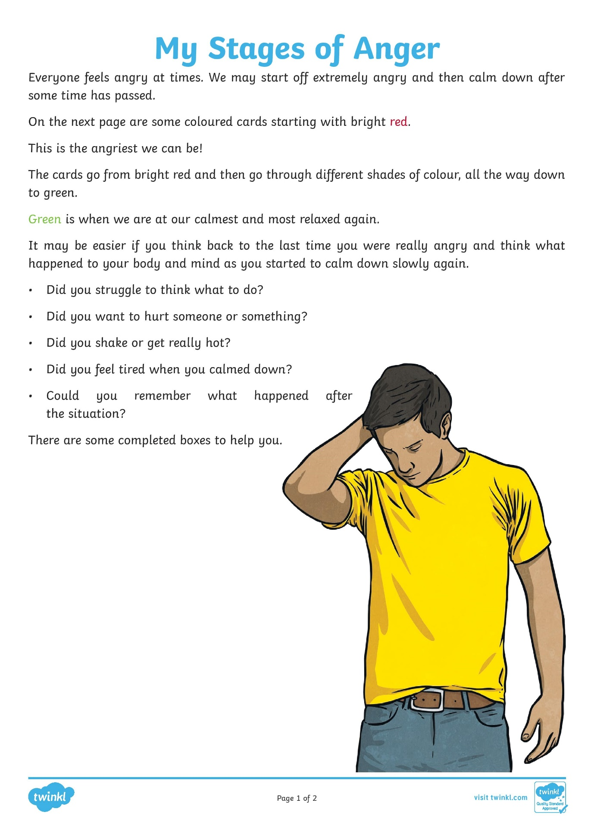

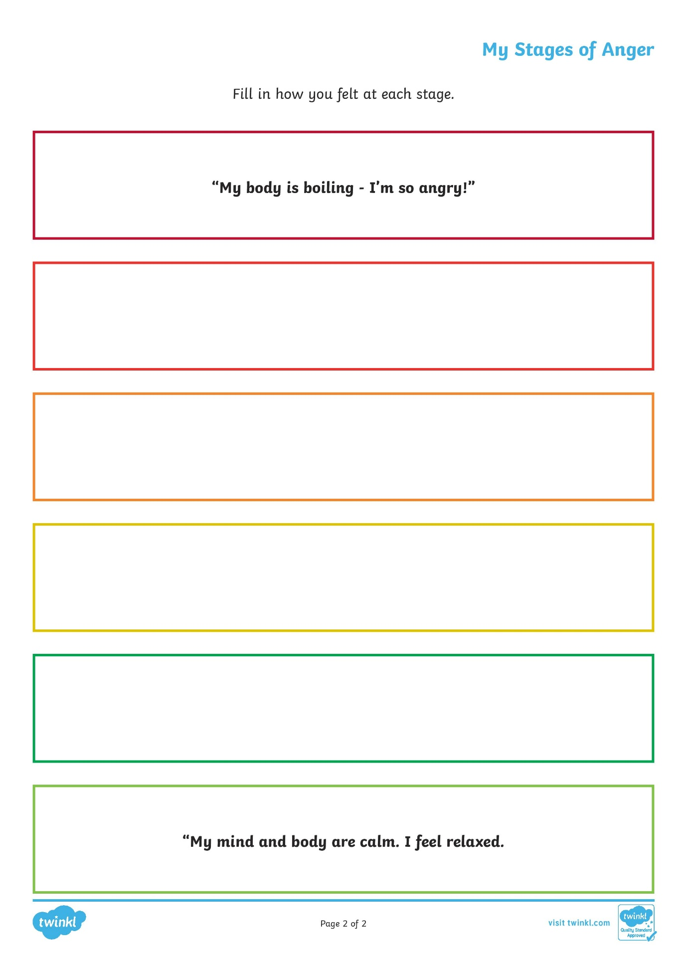

*Section 2: Anxiety*

**Helping your child with Anxiety**

This section about helping your child with anxiety has been adapted from Hands On Scotland accessible at: <http://www.handsonscotland.co.uk>.

Everyone experiences anxiety from time to time. Anxiety is a term used to describe the thoughts and feelings we get when we are frightened, worried or stressed. Feeling anxious causes the body to produce adrenaline, which leads to physical responses such as a dry mouth, a pounding heart, butterflies in the tummy, sweating, dizziness and tense muscles.

Children and young people can feel anxious about different things at different ages. They may worry about anything in their world at any point in time. For example, starting primary school, overhearing arguing at home or falling out with friends.

Many children and young people will experience anxiety and this is a normal part of growing up. However, anxiety can become a problem when it impacts on a child or young person's day-to-day life.

Things you may notice when a child or young person feels anxious:

Younger children may:

* become irritable, tearful or clingy
* have difficulty sleeping
* wake in the night
* start wetting the bed
* have bad dreams.

Older children and young people may:

* lack the confidence to try new things or seem unable to face simple, everyday challenges
* find it hard to concentrate
* have problems with sleeping or eating
* be prone to angry outbursts
* have negative thoughts going round and round their head, or keep thinking that bad things are going to happen
* start avoiding everyday activities, such as seeing friends, going out in public or attending school.

Think about your response

It is important to consider your own emotional response to the situation. If you have experienced anxiety yourself, this can be useful in helping the child or young person, but can also influence how you respond. You may feel that you want to protect the child or young person from difficult, anxiety-provoking situations. However, it is also important to support them through their challenges.

What you can do

* Normalise anxiety and explain the physical responses. This can help children and young people understand why, for example, their heart might race when they go to a class they are worried about or why they feel tense before an exam.

* Show empathy and actively listen to their worries without judgment, comment or advice.

* Let them talk things through and support their ability to problem-solve.

* If the worry can be resolved, support them to make a list of possible solutions. Remind them to focus on the things they can change, and that there might not be a perfect solution. Help them to make an action plan with steps they need to take to resolve the worry.

* Help children and young people to work out what they are anxious about. Instead of treating the worry like a fact, encourage them to develop a more balanced perspective, by asking themselves:  
  + What is making me feel anxious and what am I worried will happen?
  + What’s the evidence for this thought and what’s the evidence against it?
  + What would I say to a friend who had this worry?
  + What would a friend say about my worry?
  + Have I confused this worry with a fact?
  + Is worrying helping me? How?
  + If my worry did happen, what could I do to cope with it or handle it?
  + Is there a more rational, realistic way of thinking about this situation?

* For teenagers, encourage them to write down their worries in a journal. Children could post their worries into an old tissue box and you can go through the box together. Avoid doing this just before bed.

* Encourage them to avoid all-or-nothing thinking, like “if I don’t do this perfectly, I’m a total failure”.

* Help them to face the situations they are anxious about, by taking small steps towards overcoming their anxiety. Give them [praise and rewards](http://www.handsonscotland.co.uk/encouraging-positive-behaviour/) at each step to motivate them to keep going.

* When facing an anxious situation, encourage them to think positively, for example “these feelings will pass”, “I have faced this problem before and I know how to handle it”.

* Remind them that taking some deep breaths will help to calm down the physical symptoms of anxiety.

* Encourage them to do things that help them feel more relaxed and distracted from worries, for example spending time with friends, playing sports, [relaxation exercises](http://www.handsonscotland.co.uk/relaxation/).

* Worrying usually focuses on the past or future - [mindfulness](http://www.handsonscotland.co.uk/mindfulness/) can help children and young people focus attention on the here and now.

**What is Anxiety?**

Anxiety is a feeling we have when we worry a lot about something. This could be an event, something that happened in the past or something that might happen in the future. Everybody worries about things and it is normal to do so. If we worry too much it can make us feel unwell so it is important that we learn some tools in order to manage our anxiety.

Anxiety can affect the body in a range of ways. Draw what happens to you when you feel anxious and label your picture e.g. sweaty palms..



**Anxiety Check In**

|  |  |
| --- | --- |
| 5 | **Extremely worried/anxious** |
| 4 | **Really worried** |
| 3 | **Worried** |
| 2 | **A little worried** |
| 1 | **happy** |

Each number on the scale has a corresponding level of emotion e.g. 1 = happy, 2 = a little worried, 3 = worried, 4 = really worried, 5 = extremely worried/anxious. Explain these levels of emotion to your child so they understand and are able to communicate their feelings to you using the numbers.

*Adapted from Coffin, A. B., & Smith, S. M. (2009). The Incredible* 5-Point Scale*(Columbus)*

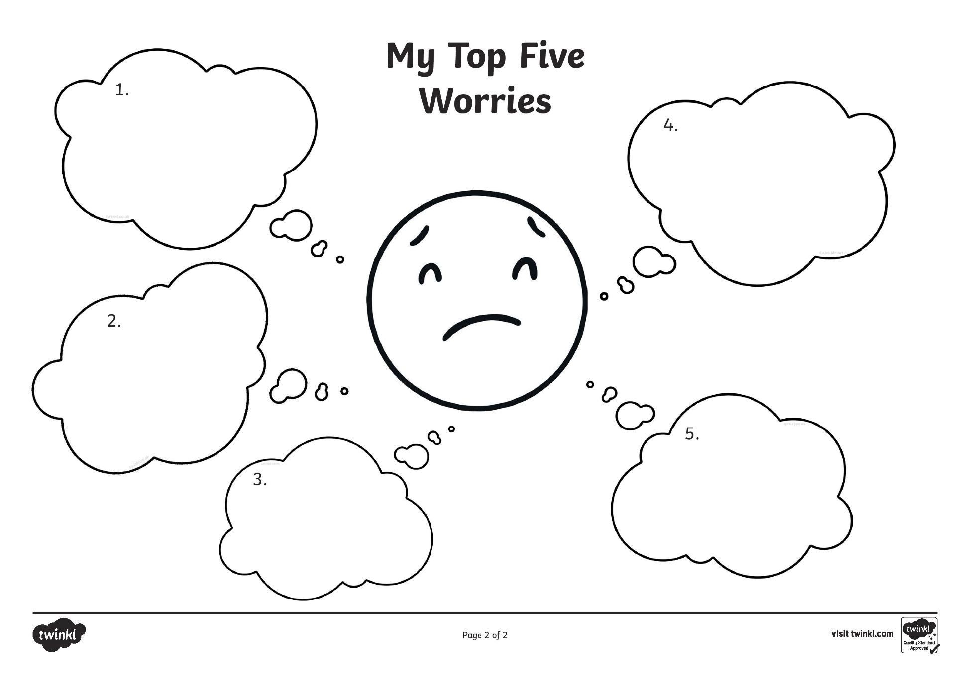

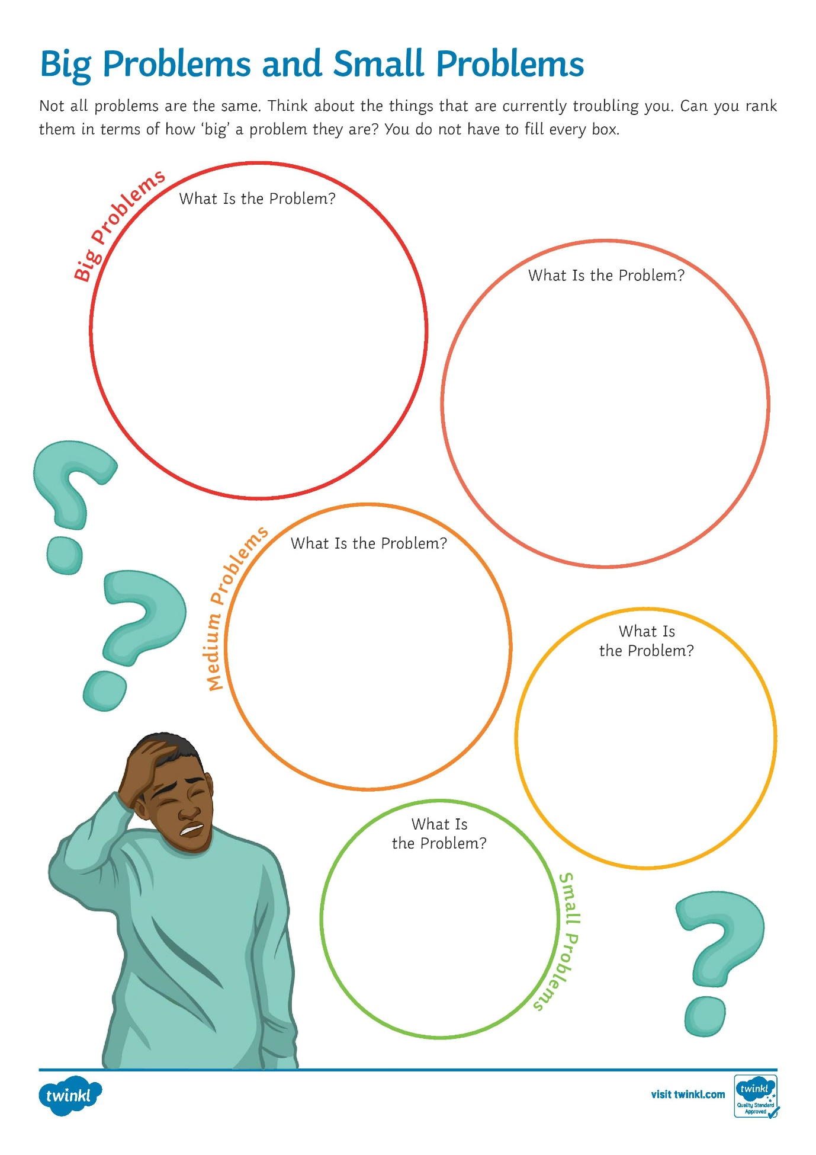

**Comic Strip Conversations**

Comic Strip conversations are simple, visual representations of conversation. They show what is said in a conversations, how people might be feeling and what people’s intentions might be. By seeing the different elements of a conversation presented visually, some of the more abstract aspects of social communication are made clearer and easier to understand.

Comic Strip Conversations use the following format

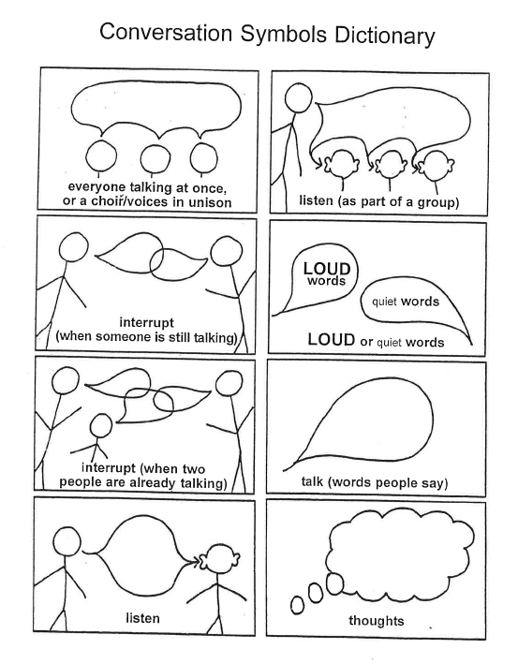

*Adapted from Gray, C. (1994). Comic Strip Conversations.*

The following colours are used to represent feelings and ideas:

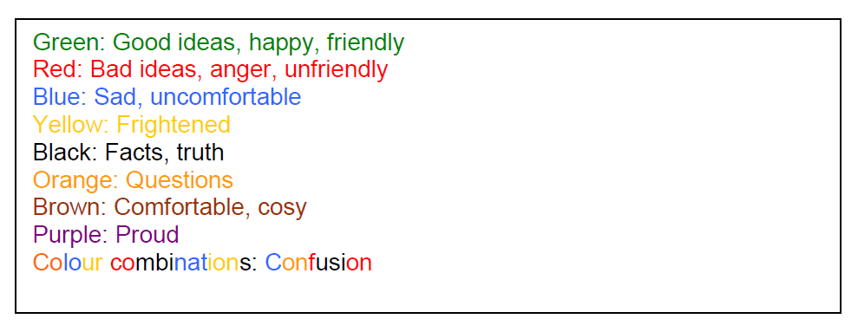

They are not meant to be used with every conversation but those which require a bit more understanding. The child should take the lead role in the conversation. For example

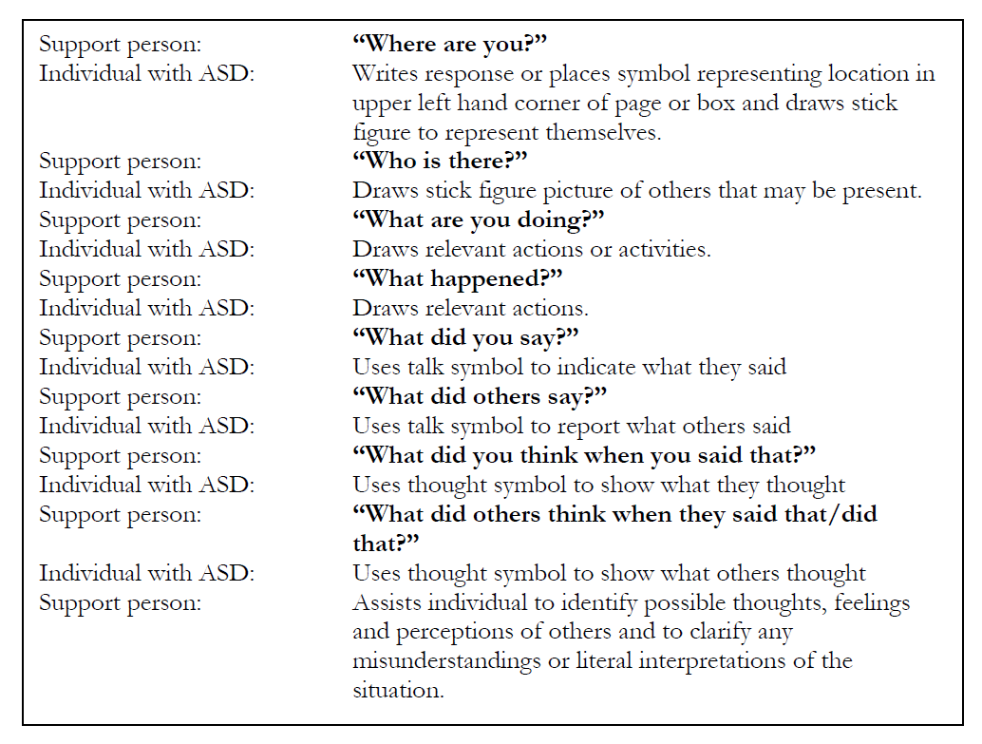

*Adapted from The National Autistic Society (2008)*

**Social Stories**

Social Stories help improve social skills. Here are a couple of examples from which you may like to devise your own. They model appropriate social interaction by describing a situation with relevant social cues, other’s perspectives and suggested appropriate responses.

Sometimes I get really frustrated and mad.

I may want to throw things, hit people, yell and cry.

When I act that way I can get in trouble and people won’t want to be my friend.

When I am frustrated, I need to take a deep breath, I can ask or a break, to take a walk, get a drink of water or put my head down.

To tell people I am frustrated right now, I use my words. Soon I will feel better.

**When Words Hurt – A Story for __________**

Sometimes other people say and do things that make me mad.

Sometimes they give the wrong answer in class or break a rule, like cutting in line.

When people do these things, I get frustrated and before I think things through, I say things that are very mean.

When I was little, I used to kick people when they said or did things that made me mad, so I figured words were better than kicking.

Actually, words are better than kicking, but words can still be scary and hurtful.

When I say hurtful or mean things, other people may think I want to hurt them or that I don’t like them.

When I say mean things, other people might decide not to be my friend any more.

My teacher can try to help by defining 4 words for me. I can write those words on my scale and try to remember not to use them when I am mad.

I can also keep a journal of the things that make me mad. Sometimes writing it down gives me just enough time to think about not using those 4 words.

Tools

**My Calming Sequence**

Try this calming sequence. Does it feel good and calming? How can you change it so that it works for you?

This calming sequence goes like this:

Squeeze your hands together.

Close your eyes and rub your head.

Rub your legs.

Repeat the sequence 5 times, bringing your stress down.

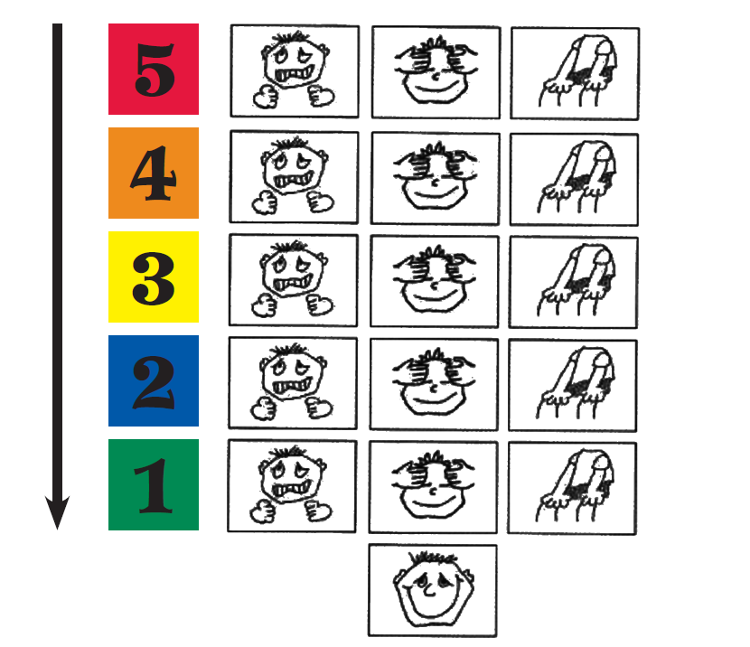

*Adapted from Kuypers, L. (2011). The Zones of Regulation. Think Social Publishing.*

**Lazy 8 Breathing**

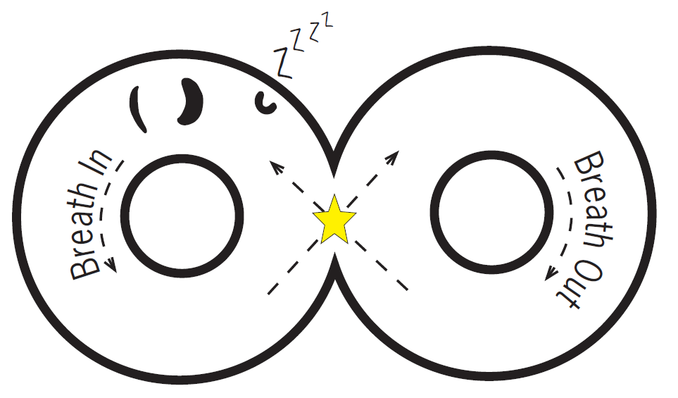

Trace the Lazy 8 with your finger starting at the star and taking a deep breath in.

As you cross over to other side of the Lazy 8, slowly let your breath out.

Continue breathing around the Lazy 8 until you have a calm body and mind.

*Adapted from Kuypers, L. (2011). The Zones of Regulation. Think Social Publishing.*

**The 6 Sides of Breathing**

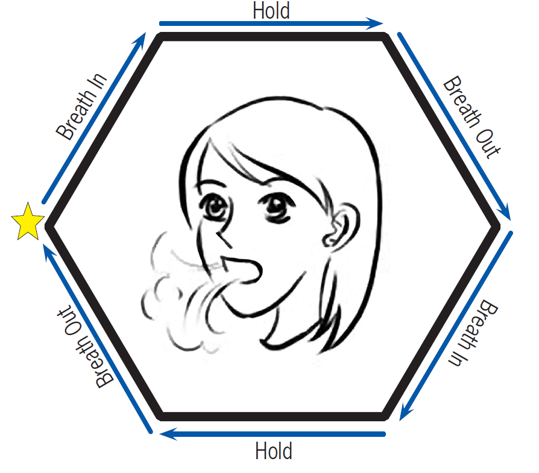Starting at the yellow star, trace with your finger around the six sides of the hexagon, taking a deep breath in, feeling your shoulders rise as the air fills you.

Trace over the next side as you hold your breath for a moment.

Slowly breathe out as you trace the third side of the hexagon.

Continue tracing around the bottom three sides of the hexagon as you complete another deep breath.

Continue the 6 sides of breathing cycle until you feel calm and relaxed.

*Adapted from Kuypers, L. (2011). The Zones of Regulation. Think Social Publishing*

**Anger Management Skill Cards**

Please use these cards as prompts for your child when they need a distraction

|  |  |
| --- | --- |
| **Take 20 Deep Breaths** | **Draw Your Anger** |
| **Do 50 Jumping Jacks** | **Write About Your Anger** |

|  |  |
| --- | --- |
| **Count to 100** | **Walk Away** |
| I’m angry  Let me help you.  **Talk to Someone about Your Problem** | **Squeeze a Ball** |

|  |  |
| --- | --- |
| **Play Outside** | **Listen to Music** |
| **Practice a Hobby** | **Your Own Idea:** |

*Adapted from TherapistAid.com (2015)*

**Appendix A**

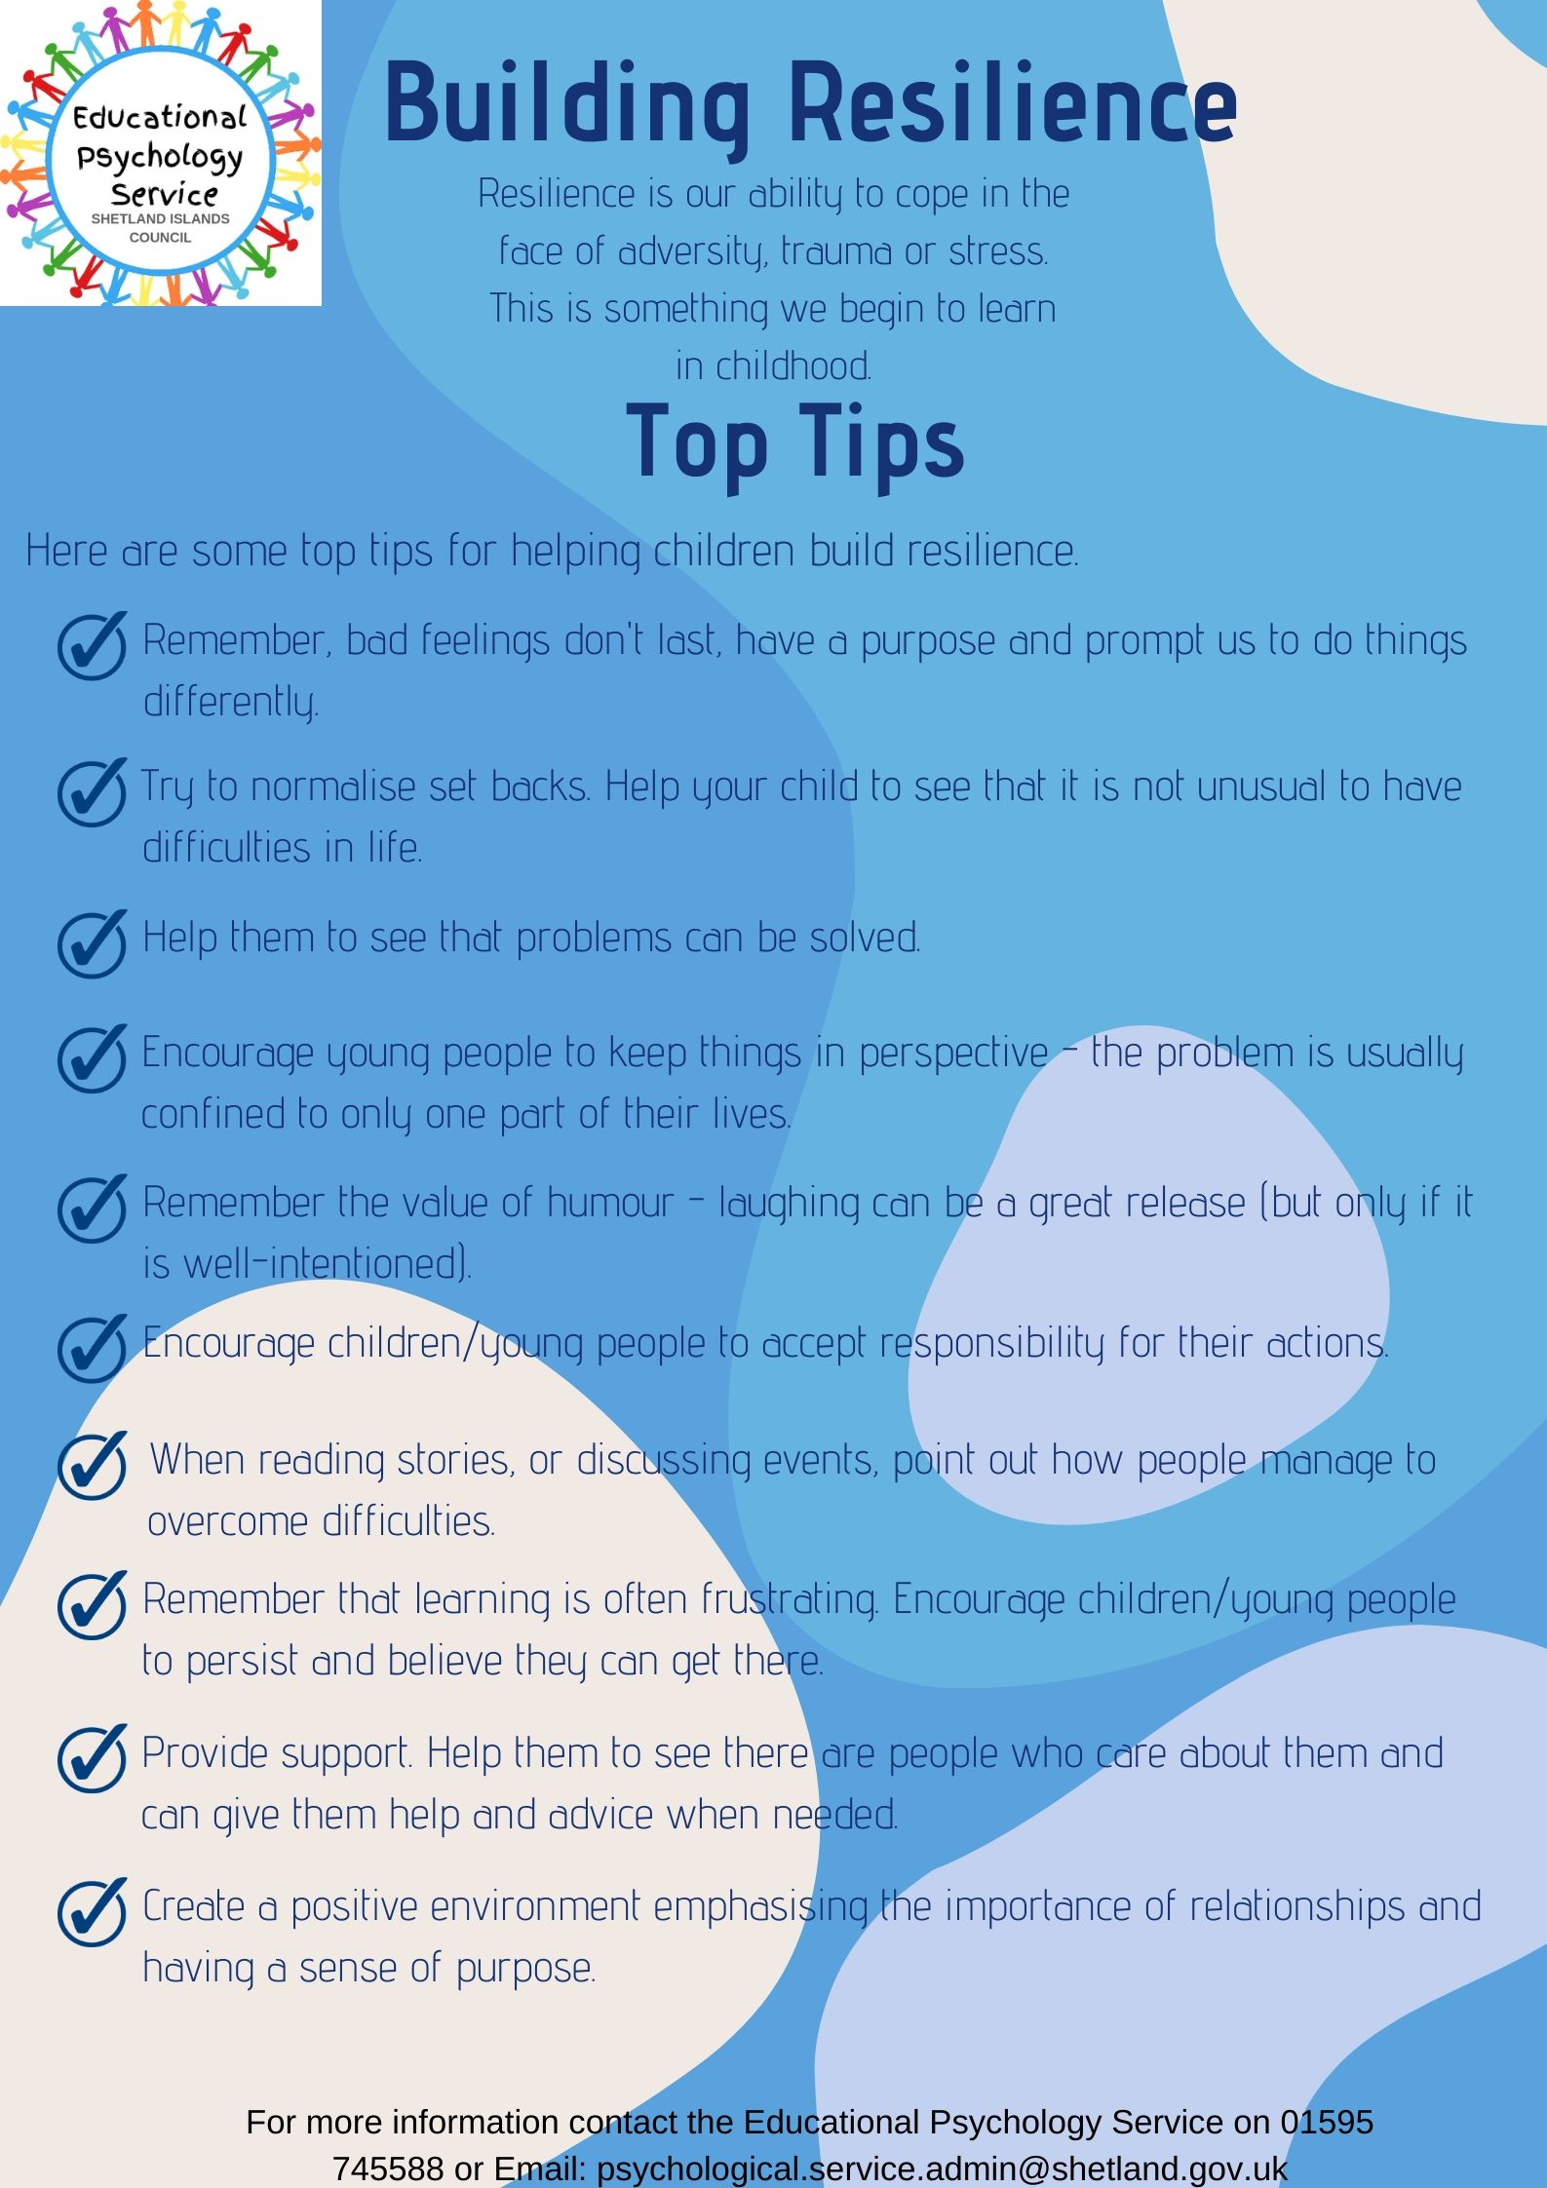

**Appendix B**

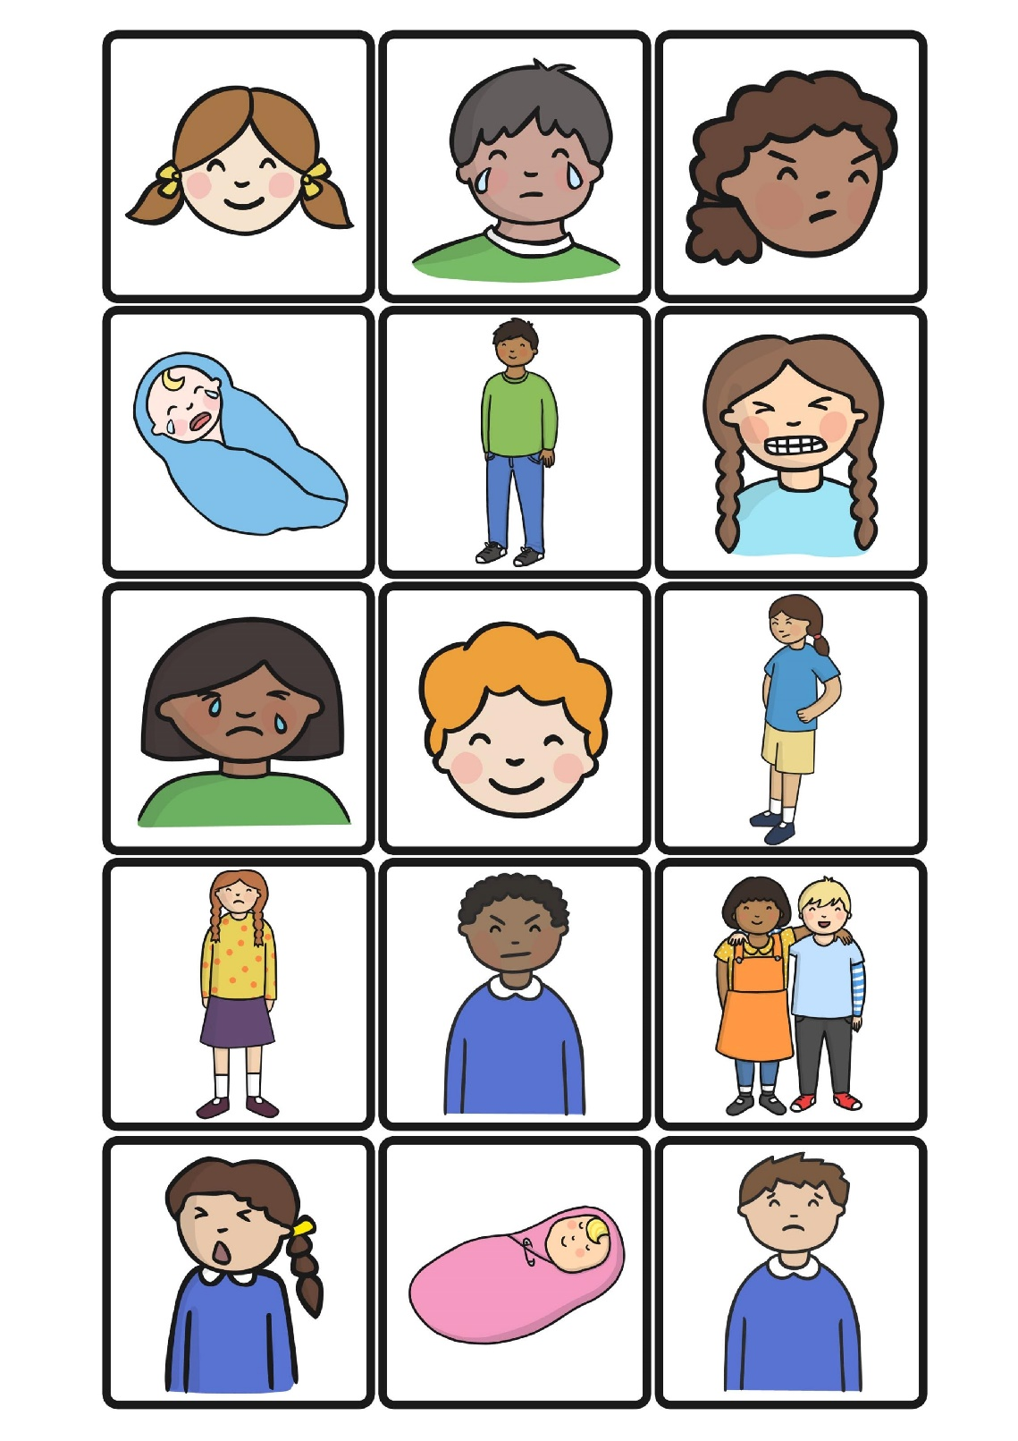**Identifying Emotions in Others**

Cut out and place the different faces in the correct emotion circles on the following pages.

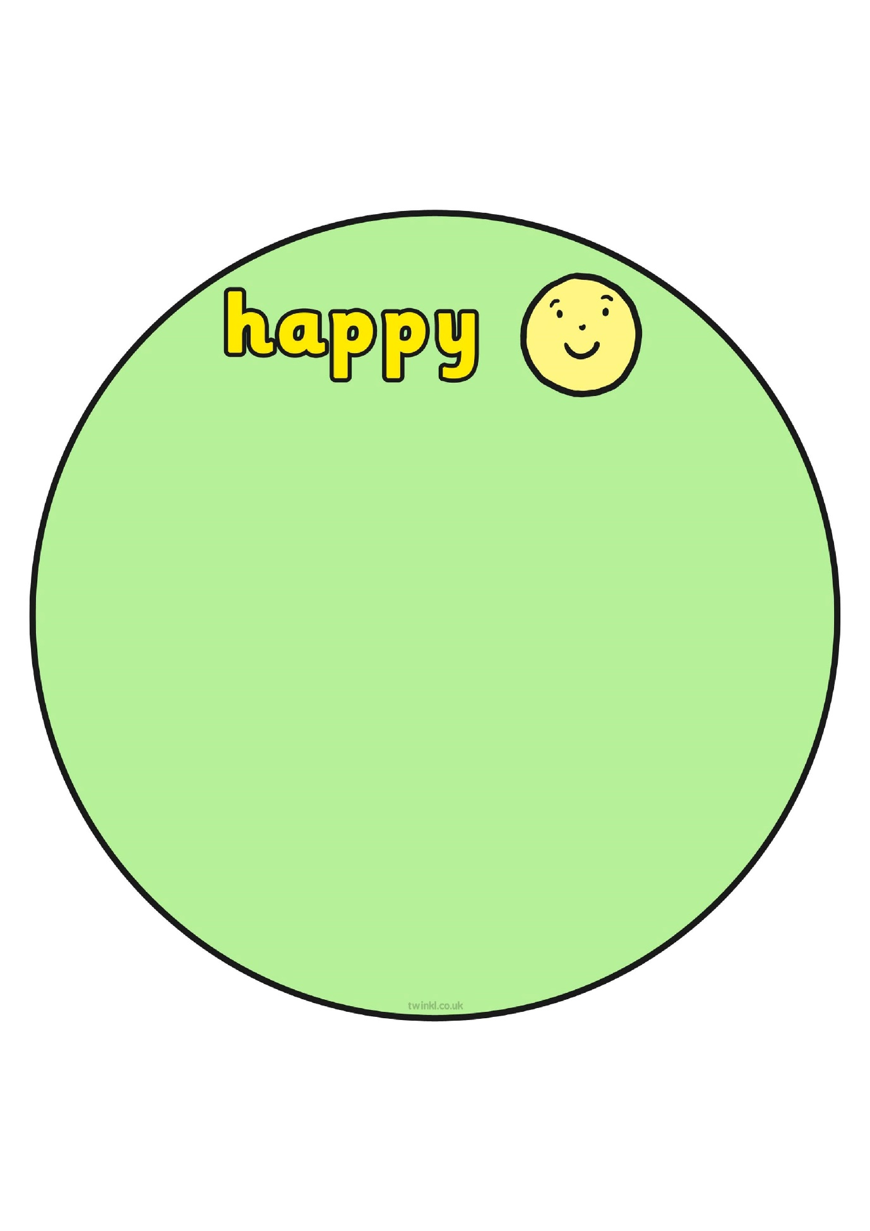

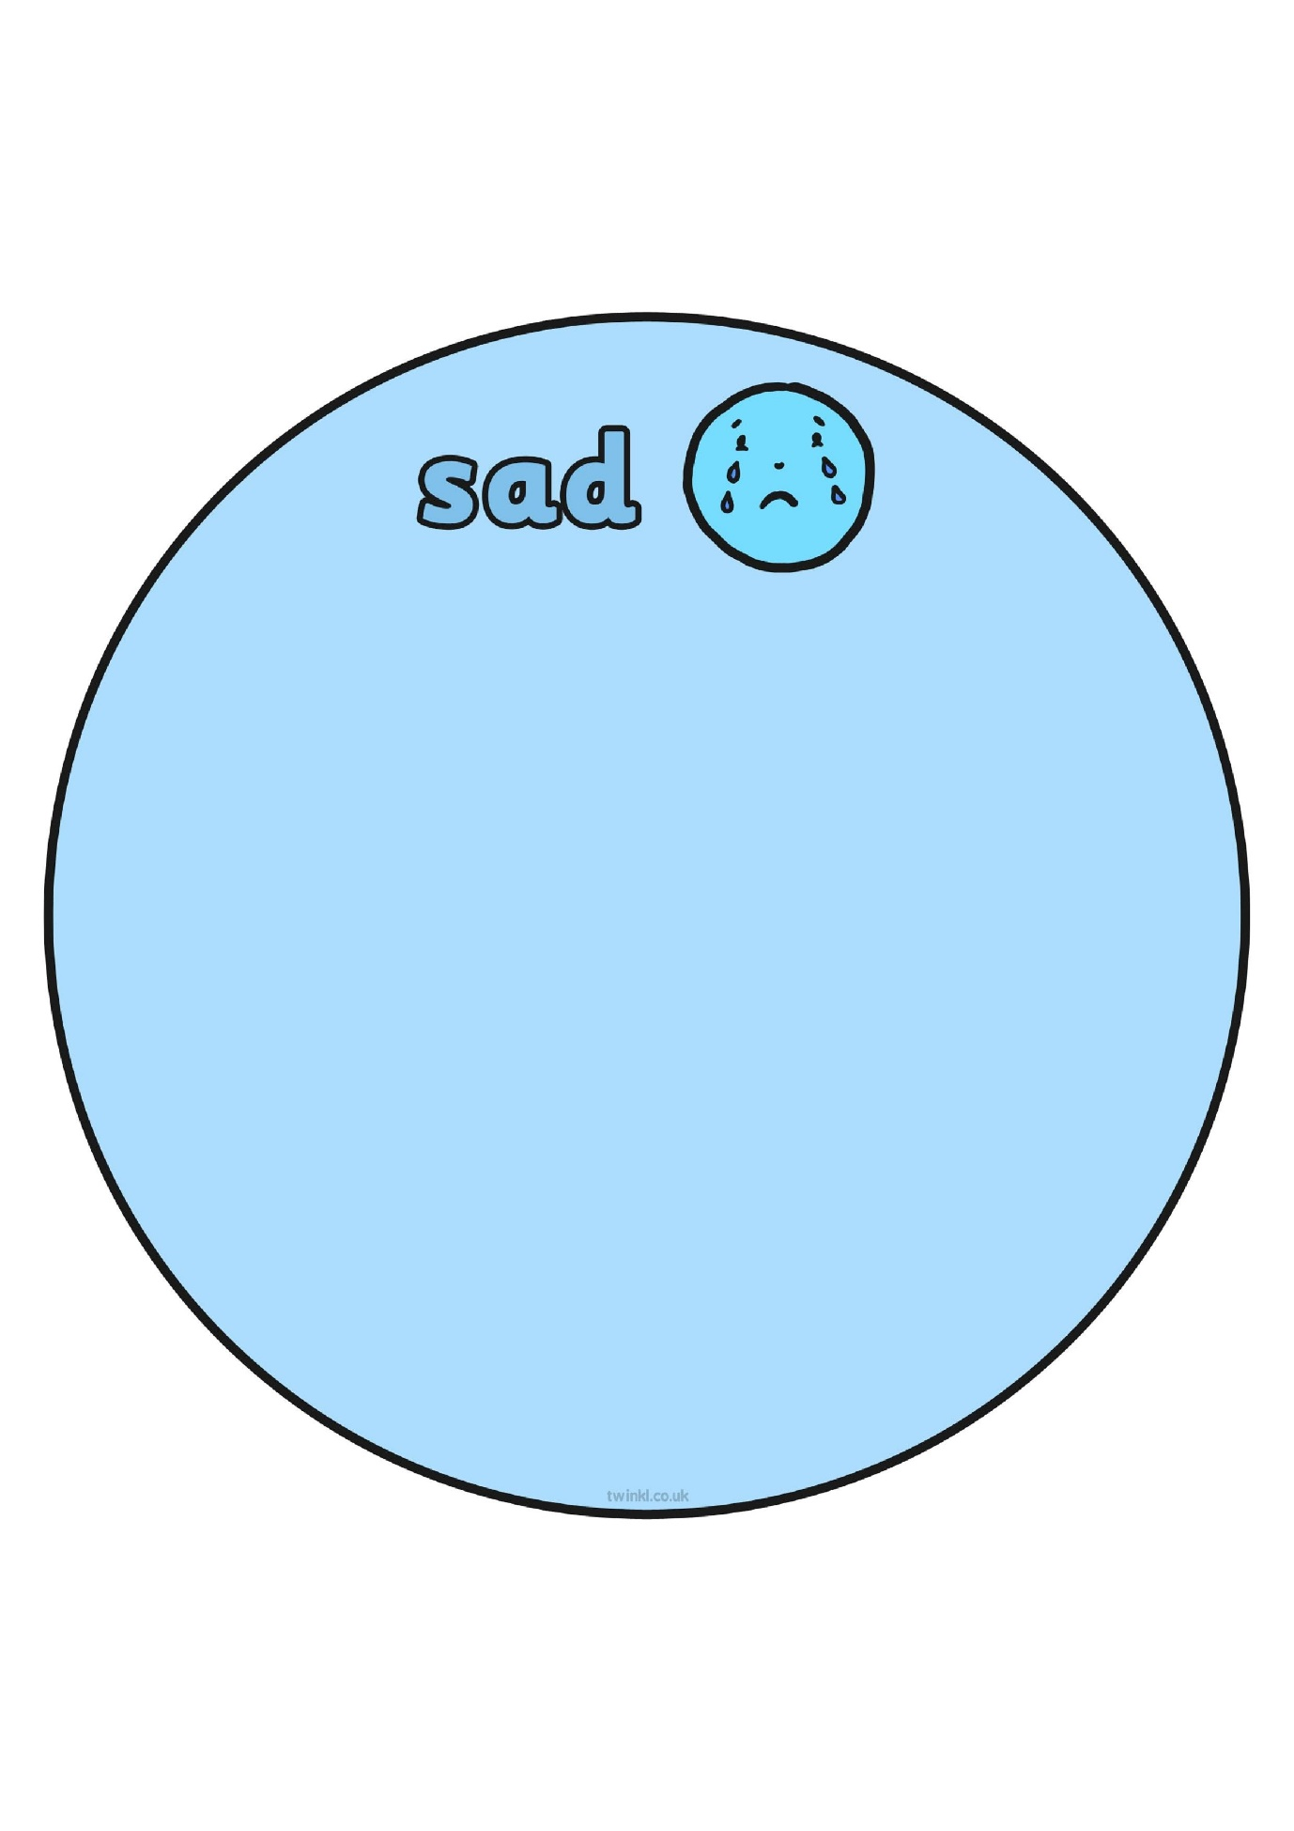

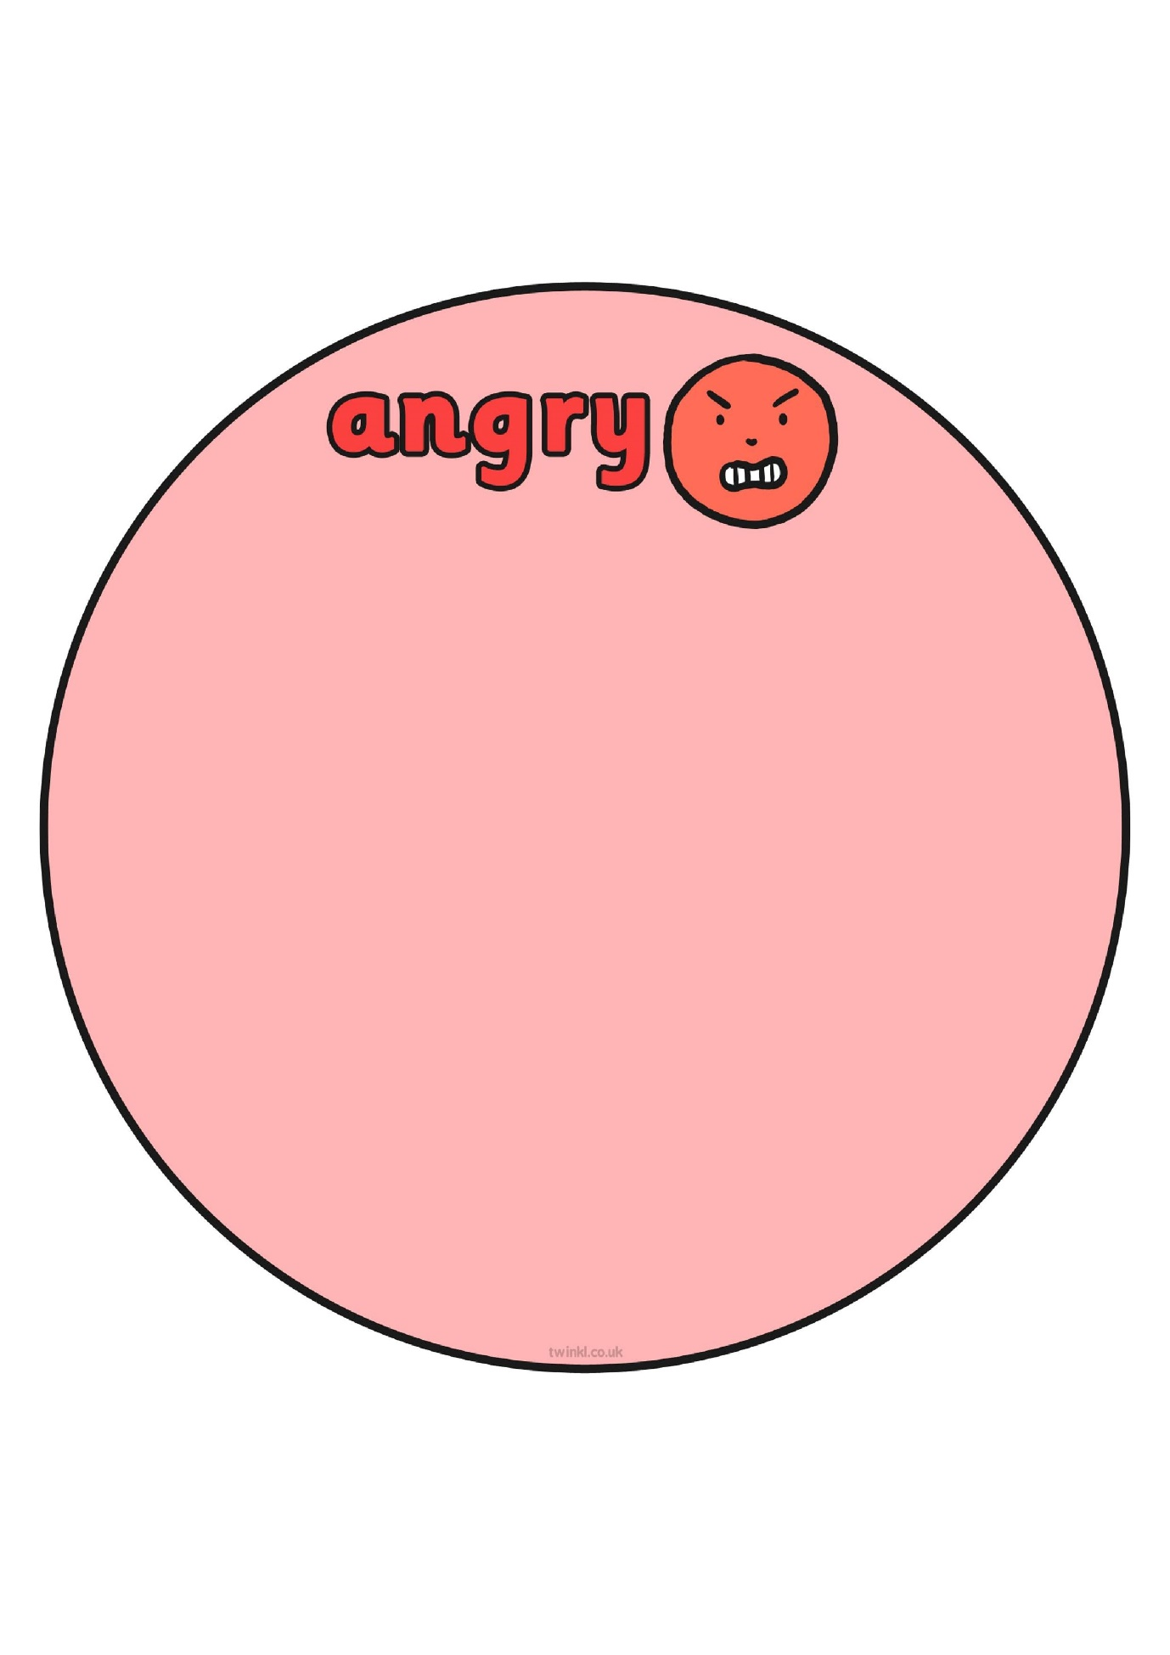Adapted from www.twinkl.com

**Appendix C**

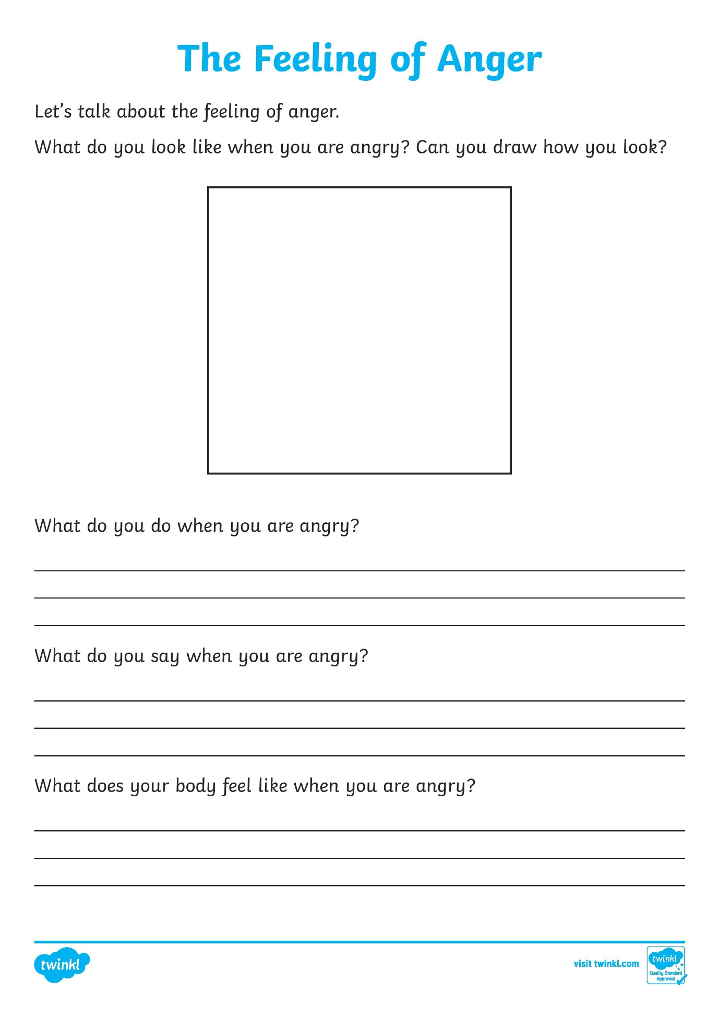

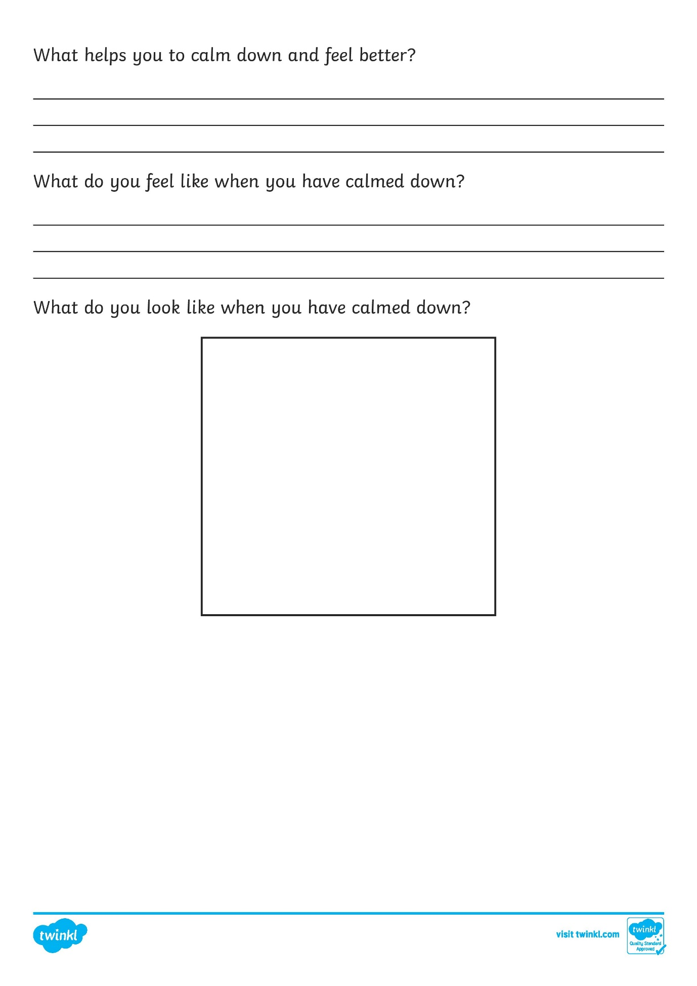

**Appendix D**

|  |  |
| --- | --- |
| 5 | I could lose control |
| 4 | Can really upset me |
| 3 | Makes me nervous |
| 2 | Bugs me |
| 1 | Never bothers me |

**The Stress Scale**

The stress scale allows children to identify what triggers them. You may need to support children with some examples e.g. I could lose control when the Xbox stops working.

*Adapted from Coffin, A. B., & Smith, S. M. (2009). The Incredible* 5-Point Scale*(Columbus)*

**Appendix E**

**The High - Low Scale**

How might you look from the high to the low end of the scale? How might this make others around you feel and how might they act towards you? Draw your own faces for each colour on the next page…

|  |  |  |
| --- | --- | --- |
| High | 5 | That person is scary! |
|  | 4 | I’m not going near them. |
|  | 3 | They look like they want to be left alone |
|  | 2 | I wonder if they are ok? |
| Low | 1 | I like to sit near you. |

**Your Turn**

|  |  |  |
| --- | --- | --- |
| High | 5 | That person is scary! |
|  | 4 |  |
|  | 3 |  |
|  | 2 |  |
| Low | 1 | I like to sit near you. |

*Adapted from Coffin, A. B., & Smith, S. M. (2009). The Incredible* 5-Point Scale*(Columbus)*

**Appendix F**

**Cut Out and Keep Scales**

Please cut out and stick the coloured scales around your home to help prompt your child. You may wish to stick one on the fridge, in their bedroom etc. You could also have one laminated to use when out and about.

|  |  |
| --- | --- |
| **5** | **5** |
| **4** | **4** |
| **3** | **3** |
| **2** | **2** |
| **1** | **1** |

|  |  |
| --- | --- |
| **5** | **5** |
| **4** | **4** |
| **3** | **3** |
| **2** | **2** |
| **1** | **1** |

**Appendix G**

**Inside Out: Getting to Know my Emotions**

|  |  |  |  |  |
| --- | --- | --- | --- | --- |
|  | My emotion | Feels like | Sounds like | A memory when I felt…. |
|  | **Sadness** |  |  |  |
|  | **Disgust** |  |  |  |
|  | **Joy** |  |  |  |
|  | **Anger** |  |  |  |
|  | **Fear** |  |  |  |

*Adapted from* [*https://elunanetwork.org/resources/activity-inside-out-getting-to-know-my-emotions/*](https://elunanetwork.org/resources/activity-inside-out-getting-to-know-my-emotions/)



**Appendix H**

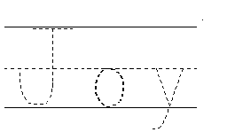

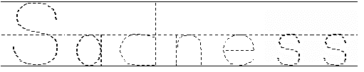

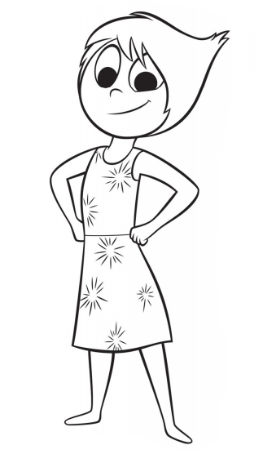

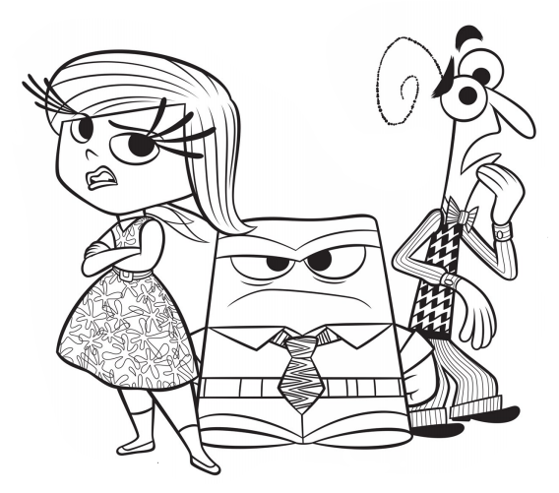

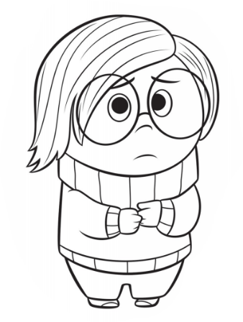

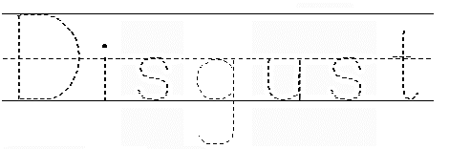

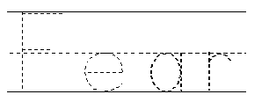

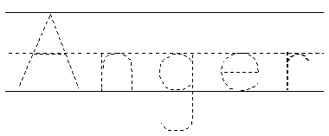

*Adapted from https://en.islcollective.com/english-esl-worksheets/search/Inside+Out*

**Appendix I**

**Inside Out Feelings and Calm Down Worksheet**

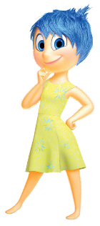

I might feel: To calm down, I can:

________________ ____________________

________________ ____________________

I might feel: To calm down, I can:

_________________ ____________________

_________________ ____________________



I might feel: To calm down, I can:

_________________ ____________________

_________________ ____________________



I might feel: To calm down, I can:

_________________ ____________________

_________________ ____________________

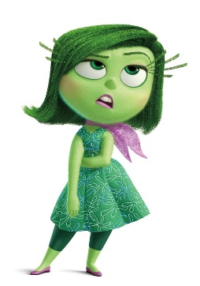

I might feel: To calm down, I can:

________________ ___________________

________________ ___________________

*Adapted from* [*https://crayonsandcompliance.wordpress.com/tag/inside-out/*](https://crayonsandcompliance.wordpress.com/tag/inside-out/)

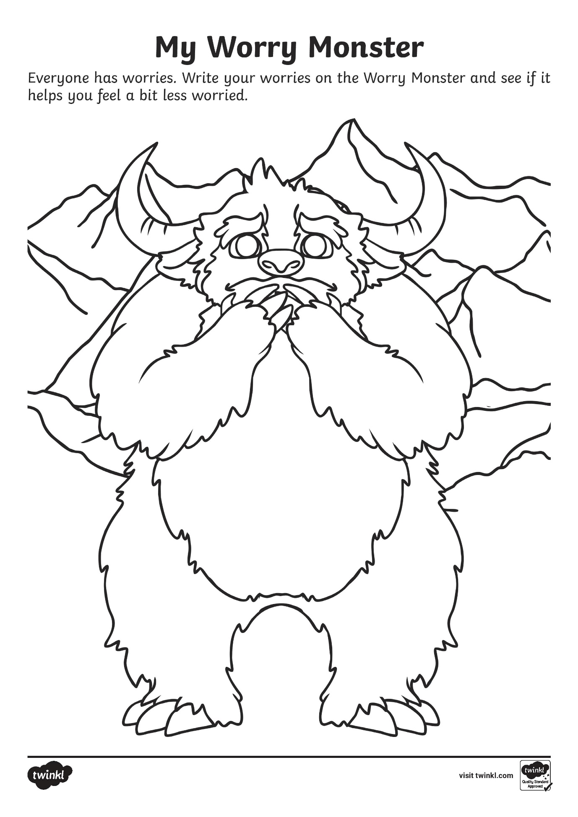**Appendix J**

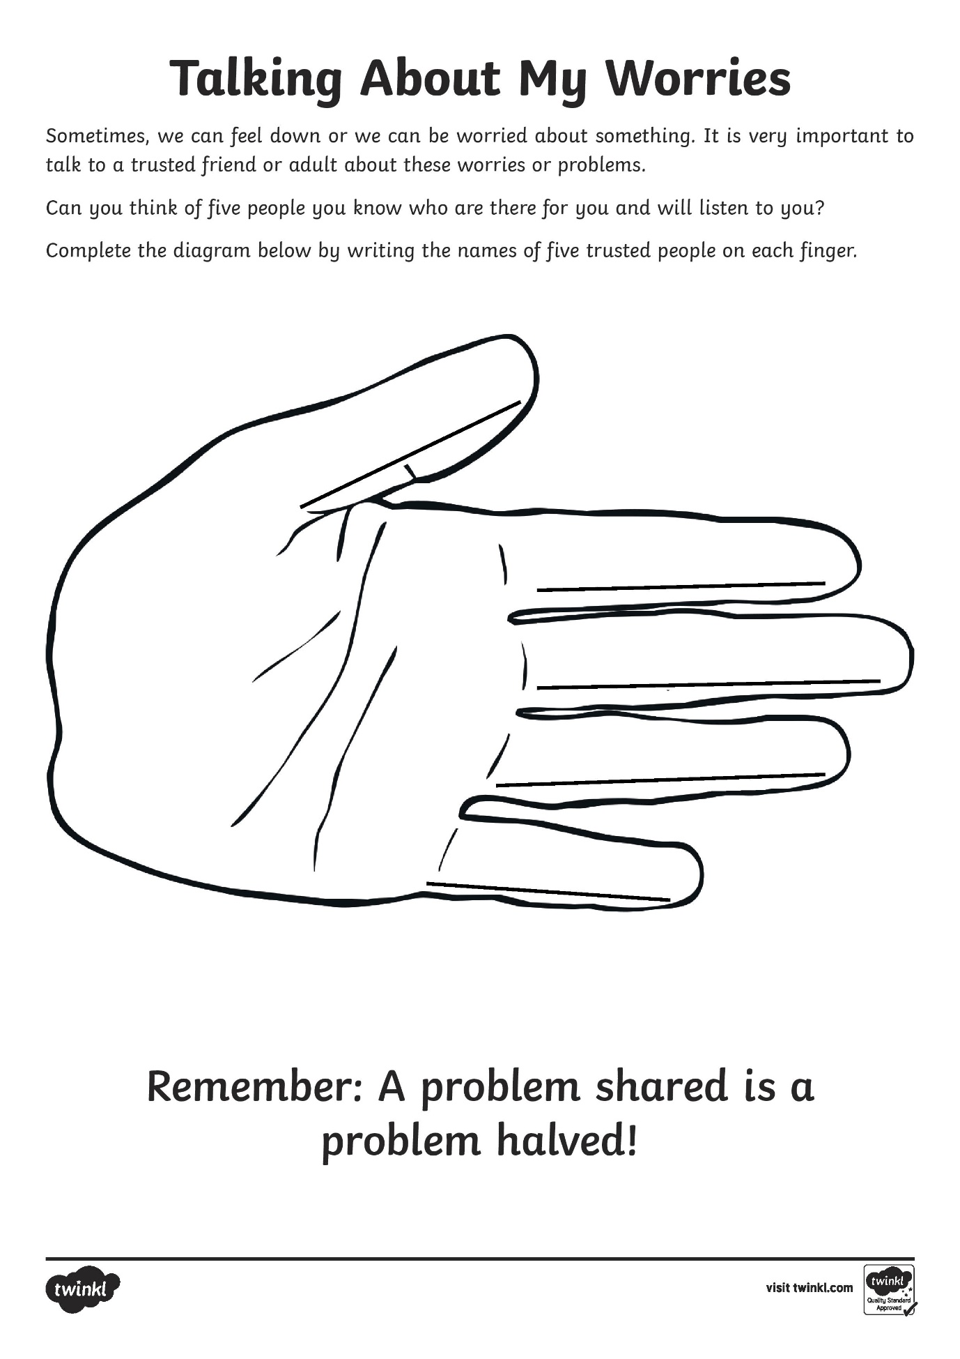**Appendix K**

**Useful Links**

***Books***

[My Hidden Chimp](https://www.amazon.co.uk/My-Hidden-Chimp-author-Paradox/dp/1787413713/ref=sr_1_1?crid=3P2JC8XOFYA2G&dchild=1&keywords=hidden+chimp+for+kids&qid=1584457653&sprefix=hidden+chimp%2Caps%2C222&sr=8-1) by Professor Steve Peters, explains the neuroscience of the brain to children in a straightforward way and introduces the use of 10 specific habits in order to manage our emotions and behaviour.

*The Big Life Journal* is a useful book to use with your child to help them develop a growth and resilient mindset so they feel like they can face life’s challenges with confidence. There are 2 journals to choose from, one for younger children (aged 7-10) [Big Life Journal for children](https://biglifejournal-uk.co.uk/collections/journals/products/big-life-journal-kids-second-edition) and one for teens (aged 11+) [Big Life Journal teens](https://biglifejournal-uk.co.uk/collections/journals/products/big-life-journal-teen-edition)

[Starving the Anxiety Gremlin](https://www.amazon.co.uk/Starving-Anxiety-Gremlin-Behavioural-Management/dp/1849053413/ref=sr_1_1?dchild=1&keywords=anxiety+gremlin&qid=1584457171&sr=8-1): *A Cognitive Behavioural Therapy Workbook on Anxiety Management for Young People* by Kate Collins-Donnelly, helps young people understand different types of anxiety and how to manage them using a cognitive behavioural therapy approach. The book can be used by those aged 10+ on their own or with a parent.

[The Incredible 5 Point Scale: The Significantly Improved and Expanded Second Edition](https://www.amazon.co.uk/Incredible-5-Point-Scale-Significantly-Improved/dp/1937473074/ref=sr_1_1?crid=3746SH9ESZHBH&dchild=1&keywords=the+incredible+5+point+scale&qid=1584971601&sprefix=the+incredible+5+point%2Caps%2C217&sr=8-1) by Kari Dunn Buron and Mitzi Cutis has been adapted to form some of this toolkit.

[The Zones of Regulation](https://www.amazon.co.uk/Zones-Regulation-Leah-Kuypers/dp/B008M7E0G8/ref=sr_1_1?crid=32VINYUXU2VX7&dchild=1&keywords=zones+of+regulation&qid=1585135074&sprefix=zones+of+%2Caps%2C221&sr=8-1) is a curriculum developed by Occupational Therapists to help children self-regulate.

[What to do When You Worry too Much](https://www.amazon.co.uk/What-When-Worry-Much-What/dp/1591473144/ref=sr_1_1?crid=3RGHXY16ZSEIT&dchild=1&keywords=what+to+do+when+you+worry+too+much&qid=1584457399&sprefix=what+to+do+whe%2Caps%2C215&sr=8-1): *A Kid’s Guide to Overcoming Anxiety* by Dawn Heubner, is a book designed to help 6-12 year olds through cognitive behavioural therapy techniques in relation to anxiety and worry.

<https://www.amazon.co.uk/What-When-Temper-Flares-What/dp/1433801345> *A Kid’s Guide to Overcoming Anger* by Dawn Heubner, is a book designed to help 6-12 year olds manage their anger.

***Links***

For some fun games and activities around self-regulation, that can be done at home please look at:

<https://www.theottoolbox.com/zones-of-regulation-activities/>

To help your child keep calm please visit:

<https://childmind.org/article/how-to-help-children-calm-down>

<https://www.bbc.co.uk/cbeebies/joinin/seven-techniques-for-helping-kids-keep-calm>

<https://bbc.co.uk/cbeebies/joinin/dualwa-anxiety-in-primary-school>

<https://www.bbc.co.uk/cbeebies/joinin/help-children-cope-with-emotions>

The following links contain useful information on mindfulness and further activities.

[www.blissfulkids.com](http://www.blissfulkids.com)

[www.educationsvoice.wordpress.com](http://www.educationsvoice.wordpress.com)

[www.mentalhealth.org.uk/publications/be-mindful-report](http://www.mentalhealth.org.uk/publications/be-mindful-report)

[www.youthmindfulness.org](http://www.youthmindfulness.org)

***Video Clips***

The following video clips talk children through calming meditations. You may find it helpful to do these alongside your child as a fun activity.

[Kindness meditation](https://www.youtube.com/watch?v=KIEcztQuyE8) is a 6 minute clip that children can listen to help them relax and learn to be kind to themselves.

[Balloon meditation](https://www.youtube.com/watch?v=bRkILioT_NA) is a 5 and half minute clip to help us gain control of our stressful energy when it becomes too hard to handle.

[Breathing meditation](https://www.youtube.com/watch?v=RtiWdN5WFm4) is a 9 and half minute clip to help children explore their breath in order to remain calm and relaxed.

***Apps***

The following are links to Apps that may be useful when implementing mindfulness based approaches within in the home.

[www.calm.com](http://www.calm.com)

[www.headspace.com](http://www.headspace.com)

[www.insighttimer.com](http://www.insighttimer.com)

[www.stopbreathethink.com](http://www.stopbreathethink.com)

www.serenitymeditations.co.uk

***References***

Buron, K. D. and Curtis, M (2012) *The Incredible 5 Point Scale.* AAPC Publishing.

Coffin, A. B., & Smith, S. M. (2009). *The Incredible* 5-Point Scale. Columbus.

Kuypers, L (2011) *The Zones of Regulation.* Think Social Publishing