What is social distancing?
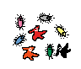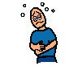
Coronavirus is a virus which is a type of illness
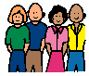
Coronavirus is spread from person to person
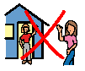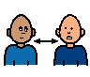
It is therefore important at this time to see less people and avoid busy places. This is called social distancing.
By doing this it can keep me healthy.
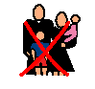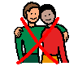
It means that you might not be able to see all your family and friends.
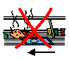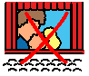
It might mean you cannot do the things you would enjoy, like going to a restaurant or the cinema.

