What do I do if I sneeze or cough?

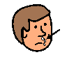
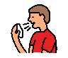
Sometimes I sneeze or cough.

Water might come out of my mouth.

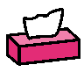
When I sneeze or cough,

I must cover my mouth and nose with a tissue.

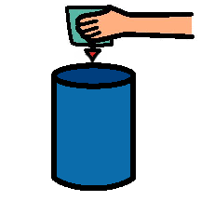
After I sneeze or cough,

I must put my tissue in the bin.

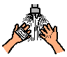
After I sneeze or cough,

I must wash my hands.

