Learning at school today
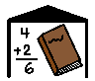
Usually I go to school with all the other children in my class
I will still go to school, but there may not be the same people in my class.
My learning might be different but it can still be fun.
Sometimes these changes might make people feel upset or frustrated.
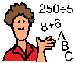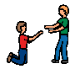
My teacher can help me if I feel like this.
My teacher will tell me when my learning at school will go back to normal.

