Learning at home today
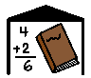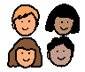
Usually I go to school with all the other children in my class.
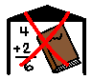
School is now closed.
Some children will do their learning at home now. I will try to do my learning at home.
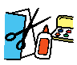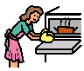
Learning at home can be fun and I can do lots of exciting things.
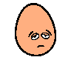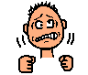
Learning at home can also make people feel upset or frustrated.
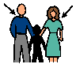
If learning at home makes me upset, I can ask an adult in the house for help.
An adult will tell me when school is open again.

