Free access to Tacpac
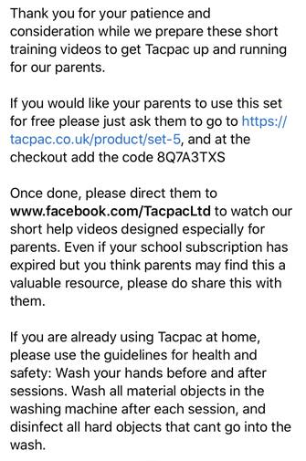
https://tacpac.co.uk/product/set-5
www.facebook.com/TacpacLtd

