**Useful programmes, apps, extensions and tools to help pupils access the curriculum**

1. **Microsoft Lens screen reader** works on a smart phone via the camera. It can read word documents/hand-outsthat you photograph.

[](https://www.google.com/imgres?imgurl=https%3A%2F%2Fstore-images.s-microsoft.com%2Fimage%2Fapps.1997.9007199266246357.2c94b93c-db8f-4615-8972-79c37bf7bc09.224bcf57-0105-4bfc-87a3-4a136c53416c%3Fw%3D498%26h%3D408%26q%3D90%26mode%3Dscale%26format%3Djpg%26background%3D%2523D83B01%26padding%3D0.0.0.0&imgrefurl=https%3A%2F%2Fwww.microsoft.com%2Fen-us%2Fp%2Foffice-lens%2F9wzdncrfj3t8&docid=tVYi5D9FJM-NOM&tbnid=8nE0wd3j1TfPZM%3A&vet=10ahUKEwjp6brUj7zkAhXGYMAKHYKRDKQQMwhFKAAwAA..i&w=408&h=408&safe=active&bih=655&biw=1366&q=microsoft%20lens%20logo&ved=0ahUKEwjp6brUj7zkAhXGYMAKHYKRDKQQMwhFKAAwAA&iact=mrc&uact=8)

Instructions are as follow:

1. Download to phone from the App Store or Google Play Store (free)
2. Open the app
3. Take a photo on your phone of the piece of print (or info on a whiteboard)
4. Crop the photo if you need to  then tap the “Done” button (bottom right corner)
5. In “Export to” select “Immersive Reader”

At this point you may need to sign into or create a Microsoft account (email address and password required).  A Glow email address and password can be used, but you may have your own Gmail or Microsoft account.

The print is then scanned and appears on the screen in **Immersive Reader**. Tap the play button at the bottom of the page to listen to the text.

1. **Glow. Microsoft Office home 365.**



This on-line version of Word has a fast and really quite accurate speech-to-text function.

Log in to Glow. The **Office 365** tile will be on the Launch Pad. Select **Word** from the Office apps:

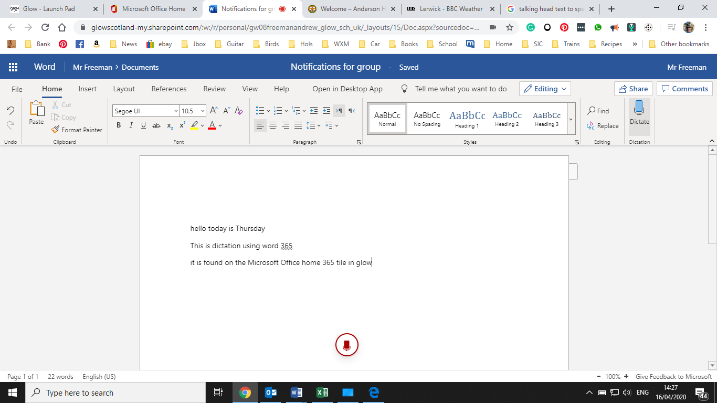

It also has a text-to speech reader in the **View** tab (called **Immersive Reader**):

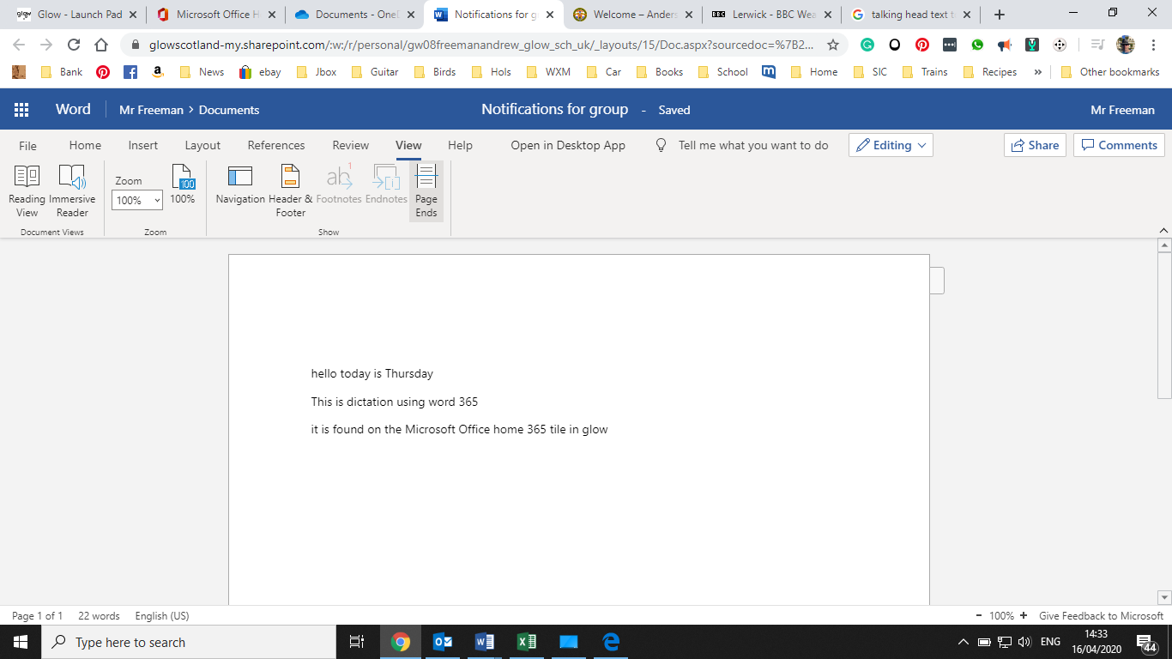

1. **Open Dyslexic font extension for Chrome**. This can be added to any computer as long as you use the Chrome browser (and you have signed into Google). This font makes text much easier to read for almost all readers.

Go to **Settings** (three dots on the top right of Chrome search bar) – **More tools** - **Extensions** – Click on **Extensions main menu** - Open **Chrome Web Store** and add.

Unfortunately Dyslexic font is not available in Word, but is available as a font option on Amazon kindles (monochrome).

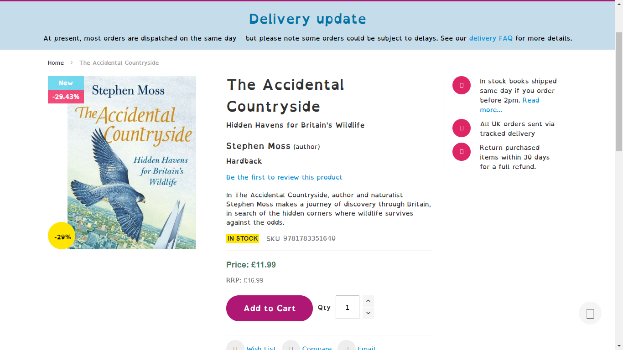

1. **Read Aloud –** Again an extension that works in the Chrome web browser.

Go to **Settings** (three dots on the top right of Chrome search bar) – **More tools** - **Extensions** – Click on **Extensions main menu** - Open **Chrome Web Store** and add.

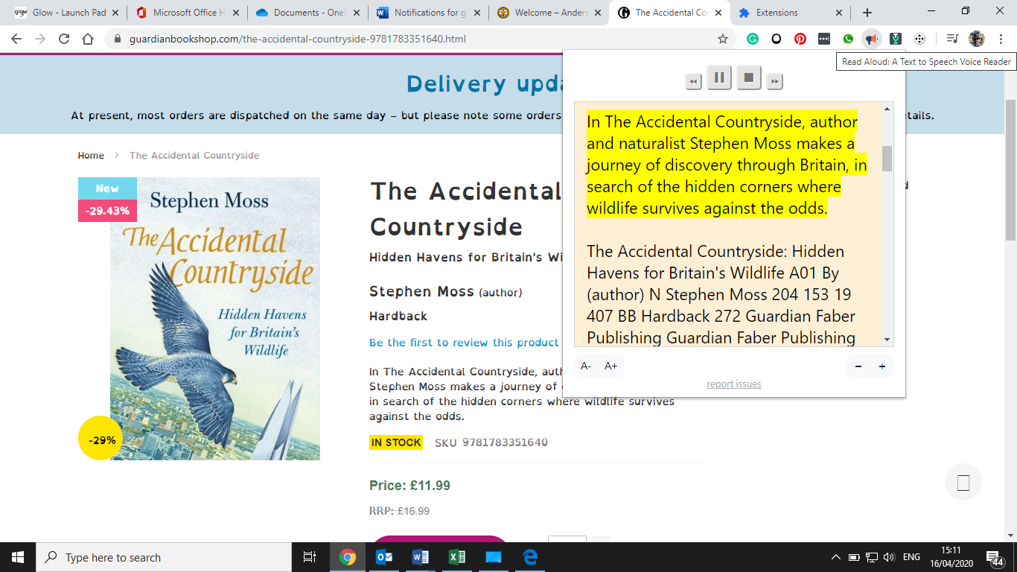

1. If you are having trouble with logging into Glow or don’t have Microsoft Word on a computer try **Google docs** (Google’s version of Word)**.** This alsohas **speech-to-text.**

Click **Tools**, then **Voice Typing** to enable. After finishing speaking click the microphone off so it starts typing – a bit like a walkie-talkie.

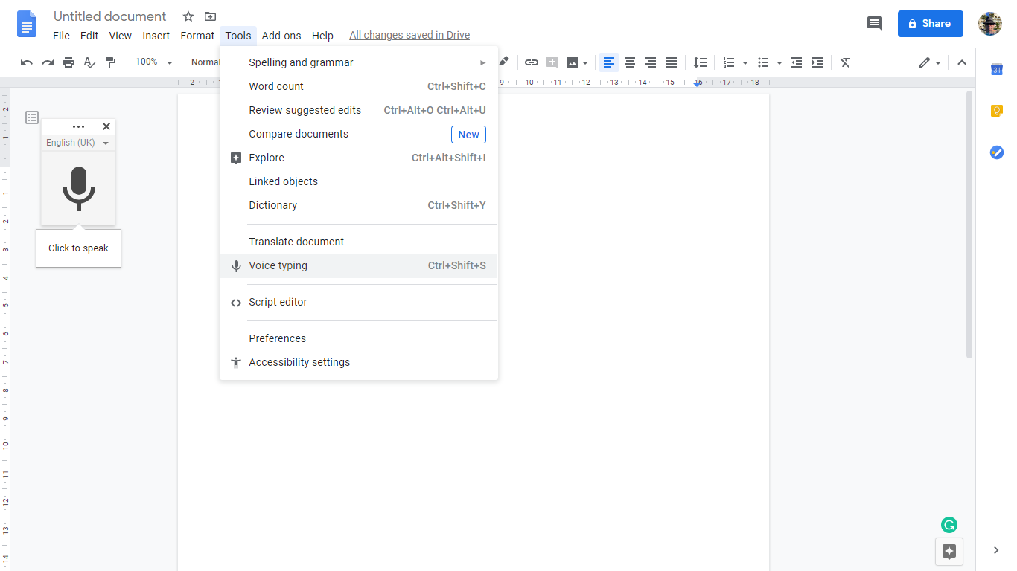

1. **Blank Slate** (blankslate.io) is a useful and quick to open writable blank web page.

Using the Chrome browser text can then be copied from a Word document/internet so you can use **Open Dyslexic font** and/or **Read Aloud**.

