Edible sensory play ideas
- Instant pudding mix can be use instead of shaving foam
- Potato flakes (dried potato) for sensory bins, playdough or finger paint

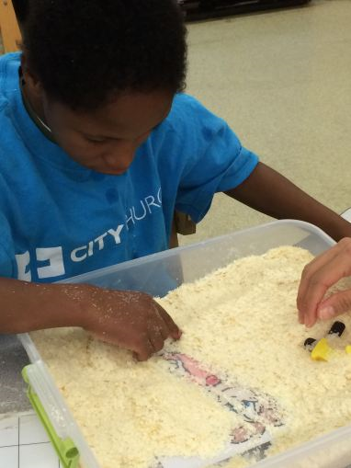

Homemade No-Cook Gluten Free Playdough (Pota-Dough)
- 2 cups (140gms) plain, instant mashed potato flakes
- 1 cup (140gms) cornflour
- ½ cup (160gms) salt
- 1 cup (240ml) hot tap water
- ¼ cup (60ml) white vinegar
- 2½ tablespoons oil
- gel food colour, or liquid food colour (the gel gives more intense colour)
Combine the instant mashed potato flakes, cornflour, and salt in a large deep bowl. Add the hot water, vinegar and oil. *If you choose to make the whole batch the same colour, add the food colouring along with the liquid ingredients.
Mix well, either by hand (stirring first with a wooden spoon until it gets too hard to stir) or with an electric mixer, until the mixture comes together in large clumps. This will take several minutes.
If you squeeze a handful of the dough, it should stick together in a clump. If it doesn’t, keep mixing and it will eventually come together. (The longer you mix it, the ‘stretchier’ the dough becomes.)
Once you have a smooth, homogenous mixture, add the food colour to get the desired shades — divide the dough into two or three parts, colouring each individually.
Start by adding about 1/8 teaspoon gel colour with the tip of a butter knife, or a few drops of liquid colour, to one ball of playdough. Beat with the mixer or work by hand until the colour is evenly mixed in. Add more if you want the colour to be more intense.
If you are using the mixer and plan to colour separate batches, either start with colours that won’t muddy the next colour (ie – yellow, then orange, then red) or wash out the bowl between each colour.
Makes three 250-gram (8-oz) balls of gluten free playdough.
Will keep for several weeks in a sealed bag or container. Will keep longer if stored in the fridge. It warms up and becomes pliable within a few minutes of working with it.
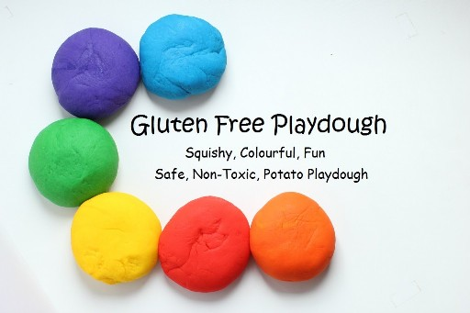
Potato Paint Play Recipe
- Potato flakes
- Food colouring
- Warm water
Pour potato flakes into varying bowls, add a few drops of food colouring, and a touch of warm water

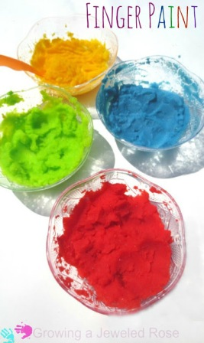

Edible finger paint

This is a wonderful multi sensory activity. Your child will have fun squishing, smelling tasting and mixing the colours.

Gather your materials. All you need is yogurt , some small containers, a cookie tray or plate and food colouring.

Ingredients
4 Tablespoons of corn flour
Cold water
1 Cup of boiling water
Liquid food colouring
Method:
I have played around with this method a few times and find this process the most successful for me in get a great consistency for the homemade paint.
- In a medium saucepan, mix the cornflour with enough cold water to make a paste. (Not too runny).
- Pour in 1 cup of boiling water and stir thoroughly so there are no lumps.
- Turn on medium heat on the cooker and mix. The mixture will start to change and you will notice some clear streaks forming in the mixture. Once you see this, turn off the heat and continue stirring. It will start to thicken and turn into a wonderful, custard-like consistency.
- Spoon equal amounts into empty jars, cups or containers and add food colouring. Mixing until completely combined. For each colour, add 3 drops of yellow, green, red and blue. To make orange, add 1 drop of red and 2 yellow and to make purple, add 1 drop of blue and 2 red.
- Store in the fridge covered with cling wrap for up to 2 weeks. This paint recipe does not have any preservative in it, so it is important to check that the paint has not expired before giving it to children.
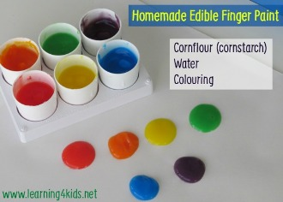
Tip: If the mixture has harden from being in the fridge, adding a little bit of boiling hot water or leave the paint our for a few hours will return to its smooth consistency.

Home made Edible Playdough

Ingredients
1 cup of Cornflour
1 ½ cups of baby rice cereal
3 tbs vegetable oil
1/4 cup pureed tin of raspberries in syrup (or fruit puree of your choice)1 Tbs water
- Food process tinned raspberries in syrup until raspberries are pulped.
- Pour all dry ingredients, baby rice cereal and cornflour into a large bowl.
- Add 3tbs of vegetable oil and ½ cup raspberry puree/juice. Combine well with an electric mixer.
- If the mixture is sticky, slowly add more Baby Rice Cereal and mix well with electric mixer completely before adding more.
- If the mixture is dry, slowly add small amounts of water and mix until the dough is smooth and malleable.
- Turn mixture out onto the bench and knead by hand until the mixture is smooth.
- Store in a plastic zip lock bag or air tight container in the fridge. When removed from the fridge, kneading with warm hands will soften the play dough again.
- This play dough recipe does not include any preservative and will last several days in the refrigerator.

Edible Yogurt Paint
Plain yogurt
Food colouring
Containers
Spoon yogurt into containers and add different coloured food colouring to each container.
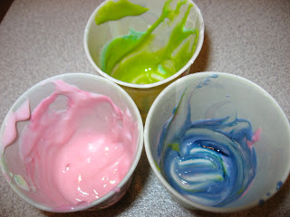

Edible sensory bin or container play ideas:
Rice krispies (added water makes them crackle), shredded wheat for ‘farm’ play (maybe some cake crumbs for soil), popcorn, oats, desiccated coconut, cooked (and coloured) spaghetti
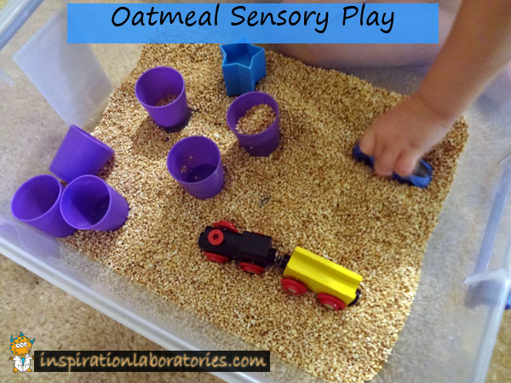

Edible Mini Water Beads
(available from Amazon)

1 Tbsp of Basil Seed
1 and 1/4 cup water
Food Colouring

Add the colouring to the water, if desired. Soak 1 Tablespoon of the basil seeds, stirring occasionally. Within about 5 minutes, they will have absorbed all the water. When you are ready to play with them, add a little extra water to your container to allow them to move a bit more fluidly (otherwise they tend to stick to each other and hands).

Edible Water Beads
- Quick cook tapioca pearls (available from Amazon)
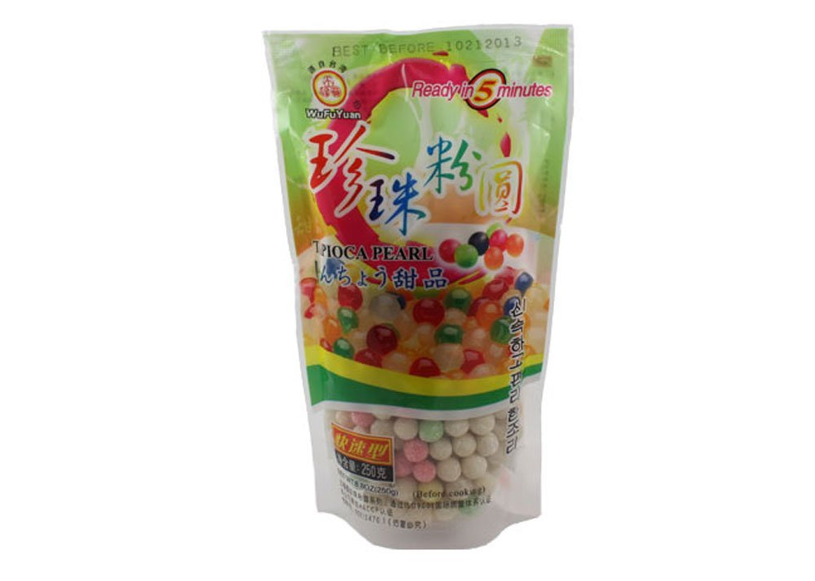
- A Pot
- Water
- Optional addition: food colouring for added colour
- A sensory bin or container for play
Making edible water beads is so easy. You can find tapioca pearls at Asian food markets or online. Make sure you get the quick cook tapioca pearls; they only take 5 minutes to cook. All you have to do is boil water, add the tapioca pearls, stir, cover the pot, and cook on medium heat for 5 minutes.

Once cooked drain the pearls and run them under cold water for several minutes. Children can play with the pearls once they are cool, or you can add extra colour by using food colouring. Divide the pearls into cups, added a few drops of food colouring and mix. Let the colours absorb into the pearls for 5 minutes, then dump the pearls back into a colander and rinse them under cold water for several minutes.



