Read the Conservation Education newsletter and then see if you can answer some of these questions.
https://dnk4skl3hw8rq.cloudfront.net/assets/476b55699b5f2ef5f97cd3625c8ad1565c46106f/6._TheRockyShore-ConservationEducation-YPTE.original.pdf?1411742876

- How long, approximately, is the coastline of Britain?

- When is the best time to visit rockpools?

- What is meant by the intertidal zone?

- What are the various Zones on the shore called? Can you remember the order they come?
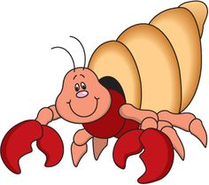

- What is a herbivore? Can you give an example of a herbivore you’d find on a rocky shore?

- What is a carnivore? Can you give an example of a carnivore you’d find on a rocky shore?

- A scaddy man’s head, or Sea Urchin is an “omnivore”. What does that mean?

- Explain how a dog whelk attacks its prey

- State two rules of the Seashore Conservation Code

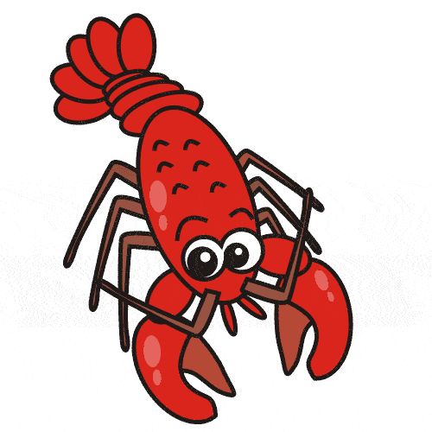
10. Give three examples of pollution that threatens seas and seashores.

